Learner Workbook

Module 2:
Understanding ECD

Learner Name and Surname
Learner ID
Company/Branch
Date
Learner Signature

SAQA ID 244484: Demonstrate knowledge and understanding of the development of babies, toddlers and young children; NQF Level 4, 8 Credits
SAQA ID 119471: Use language and communication in occupational learning programmes; NQF Level 4, 5 Credits

Table of Contents

Class Activities 3
Class Activity 1: The development of babies, toddlers and young children 3
Class Activity 2: Learning resources and the occupational learning materials and context 6
Class Activity 3: Formulate and use learning strategies 12
Class Activity 4: Conduct research, analyse and present findings 18
Rubric for Evaluating Written Report 19
Class Activity 5: Lead and function in a team 21
Reflection 27
Facilitator Observation Checklist 28

Class Activities

During and after the initial training you will be required to complete a number of activities. These activities will be both individual and group activities (class activities formative activities). The activities are numbered and are to be included in your Portfolio of Evidence. These activities will measure your progress through the programme. For authenticity reasons these activities must be handwritten.

 | Class Activity 1: The development of babies, toddlers and young children  Complete the following in small groups/individually as per the instructions from your facilitator: | 244484.1  244484.2  244484 EEK1, 2
- Work with a partner.
- Using your Learner Guide and conversations with other ECD professionals, describe three (3) examples of the different approaches to child development:

- Discuss your own idea of child development with your partner: how you think it happens, and what kind of physical and emotional environment you would set up at your ECD centre to ensure that children developed healthily and happily. Summarise the ideas you and your partner have come up with below:

- Give feedback to the group in the form of a short presentation.
Ask your partner and one other learner to verify that you have participated in the feedback session:

Print name | Sign | Date

- Work with a partner.
a) Complete the following table with the theories introduced to you in this Learning Unit:
Name of theorist | Main focus of theory | How I can apply these insights  in my ECD centre
Freud
Erik Erikson
Bandura
Vygotsky

- Work with a partner
Use the old magazines and newspapers, glue, scissors and five sheets of clean paper that you have brought to class.
- Find photographs in the magazines and newspapers, of fine motor activities and of gross motor activities, to match the ages of children at the following ages: 3, 4, 5, 6 and 7-9 years. The pictures don’t have to include children but must show the activity, for example an adult riding a bicycle could be used to illustrate what a child of six years old can do (the age when you think this skill is fully accomplished). On each page, identify the age you are presenting, and paste your pictures of the two kinds of activities (gross motor and fine motor) which fit for that age. Label them: fine motor skills OR gross motor skills.
- Write a paragraph below, giving an example of the relationship between physical growth and improvement in skills, in one of the age stages identified above.

- Work on your own to answer the following questions:

- Write a paragraph to show how a child of six years old in your ECD centre may show a sense of moral values by doing something to show caring or compassion.

- A six-year old child is regarded as being in middle childhood. Use the different domains as key identifiers and write a sentence or two for each domain listed, about the six-year-old’s development.

Middle childhood (6 years - 9 years)
Emotional/Social Changes

Thinking and Learning

Place your five (5) pages after this page; mark it clearly for easy reference.

 | Class Activity 2: Learning resources and the occupational learning materials and context  Complete the following in small groups/individually as per the instructions from your facilitator: | 119471.1  119471.3  119471.6  119471 EEK1, 2
- Describe how you would access and select appropriate information when trying to solve a work-related problem in the ECD centre:

- List the learning resources at your disposal in your ECD centre under the following headings:

- Communication resources
- Human resources
- Financial resources
- Physical resources
- Technological resources
- Information resources

- In column A there are some tasks and in column B there are different kinds of learning resources. Think about each task, and think about each resource. Decide which resource would be most suitable for each task:
Column A | Column B | Answer
- You are studying ECD centre management and need to find a film that shows the different systems in action. | - Trade magazine  - Reference book  - Dictionary  - Internet  - DVD  - Teacher  - Local person with suitable experience and knowledge
- You want to know how managers in your area consult with each other about marketing their preschool.
- You need guidance on how to approach a written assignment.
- You want to find the meaning of a word.
- You are learning about a new management process and want to get some information about it.
- You want to find out what recent educational products are being advertised for the South African market.
- You have an assignment on the structure and functions of the Department of Education..

- Explain how you can use the knowledge of subject matter experts and your peers to enhance your learning in the workplace.

- Explain in what way this qualification can impact your future career and education opportunities.

- Explain how you keep your learning material in an orderly way and store it safely at home and in the workplace:
A group member must sign to verify that your work meets the following criteria:
The learner has correctly: |  | Yes | No
explained how s/he keeps learning material in an orderly way and store it safely at home and in the workplace
Name of member
Signature
Date

- Identify the features of the following book:

Title:
Sub-title:
Author:

- Request your partner to verify that you can identify the following elements in your learning materials. Please feel free to access any learning materials to identify the following elements:

Learner Name |  |  |  | Date
Learning materials layout elements  Did the learner identify: |  |  | Yes/No |  | Comments
- index?
- contents page?
- glossary?
- electronic texts?
Person Signature
Person Name
Person Designation
Person Contact Details

- List five technical (5) (work-related) terms that are used in your ECD centre and explain them so that a lay person (not ECD specialist) can understand what you are referring to:

Technical term | Explanation

- Which words best describe your occupational environment (workplace)? Tick all the answers that apply.

Workplace/occupational focus:
Services
Manufacturing
Financial services
Educational
Type of organisation:
Government
Parastatal (para = beside)/ semi- government
Heavy industry
Light industry
Large organisation
Small business

- Discuss how the learning conditions and learning environment in your ECD centre influence your ability to study and learn:

- Describe how you overcome the negative aspects of your working environment and working conditions when it comes to studying and learning:

Place any extra evidence after this page; mark it clearly for easy reference.

 | Class Activity 3: Formulate and use learning strategies  In small groups, complete the following: | 119471.2
- Match the task in Column A with the learning technique in Column B and write the correct number and letter in Column C:
Column A | Column B | Column C
- You and a group of colleagues start work on a group assignment by contributing a wide range of ideas. | - Brainstorming
- You have a list of websites and you want to find one that deals with management skills. | - Note-taking
- You want to get an overview of the scope of an article. | - Memorising
- During a seminar, you want to record key ideas. | - Scanning
- You have to learn something off by heart so you use a mnemonic. | - Skimming

- You have learnt of several ways of getting information when you want to learn (e.g. this programme). Use a mind map to generate ideas on starting a Study Group – answer the following questions:
1. When do you meet?
2. Where do you meet?
3. What subjects are going to be studied?
4. How will you gather the required information?
5. And more…

Mind map:

- In small groups, brainstorm how to have more effective meetings in your ECD centre:

a) Select a topic for the brainstorming session
Topic:

b) Identify the purpose for the brainstorming session
Purpose:

c) Monitor developments during the brainstorming session and keep notes of these. Describe how the brainstorming session was done.

Brainstorm notes:

d) Retain focus of the brainstorming session and provide notes of how you achieved this.

e) Draw a conclusion towards the end of the brainstorming session and summarise it.

f) Ensure that the group/team take ownership of the conclusions/action plan. Describe how the group/team did this:

Request three (3) attendees of the brainstorming session to provide you with feedback about how you participated in the brainstorming session:
Learner Name |  |  | Date
Team brainstorming session  Did the learner: |  | Team Member 1  Yes/No | Team Member 2  Yes/No | Team Member 3  Yes/No
- actively participate in this group situation?
- make contributions to this group session/group work appropriate to the task and nature of the group?
- promote effective communication and teamwork?
- participate in the discussions, debates or negotiations appropriate to the purpose and topic?
Signature
Name
Designation
Contact Details

- Summarise the following passage in no more than 60 words and supply an appropriate title:

Every second, 1 hectare of the world's rainforest is destroyed. That's equivalent to two football fields. An area the size of New York City is lost every day. In a year, that adds up to 31 million hectares - more than the land area of Poland. This alarming rate of destruction has serious consequences for the environment; scientists estimate, for example, that 137 species of plant, insect or animal become extinct every day due to logging. In British Columbia, where, since 1990, 13 rainforest valleys have been clearcut, 142 species of salmon have already become extinct, and the habitats of grizzly bears, wolves and many other creatures are threatened. Logging, however, provides jobs, profits, taxes for the government and cheap products of all kinds for consumers, so the government is reluctant to restrict or control it.

- Try to memorise the facts in the passage in Activity 4 and retell them to your partner:
A group member must sign to verify that your work meets the following criteria:
The learner has correctly: |  | Yes | No
summarised the passage
retold the facts
Name of member
Signature
Date

- Devise a memory aid to help you remember the main facts of the passage above:

A group member must sign to verify that your work meets the following criteria:
The learner has correctly: |  | Yes | No
retold the main points of the passage correctly
created a memory aid
Name of member
Signature
Date

- Read the following case study and answer the question below:
Critical Carrie:
Critical Carrie listens to get all the facts, but is so critical of each item that she often misses the "big picture". Carrie frowns or rolls her eyes in disbelief as she listens to elements of a problem. Her questions for clarification are demanding and make her co-workers feel cornered. Critical Carrie is an incessant note taker, so her eye contact is limited. She finds little time for small talk. Her friends wish she would "lighten up" and not take things so seriously.

What steps should Carrie take to improve her listening skills?

- Identify a problem with conflict in your workplace.
Brainstorm and list various types of conflict that may happen in your workplace.

Choose ONE (1) of the conflict situations listed above and in your group discuss how it can be solved. Summarise your findings in a table.

A group member must sign to verify that your work meets the following criteria:
The learner has correctly: |  | Yes | No
identified types of conflict in the workplace
summarised the findings in a table
Name of member
Signature
Date

Place any extra evidence after this page; mark it clearly for easy reference.

 | Class Activity 4: Conduct research, analyse and present findings  In small groups, complete the following: | 119471.4
- Identify a learning-related problem that needs to be solved by conducting research in the classroom (You can use any resources available). Define the problem in a complete sentence, underlining the key words.

- List the research steps that you will undertake.

- Brainstorm possible solutions. Show your brainstorming notes.

- Draw a mind map of main ideas and supporting ideas. Show your mind map.

- Whom did you interview to obtain information? Request the interviewee(s) to sign the following document to confirm that the interview did take place:
Name and signature: | Date:
Name and signature: | Date:

- Present your research to the class. Ask three (3) group members to sign to verify that you have covered the topic adequately:

Name | Signature

Self-assessment Checklist:
- Complete the following self-assessment to show that you successfully completed the following in your research:
Questions:  Did I: | Yes/No  Where in my presentation?
- identify and define an appropriate or relevant topic and scope?
- plan and sequence the research steps appropriately?
- apply research techniques? (gathering information, reading/viewing, interviewing, observing, using appropriate electronic sources)
- evaluate the research information for relevance?
- classify, categorise and sort the information?
- analyse my research findings and present it in the appropriate format?

- Compile a written report in which you present your research findings and make recommendations to the head of the ECD centre. Your facilitator will use the rubric below to mark your report.

Place any extra evidence after this page; mark it clearly for easy reference.

Rubric for Evaluating Written Report
Attribute | 1-Not acceptable | 2-Below expectations | 3-Meets expectations | 4-Exceeds expectations | Score
Report Mechanics
Organisation | Inappropriate content of several sections of report | Some content placed incorrectly in report | Content appropriate to all sections of report | Excellent organisation enhances readability and/or understandability  of report
Complete | Information is incomplete | A few aspects of information missing | Information  is complete | Material added enhances quality  of information
Aesthetics | Unacceptable appearance e.g., tables and figures cannot be read or understood, fonts difficult to read; style unclear | Some portions are sloppy and difficult to read; style needs improvement | Text, tables, figures readable and understandable; style is acceptable | Text, tables, figures so clear and understandable as  to enhance report impact; style enhances readability
Format | So many format errors as to make report ineffective | A few format errors | Followed specified format | Unique format aspects that enhance report impact
Spelling | Many spelling errors | Only spelling errors are different spellings for same pronunciation | No spelling errors
Grammar and Punctuation | Pages or paragraphs with multiple grammar and punctuation errors | A few significant grammar and punctuation errors | Minor grammar or punctuation errors | No grammar or punctuation errors
Length | More than 20% too long or too short | 10% to 20% too long or too short | Length is appropriate
Content
Problem stated, constraints explained | Not present | Simply says “here it is” | Clearly explained problem and constraints | So clear and complete as to enhance impact of report
Benefits | No discussion of benefits | Limited discussion of benefits | Benefits clearly listed | So clear and complete as to enhance impact of report
Procedures | Many ambiguous statements, incomplete or inconsistent set of requirement, or poorly written statements | Some ambiguous statements, some wording could be improved | All requirements clearly stated | So clear and complete as to eliminate any questions about what is required
Conclusions/Recommendations | Not stated, includes ideas not already discussed in report | Includes ideas not already discussed in report, some recommendations not supported in document | Clear, clearly follow report discussion, meaningful recommendations | So clear and complete as to enhance impact of report
References provided as appropriate | Incorrect format, not cited in report |  | Correct format, all cited in report

 | Class Activity 5: Lead and function in a team  In small groups, complete the following: | 119471.5
- Summarise how you have actively participated in the following group learning situations:
Group Learning Situation | How I actively participated
Meetings
Site/field visits
Excursions
Discussions
Activities
Workshops

- List the advantages and disadvantages of group learning in your view:

A group member must sign to verify that your work meets the following criteria:
The learner has correctly : |  | Yes | No
listed the opportunities for group learning in the workplace
listed the advantages and disadvantages of group learning
Name of member
Signature
Date

- Take up responsibilities in the team and apply group work conventions in learning situations:
- Select a team.
- Assign team responsibilities: chairperson, scribe, report back and/or presentation.
- Assign one (1) learner to be an independent observer. S/he must observe groups for signs of disagreement/conflict, who dominates, who does not participate, etc.
- Read the following:
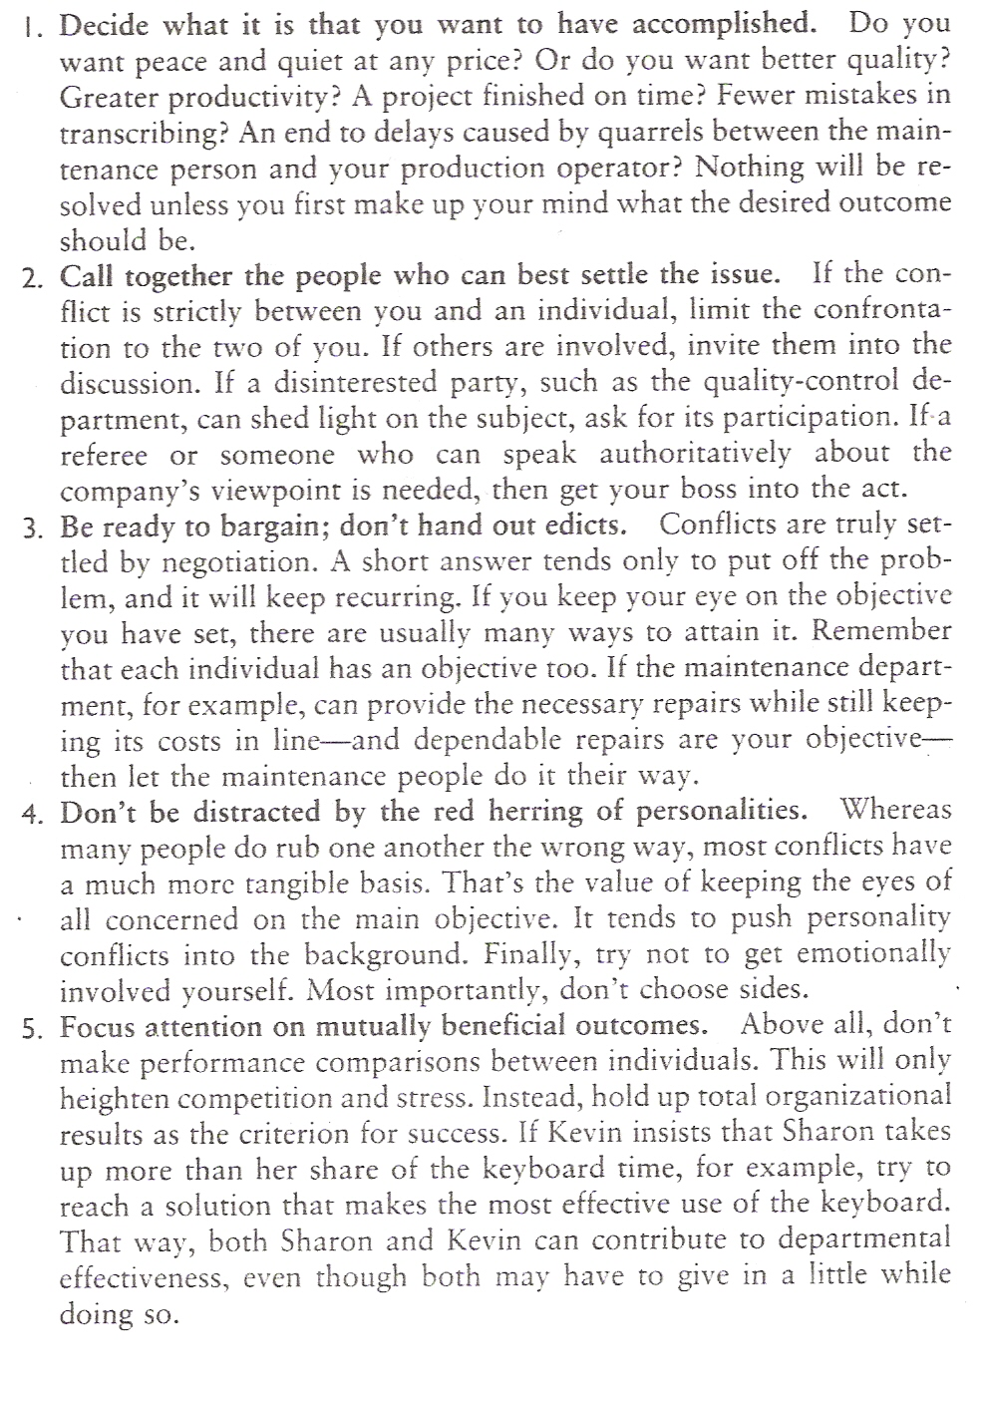
The piece you have just read describes conflict management.
- Identify a problem with conflict in your ECD centre.
- Brainstorm possible solutions.
- Write down the brainstorming ideas here:

- Draw a mind map showing the main and supporting ideas of the report you will draw up:

- Identify the responsibilities and roles each member of your team played while involved in the teamwork:
Names: | Responsibilities: | Roles:
- Which roles did you lack or have too many of in your team?

- How did you compensate for that lack or over-supply?

- Describe any conflict you had in your team while working on this exercise and how you dealt with the conflict as a team. If you didn’t have any conflict, give reasons why you think there was no conflict.

- What lessons regarding teamwork could one learn from the above?

- Identify the learning strategies that were used during the course of this exercise:
Learning strategies
Brainstorming
Group analysis
Peer assessment
Self-assessment
Mind maps
Note taking
Memorising
Key words
Underlining
Skimming
Scanning

Place any extra evidence after this page; mark it clearly for easy reference.

 | Reflection  Individually complete the following: | 119471  244484
The purpose of reflection is for you to consider what you have learnt and how you will use it in the future. Answer the following questions as honestly as you can:

- After the training programme, I can now (tick):
- demonstrate knowledge and understanding of ways of seeing the development of babies, toddlers and young children
- demonstrate knowledge and understanding of the development of babies, toddlers and young children within each domain of development
- access, use and manage suitable learning resources
- formulate and use learning strategies
- manage occupational learning materials
- conduct research, analyse and present findings
- lead and function in a team
- reflect on how characteristics of the workplace and occupational context affect learning

- How would you apply what you have learnt during this skills programme in the workplace?

- What was the most significant thing you have learnt in this programme?

- What do you think you still need to learn more about? (Action Plan)

- What did you enjoy most about the training?

- If there was something about the training that you could change, what would it be?

 | Facilitator Observation Checklist  The facilitator needs to provide feedback on the participation of each learner in the class: | 119471  244484
The purpose of the Facilitator Observation Checklist is to provide the learner with feedback about his/her participation during the formative class activities and also to highlight the observed strengths and perceived weaknesses that the learner displayed during the workshop and/or learning programme.
The facilitator is required to complete the Facilitator Observation Checklist for each learner in his/her Learner Workbook. The learner needs to sign off the document to confirm that he/she has received the observation feedback.

Learner Name |  | Facilitator Name |  | Date

Class Activity |  | Group/Individual | Completed | Participation |  |  |  | Comments on perceived strengths and weaknesses of the learner
- The development of babies, toddlers and young children.
- Learning resources and the occupational learning materials and context.
- Formulate and use learning strategies.
- Conduct research, analyse and present findings.
- Lead and function in a team.
- Reflection |  | Individual
Has the learner sufficiently demonstrated application of the following CCFOs during the facilitated session?
CCFO1: IDENTIFYING  Identify and solve problems: using learning programme material and learning tasks to solve problems. | CCFO2: WORKING  Work effectively with others and in teams: using interactive speech/sign and roles in activities, discussions and projects. |  |  |  | CCFO3: ORGANISING  Organise and manage oneself and one's activities responsibly and effectively: through organisation of learning materials and evidence. |  |  |  | CCFO4: COLLECTING  Collect, analyse, organise and critically evaluate information: through application of information processing skills in study.
Yes/No | Yes/No |  |  |  | Yes/No |  |  |  | Yes/No
CCFO5: COMMUNICATING  Communicate effectively using visual, mathematical and/or language skills in formal and informal learning situations. | CCFO6: SCIENCE  Use science and technology effectively and critically: using electronic media for learning. |  |  |  | CCFO7: DEMONSTRATING  Reflect on and explore a variety of strategies to learn more effectively. |  |  |  | CCFO8: CONTRIBUTING  Explore education and career opportunities.
Yes/No | Yes/No |  |  |  | Yes/No |  |  |  | Yes/No
Statement by the facilitator:  The learner has demonstrated sufficient knowledge and skill during class to proceed with the summative assessment (circle Yes or No). |  | Yes | No | Additional comments: (optional)

Learner Signature |  | Facilitator Signature

