**MODULE 2: HUMAN EVOLUTION**

**INTRODUCTION**

After learning about speciation and natural selection it is time to move closer to home namely human evolution. This module deals with the evolution of the family Hominidae. There are many characteristics that humans share with African apes but also many anatomical differences between humans and African Apes. This point to a common ancestor.

There are many lines of evidence that points to the idea of a common ancestor and human evolution. These lines include fossil evidence, genetic evidence, and the use of tools.

The out of Africa hypothesis states that humans evolved in Africa and slowly moved out of Africa and spread throughout the Earth.

**OVERVIEW**

This module deals with human evolution. The module starts with notes on how phylogenetic trees work. It is followed by the characteristics that humans and Africa apes share and their anatomical differences. The evidence for common ancestors for living hominids is then discussed in detail. After this it is followed by the out of Africa hypothesis.

**SPECIFIC OBJECTIVES**

By the end of this session, participants will be able to:

* Interpret a phylogenetic tree to show the place of the family Hominidae in the animal kingdom
* List the characteristics that humans share with African apes
* Explain the anatomical differences between African Apes and humans with the aid of diagrams
* Describe the lines of evidence that support the idea of common ancestors for living hominids including humans
* Explain the out of Africa hypothesis with evidence
* Set questions on different levels of Bloom’s taxonomy

**CONTENT**

You will study this module through the following units:

|  |
| --- |
| **Unit 1: How do we teach phylogenetic trees?** |
| **Unit 2: What is the traits humans share with African apes and what are the anatomical differences between them?** |
| **Unit 3: What is used as evidence for common ancestors for living hominids?** |
| **Unit 4: What is the “out of Africa” hypothesis?** |

**UNIT 1 – How do we teach phylogenetic trees?**



**Phylogenetic trees:**

A phylogenetic tree is a schematic form that shows the evolutionary relationships within a set of organisms or groups of organisms. *Phylo* = organism’s phylum group and *genetic* = from the genes/relationship between the genes

**The hominin family bush: a simplified version**

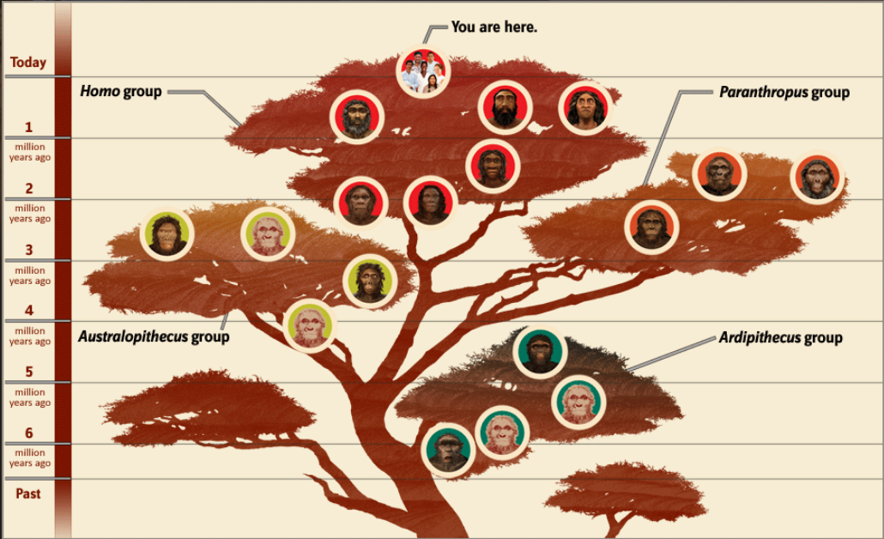

http://humanorigins.si.edu/evidence/human-family-tree

**Hints on interpreting phylogenetic trees:**

**(Modified from Mind the Gap: Grade 12 Life Sciences)**

Reading a phylogenetic tree is similar to understanding a family tree. The base of the tree represents the oldest ancestor and the tips of the branches represent the most recent descendants of that ancestor. As you move from the base of the tree, to the tips of the branches, you are moving forward in time.

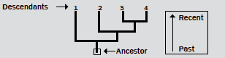

When speciation occurs, it is represented as branching on the tree.

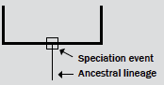

Each lineage has a part of its history that is unique and parts that are shared with other lineages.

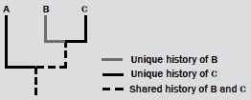

Similarly, each lineage has ancestors that are unique to that lineage and common ancestors that are shared with other lineages.

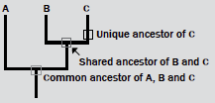

|  |  |  |  |  |  |  |  |  |  |  |  |  |  |  |  |  |  |  |  |  |  |  |  |  |
| --- | --- | --- | --- | --- | --- | --- | --- | --- | --- | --- | --- | --- | --- | --- | --- | --- | --- | --- | --- | --- | --- | --- | --- | --- |
| http://png.clipart.me/graphics/thumbs/214/summer-sports-icon-volleyball-icons_214110949.jpg **ACTIVITY 2.1**  **AIM-** To interact with a phylogenetic tree in order to understand how it works.  **BACKGROUND:** Phylogenetic trees are used in all NSC papers and learners have difficulty in answering questions relating to this concept.  **METHOD:**  Use the table below and cut out the hominids (including their names). Paste each hominid on the correct place on the phylogenetic tree page given to you. (You have to look at the time period first.) Paste each hominid on the circle provided at the end of the time line.   |  |  | | --- | --- | | **Time period (mya= million years ago)** | **Hominid** | | 20 0000 ya - present |  | | 400 000ya - 40 000ya |  | | 1.8 – 0.5mya |  | | 2.4 -1.4mya |  | | 2 - 1.2mya |  | | 2.1 - 1.5mya |  | | 3.3 - 2.1mya |  | | 3.9 - 2.9mya | ***Australopithecus***  ***afarensis*** | | 5mja - present |  | | 4.35- 4.45 mya |  |   Paste the correct homonid in the circles on the phylogeneitc tree below:    **million years ago**  Indicate where the following could be found on the phylogenetic tree above:   * Number 1: the common ancestor of all hominids * Number 2: the common ancestor of all organisms of the genus *Homo*   2.1.2. The diagram below shows possible evolutionary relationships among some hominids.    2.1.2.1 What is this type of diagram called? (1)  2.1.2.2 How many of EACH of the following are represented in the diagram:  (a) Genera (1)  (b) Homo species (1)  2.1.2.3. Name the species that have *Paranthropus aethiopicus* as a common ancestor. (2)  2.1.2.4. Name the:  (a) Hominid species that existed at the same time as *Homo sapiens* (1)  (b) First *Homo* species to appear (1)  **(7)**  **2.1.3**  **Choose the correct answer:**  According to the phylogenetic tree, the most recent common ancestor of …       |  |  | | --- | --- | | A  B  C  D | humans and chimpanzees became extinct 2 million years ago.  humans and gorillas became extinct 15 million years ago.  humans and chimpanzees became extinct 6 million years ago.  gorillas and chimpanzees became extinct 2 million years ago. |   **REFLECTION:**  Think about Bonobos and Chimpanzees. They are able to make fire, draw pictures, carry out difficult tasks. Relate this to the phylogenetic tree. What does this tell you?  **FOLLOW UP:**  Follow up on the newest findings on National Geographic website,  Sciencenewsforstudnets.org. [www.maropeng.co.za](http://www.maropeng.co.za). humanorigins.si.edu.  Almost every day new discoveries are made. |

**UNIT 2 – What are the traits humans share with African apes and what are the anatomical differences between them?**



**Characteristics that humans share with African apes:**

* Olfactory brain centres reduced/ reduced sense of smell
* Eyes in front/ Binocular vision / stereoscopic vision
* Eyes with cones/ colour vision
* Freely rotating arms
* Elbow joints allowing rotation of forearm
* Flat nails instead of claws/ bare, sensitive fingertips
* Opposable thumbs
* Bipedal/ upright posture / foramen magnum in a more forward position
* Sexual dimorphism/ distinct differences between males and females
* Parts of the brain that process information from the hands and eyes are enlarged
* Longer upper arms
* Large brains / skulls compared to their body mass
* Five digits per limb

**Anatomical differences between Humans (*Homo sapiens*) and African Apes**

| **FEATURE** | **Humans (*Homo sapiens*)** | **African Apes** |
| --- | --- | --- |
| Cranium | Large cranium/brain | Small cranium/brain |
| Brow Ridges | Brow ridges are not well developed | Brow ridges well developed |
| Spine | More curved spine | Less curved spine |
| Pelvic girdle | Short, wide pelvis | Long, narrow pelvis |
| Canines | Small canines | Large canines |
| Palate shape | Small and semi-circular | Long and rectangular |
| Jaws | * Small jaws * Less protruding jaws/less-prognathous | * Large jaws * More protruding jaws/   more prognathous |
| Cranial ridges | No cranial ridge | Cranial ridge across the top of the cranium |
| Foramen Magnum | Foramen magnum in a  forward position | Foramen magnum in a backward position |

 **ACTIVITY 2.2**

**AIM**: To analyse the differences between humans and African apes.

**BACKGROUND**: It is important for participants to recognize the differences and similarities between African apes and humans.

**METHOD:** Answer questions based on diagrams.

Study the diagrams below showing the different anatomical structures of a chimpanzee and a human. The diagrams are not drawn to scale.

.

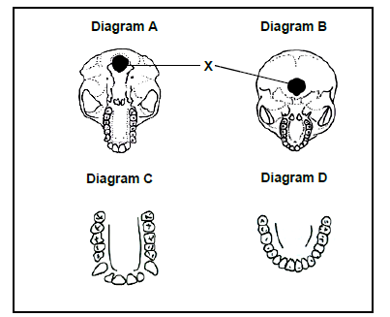

1. Provide a label for X. (1)

2. Tabulate TWO anatomical differences between the jaws in diagrams C and D which represent trends

In human evolution. (5)

3. Give the LETTER ONLY of the diagram that represents:

(a) The skull with a larger brain capacity. (1)

(b) A more prognathous skull (1)

4. Account for the position of X in the skull in diagram B. (2)

5. Explain the significance of the shape of the spine that is associated with the skull in diagram B. (2)

**REFLECTION:**

How would you go about teaching the differences and similarities to learners?

**FOLLOW-UP:**

Read articles on Wikipedia (consult reference list to ensure reputable references were used in the article. this should include university references), National Geography on the differences between Humans and African apes.

**UNIT 3 – What is used as evidence for common ancestors for living hominids?**



**Evidence of common ancestors for living hominids, including humans**

The term ‘*Homo*’ refers to the genus and means ‘human’. Studies of human evolution must include hominids such as the Australopithecines, as it is theorized that the *Homo* genus diverged (split) from them about four million years ago in Africa. Scientists have estimated that humans branched from their common ancestor with the chimpanzee about five to six million years ago. Other species of *Homo* like *Homo erectus* and *Homo neanderthalensis* have all become extinct. Substantial fossil proof exists to explain hominid evolution, although it is not enough to make specific conclusions. The poster below was constructed by Wits university to explain human ancestry to students:

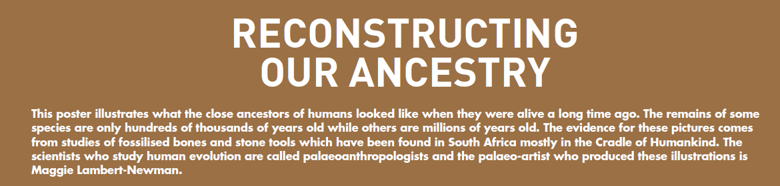

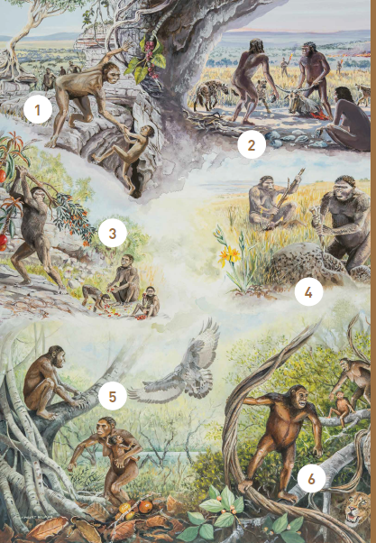

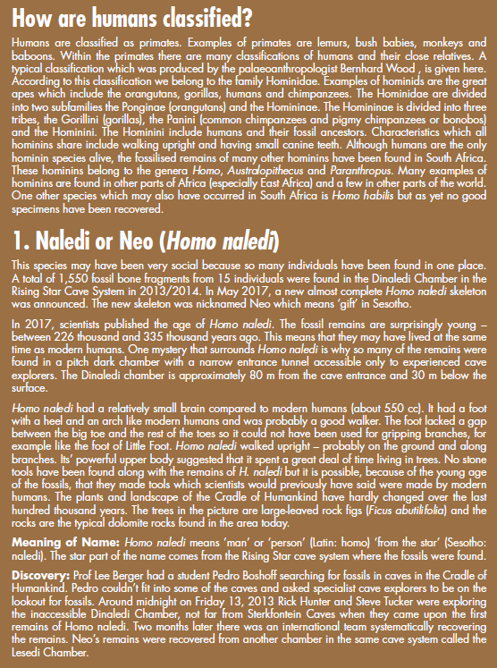

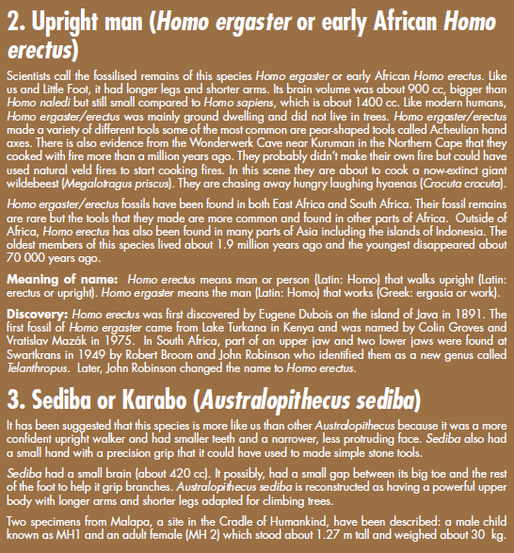

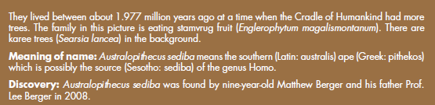

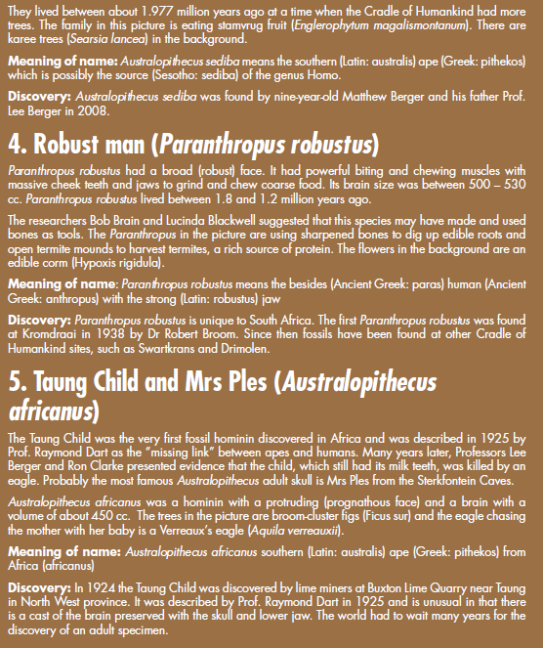

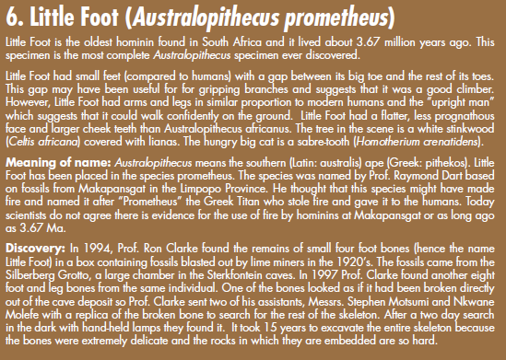



**Following is the evidence that is used to explain human evolution.**

**3.1. Fossil Evidence:**

* Archaeologists have provided **fossil evidence** to prove that relationships existed between the Early Stone Age cultures in Europe and Northern Africa.
* Discoveries in South Africa, Kenya and Zimbabwe have been used to prove and validate that Africa was the home of early man.
* Fossil sites in Africa:

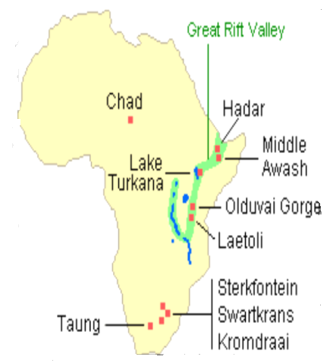

**Fossil records:**

| **Organism** | **When organism existed** | **Fossil site** | **Discovered by** | **Characteristics** |
| --- | --- | --- | --- | --- |
| *Ardipithecus ramidus* | 5-4 mya | North-East Ethiopia | Tim White | Brain size: 300-350 ml  Forward position of foramen magnum. Very prognathous (more protruding jaws). Heavy brow ridges. Pelvis structure: bipedal and tree climbing. |
| *Australopithecus afarensis* | 4-2,7 mya | Ethiopia  Kenya  Tanzania | Donald Johanson | Brain size: 375 – 550 ml  Forward position of foramen magnum  Very prognathous  Heavy brow ridges  Canines large and pointed  Long arms  No cranial ridge |
| *Australopithecus africanus* | 3-2 mya | Taung  Sterkfontein | Raymond Dart  Robert Broom Ron Clarke | Brain size: 428-625 ml  Forward position of foramen magnum  Prognathous  Brow ridges  Teeth large; canines not long  Long arms  No cranial ridge |
| *Australopithecus sediba* | 1,9-1,8 mya | Malapa Cave – in the cradle of humankind | Lee Burger | Brain Size: 420 ml  Lee prognathous  Brow ridges  Large teeth; canines not long  Long arms  No cranial ridge |
| *Homo habilis* | 2,2-1,6 mya | Tanzania | Louis and Mary Leakey | Brain size: 650 ml  Less prognathous  Less pronounced brow ridges  Human-like teeth; smaller canines  Long arms |
| *Homo erectus* | 2-0,4 mya | Java in Indonesia and then Swartkrans | Eugene Dubois | Brain size: 900 ml  Prognathous  Cranial ridges  Short canines  Longer legs and shorter arms |
| *Homo sapiens* | 200 000 years ago - present | Makapansgat in Limpopo  Border Cave in KZN  Blombos Cave in the Western Cape | Tim White | Brain size: 1200-1800 ml  No brow ridges  Small teeth  Short arms |

|  |  |  |  |  |  |  |  |  |  |  |  |  |  |  |  |  |  |  |  |  |  |  |  |  |  |  |  |  |
| --- | --- | --- | --- | --- | --- | --- | --- | --- | --- | --- | --- | --- | --- | --- | --- | --- | --- | --- | --- | --- | --- | --- | --- | --- | --- | --- | --- | --- |
| http://png.clipart.me/graphics/thumbs/214/summer-sports-icon-volleyball-icons_214110949.jpg **ACTIVITY 2.3**  **AIM:** To classify the anatomical differences between hominids.  **BACKGROUND:** This content is asked in a number of different ways in the NSC papers. Learners should be able to take any data, interpret it and classify it accordingly.  **METHOD:** Using diagrams to indicate the anatomical differences between hominids  **Question 2.3.1**  Cut the diagrams on the diagram sheet provided. The correct diagram must be pasted in the correct row and column in the table below. Label where required. In the case of the spine, only two diagrams are available; paste them under the correct headings.   |  |  |  |  | | --- | --- | --- | --- | | **Features** | **Chimpanzee**  **(*Pan troglodytes*)** | ***Australopithecus*** | **Human**  **(*Homo sapiens*)** | | **Skull**  Indicate brow ridges, cranial ridges and prognathous where applicable |  |  |  | | **Dentition and palate** (indicate differences with labels) |  |  |  | | **Position of Foramen magnum** |  |  |  | | **Position of spine in skull** |  |  |  | | **Shape of spine** |  |  |  | | **Pelvic girdle**  **and pelvis bone** |  |  |  |   **Template of diagrams FOR HUMAN EVOLUTION**                2.3.2. Study the following graph and answer the questions that follow.    2.3.2.1. Name the family to which all these species belong. (1)  2.3.2.2. What is the largest cranial capacity (in cm3) of *Australopithecus africanus*? (1)  2.3.2.3. When did *Homo habilis* become extinct? (1)  2.3.2.4. Name TWO *Australopithecus* fossils found in South Africa. (2)  2.3.2.5. Which of the organisms represented above has the greatest range in cranial  capacity? (1)        2.3.3.1 Based on the differences in dentition, what conclusion can be made about the change  in diet from *Australopithecus afarensis* to *Homo sapiens?* (2)  2.3.3.2. Australopithecus may be described as a transitional species between the chimpanzee  and *Homo sapiens.*   1. Define a *transitional species.* (1)   (b) Use ONE visible feature of the jaw to explain why *A. afarensis may be described as*  *a transitional species*. (2)    **REFLECTION:**  How would you teach your learners this content? Would you use this activity to enforce the content knowledge?  **FOLLOW-UP:**  Ensure that your learners have access to pass papers in order to see how this content can be assessed. |

**3.2. Genetic Evidence:**

* **Mitochondrial DNA:** MtDNA is the smallest chromosome located in the mitochondria and forms part of the organisms’ genome. In most species, mtDNA is inherited from the mother (maternal inheritance). The sequencing of the mtDNA shows a link in **phylogenetics** and **evolutionary relationships** between species. The age of the common ancestral mtDNA can be estimated to have existed approximately 140,000 to 290,000 years ago linking humans to **Mitochondrial Eve**.

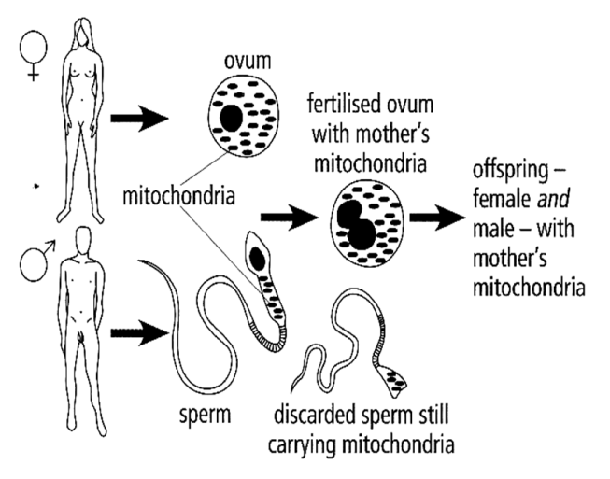

|  |
| --- |
| http://png.clipart.me/graphics/thumbs/214/summer-sports-icon-volleyball-icons_214110949.jpg **ACTIVITY 2.4**  **AIM:** To combine phylogenetic trees with genetic evidence of human evolution.  **BACKGROUND:** Participants should be able apply their knowledge on phylogenetic trees to solve questions based on genetic evidence.  **METHOD:** Answering questions based on diagrams.  The diagram below shows a phylogenetic tree based on DNA similarities. The percentage next to each branch shows the amount of difference in the genome (DNA nucleotide sequence) of the two relevant groups.    1. From the diagram, determine how long ago the chimpanzees split from the line to humans. (2)  2. Which organism is most closely related to humans? (1)  3. Calculate the DNA similarity between the genome of the chimpanzee and the human. (2)    **REFLECTION:**  How would you teach genetic evidence to your learners?  **FOLLOW-UP:**  Follow up on the newest findings on National Geographic website,  Sciencenewsforstudnets.org. [www.maropeng.co.za](http://www.maropeng.co.za). humanorigins.si.edu.  Almost every day new discoveries are made. |

**3.3. Cultural evidence: tool-making**

* The earliest hominids to use simple tools known as **Oldowan stone tools**, were *Homo habilis* that lived around 2.6 Ma and signifies the start of the Stone Age.
* *Homo habilis* fossils have been found in many parts of Africa with tools that were made of stone and used to aid hunting and cutting of food.
* *Homo erectus* developed more advanced tools that included **sharpened stones** placed on wooden handles, like an axe.
* They were also the first species to use **flints** and quartzite to make fire.
* Later fossil evidence shows tools like **scrapers** probably used to clean animal skins, slicers and **needles** used to sew animal pelts into the first form of clothes.
* From this point, tools progressed to **knives and blades** used by the Neanderthals used for hunting and protection.
* Fossil evidence shows that as the different species developed larger brains and greater intelligence, so their tools became more complex.

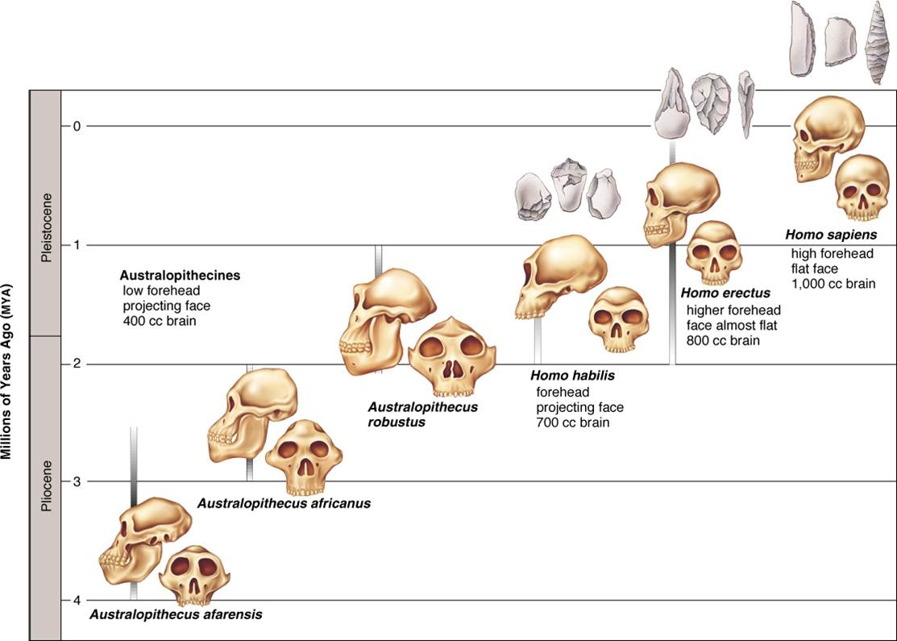

|  |
| --- |
| http://png.clipart.me/graphics/thumbs/214/summer-sports-icon-volleyball-icons_214110949.jpg **ACTIVITY 2.5**  **AIM:** To link the use of tools to the different hominins.  **BACKGROUND:** Phylogenetic trees are a popular way of assessing learner’s knowledge on the different human evolution topics.It is important to link different topics with the use of phylogenetic trees.  **METHODS:** Answering questions on a phylogenetic tree.  Study the phylogenetic tree below which shows a possible representation of human evolution. The solid lines represent the origin and extinction of the species. The skulls are not representative of the species and are not drawn to scale.    2.5.1. According to the phylogenetic tree, which species was the first to use simple stone tools? (1)    2.5.2. Name THREE species represented that used simple stone tools and fire. (3)  **REFLECTION:**  How would you teach cultural evidence to your learners?  **FOLLOW-UP:**  Follow up on the newest findings on National Geographic website,  Sciencenewsforstudnets.org. [www.maropeng.co.za](http://www.maropeng.co.za). humanorigins.si.edu.  Almost every day new discoveries are made. |

**UNIT 4 – What is the “out of Africa” hypothesis?**

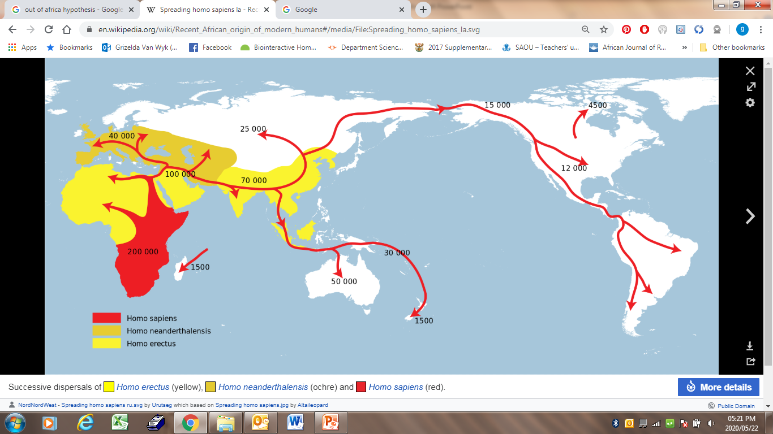

source: wikipedia

**Out of Africa hypothesis**

This hypothesis states that modern *Homo sapiens* evolved in Africa about 200,000 years ago and migrated outwards to Europe and Asia, according to the Southern Dispersal theory.

Most scientists agree that **modern humans** *(Homo sapiens*) **evolved in Africa and spread outwards across the continents.**

The following lines of evidence have been used to support this hypothesis:

* The oldest fossils of australopithecines/*Homo habilis*/bipedal organisms have been found in Africa
* The oldest fossils of *Homo erectus* have been found in Africa
* Analysis of mitochondrial DNA shows that the oldest female ancestors of humans are from Africa
* Analysis of Y chromosome shows that the oldest male ancestors of humans are from Africa

**Fossil Evidence:**

* *Ardipithecus* fossil were found in Africa ONLY, nowhere else in the world
* *Australopithecus* fossils found in Africa only (Karabo, Littlefoot, Taung child and Mrs Ples)
* Oldest fossils of australopithecines, *Homo habilis and* other bipedal organisms were found in Africa
* Oldest fossils of *Homo erectus* were found in Africa, followed by Asia and the youngest fossils of Homo erectus were found in Europe.

**Genetic Evidence:**

* Analysis of mutations in mtDNA trace oldest female ancestor to East Africa

|  |  |  |  |  |  |  |  |  |  |  |  |  |  |  |  |  |  |  |  |  |  |
| --- | --- | --- | --- | --- | --- | --- | --- | --- | --- | --- | --- | --- | --- | --- | --- | --- | --- | --- | --- | --- | --- |
| https://encrypted-tbn3.gstatic.com/images?q=tbn:ANd9GcTmvb5W3o3iVwoibBV6dgGW1cSvmySKmDtq6S6HPelleSIjW6OVN1fL4lQ **ACTIVITY 2.6**  **AIM:** To discuss the Out of Africa hypothesis.  **BACKGROUND: L**earners in the past have struggled to questions relating to this topic. It is important that they are able to order the content.  **METHOD: A**nswering questions.  **Question 2.6.1**  **5.1.** Read the following and draw a flow chart to discuss the possible answers.  Fossils of the bipedal primates *Ardipithecus*, *Australopithecus* and early *Homo* species are used to support the 'Out of Africa' hypothesis.  State the 'Out of Africa' hypothesis. Describe the evidence that supports the 'Out of Africa' hypothesis and the evidence that shows that the three primate genera mentioned above, were all bipedal.  **Question 2.6.2**  Analyse the data in the table and follow the instructions that follow the table.   |  |  |  | | --- | --- | --- | | **NAME** | **Key** | **Area where fossils were found** | | *Australopithecus africanus* | 1 | South Africa | | *Australopithecus afarensis* | 2 | East Africa Ethiopia Rift valley | | *Ardipithecus ramidus* | 3 | East Africa, Ethiopia Rift valley | | *Australopithecus sediba* | 4 | South Africa | | *Homo erectus* | 5 | Africa, China Indonesia, Rep of Georgia, Arabia, India, Thailand | | *Homo habilis* | 6 | East Africa, Olduvai Gorge Tanzania |   1. Use the key given in the table above and indicate where the fossils were found on the world map provided.  2. Use a coloured pen to indicate, with arrows, the route that illustrate the Out of Africa hypothesis. Also indicate the *Homo sapiens* exodus from Africa with different colour pen.  3. Arrange the genus groups from oldest to youngest.  4. Which genus groups’ fossils are only found in Africa?  5. Which specie’s fossils are found in Africa as well as the rest of the world? What does this tell us about this species?  6. On which continent are the oldest fossils of *Homo sapiens* and *Homo erectus* found?  7. State how fossils provide evidence for the Out of Africa hypothesis.  Image result for world map  **Question 2.6.3**  Use the table below, which indicates some of the hominid fossils found in different parts of the world and  set questions on the FOUR levels of Bloom’s taxonomy (p.11) used in Life Sciences.    **REFLECTION:** How would you teach this topic to your learners?  **FOLLOW-UP:**  Follow up on the newest findings on National Geographic website,  Sciencenewsforstudnets.org. [www.maropeng.co.za](http://www.maropeng.co.za). humanorigins.si.edu.  Almost every day new discoveries are made. |

**THE PERFECT EXAMPLE OF EXPLAINING THE OUT OF AFRICA HYPOTHESIS: (NOV 2016 P2 ESSAY MEMO)**

**HYPOTHESIS**

All modern humans /*Homo sapiens* originated in Africa

-and migrated to other parts of the world

**FOSSIL EVIDENCE**

* Fossils of *Ardipithecus* were found ONLY in Africa /Rift Valley/Ethiopia/South Africa
* Fossils of *Australopithecus* were found ONLY in Africa /Rift Valley/Ethiopia/South Africa
* The fossils of *Homo habilis* were ONLY found in Africa
* The OLDEST fossils of *Homo erectus* were found in Africa
* The OLDEST fossils of Homo sapiens were found in Africa

**GENETIC EVIDENCE**

- Mitochondrial DNA is inherited only from the maternal lines

- Analysis of mutations on this mitochondrial DNA

- shows that the oldest female ancestor were located in Africa

- and that all humans descended from her /mitochondrial Eve

- The Y chromosome shows the paternal line

**CULTURAL EVIDENCE**

- The OLDEST/most primitive artefacts (tools, cutlery, art etc.) were found in Africa

**BIPEDALISM**

The fossils of all three genera indicate that: The foramen magnums are located in a more forward position

- The pelvis is wider and shortened

- The spine is S-shaped

**RESOURCES**

The article below is a good summary of some recent work published about a human skeleton found in Ballito Bay.

<https://www.thetimes.co.uk/edition/comment/it-took-10-000-generations-to-make-an-iphone-8phfggzqz>

Exploring evolution: <http://www2.edc.org/weblabs/ExploringEvolution/ExploringEvolutionMenu.html>

Biology in Motion – Evolution Lab: <http://biologyinmotion.com/evol/>

Wonderful animations: <http://www.sumanasinc.com/webcontent/animation.html>

Evolution: <http://evolution.berkeley.edu/>

Evolution: [www.maropeng.co.za](http://www.maropeng.co.za)

For videos: [www.eChalk.ca.uk](http://www.eChalk.ca.uk).

Human Evolution: The Fossil Evidence in 3D (requires Shockwave plug-in):

<http://www.anth.ucsb.edu/projects/human>

Hominid Evolution: Distinguishing Features and Characteristics:  [http://www.geocities.com/SoHo/Atrium/ 1381/hominids2.html](http://human-evolution-firstman.blogspot.com/)

Human Evolution: A Look at Our Ancestors: [http://www.humboldt.edu/~mrc1](http://www.becominghuman.org/)

Human Evolution: You Try It: [http://cgi.pbs.org/wgbh/aso/ tryit/evolution](http://cgi.pbs.org/wgbh/aso/tryit/evolution)

**MODULE SUMMARY**

In order to understand human evolution it is important to know the different kind of evidences that are used to substantiate this claim namely fossil evidence, genetic evidence and cultural evidence. Special care has been taken to focus on phylogenetic trees as this has been pointed out as being a problematic topic. This module covers all the requirements for the DBE NSC exams w.r.t. the topic: Human evolution.

**REFERENCES**

* DBE Exam guidelines for learners
* GDE ATP
* 2015-2018 NSC past papers
* 2014-2018 national diagnostic report on learner performance
* Approved grade 12 national textbooks
* Internet
* Gauteng grade 12 Life Sciences Revision booklet