**DNA and Protein synthesis**

**DEFINITIONS AND IMPORTANT TERMS AND CONCEPTS:**

|  |  |
| --- | --- |
| Term | **Meaning/Definition** |
| **base pairing** | Adenine (A) always bonds to thymine (T) and guanine (G) with cytosine (C) in DNA molecule, to ensure the precision of DNA replication |
| **chromatin** | Tangled network of chromosomes located within the nucleus |
| **chromatid** | The individual threads that form a chromosome |
| **centromere** | Structure joining two threads of a chromosome |
| **chromosome** | A structure made up of two chromatids joined by a centromere that carries the hereditary characteristics within the DNA |
| **chromatin network** | Visible as thread-like structures in the nucleus of an inactive cell |
| **nucleolus** | Structure in the nucleus responsible for forming ribosomal RNA |
| **nucleoplasm** | That part of the protoplasm within the nucleus |
| **cytoplasm** | That part of the protoplasm outside the nucleus. |
| **ribosome** | Structure that is the site of protein synthesis |
| **gene** | Segment of a chromosome that controls each characteristic/ a unit of sequenced pieces of DNA that carry the genetic information that will determine the hereditary characteristics of an organism. |
| **hereditary** | Characteristics that are passed from parents to offspring |
| **DNA** | Nucleic acid that is a constituent of chromosomes |
| **helix** | Natural shape of a DNA molecule |
| **RNA** | Type of nucleic acid that occurs as a single strand / nucleic acid that contains uracil |
| **nucleotide** | Building blocks of nucleic acids consisting of a sugar, a base and a phosphate |
| **replication** | The formation of an exact copy of the DNA in a cell |
| **template** | The original strand upon which a new strand is developed |
| **complementary strand** | The new strand that is made based on the sequence of nucleotides on the template |
| **cytosine** | The base that pairs off with guanine |
| **thymine** | The base that pairs off with adenine |
| **uracil** | The base found in RNA and not DNA |
| **Hydrogen bonds** | The chemical bonds which link base pairs in the DNA molecule |
| **DNA:** | (Deoxyribonucleic acid) forms the chromosomes in the nuclei of all living cells and carries the hereditary information of the organism. The DNA molecule is a double helix (twisted) strand. |
| **DNA replication** | Process involving the formation of two new identical DNA molecules from an original DNA. |
| **enzyme** | A protein that speeds up a chemical reaction / a catalyst |
| **codon** | The three adjacent bases found on a DNA or m-RNA molecule |
| **anticodon** | The three adjacent bases found on a t-RNA molecule that will determine which amino acid will be brought to the ribosome |
| **transcription** | The synthesis of m-RNA from a DNA template |
| **translation** | The process of converting the information carried by m-RNA to the correct sequence of amino acids to form a particular protein |
| **RNA** | (Ribose nucleic acid) a single strand, located in the nucleoplasm and cytoplasm. The RNA molecule is always a single strand of nucleotides. Remember that the RNA contains **Uracil** instead of Thymine (**A, G, C** and **U**). RNA is responsible for protein synthesis. |
| **synthesis** | Building up of separate parts into a whole |
| **amino acid** | The basic building block of a protein molecule |
| **peptide bond** | A bond between two adjacent amino acids |
| **monomer** | A single unit that makes up a larger molecule |
| **polymer** | A large molecule which is formed from many small molecules (monomers) |
| **mutation** | A sudden and relatively permanent gene / chromosomal change |
| **mitochondrial DNA** | The type of DNA found only in the mitochondrion |
| **messenger RNA (mrna)**: | Responsible for carrying the genetic code that is transcribed from DNA, to specialized sites of the ribosomes where the information is translated for protein synthesis |
| **nitrogenous bases:** | This is a nitrogen containing molecules viz. Adenine, (A); Thymine (T); Guanine (G); Cytosine (C) and Uracil (U). |
| **nucleotide:** | The building block (monomers) of RNA and DNA. Each nucleotide consists of a pentose sugar, a phosphate ion and a nitrogenous base. |
| **ribosomal RNA (rRNA)** | Form the ribosomes and produce the proteins, based on the information received from the tRNA |
| **transfer RNA (tRNA)** | Has anticodons which codes for a specific amino acid. The anticodons are complementary to the mRNA codon, during the production of proteins. |
| **genome** | All the genes present in an organism |

**1. DNA and where it is found**

In the nucleus of almost every cell I your body is the collection of DNA needed to make you. DNA in the nucleus is grouped into 23 sets of chromosomes that are called your genome. DNA is grouped into groups called genes within each chromosome. Your genome contains about 35000 genes.

Some interesting facts regarding chromosomes:

* Chromosome 1 is the largest chromosome with roughly 250 million nucleotide base pairs, and 4316 genes have been identified on this chromosome. If we could stretch out this chromosome it would be 8.5 cm. 890 diseases linked to this chromosome (Alzheimer's type 4, breast cancer etc. )
* **Chromosome 21** is the smallest with roughly 48 million nucleotide base pairs, with between 477-635 genes. Diseases related to genes on chromosome 21 is Alzheimer, lateral sclerosis, Down syndrome, certain types of deafness and 8 other identified syndromes.

**Following is a diagram illustrating where DNA is found in a cell:**

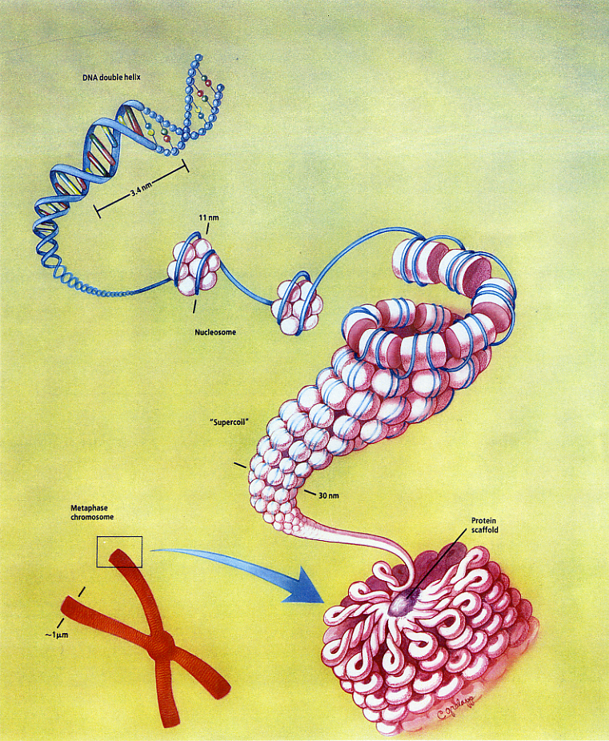

**The Structure of DNA**

Each nucleic acid consists of a number of basic building blocks called nucleotides. Each **nucleotide** consists of three parts:

* 1 phosphate ion,
* 1 pentose sugar
* and 1 nitrogenous base.

The structure of a nucleotide:

**phosphate**

**ion**

**pentose**

**sugar**

**nitrogenous base**

* The phosphate and sugar form the backbone of the DNA molecule, whereas the bases form the “rungs”.
* There are four types of nitrogenous bases.
* Thymine
* Guanine
* Cytosine
* Adenine

**Combination is ALWAYS:**

**Guanine** **Cytosine**



**Adenine Thymine**



**Adenine Thymine**



* A gene is a section of DNA that codes for a protein.
* Each unique gene has a unique sequence of bases.
* This unique sequence of bases will code for the production of a unique protein.
* It is these proteins and combination of proteins that give us a unique phenotype.

**2. DNA REPLICATION:**

1. The double helix unwinds.

2. Weak hydrogen bonds between nitrogenous bases break and two DNA strands unzip

*(separate).*

3*. Each original* DNA strand serves as a template on which its complement is built.

4. Free nucleotides build a DNA strand onto each of the original two DNA strands by

attaching to their complementary nitrogenous bases (A to T and C to G)

5. This results in two identical DNA molecules. Each molecule consists of one original strand

and one new strand

**Step 1: DNA molecule unwinds (unzip)**

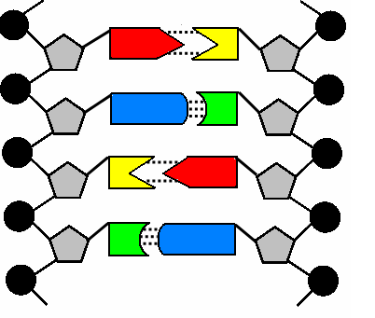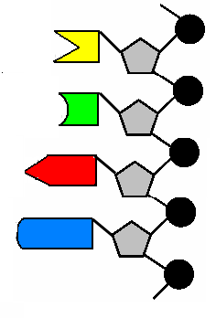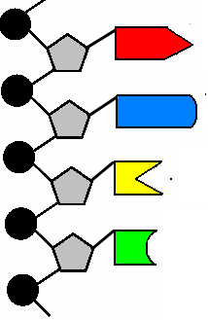

Enzyme that “unzips” helix is DNA helicase

**Step 2: New bases attach themselves**



**New bases attached themselves in the correct place of each strand**

**Free nucleotides in nucleoplasm**

**Step 3: Two identical strands are formed. Each strand now becomes a double helix.**

**Strand 1 Strand 2**

 

**The significance of DNA replication:**

* Important for growth and reparation
* mutations in DNA could cause genetic variation.

**3. DNA profiling**

**What is DNA profiling?**

A technique used by scientists to distinguish between individuals of the same species using only samples of their DNA.

The process is as follow:

* The nucleotides are separated from each other in

the order that they are found in strand of DNA

* Nucleotides appear as dark bands
* The sequence of the bases in this segment is identified
* Use as DNA fingerprint - Unique for every person

**What is DNA profiling used for:**

Solving crimes

Paternity tests

Identifying bodies

**The process followed in paternity cases are** :

1.The potential father, mother and child’s DNA profiles are compared next to each other. (All three

persons DNA bands are on same diagram)

2. Eliminate all the bands that match the mother.

3. All the remaining bands are compared to the father and if all the remaining bands correspond

with the DNA bands of the potential father , he is the biological father

**Solving crimes by using a DNA fingerprint:**

* A useful but controversial method
* A sample of a suspect’s bodily fluid or tissue is to be compared with a sample found at the

scene of a crime.

* The pattern of lines represents a person’s specific genetic make-up.
* DNA fingerprinting used in 11/9 disaster to identify victims

**4. RNA**

There are three types of RNA molecules, namely messenger RNA (mRNA) and transfer RNA (tRNA) and ribosomal RNA (rRNA).

1**. Messenger RNA (mRNA)**

Has the same sequence of bases as the DNA strand that has the gene sequence. Acts as a template for protein synthesis.

**2. Transfer RNA (tRNA)**

One for each triplet codon that codes for a specific amino acid.

tRNA molecules are covalently attached to the corresponding amino acid at one end.

At the other end they have a triplet sequence (called the anti-codon) that is complementary to the triplet codon on the mRNA.

3. **Ribosomal RNA (rRNA)**

Make up an integral part of the ribosome, the protein synthesis machinery in the cell. Not examinable.

**How do transcription and translation fit into protein synthesis?**

**1. The importance of proteins:**

* Play essential roles in the cells of all living creatures.
* They serve as building blocks of cells, control chemical reactions, and transport materials to and from cells.
* Composed of long chains of amino acids.
* The specific sequence of amino acids in a chain determines the exact function of the protein.

**2. The process of protein synthesis**

Protein synthesis takes place in two steps namely transcription and translation. The two steps will now be dealt with in detail.

**Transcription:**

* Takes place in the nucleus
* Double stranded DNA unzips
* When the weak hydrogen bonds break
* One strand is used as a template
* To form mRNA
* Using free mRNA nucleotides from the nucleoplasm
* mRNA is complementary to the DNA
* mRNA moves from the nucleus to the cytoplasm and attaches to the ribosome

**REMEMBER:**

**DNA RNA**

**T – A U – A**

**G – C G - C**

**Translation**:

* Takes place in cytoplasm
* Each tRNA carries a specific amino acid
* When the anticodon on the tRNA
* Matches the codon on the mRNA
* Then tRNA brings required amino acid the ribosome
* Amino acids become attached by peptide bonds
* To form the required protein

Each protein is formed specifically to the **genetic code** stored on the DNA in the nucleus of every cell in the organism. Any change during this coding process will result in a **gene** **mutation**.