**MODULE 4: THE HUMAN EAR**

**INTRODUCTION**

The body responds to a variety of different stimuli such as light, sound, touch, temperature, pressure, pain and chemicals (taste and smell).

The Human ear is the [organ](https://www.britannica.com/science/organ-biology) of [hearing](https://www.britannica.com/science/hearing-sense) and [equilibrium](https://www.merriam-webster.com/dictionary/equilibrium) that detects and analyses sound by [transduction](https://www.britannica.com/science/transduction-microbiology) (or the conversion of sound waves into electrochemical impulses) and maintains the sense of balance (equilibrium).

Only one week is allocated on the ATP for the teaching of the human ear. Because the structure and function of the ear has to be taught, it is important to use diagrams for the teaching and learning of this topic. You will also notice that we have included terminology lists as these are crucial for good performance. Please ensure that your learners do regular terminology activities and tests. The role of the ear in maintaining balance is also very important and examiners often set questions on this topic.

**OVERVIEW**

This module deals with the human ear. There is a detailed terminology list, followed by the structure and functions of certain parts of the ear, the functioning of the human ear in hearing (include the role of the organ of Corti without details of its structure) and balance (include the role of maculae and cristae without details of their structure) and the cause and treatment of middle ear infections (Use of grommets) and deafness (Use of hearing aids and cochlear implants).

**SPECIFIC OBJECTIVES**

By the end of this session, participants will be able to:

* Draw and label the parts of the ear.
* Describe the functions of the different parts.
* Briefly describe the path of sound as it travels through the ear.
* Briefly describe the functioning of the maculae and cristae and their role in balance.
* Briefly describe the nature and treatment of hearing defects.

**CONTENT**

You will study this module through the following units:

|  |
| --- |
| **Unit 1: Structure of the human ear and the functions of the different parts, using a diagram** |
| **Unit 2: Functioning of the human ear in hearing and balance** |
| **Unit 3: The nature and treatment of hearing defects** |

**UNIT 1 - Structure of the human ear and the functions of the different parts, using a diagram**

**Terminology & definitions:**

|  |  |
| --- | --- |
| **Biological term** | **Description** |
| Auditory Canal | The open passage through which sound waves travel to the middle ear. |
| Auditory Nerve | Bundle of nerve cells that carry signals from the sensory fibres to the brain. |
| Cochlea | Coiled, fluid-filled structure of the inner ear that contains hair cells called cilia. Cilia sway in response to sound waves, transmitting signals toward the brain. |
| Eardrum | A taut, circular piece of skin that vibrates when hit by sound waves. |
| Eustachian Tube | The passageway that connects the ear to the back of the nose to maintain equal air pressure on both sides of the eardrum. |
| Mechanoreceptors | The Organs of Corti are receptors located in the cochlea of the ear, which are stimulated by sound waves and convert the sound waves into impulses. |
| Ossicles | Three little bones called the hammer, anvil and stirrup located in the middle ear and that function to amplify sound. |
| Otis media | Inflammation and infection of the middle ear which causes pressure on the eardrum. |
| Pinna | The outer portion of the external ear: sound travels through the outer ear to the ear canal. |
| Semi-circular Canals | Fluid-filled structures in the inner ear that detect movement and function as balance organs. |

**The Human Ear:**

The ears are the sense organs for **hearing**. **Mechanoreceptors** in the ear are stimulated by sound waves, which are converted to impulses. The impulses are transmitted via sensory neurons to the auditory centre in the **cerebral cortex** of the brain where they are interpreted. The ears are also the organs for **balance and equilibrium**. These impulses are transmitted via sensory neurons to the **cerebellum** where they are interpreted to ensure balance and equilibrium.

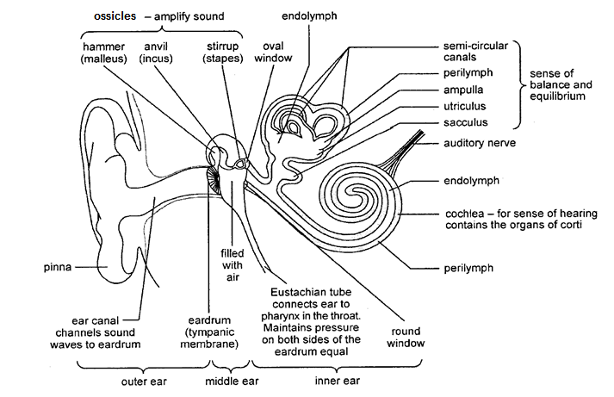

** Activity 4.1**

**AIM: To identify and label the different parts of the ear**

**METHOD: Complete the spaces provided**

Fill in the labels of the parts of the ear

**UNIT 2 - Functioning of the human ear in hearing and balance**

**Functioning of the human ear - path of sound:**

Sound waves move from the vibrating source (for example, a person talking or a car driving past) in horizontal waves. Humans hear sounds with a vibration frequency of between 16 and 20 000 Hz.

| **Part of ear** | **Function during hearing process** |
| --- | --- |
| Pinna | Traps the sound waves and directs them into the auditory canal |
| Tympanic membrane (ear drum) | Vibrates to the frequency of the sound waves and transmits the vibration to the ossicles in the middle ear |
| Ossicles | * The **three ossicles** (the hammer, anvil and stirrup) **amplify** the vibrations * The stirrup passes the vibration through the **oval window**, into the inner ear |
| Oval window | Vibrates and causes pressure wave movements in the liquid of the **perilymph**  in the inner ear to the **endolymph** inside the **cochlea** |
| Cochlea | These vibrations cause the sensory cells in the **Organ of Corti** (the mechanoreceptors) to brush or bend against the membranes converting the stimulus into an **impulse** |
| Auditory nerve | Transmits the impulse to the cerebrum where the sensation of sound is perceived and interpreted |
| Round window | **Excess vibrations** are passed out through the **round window**, to prevent pressure and echoes |

The pathway of sound through the ear:

**Balance and equilibrium:**

**The human ear is responsible for maintaining balance.**

* Thesemi-circular canals each have a swelling called the **ampulla.** The ampulla contains fine sensory hair cells called **crista**. When there is a change in speed or direction, the cristae are stimulated and a nerve impulse is discharged. This impulse is transmitted along the auditory nerve to the **cerebellum** where it is interpreted. The cerebellum will send impulses to the muscles, to restore balance.
* The **sacculus and utriculus** contain sensory hair cells called **maculae**. When the head position changes, the **pull of gravity** stimulates the maculae, which convert the stimulus into an impulse, transmitted along the auditory nerve to the **cerebellum** where it is interpreted. The cerebellum will send impulses to the muscles, to restore balance.

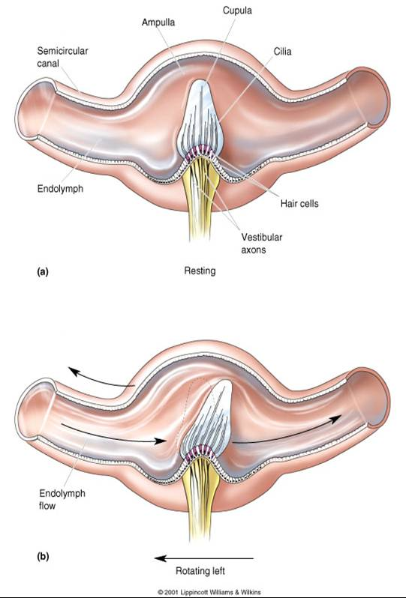

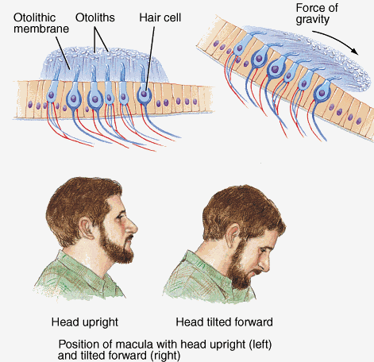





**Activity 4.2**

**AIM: to be able to identify, label and give the functions of different parts of the ear.**

**METHOD: Annotated diagrams**

**Label structures and write function next to structure:**



**UNIT 3 - The nature and treatment of hearing defects**

**Hearing defects:**

|  |  |  |
| --- | --- | --- |
| **Hearing defect:** | **Causes:** | **Treatment:** |
| **Middle ear infection**  (called **otitis media)** | Middle ear becomes infected with bacteria. Pressure builds up (pus and excess fluid) in the middle ear behind the ear drum, causing **extreme pain.** | * inserting grommets   (allows excess fluid to drain from middle ear)   * antibiotics |
| **Deafness**  (‘hearing impairment’, ‘hard of hearing’ or ‘deafness’) | * Injury to parts of the ear, nerves or parts of the brain. * Hardened wax collected in the auditory canal * Hardening of ear tissue like around ossicles | * Hearing aids (amplify sounds) * Cochlear implants (stimulates the auditory nerves with an electronic field, inside the cochlea) |



|  |
| --- |
| **Activity 4.3**  **AIM: to be able to answer questions set on the human ear**  **METHOD: Questions and answers** |
| **QUESTION 1: *(Taken from DBE November 2017 Paper 1)***  Study the diagram of the human ear below.    1.1. Identify:  (a) B  (b) D  1.2 Describe the role of the semi-circular canals in maintaining balance.  1.3 Describe how an increased production of mucus in the nose and throat may lead to the bursting of part E.  1.4 Explain why fusion of the structures at A may lead to hearing loss.  1.5 Which part of the brain will receive impulses from part C?    **QUESTION 2: *(Taken from DBE Feb/March 2016)***  The diagram below represents a part of a human ear.    2.1 Identify part:  a) A  b) D  2.2 Name the receptors that are found in part B.  2.3 Explain the consequence to the human body if:  a) Part C is damaged  b) Part A becomes hardened  2.4 Explain why people with middle-ear infections are usually advised not to travel by aeroplane.    **QUESTION 3: *(Taken from DBE Nov 2015 P1)***  Describe how the sacculus and utriculus in the human ear maintain balance in the human body. |

**RESOURCES**

<https://slocountyhearingaids.com/how-the-ear-works/>

<http://www.scholastic.com/browse/article.jsp?id=3757140>

<http://www.scholastic.com/listencarefully/pdf/starkey_68_imallears.pdf>

<https://www.britannica.com/science/ear>

**MODULE SUMMARY**

This module covers all the requirements for the DBE NSC exams w.r.t. the topic: The human ear. It is very important to be able to identify parts of the human ear on a **diagram** and to provide the functions of that part. It is important to remember that the ear plays a role in hearing as well as in balance.

**REFERENCES**

* DBE Exam guidelines for learners
* GDE ATP
* 2015-2019 NSC past papers
* 2014-2019 national diagnostic report on learner performance
* Approved grade 12 national textbooks
* Internet
* Gauteng grade 12 Life Sciences Revision booklet