**The human endocrine system**

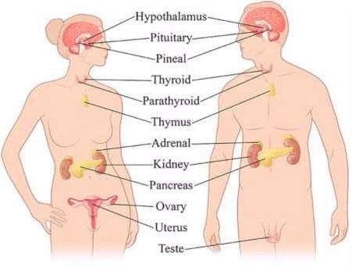

**1. Terms:**

* **Endocrine glands**: Ductless glands secreting hormones directly into bloodstream
* **Exocrine glands**: secrete substances into **ducts** that lead **into cavities** in the body or lead directly to the external environment. (Examples: sweat glands, mammary glands, the liver, salivary glands and the pancreas.)
* **Hormones:** organic chemical messengers secreted directly into the blood by an endocrine gland.
* **Homeostasis:** is the process of **maintaining a constant internal environment** within narrow limits, despite changes that take place internally and externally.
* **Negative feedback mechanism:** when there is an increase from normal, a corrective mechanism causes a decrease and vice versa to maintain a balanced system.

**2. What is the endocrine system?**

* The Endocrine system works in conjunction with the Nervous system. The endocrine system is responsible for **chemical coordination**, regulating the functioning of all the organs in the body
* Consists of glands situated throughout the body
* These endocrine glands secreteorganic chemical messengers called hormones in the bloodstream
* **Hormones** are organic substances and are mostly proteins, but a few are lipids(fats) (usually the sex hormones)
* Hormones are produced in small quantities
* They are carried in blood stream to target organ/tissue where they control the activities of a target organ to perform a specific function
* Hormones work together as an **integrated** **system** where they either stimulate or inhibit organs

**3. The differences between the endocrine system and the nervous system**

* The nervous system and endocrine system controls different types of activities in the body.
* They are jointly responsible for the functioning of all the different organs and systems, this is known as coordination
* The nervous system co-ordinates very quick responses to external stimuli
* The endocrine system controls responses that are not that fast but are long-lasting and reflect the body’s internal environments

|  |  |
| --- | --- |
| **Endocrine system** | **Nervous system** |
| 1. Made up of glands 2. Produces hormones 3. Hormones transported by the blood 4. Effects are slower and more general 5. Hormones control long-term changes (e.g. growth) | 1. Made up of nerves 2. Produces nerve impulses 3. Impulses transmitted along the nerves 4. Effects are very quick and very specific 5. Nerve impulses control short-term changes (e.g. sneezing, lifting your arm) |

**4. The differences between endocrine glands and the exocrine glands**

|  |  |
| --- | --- |
| **Endocrine glands** | **Exocrine glands** |
| **Glands** are **ductless,** secrete **directly into bloodstream** | Secrete their substances into **ducts** and not the bloodstream (think of the salivary glands secreting saliva in ducts that transports it to the mouth) |
| Secrete hormones | Does not secrete hormones |

**The pancreas is the only gland that is both exocrine (pancreatic juices for digestion) and endocrine (insulin and glucagon).**

**5. Position and function of the endocrine glands**

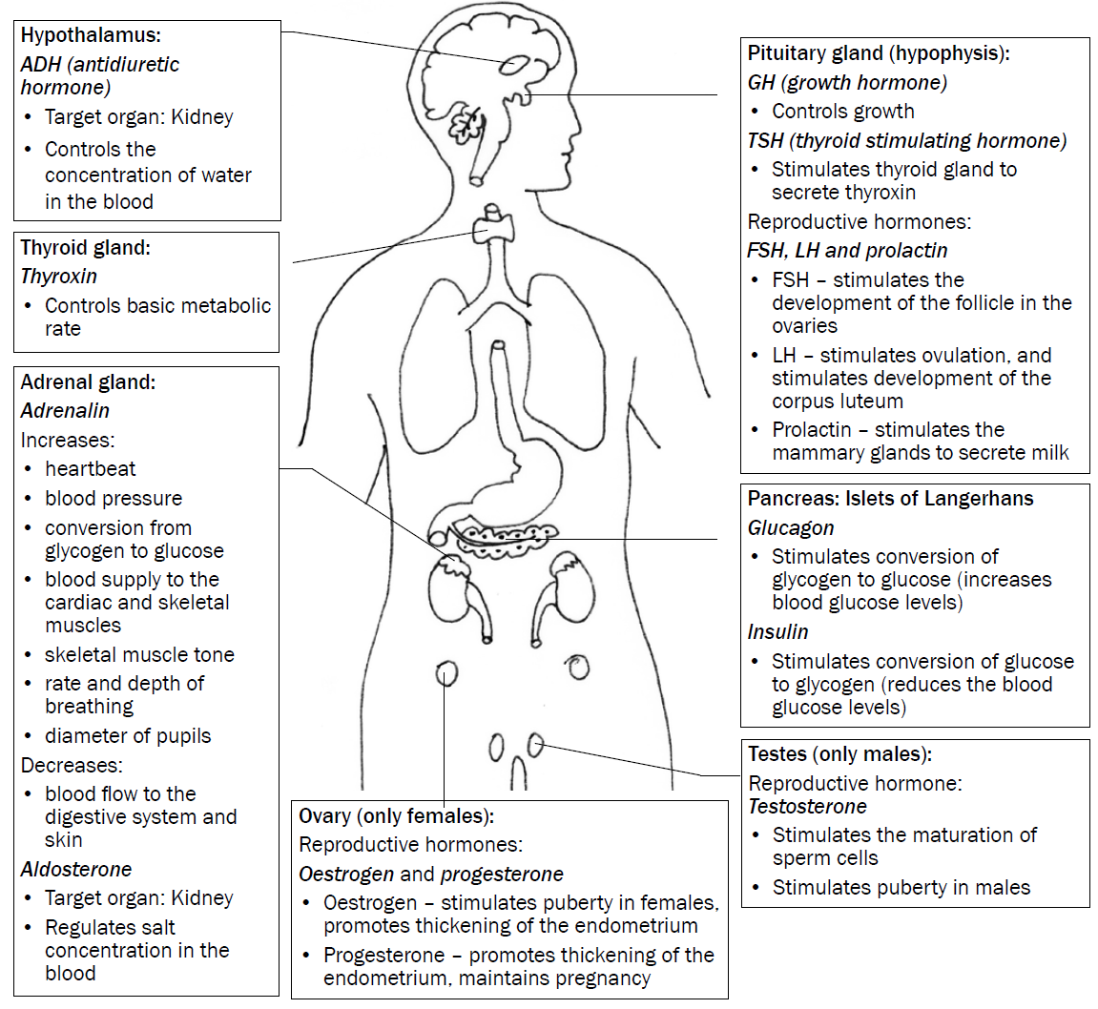

| **Hormone** | **Gland** | **Location** | **Function** |
| --- | --- | --- | --- |
| **Antidiuretic hormone (ADH)** | Neurosecretory cells of the **hypothalamus**  ADH is stored in the **Pituitary gland** | In the centre of the brain | Regulates osmoregulation in the kidneys (in the distil convoluted tubules and the collecting tubules) |
| **Thyroxin** | **Thyroid gland** | Below the larynx in the neck region | * Regulates the basal metabolic rate of the cells in the body * Affects growth and functioning of the heart and the nervous system * Stimulates growth and differentiation of tissue in a foetus and in children * Regulates the body temperature when stimulated by the hypothalamus |
| **Adrenalin**  **(fight-and-flight hormone)** | **Adrenal gland** | Above the kidney | Prepares the body to deal with stress:   * Increase in heartbeat rate * Increase in breathing rate * Increase in blood pressure * Increase in muscle tone * Increase in blood sugar levels * Decrease in blood supply to the skin and digestive system * Causes pupils to dilate |
| **Aldosterone** | **Adrenal gland** | Above the kidney | Helps the uptake of sodium ions in the loop of Henle in the kidneys |
| **Prolactin** | **Pituitary gland:** | Base of the brain and attached to the hypothalamus | * Stimulates the mammary glands to produce milk * Counteracts the effect of dopamine which is responsible for sexual arousal |
| **Oestrogen** | **Gonads: ovaries** | Located in the lower abdominal region with each ovary located within the pelvic bones (in line with the ball-and-socket joints of the femurs) | * Oestrogen promotes the development of the secondary sexual characteristics in females like breasts, the thickening of the endometrium (uterus) and the female body shape * Necessary for the process of ovulation * Oestrogen **inhibits** the secretion of FSH by the anterior pituitary gland so that only one follicle is produced during ovulation * High oestrogen levels will trigger the secretion of **luteinising hormone (LH)** |
| **Progesterone** | **Gonads: ovaries** | Located in the lower abdominal region with each ovary located within the pelvic bones (in line with the ball-and-socket joints of the femurs) | * Progesterone prepares the endometrium of the uterus for implantation once fertilisation of the ovum has occurred * Necessary for the production of the mucus plug to prevent sperm or other substances from entering the uterus during pregnancy * Decrease in progesterone levels causes menstruation * Progesterone improves memory and cognitive ability |
| **Testosterone** | **Gonads: testes** | Leydig cells in the testes of males located in the scrotum at the bottom of the pelvis | * Testosterone is responsible for the secondary sexual characteristics in males like a deeper voice, pubic hair, hair on face * Necessary for the normal development of sperm * Activates genes in the cells of Sertoli to promote the differentiation of the spermatogonia |
| **Glucagon** | Pancreas: **Islets of Langerhans** | Endocrine cells of the pancreas | Controls the increase in the blood sugar level by causing the conversion of glycogen to glucose |
| **Insulin** | Pancreas:  **Islets of Langerhans** | Endocrine cells of the pancreas | * Controls blood sugar by causing the conversion of glucose into glycogen * Inhibits the functioning of glucagon |
| **Growth hormone**  **(somatotrophin)** | **Pituitary gland:** | Base of the brain and attached to the hypothalamus | For growth, repair and replacement of cells |
| **Follicle stimulating hormone (FSH)** | **Pituitary gland:** | Base of the brain and attached to the hypothalamus | **In males:** stimulates spermatogenesis  **In females:** stimulates the development of the follicle for process of ovulation |
| **Luteinising hormone (LH)** | **Pituitary gland:** | Base of the brain and attached to the hypothalamus | **In males:** stimulates the synthesis of the hormone testosterone by the Leydig cells in the testes  **In females:** LH stimulates the release of the secondary oocyte from the Graafian follicle and then the development into the corpus luteum |
| **Thyroid- stimulating hormone (TSH)** | **Pituitary gland:** | Base of the brain and attached to the hypothalamus | Stimulates the production of thyroxin by the thyroid gland |
| **Prolactin** | **Pituitary gland** | Base of the brain and attached to the hypothalamus | Stimulates mammary glands to secrete milk |

1. **Homeostasis**

It is a process of maintaining a constant internal environment (blood and tissue fluid) within the body. This enables the body to function efficiently, despite changes in the external or internal environment

The following changes of the internal environment in the tissue fluid and blood, will affect the homeostatic balance of the body:

* temperature
* glucose levels
* carbon dioxide levels
* water levels and
* salt levels

1. **NEGATIVE FEEDBACK MECHANISMS**

They operate in the human body to detect changes or imbalances in the internal

environment and to restore the balance.

**General sequence of events in a negative feedback mechanism:**

* **STEP 1-** An **imbalance** is **detected**
* **STEP 2** - A **control** centre is **stimulated**
* **STEP 3-** Control centre **responds**
* **STEP 4-** Message sent to **target organ/s**
* **STEP 5-** The **target organ responds**
* **STEP 6-** It opposes/**reverses** the **imbalance**
* **STEP 7- Balance is restored**

**7. Regulation of thyroxin levels in body**

* **Thyroxin levels are too high:**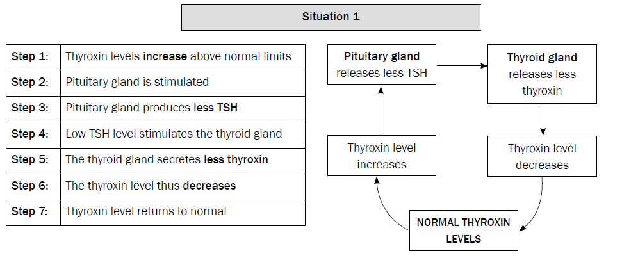
* **Thyroxin levels are too low**

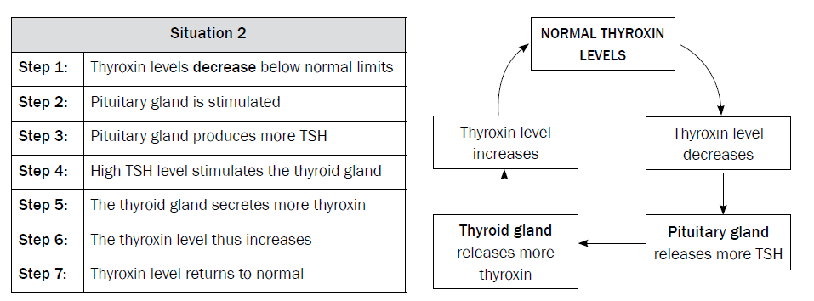

1. **Regulation of Glucose levels through negative feedback mechanism**

|  |  |  |
| --- | --- | --- |
| **When the glucose level in the blood INCREASES above normal levels:** | | |
| Step 1 | | Glucose levels in the blood **increase** above normal levels |
| Step 2 | | The beta cells of the pancreas are **stimulated** |
| Step 3 | | to secrete **insulin** into the blood |
| Step 4 | | Insulin travels in the blood to the liver and muscle cells (target organ/s) |
| Step 5 | | where it stimulates the conversion of **excess glucose** to **glycogen** which is then stored |
| Step 6 | | The glucose level in the blood now **decreases** |
| Step 7 | | and returns to normal |
| **When the glucose level in the blood DECREASE below normal levels:** | | |
| Step 1 | Glucose levels in the blood **decrease** below normal levels | |
| Step 2 | The alpha cells of the pancreas are **stimulated** | |
| Step 3 | to secrete **glucagon** into the blood | |
| Step 4 | Glucagon travels in the blood to the liver and muscle cells (target organ/s) | |
| Step 5 | where it stimulates the conversion of **stored glycogen** to **glucose** | |
| Step 6 | The glucose level in the blood now **increases** | |
| Step 7 | and returns to normal | |

1. **A flowchart depicting the negative feedback mechanism of glucose levels in the blood**

Pancreas secretes **insulin**

Glucose is converted to **glycogen**

Glucose level **increases**

Glucose level **decreases**

**Normal Glucose Levels in blood**

Glucose level **decreases**

Glucose level **increases**

Pancreas secretes **glucagon**

Glycogen is converted to **glucose**

**10. The regulation of Carbon dioxide levels in the blood:**

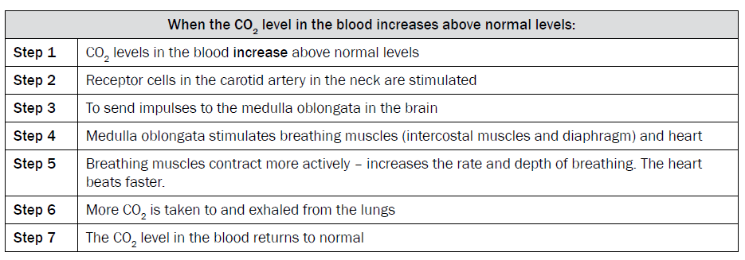

1. **The regulation of water balance in the blood. Osmoregulation in the blood.**

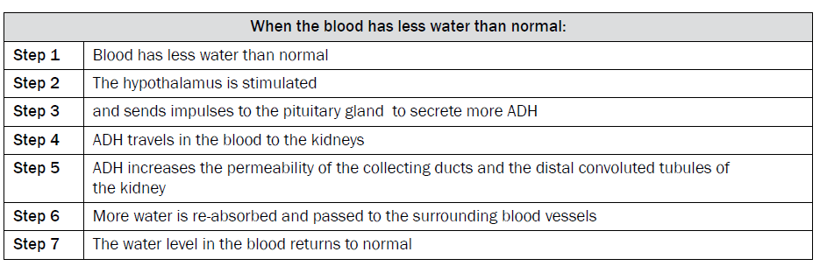

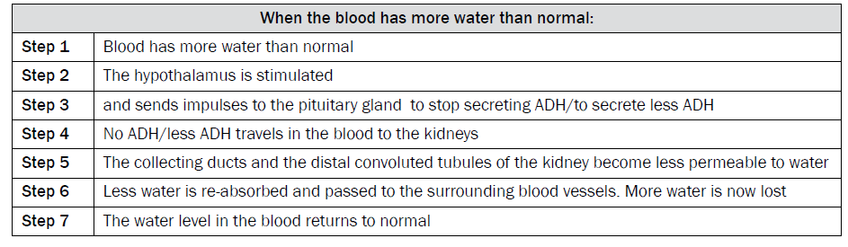

1. **The regulation of Salt levels in the bloodstream**

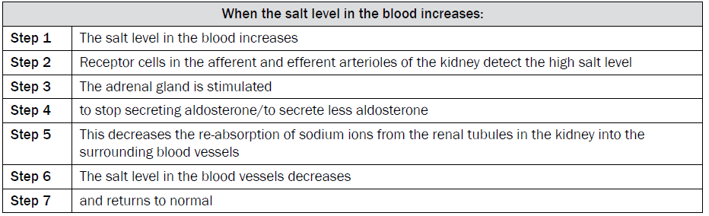

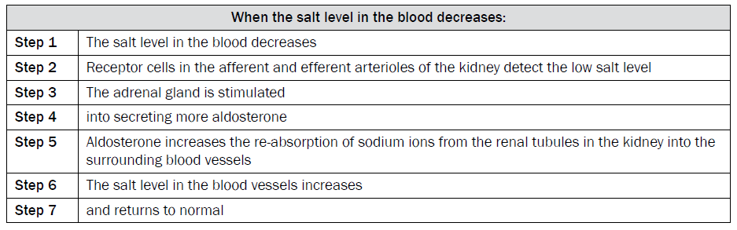

**Flow chart depicting the regulation of salt levels in the bloodstream**

