Responding to the environment: Plants
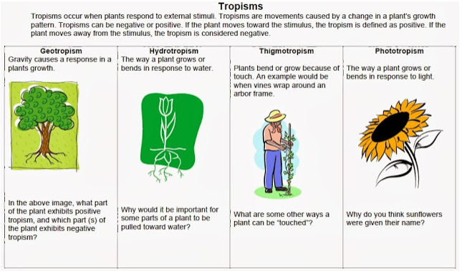

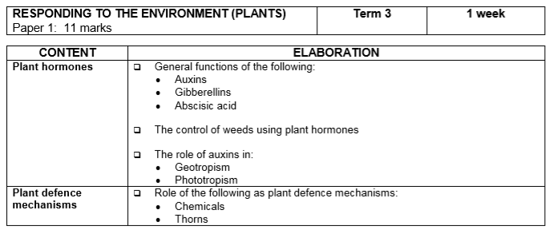
Terminology & definitions:
Biological term | Description
Abscisic acid | The plant hormone that promotes seed dormancy  A plant hormone that causes leaves to fall off trees in autumn.
Apical dominance | Is the phenomenon whereby the main, central stem of the plant is dominant over other side stems
Auxins | The plant hormone that promotes root and stem growth
Geotropism | The growth of part of a plant in response to gravity.
Gibberellins | A plant growth hormone that stimulates seed germination.
Herbicide | Chemical used to kill weeds
Hormone | Chemicals that allow a plant to respond to some stimulus in the environment
Phototropism | The growth of a plant in response to light
Tropism | The growth movement of a plant or part of a plant in response to an environmental stimulus

Growth development in plants
- Plants respond to stimuli in the environment by growing towards or away from the stimulus.
- This growth movement is controlled by plant hormones such as auxins, gibberellins, and abscisic acid.
- These substances are not true hormones because they work in the part of the plant where they are produced.
- Therefore, they are also referred to as plant growth substances.
- These allow plants to respond to certain stimuli in the environment:
  - allow plants to bloom at an appropriate time
  - allow plants to grow toward a light source
  - allow seeds to germinate at the appropriate time
  - induce dormancy in plants at the appropriate time
https://www.youtube.com/watch?v=PxSkuyjZ3MM

The role of auxins
- Auxins stimulate the following responses in plants:
  - Cell division
  - Cell elongation (growth in stem length)
  - The development of fruit
  - The abscission of leaves and fruit
  - The development of adventitious root in stem cuttings
  - Tropic movement in stem and roots
  - Apical dominance it suppresses the growth of the lateral buds.
The role of gibberellins
- Gibberellins stimulate the following responses in plants:
  - Stem elongation
  - Root growth
  - The germination of seeds
  - Promotes flowering
  - Fruit growth
https://www.youtube.com/watch?v=EZ5tU45Ti_g&t=29s
The role Abscisic Acid
- Abscisic Acid stimulate the following responses in plants:
  - Is an inhibitor of growth
  - Causes plants to become dormant in winter
  - It causes abscission in leaves and fruit (they fall off the tree)
  - Lack of water (water stress) stimulates the production of Abscisic acid
  - Causes the closing of stomata when the plant wilts

Use of auxins as weed killers
- Hormone weed killers are auxin-based selective herbicides.
- The auxins used in these weed killers are made by chemical synthesis.
- The main factor that controls the weed growth in these herbicides are the auxins.
- These herbicides can only kill weeds.
Advantages of Hormone Weed-killers…
- They are non-toxic to animals and humans.
- There is no longer the need for weeding the garden.
https://www.youtube.com/watch?v=TTLgTIipmA8
Role of auxins in phototropism and geotropism
- Hormones control growth and development in plants.
- Auxin is an example of a hormone.
- Phototropism is the growth of a plant in the direction of a light source.
- Geotropism is the growth of a plant in response to gravity.
- The growth movement of phototropism and geotropism is due to chemical messengers (hormones) called auxins in a plant.
Role of auxins in phototropism | Role of auxins in geotropism
Produced at the tip of the stem/shoot | Produced at the tip of the roots
Auxins move downward evenly | Auxins move upward evenly
This even distribution brings about equal growth on all sides of the stem | This even distribution brings about equal growth on all sides of the root
As a result the stem grows upward | As a result the root grows downward
When the stem is exposed to a unilateral light (light from one side) | When the root is placed horizontally (only one side exposed to gravity)
The auxin concentration will be high on the dark side of the stem – light destroys auxins | The auxin concentration will be high on the lower side of the root – gravity attracts auxins
More growth occurs on the dark side because auxins stimulate growth on the dark side | More growth occurs on the upper side because auxins inhibit growth on the lower side
As a result the stem bends towards the light | As a result the root bends downwards

Remember: In plant stems/shoots, a high concentration of auxins STIMULATES cell division and growth, BUT in roots, a high concentration of auxins INHIBITS cell division and growth.
Plant defence mechanisms
Plants have adapted to prevent herbivores from eating them.
- Chemical defences: plants produce chemicals called phytoecdysteroids to defend against insects. The chemicals cause insects to moult prematurely, lose weight and if enough is ingested, metabolic damage and death. Cultivated tobacco plants produce nicotine. The leaves are eaten by insects and kills them. The leaves of mopane trees contain high levels of tannins making the leaves distasteful to herbivores.
- Thorns: this is a common term for a sharp structure found on plants for protection against herbivores. There are various types of sharp structures:
o Prickles are modified extensions of the cortex and epidermis of a plant that shape into a sharp, needle-like structure, for example rose bushes.
o Thorns are modified branches or stems that form hard, pointed and sharp ends that can pierce the skin of herbivores. Examples are acacia trees, kei apples and lemon trees.
o Spines are modified leaves that have a cylindrically shaped hard and sharp point, for example aloes and cacti. Spines also reduce water loss by the plant.

