MODULE ONE: EVOLUTION BY NATURAL SELECTION
INTRODUCTION
Evolution is a process of gradual change that takes place over many generations, during which species of animals, plants, or insects slowly change some of their physical characteristics.
Theories of human evolution are based on research and scientific evidence that support the concept of continual change. Sources like geology, anatomy, embryology, genetics and physiology have been used as explanations for the theories. Further lines of evidence are fossil records, modification of descent, Biogeography and genetics.
Lamarck and Darwin are two of many scientists that have formulated theories about evolution. Lamarck’s theory has been rejected while Darwin’s theory of evolution through natural selection has been accepted.
At this point in time, you as the grade 12 teacher, have not yet taught Evolution as a topic. This training offered will assist in the teaching of the topic. It is also important that the Diagnostic report of November 2019 is also consulted to ensure we don’t make the same mistakes as in the past. You will also notice that we have included terminology lists as these are crucial for good performance. Please ensure that your learners do regular terminology activities and tests.
OVERVIEW
This module deals with Evolution by natural selection. The module starts with notes and important “tips” for learners. There is a detailed terminology list, followed by evidence of evolution, Lamarckism and Darwinism, punctuated equilibrium, artificial selection, speciation, mechanisms of reproductive isolation and evolution in present times.
SPECIFIC OBJECTIVES
By the end of this session, participants will be able to:
- Teach the terminology associated with evolution
- Create a cross word puzzle on the computer
- Explain the following as evidence for evolution:
- Fossil records
- Biogeography
- Modification by descent
- Genetics
- Give a review of the contribution of each of the following to variation that exists amongst individuals of the same species:
- Meiosis
- Crossing over
- Random arrangement of chromosomes
- Mutations
- Random fertilisation
- Random mating
- Distinguish between continuous and discontinuous variation
- Describe and apply the evolutionary theories of Darwin and Lamarck
- Explain what Punctuated Equilibrium is
- Explain what artificial selection is
- Able to classify questions according Bloom’s taxonomy
- Explain how speciation takes place through geographic isolation
- Give a brief outline of reproductive isolation mechanisms that help to keep species separate
- Describe and explain an example of natural selection and evolution in present times

CONTENT
You will study this module through the following units:
Unit 1: How do we teach terminology and define the concepts of evolution?
Unit 2: Evidence of evolution and sources of variation
Unit 3: Lamarckism and Darwinism
Unit 4: Punctuated equilibrium
Unit 5: Artificial selection
Unit 6: Speciation
Unit 7: Mechanisms of reproductive isolation
Unit 8: Evolution in present times

IMPORTANT notes:

- Learners MUST understand the link between genetics and evolution.
- During the crossing over in prophase I of meiosis, chromosomes exchange information and then during metaphase I, arrange themselves on the equator randomly.
- This creates genetic variation in gametes.
- This determines the combination of chromosomes and genes that you have as an individual. Genetics determines individual variation (to be different) and survival of the fittest.
- Learners MUST have a clear understanding of the evolution terminology in order to study evolution and study the different theories and mechanisms of evolution.
- Lamarck and Darwin’s theories are important for the understanding of how scientific knowledge developed and how the mechanisms of evolution occur.
- Be aware not to confuse the theories of Lamarck and Darwin. Lamarck’s theory has been rejected and Darwin’s theory of Natural Selection accepted. However, both theories may be asked for to explain specific case studies in evolution, so learners must be clear of the difference between these two theories.
- Questions on natural selection and speciation are often asked. The more examples of these two mechanisms that learners do, the better they will do in the exams.
- There are basically FOUR types of questions on Evolution by Natural Selection asked :

    - Natural selection
    - Speciation
    - Artificial selection
    - Evolution in present times

UNIT 1 - How do we teach terminology and define the concepts of evolution

STRATEGIES TO TEACH TERMINOLOGY
- In every lesson identify new terms/concepts and write it on the board.
- Learners will take down terms/concepts at the back of their notebooks noting the correct spelling.
- Learners must define/write down the meaning of these words from listening to the educator’ lesson/finding meaning from the dictionary or textbook.
- Break down the concept/term where possible- give the meaning of the prefix and suffix e.g. photo (light) synthesis (to build up).
- Use the concept in a sentence.
- Educators must check that learners have done the above, on a daily basis e.g. asks any learner to define a concept.
- By the end of the year ALL learners have a comprehensive GLOSSARY of ALL terms /concepts.
- ASSESSMENT: Biological terms to be included in all daily assessment tasks. Develop crossword puzzles. (Use various websites from the internet e.g. eclipse)
- Learning terminology also helps in answering MCQs and matching questions, etc.

DEFINITIONS AND IMPORTANT TERMS AND CONCEPTS
Biological term | Description
Acquired characteristic | Is a characteristic that an offspring is not born with but which develops/is acquired through the course of its lifetime; a characteristic not controlled by a gene.
Alleles | Two alternative forms of a gene at the same locus
Analogous structures | Pertain to the various structures in different species having the same function but have evolved separately, thus do not share common ancestor.
Artificial selection/selective breading | The breeding of organisms over many generations in order to achieve a desirable phenotype
Biodiversity | The variety of plant and animal species on earth
Biotechnology | The use of biological processes, organisms or systems to improve the quality of human life
Common ancestor | An ancestor that two or more descendants have in common
Continuous variation | Type of variation within a population in which there is a range of intermediate phenotypes
Discontinuous variation | The type of variation in a population with no intermediate phenotypes
Extant | Still in existence; surviving.
Extinction | The permanent disappearance of a species from earth
Fossils | The mineralized remains of organisms that have lived in the past
Gene | A segment of DNA/a chromosome that codes for a particular characteristic
Genetic variation: | This includes a variety of different genes that may differ from maternal and paternal genes resulting in new genotypes and phenotypes.
Genome | The complete set of chromosomes in the cell of an organism
Harmful mutations | Causes changes in the DNA that can cause errors in protein sequencing that can result in partially or completely nonfunctioning proteins
Harmless mutations | Have no effect on the structure or functioning of the organism.
Homologous structures | Pertain to the structures that show similar morphology and anatomy but have different functions, believed to have developed from a common ancestor
Hypothesis | A tentative explanation of a phenomenon that can be tested and may be accepted or rejected
Inherited characteristic | Is a characteristic that an offspring is born with, having been inherited from one of the parents; a characteristic controlled by a gene.
Mutation | A sudden change in the sequence/order of nitrogenous bases of a nucleic acid
Natural selection | The process by which organisms best suited to survival in the environment achieve greater reproductive success, thereby passing advantageous characteristics onto future generations
Palaeontology | Study of fossils
Phenotype: | This is the external, physical appearance of an organism. The phenotype is determined by the genotype.
Phylogenetic tree/cladogram | A diagrammatic representation showing possible evolutionary relationships among different species
Population | A group of organisms of the same species living in the same habitat at the same time
Speciation | Process whereby new species are formed from the original population
Species | A group of organisms which can interbreed to produce fertile offspring
Theory | Explanation of an observation that is supported by facts, models and laws
Useful mutations | Can be advantageous to the organism and are passed on from parent to offspring

ACTIVITY 1.1

AIM: To enable participants to create a quiz on google forms, crossword puzzles, or word search on the internet in order to enforce terminology activities in class
BACKGROUND: Learners have a general lack of terminology. Using other methods to learn these concepts and terms will result in improved performance.
METHOD: Complete the following crossword puzzle and word search.
The facilitator will then illustrate how to create your own quiz, crossword puzzle and word search,
afterwhich you will then try to do it yourself.

https://forms.gle/5a15txNoQQVvRPYU7

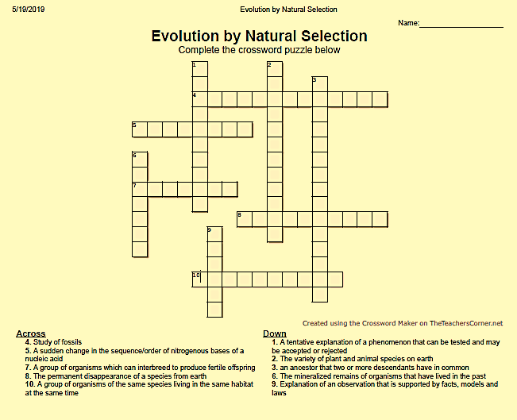

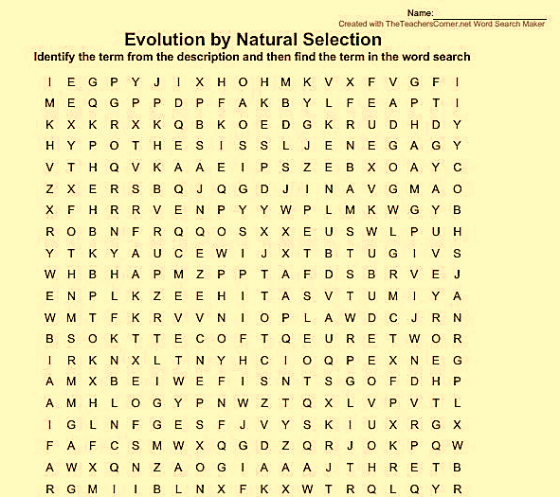

Description
- Two alternative forms of a gene at the same locus
- The mineralized remains of organisms that have lived in the past
- A group of organisms of the same species living in the same habitat at the same time
- A tentative explanation of a phenomenon that can be tested and may be accepted or rejected
- A sudden change in the sequence/order of nitrogenous bases of a nucleic acid
- The complete set of chromosomes in the cell of an organism
- Explanation of an observation that is supported by facts, models and laws
- A segment of DNA/a chromosome that codes for a particular characteristic
- A group of organisms which can interbreed to produce fertile offspring
- The permanent disappearance of a species from earth

REFLECTION: Ensure that the terminology list is complete by revising previous question papers.
FOLLOW UP: Use the internet to create more activities. Several web addresses can be used:
TheTeachersCorner.net
Atozteacherstuff.com

INTRODUCTION TO EVOLUTION
WHAT IS EVOLUTION?
The processes that have transformed life on earth from its earliest forms to the vast diversity that characterizes life on earth today.
A change in the genes!!!!!!!!
WHAT IS BIOLOGICAL EVOLUTION?
All present-day forms of life have descended from, and are related to, those that lived in the past. They may look different because they became modified from one generation to another.
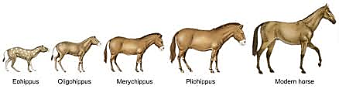
ACTIVITY 1.2

AIM: To distinguish between a hypothesis and scientific theory.
BACKGROUND: Learners are often asked to differentiate between the two terms.
METHOD: Complete the table below:

TERM | Hypothesis | Theory
DEFINITION

EXAMPLE

REFLECTION: To ensure understanding let learners give examples from daily life.
FOLLOW UP: Collect questions from past papers to practice answering similar questions.

UNIT 2 – Evidence of evolution and sources of variation

EVIDENCE OF EVOLUTION
- Fossil evidence: The evidence that shows characteristics that makes us similar to, or different from African apes comes largely from a study of fossils (thousands of fossil fragments).
- Genetic evidence: Scientists state that organisms are closely related and are likely to have a common ancestor if they have:
- Identical DNA structure
- Similar sequence of genes
- Similar portions of DNA with no functions and
- Similar mutations (mitochondrial DNA)
Species that are closely related have a greater similarity to each other than distant species.
• Cultural evidence: Cultural evidence from studies of tools and weapons, as well as language is also used to show similarities and differences between humans and African apes.

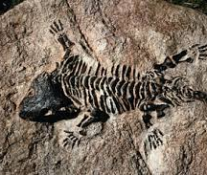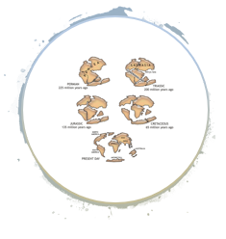
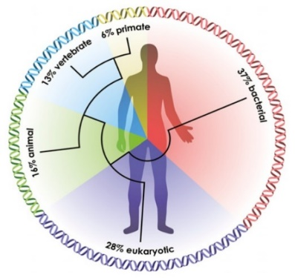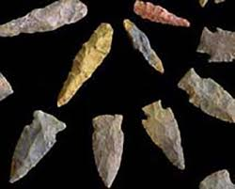

SOURCES OF VARIATION
The genotypes and therefore phenotypes (appearance) of individuals of the same species are different from each other because:
- Crossing over in Prophase I of meiosis involves an exchange of
genetic material, leading to new combinations of maternal and
paternal genetic material in each new cell resulting from meiosis.
- Random arrangement of maternal and paternal chromosomes at the equator
during metaphase allows different combinations of chromosomes/chromatids
to go into each new cell resulting from meiosis, making them different.
- Random fertilisation between different egg cells and different sperm
cells formed by meiosis result in offspring that are different from each other.
- Random mating between organisms within a species leads to a different set of offspring from each mating pair.
- A mutation changes the structure of a gene or chromosome and therefore the organism’s genotype. Since the genotype influences the phenotype, it creates organisms with new, different characteristics from one generation to the next.

UNIT 3 – Lamarckism and Darwinism

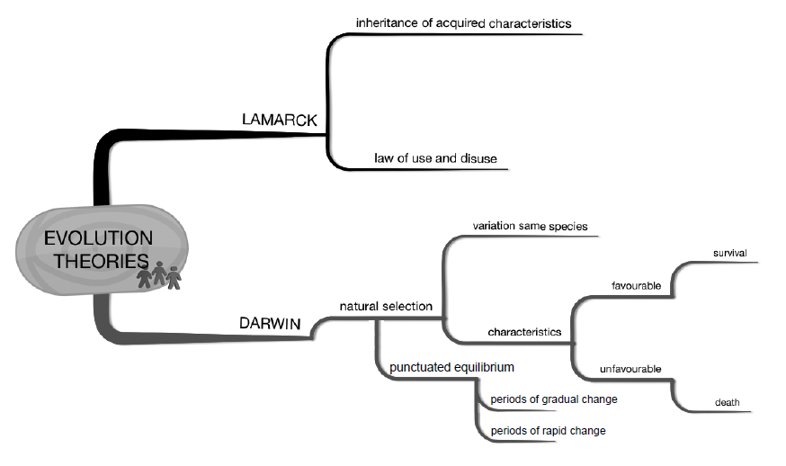

LAMARCK’S THEORY

Use and disuse of organs
- Changes in the environment create new needs that cause organisms to modify their existing organs to meet the need.
- Repeated use of the organ would cause it to enlarge and become more efficient.
- Disuse of an organ would cause it to degenerate
Inheritance of acquired characteristics
- The modification an organism acquired during its lifetime could be pass on to its offspring.
Guiding questions when Lamarck’s theory is applied to a new situation:
- What was the original characteristic?
- What was the challenge?
- What did the organism do/what characteristic was then acquired?
- What was the result?
- What happened to this acquired characteristic?
- What was the result of this?

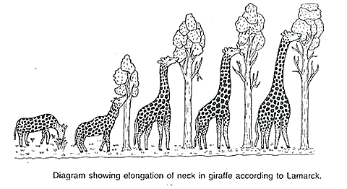

ACTIVITY 1.3

AIM: To enable participants to apply Lamarck’s theory to a case study.
BACKGROUND: It is important to be able to apply knowledge to a new situation.
METHOD: Complete the following questions:
Read the extract below (DBE/Feb.–Mar. 2018)

The red-bellied black snake (Pseudechis porphyriacus) and the green tree snake (Denderelaphis punctulatus)are predators that sometimes feed on cane toads (Bufo marinus) that contain a toxin that may kill them.
The snakes consume the toads by swallowing them whole. A decrease in the average jaw size of the snakes has been observed over a period of 70 years. With this change it was also noted that the snakes could no longer swallow large cane toads. This has resulted in an increase in the survival of the snakes.

- Name Lamarck’s laws. (2)
- How would Lamarck have explained the development of a small jaw size
in the snakes? (4)

REFLECTION: How could Lamarck have reworded his theory if he had all the knowledge available today?
FOLLOW UP: Use any diagram showing the evolutionary process in a species and apply Lamarck’s theory to explain the process observed.

REJECTION OF LAMARCK’S THEORY

- Organisms do not evolve because they were determined to change but changes took place randomly due to mutations
- Acquired characteristics cannot be inherited i.e. the phenotype cannot affect the genotype as discovered later by Mendel

DARWIN’S THEORY
- Darwin’s book published in 1859 called “On the Origin of Species by Means of Natural Selection” put forward two main ideas:
- Species were not created in their present form but evolved from ancestral species.
- Proposed a mechanism for evolution - NATURAL SELECTION
Darwin’s theory of evolution by natural selection:
- Organisms produce a large number of offspring.
- There is a great deal of variation amongst the offspring.
- Some have favourable characteristics, and some do not.
- When there is a change in the environmental conditions or if there is competition,
- then organisms with characteristics, which make them more suited, survive
- whilst organisms with unfavourable characteristics, which make them less suited, die.
- The organisms that survive, reproduce
- and thus, pass on the allele for the favourable characteristic to their offspring.
- The next generation will therefore have a higher proportion of individuals with the favourable characteristic.
- In this way, the characteristics of a population gradually change over a long period of time.
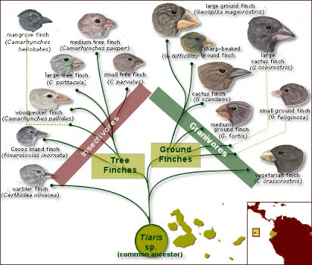

ACTIVITY 1.4

AIM: To enable participants to apply Darwin’s theory to a case study.
BACKGROUND: It is important to be able to apply knowledge to a new situation.
METHOD: Complete the following question:

Read the extract below (Adapted from DBE/Feb.–Mar. 2018)

The red-bellied black snake (Pseudechis porphyriacus) and the green tree snake (Denderelaphis punctulatus)are predators that sometimes feed on cane toads (Bufo marinus) that contain a toxin that may kill them.
The snakes consume the toads by swallowing them whole. A decrease in the average jaw size of the snakes has been observed over a period of 70 years. With this change it was also noted that the snakes could no longer swallow large cane toads. This has resulted in an increase in the survival of the snakes.

- How would Darwin have explained the development of a small jaw size
in the snakes? (6)

REFLECTION: Are there any new theories for the evolutionary process?
FOLLOW UP: Use any diagram showing the evolutionary process in a species and apply Darwin’s theory to explain the process observed.
Past papers
SSIP high-flyers booklet

ACTIVITY 1. 5

AIM: To enable participants to answer questions on natural selection.
BACKGROUND: Questions on natural selection appear in every exam paper II. These questions can be found in every section of the papers (A, B or C) and on all levels of Bloom’s taxonomy.
METHOD: Answer the following questions:

1.5.1 | Who formulated the law of use and disuse? Choose the correct answer.  - Lee Berger  - Rosalind Franklin  - Gregor Mendel  - Jean Baptiste de Lamarck
1.5.2 | Indicate whether each of the descriptions in COLUMN I apply to A ONLY, B ONLY, BOTH A AND B or NONE of the items in COLUMN II. Write A only, B only, both A and B or none next to the question numbers (1.5.2.1 to 1.5.2.3).  COLUMN I COLUMN II  1.5.2.1 Law of inheritance of acquired characteristics A: B: Darwinism Modification by descent  1.5.2.2 Humans select the characteristics when breeding organisms A: B: Artificial selection Natural selection  1.5.2.3 A testable statement that may be accepted or rejected A: B: Theory Law

Question 1.5.3 (EC/SEPTEMBER 2018)
Salmonberry plants produce ripe fruits that occur in two colours, red and orange.
These fruits are eaten by birds and in so doing, they assist in seed dispersal.
Birds appear to choose fruits based on colour.

Scientists investigated the preference for red and orange fruit amongst four bird species.

The procedure for the investigation was as follows:
- 10 birds of each species were captured and housed in separate cages of equal size
- Each bird was presented with an identical single petri dish containing four pieces
of fresh salmonberry, two red and two orange
- The first choice of fruit colour made by the bird was recorded

The results are shown in the table below:

Species | Number of birds that chose red | Number of birds that chose orange
Common raven | 10 | 0
American robin | 5 | 5
Swainson’s thrush | 7 | 3
Hermit thrush | 8 | 2

1.5.3.1 Name the:
(a) Independent variables (2)
(b) Dependent variable (1)
1.5.3.2 Identify TWO factors that were kept constant in this investigation. (2)
1.5.3.3 Explain why the investigators used 10 birds of each species instead of 1 bird of
each species. (2)
1.5.3.4 Calculate as a percentage, the number of birds that preferred red fruit.
Show ALL working. (3)
1.5.3.5 Use the theory of evolution through natural selection to explain why you would
expect an increase in the proportion of salmonberry plants that produce red fruit. (6)

REFLECTION: Any topic can be used to set investigative type of questions.
FOLLOW UP: Use questions from past papers to compile an activity for learners to practice the skill of answering investigative type of questions.

Activity 1.6
AIM: To enable participants to administer and assess the grade 12 SBA on natural selection
successfully

Method: Follow the instructions.

LIFE SCIENCES Grade 12
Total
30
Practical Task Term 3: Natural selection

Date: _____________________________________

Name: ___________________________________

Duration: 1 hour
INSTRUCTION TO LEARNERS – THIS IS AN INDIVIDUAL TASK
Watch the following video: Rock pocket mouse: https://youtu.be/sjeSEngKGrg

BACKGROUND INFORMATION
A typical rock pocket mouse is about 170 millimetres long from its nose to the end of its tail, shorter than an average pencil. And at just 15 grams, this tiny mouse weighs about as much as a handful of paper clips. You can find populations of rock pocket mice all over the Sonoran Desert in the southwestern United States.
There are two common varieties: a light-coloured variety and a dark-coloured variety. There are also two major colours of substrate, or surface materials, which make up the desert floor. Most of the landscape consists of light-coloured sand and rock, but patches of dark volcanic rocks that formed from cooling lava flows are found, separated by several kilometres of light-coloured substrate.
ACTIVITY 1
1. View the images of the rock pocket mouse populations in each location and record the numbers for each colour. (Your teacher will either display these in class or you will be given a set)

Card 1
Location A: Number of mice with light-coloured fur ______ Dark-coloured fur _____
Location B: Number of mice with light-coloured fur ______ Dark-coloured fur _____

Card 2
Location A: Number of mice with light-coloured fur ______ Dark-coloured fur _____
Location B: Number of mice with light-coloured fur ______ Dark-coloured fur _____

Card 3
Location A: Number of mice with light-coloured fur ______ Dark-coloured fur _____
Location B: Number of mice with light-coloured fur ______ Dark-coloured fur _____

Card 4
Location A: Number of mice with light-coloured fur ______ Dark-coloured fur _____
Location B: Number of mice with light-coloured fur ______ Dark-coloured fur _____ (8)

2. Arrange the cards in what you think is the correct order from the oldest to the most recent.
Write only the number of the cards to show the order you choose: _________________________________ (4)

3. What are the two types of substrate that these mice live on?

__________________________________________________________________________ (2)
Hand in this activity BEFORE you start the next activity.

ACTIVITY 2

The table below shows the data recorded for each location:

 |  | Sequence (oldest to newest)
 |  | 1st (Oldest) | 2nd | 3rd | 4th (Most recent)
Location A  (Light desert sand) | # of Light Mice | 10 | 11 | 10 | 11
 | # of Dark Mice | 2 | 1 | 2 | 1
Location B  (Dark volcanic rock) | # of Light Mice | 10 | 9 | 6 | 2
 | # of Dark mice | 2 | 3 | 6 | 10

Draw two BAR GRAPHS; one for each location to show the numbers and colour of mice at Location A and Location B.

(8)
ACTIVITY 3

1. Compare the graphs at Location A and B. What is the difference between the two?

___________________________________________________________________

___________________________________________________________________

___________________________________________________________________ (2)

2. Explain why a rock pocket mouse’s colour influences its overall ability to survive and
produce offspring in these environments.

___________________________________________________________________

___________________________________________________________________

___________________________________________________________________(2)

3. Explain the presence of dark-coloured mice at location A. Why is this phenotype
(appearance) not more common in the population at that location?

___________________________________________________________________

___________________________________________________________________

___________________________________________________________________(2)

4: “Mutation is random, but natural selection is not random.” Explain how the number of
dark mice increased in Location B, according to this statement.

___________________________________________________________________

___________________________________________________________________

___________________________________________________________________(2)

[30]

REFLECTION: At the rate humans are misusing the earth, the possibiliy to have a very different earth in 100 year’s time is very strong. What impact will this have on the animal and plant specie on earth?
FOLLOW UP: Find similar examples of natural selection on the internet and use them to expose learners to other situations in which they must use their knowledge.

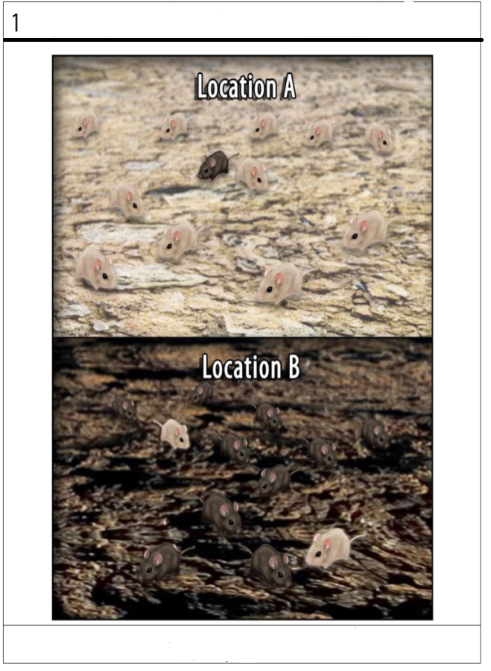
ACTIVITY 1: CARDS OF LOCATIONS TO BE USED TO DETERMINE NUMBER OF EACH COLOUR MOUSE IN A LOCATION

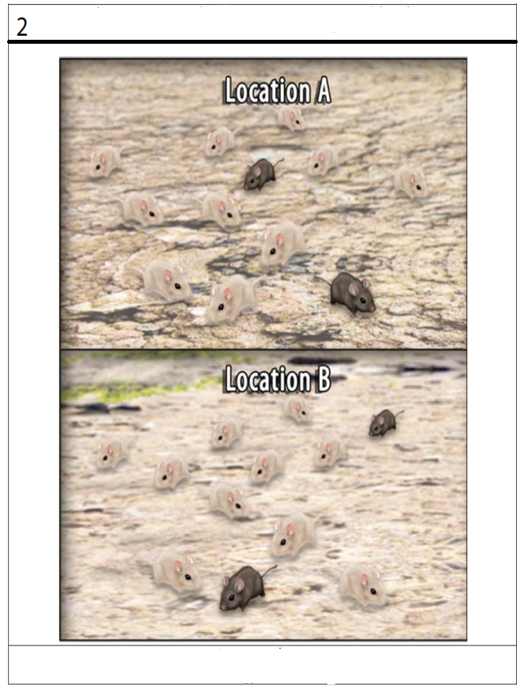

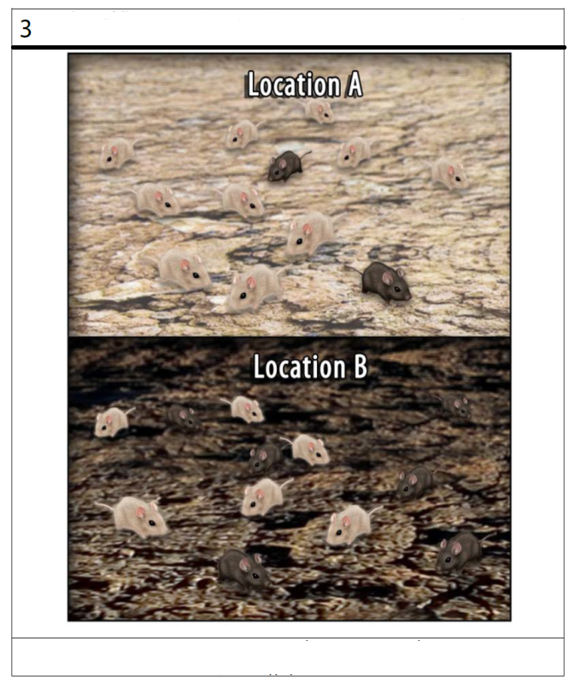

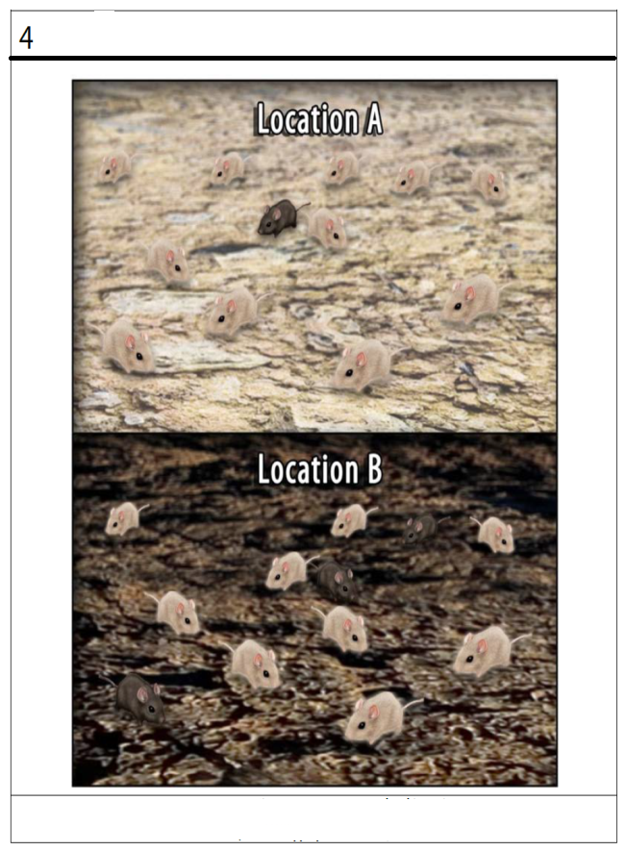

UNIT 4 – Punctuated Equilibrium

PUNCTUATED EQUILIBRIUM
Eldredge and Gould formulated this model (1972)
They observed that the fossil record gives a different picture of evolution.
They claim that there were long periods of stasis (4-10 million years) involving little evolutionary change.
Then there is occasional rapid formation of new species (5,000 - 50,000 years).
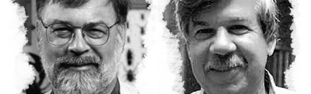
Punctuated Equilibrium explains the speed at which evolution takes place:
- Evolution involves long periods of time where species do not change or change gradually through natural selection (known as equilibrium).
- This alternates with (is punctuated by) short periods of time where rapid changes occur through natural selection,
- during which new species may form in a short period of time.
ACTIVITY 1.7
AIM: To enable participants to do an activity based on punctuated equilibrium.
BACKGROUND: This activity provides a practical way in which the concept of punctuated equilibrium can be demonstrated to learners.
METHOD: Follow the instructions and make two stratigraphic timelines showing gradualism and punctuated equilibrium.

A PEEK AT THE PAST
Fossil Patterns, Gradualism, or Punctuated Equilibria?
Every now and then, palaeontologists uncover what appears to be a complete series of fossils. They find batches of fossils which seem to represent a population of one species, living at one period of time, and showing a typical range of variation, but still clearly members of one species. As they search layers of sediment above and below, they find more fossil groups of what appear to be the same species.
As palaeontologists study the entire series of fossils, they tend to find two kinds of patterns. Sometimes there appear to be slight shifts in the average features of the fossils over time, eventually becoming so different from the earliest form that they have to say a new species has formed. But with another series of fossils (may be a totally different kind of organism), they find very little difference for long periods of time, then, all of a sudden, they begin to find fossils similar to the earlier ones, but showing some striking differences, clearly a new species. Sometimes, in both cases, the original species continues to exist along with the new species, and sometimes the original species can no longer be found.

The purpose of this exercise is to reconstruct these patterns, compare and contrast them with each other, and arrive at some conclusions about what happens to the species over time. (The "fossils" in this study are imaginary, for easier analysis, but they do accurately represent what we find in the fossil record). One group of fossils represents the genus Molluscaformis (elongated, sausage shaped), the other represents the genus Pedivarious (short thick body, with thick black markings on it).

You will be provided with a collection of fossils representing one of these genera. You will also be provided with a two-page layout which shows the layers of sedimentary rock from which the fossils were taken (the "Stratigraphic Sequence"). Each layer ("Formation") is identified with a unique name, and an indication of how long it took to form (its "duration").

INSTRUCTIONS
1. Place the two "Stratigraphic" sheets so that the title sheet is above the other, and
the identical parts of their ends overlap perfectly.
2. Place the fossils (in the Fossil Sequence" column) according to the "Formation"
from which they were taken. "Upper" means it was found in the upper (more
recent) portion of that formation; "Lower" means it was found in the lower (older)
portion of that formation. (The little numbers in parentheses indicate the number
of fossils which are represented by that one "average" fossil shown).
3. Once all the fossils are arranged chronologically (from the oldest at the bottom, to
the youngest near the top), start adjusting their horizontal positions (representing
their overall morphology, or appearance of form). This usually works best if you
place the lowest (oldest) fossil in the lower left corner of the workspace column. If
the next fossil above it is identical in appearance, place it directly above the first.
If it appears slightly different, place it above and slightly to the right of the one
below it. If there is a major difference in form (appearance), shift it even more to
the right. Repeat this with each fossil as you move up the column.
4. If there appears to be two kinds of fossils at the same level, check the fossils
further up, and look for a consistent pattern of change away from (different from)
the lower sequence; locate those fossils further to the right. If the differences are
very slight, show this with very slight shifts to the right. If they have major
differences shift them even more to the right.
5. Once you have your pattern developed, ask your teacher to check it. If it
represents the arrangement described above, then diagram the pattern on the
appropriate chart, using simple lines to represent the sequence of fossils through
time. The result may look like a leaning branching tree, or it may look like a couple
of vertical or near vertical lines.
6. Assign a proper species name to the original species, and to any other species
which may have formed. You can invent the trivial part of the name, reflecting
some unique feature of that species, e.g. "M. megawings". Print their names next
to each somewhat vertical line on your chart. Use the form "M. species" or P.
species" in each case.
7. Answer the discussion questions for that particular genus.

A PEEK AT THE PAST: DISCUSSION
Molluscaformis Fossils
1. How would you describe these fossils generally through time (except for any
"sudden" major change)?

[ ] static (generally unchanging), or [ ] non static (gradually changing)?

2. Have any new species evolved? _______. If so, how many?_____. In which
formation did it/they first appear?

3. Have any species apparently become extinct?______ If so, which one(s)?

(For each extinction, indicate in which formation its last fossils were found.)

4. Which pattern of evolution seems to be occurring here?
[ ]"Gradualism", in which changes to new species are gradual, followed by
continuous little changes, or

[ ]"Punctuated Equilibrium", in which changes to new species appear to be
sudden, followed by little or no change

5. Would you be likely to find any intermediate or transitional fossils if we searched
more thoroughly in the formation just below the first appearance of changed
fossils?______ Why?

Pedivarious Fossils
1. How would you describe these fossils generally through time (except for any
"sudden" major change)?

[ ] static (generally unchanging), or [ ] non static (gradually changing)?

2. Have any new species evolved? _______. If so, how many?_____. In which
formation did it/they first appear?

3. Have any species apparently become extinct?______ If so, which one(s)?

(For each extinction, indicate in which formation its last fossils were found?)

4. Which pattern of evolution seems to be occurring here?
[ ]"Gradualism", in which changes to new species are gradual, followed by
continuous little changes, or

[ ]"Punctuated Equilibrium", in which changes to new species appear to be
sudden, followed by little or no change
5. Would you be likely to find any intermediate or transitional fossils if we searched
more thoroughly in the formation just below the first appearance of changed
fossils?______ Why?

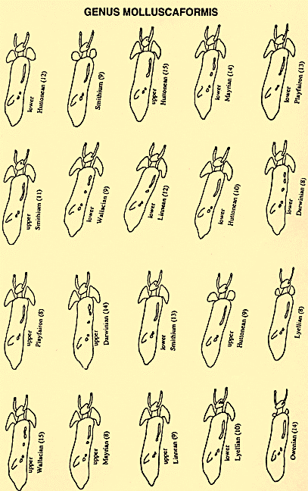

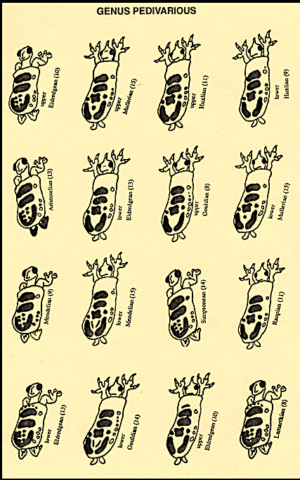

REFLECTION: What other species can you think of where punctuated equilibrium has occurred? What role does the environment plays in punctuated equilibrium?
FOLLOW UP: Learners must be able to apply their knowledge to new situations. Look for application questions in past papers.
https://biologos.org/common-questions/what-does-the-fossil-record-show/
https://courses.lumenlearning.com/boundless-biology/chapter/evidence-of-evolution/

UNIT 5 – Artificial Selection

ARTIFICIAL SELECTION 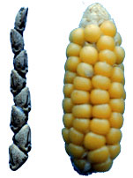
- Artificial selection is the intentional reproduction of individuals in a population that have desirable traits.
- Some consider domesticated animals to be the ultimate products of artificial selection.
  - Food crops – many of the green leafy vegetables have been selectively bred from the ‘wild mustard’ plant
  - Thoroughbred racehorses are one example of artificial selection of animals.
  - The meats we eat are the result of the careful selective breeding of cows, pigs, sheep, and chickens.
  - Our pets are a far cry from their “wild” ancestors. Cats and dogs, which were originally domesticated for pest control, hunting, or shepherding, eventually were bred to become companion animals.
- There can be a downside to artificial selection.
  - Because this process essentially removes variation in a population, selectively bred organisms can be especially susceptible to diseases or changes in the environment that would not be a problem for a natural population.
  - Inbreeding — the mating of closely related individuals — is also a problem.
  - In dogs, this has resulted in breeds that have health issues ranging from decreased life span to hip dysplasia.

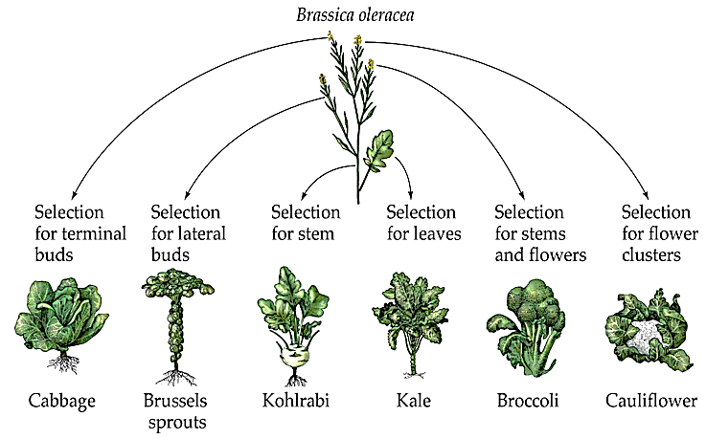
ACTIVITY 1.8
AIM: To enable participants to answer questions based on artificial selection.
To enable participants to classify questions according to Bloom’s taxonomy.
BACKGROUND: Questions on artificial selection appear in every exam paper II. These questions can be found in every section of the papers (A, B or C) and on all levels of Bloom’s taxonomy.
METHOD: Classify the questions according to Blooms Taxonomy in the weighting grid provided
below.
Answer the following questions based on artificial selection.

Question 1.8.1 DBE/November 2015
An investigation was done by Grade 12 learners to determine which chickens grow faster: chickens that are selectively bred for laying eggs or chickens that are selectively bred for meat production.

The following steps were carried out:
- The learners bought 30 one-day-old chickens from a commercial supplier.
- Fifteen of the chickens had been selectively bred for laying eggs and 15 of
the chickens had been selectively bred for meat production.
- All the chickens were kept under the same environmental conditions. This
included being fed the same chicken feed, made mostly from cereal grains and
protein sources.
- The chickens were weighed regularly for a period of 45 days.

The results of the investigation are shown in the graph below.
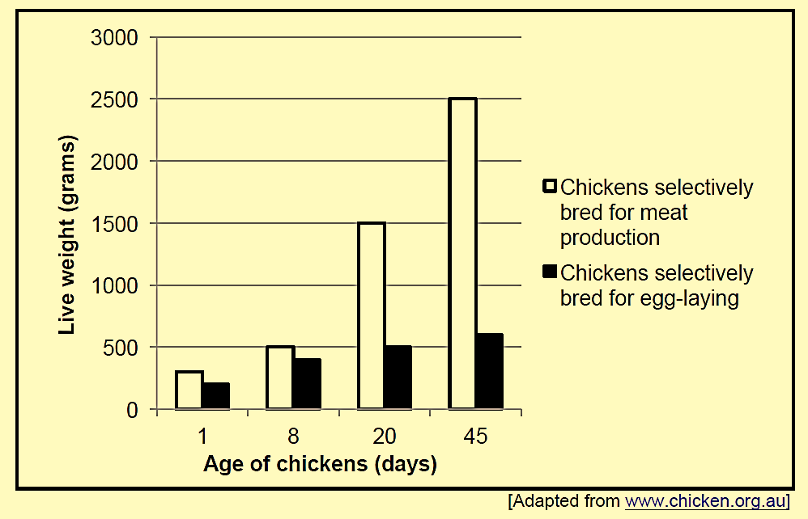
1.8.1.1 Formulate a hypothesis for this investigation. (2)

1.8.1.2 State the independent variable in this investigation. (1)

1.8.1.3 Calculate the percentage weight increase of the chickens that
Were selectively bred for meat between day 8 and day 45.
Show ALL working. (2)

1.8.1.4 State ONE advantage of repeating the investigation with
100 chickens. (2)

1.8.1.5 State THREE factors that the learners should keep constant in
this investigation. (3)

1.8.1.6 Write a suitable conclusion for the investigation based on the
results in the graph. (2)

1.8.1.7 State TWO benefits of the selective breeding of chickens, other
than for increasing meat production. (2)

1.8.1.8 Explain ONE reason why selective breeding of chickens for better
meat production may not be an advantage for the chickens if they
were to live in the wild. (2)
(16)
Question 1.8.1.9: Complete the weighting grid using the questions above.
Weighting grid
LIFE SCIENCES
ANALYSIS GRID NOVEMBER Paper II GRADE 12 2015
 | COGNITIVE LEVELS |  |  |  | KNOWLEDGE STRANDS
Question no | A | B | C | D | Life at Molecular, Cellular and Tissue Level |  |  | Diversity, Change and Continuity
 | Knowing Science | Understanding Science | Applying Scientific knowledge | Evaluating, analysing & synthesizing scientific knowledge | DNA: code of life | Meiosis | Genetics and inheritance | Evolution by natural Selection | Human evolution
1.8.1.1
1.8.1.2
1.8.1.3
1.8.1.4
1.8.1.5
1.8.1.6
1.8.1.7.
1.8.1.8
Sub total

Question 1.8.2 DBE/November 2017
Read the extract below.
Long before the development of agricultural crops, South African villagers would pick the sweetest and largest fruits of the marula tree and scatter them around their camps. The seeds of these fruit would germinate and grow into fruit-bearing trees. The best fruit would then be chosen from these trees and the process would be repeated.
In recent times, farmers use a process called marcotting. This involves peeling away the bark in one area around a branch. This area is stimulated to form roots. The branch is then removed from the tree and planted in the soil to produce more marula trees.

1.8.2.1 | Name the characteristics that the villagers were selecting. | (2)
1.8.2.2 | Explain how this practice is an example of artificial selection. | (3)
1.8.2.3 | Give ONE environmental factor that could affect the characteristics named in QUESTION 1.8.2.1. | (1)
1.8.2.4 | Explain ONE disadvantage of a plantation of marula trees grown through marcotting compared to a population of marula trees that have reproduced naturally. | (2)
1.8.2.5 | Explain whether the fruits from marcotted marula trees could be classified as genetically modified (GM). | (2)
REFLECTION: Any topic can be used to set investigative type of questions and questions based on an extract. Reading with understanding comes with practice. Scientific reading material should be made available to learners in the classroom.  FOLLOW UP: Use questions from past papers to compile an activity for learners to practice the skill of answering investigative type of questions and questions based on an extract.  The format of the weighting grid provided should be used when setting Life Sciences question papers. |  | (10)

UNIT 6 – Speciation

SPECIATION

- Population: individuals of the same species living in the same area that can randomly interbreed
- Species: organisms that have the same characteristics, capable of random interbreeding and producing fertile offspring
- Speciation: is the evolutionary process by which populations evolve to become distinct species.
- Geographical isolation and reproductive isolation mechanisms isolate the gene pool of a species resulting with formation of new species.

Speciation through geographic isolation:
- If a population of a single species
- becomes separated by a geographical barrier (sea, river, mountain, lake)
- then the population splits into two.
- There is now no gene flow between the two populations.
- Since each population may be exposed to different environmental conditions/the selection pressure may be different
- natural selection occurs independently in each of the two populations
- such that the individuals of the two populations become very different from each other
- genotypically and phenotypically.
- Even if the two populations were to mix again
- they will not be able to interbreed.
- The two populations are now different species.

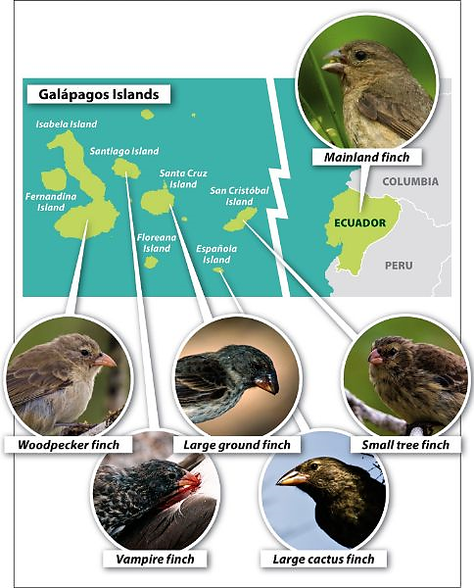

ACTIVITY 1.9
AIM: To enable participants to answer questions based on speciation
BACKGROUND: Questions on artificial selection appear in every exam paper II.
METHOD: Answer the following questions.

Question 1.9.1 (Adapted from F/State P 2 Sept.2016)
Earth originally existed as one large land mass that later drifted apart and formed the continents as we know it today. The following two pictures are those of baobab trees found on the continent of Africa (Diagram I) and found on the continent of Australia (Diagram II).
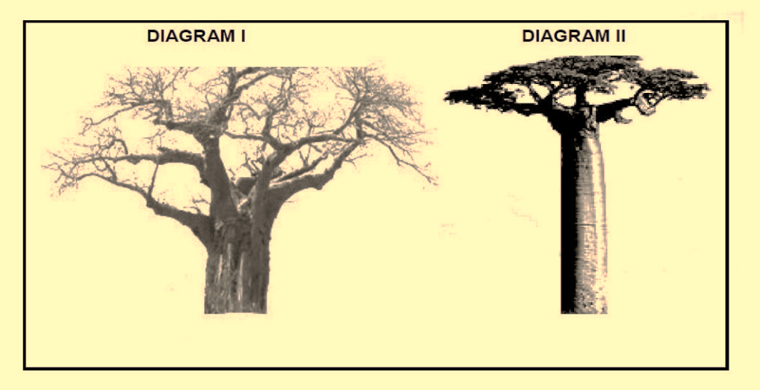
Explain how the two species of baobab trees shown above might have formed. |  | (6)

Question 1.9.2 (EC/SEPTEMBER 2017)
The diagram below shows an evolutionary process taking place in a population of salamanders in California. The process took place gradually, millions of years ago. Study the diagram and answer the questions that follow.
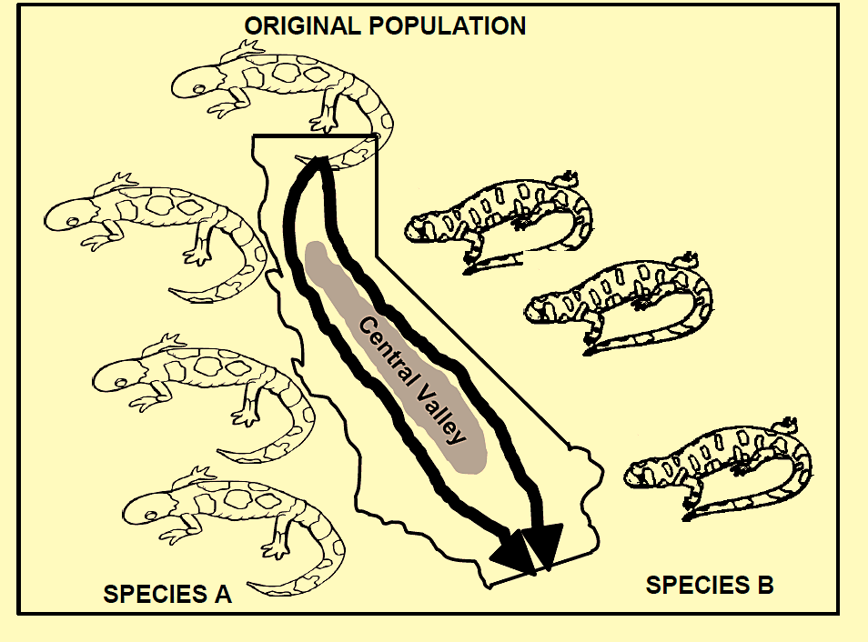

1.9.2.1 | What evolutionary process is illustrated in the diagram above? | (1)
1.9.2.2 | Use the diagram to explain how the Species B evolved from the original population. | (6)
1.9.2.3 | Explain why this is not an example of punctuated equilibrium. | (3)
 |  | (10)
REFLECTION: What is the difference between speciation and natural selection?
FOLLOW UP: The more learners practice to answer questions on speciation and natural selection, the easier it would become to differentiate between the two concepts.

ACTIVITY 1. 10

AIM: To enable participants to carry out a group practical task based on speciation successfully.
BACKGROUND: Learners get easily confused between speciation and natural selection. This hands-on activity will assist in making a clear distinction between the two concepts.
METHOD: Follow the instructions.

Zeebo Instructions (for learners):

A standard Zeebo

Body
Eye
Mouth

Foot

1. Zeebos are fictional animals that travel with sailors on boats and sometimes land up on different island. These islands are divided by large stretches of ocean and once zeebos land on an island they will never be able to mix with the other zeebo who landed on the other islands.
2. You will be divided in groups and each group will be “living” on their own island.
3. You will receive a card with information on the island that you landed on.
4. After you have received your islands’ card you will look at the different environmental conditions and decide what your Zeebo will have to look like to survive (for example look at legs, arms, teeth, size of eyes, fur/no fur and many other things that you think your zeebo will need).
5. Draw your new Zeebo that will result because of natural selection after 500 thousand years.
6. Your teacher will call out “Random Mutation time” - when this happens you will receive a mutation which you will have to incorporate in your Zeebo’s look.
8. Draw your new Zeebo that will result after the random mutation. Give your Zeebo a new name. Base it on its looks.
9. Present this new Zeebo as well as the one without mutations to the other islands.
10. Look at the different Zeebos, would they be able to recognise each other? Do you think they
are still the same species?

REFLECTION: You can see the divergent evolution of the Zeebos. Choose two Zeebos from different islands – do you think these Zeebos would recognise each other? Could they successfully breed? Nope – they are now separate species.
FOLLOW UP: Let the learners write down the sequence of speciation.

UNIT 7 – Mechanisms of reproductive isolation
MECHANISMS OF REPRODUCTIVE ISOLATION
Besides geographical barriers, other ways of isolating species is through various reproductive strategies.
- Breeding at different times of the year
  - E.g. Two species of mayflies emerge during different weeks in springtime.
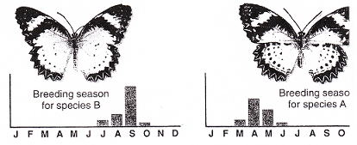
- Species-specific courtship behaviour
  - E.g. Two similar species of birds have different mating rituals.
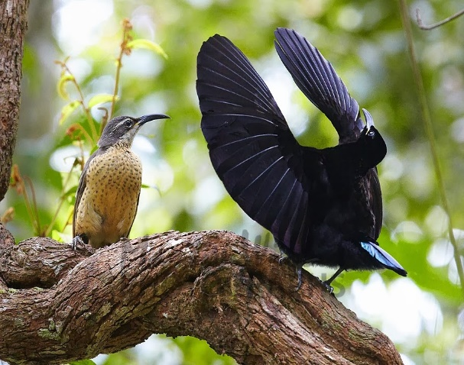

- Adaptation to different pollinators
  - E.g. Two species of orchid have different length nectar tubes and are pollinated by different species of moths.
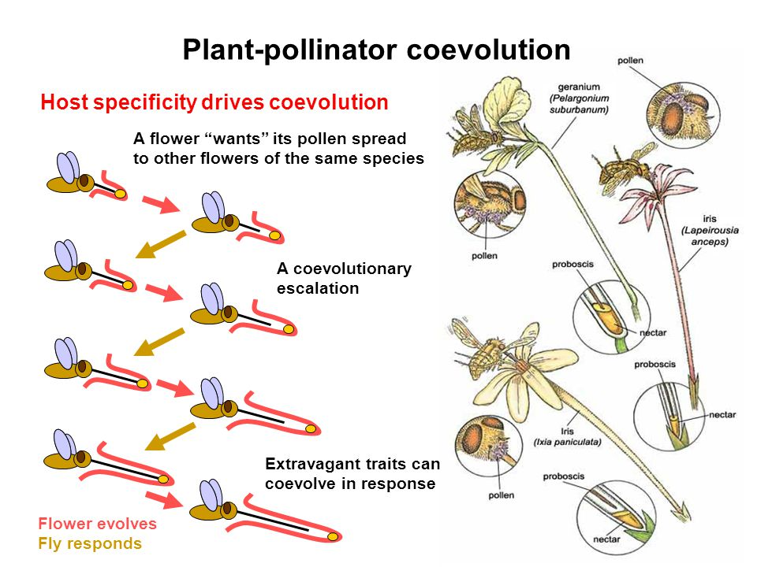
- Infertile offspring
  - E.g. A donkey and a horse are mated and produce a viable mule, however, it is sterile .
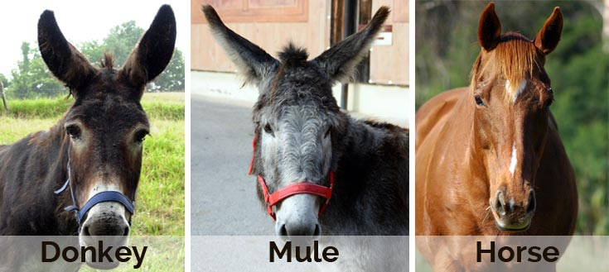
- Prevention of fertilization due to lack of fit between sexual organs. The species will have specialized genitalia for mating and when it is not the correct size, mating will not be possible.
  - E.g. Two different breeds of dog.
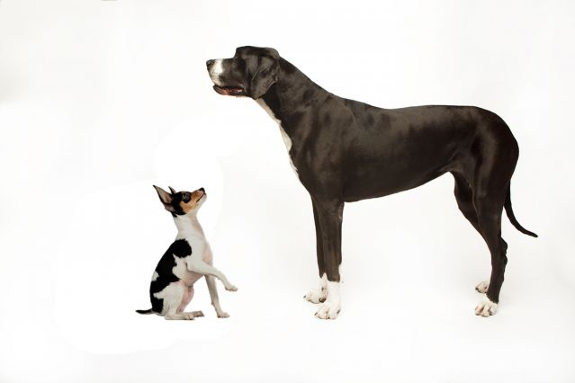

ACTIVITY 1.11
AIM: To enable participants to identify reproductive isolating mechanisms
BACKGROUND: These are easy marks to get in the exam papers.
METHOD: Answer the following questions:
Question 1.11.1 (EC/SEPTEMBER 2017)
1.11.1.1 | Scientists visiting a group of four islands P, Q, R and S found similar spiders on each island. They carried out investigations to see if the spiders from the different islands belonged to the same species.  The results are in the table below (indicates successful interbreeding. X indicates unsuccessful interbreeding)
Which two populations belong to the same species?

A | Q and R
B | R and S
C | Q and S
D | P and Q

DBE/Feb.–Mar. 2018
1.11.1.2 | Different frogs, which all belong to the genus Lithobates, are found in the same forest. The graph below shows their mating activity

Based on the information, what kind of isolating mechanism is most likely keeping the bullfrogs and wood frogs as separate species?
A Geographic isolation through the presence of geographic barriers
B Reproductive isolation through species-specific courtship behaviour
C Reproductive isolation through breeding at different times of the year
D Reproductive isolation through the production of infertile offspring
1.11.1.3 | Which ONE of the following is a reproductive isolating mechanism?  A Breeding at different times of the year  B Same pollinators for different species of plants  C Absence of a geographic barrier  D Cloning

QUESTION 1.11.2 DBE/May–Jun. 2019
A group of students observed that the mating calls of a population of frogs at the local dam had recently become much louder. The dam is close to a highway, where the traffic noise has increased over the years.

They wanted to investigate if the increase in traffic noise from the highway had an evolutionary effect on the loudness of the frogs’ mating calls in the mating season.

They recorded the following:
- Average level of traffic noise over a period of 6 years
- Average loudness of the frogs’ mating calls during the same period
 | The results are shown in the table below:
 | 1.11.2.1 Explain the advantage of a louder mating call. | (2)
 | 1.11.2.2 State why these results may be considered to be reliable. | (1)
 | 1.11.2.3 State the conclusion for this investigation. | (2)
 | 1.11.2.4 Give TWO variables that should be kept constant in this investigation. | (2)
 | 1.11.2.5 Draw line graphs on the same set of axes to show the change in  average loudness of traffic noise and mating calls for the period 2006  to 2009. | (7)
 |  | (14)

REFLECTION: This content is assessed by using examples of the different strategies.
FOLLOW UP: Expose learners to as many as possible examples.

UNIT 8 – Evolution in present times
EVOLUTION IN PRESENT TIMES
- Malaria mosquitoes became resistant to insecticide.
- Small finches on Galapagos died out during drought because plants with small seeds died, big finches survived because plants with big seeds were still around.
- Tuberculosis bacteria became resistant to TB drugs because of mutations.
- HIV virus became resistant to ARV
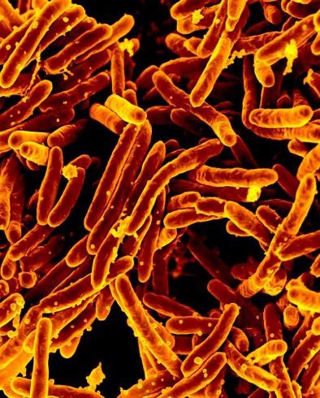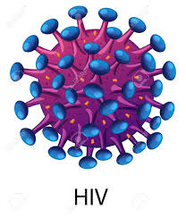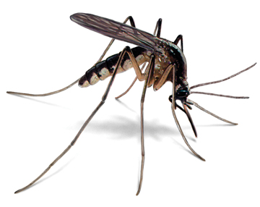

Activity 1.12
AIM: to enable participants to identify and describe case studies of evolution taking place in
current times
Method: Answer the following questions:
DBE/Nov 2019 P2
1.12.1 |  |  | The E. coli bacterium lives in the intestines of pigs where they reproduce rapidly. Certain strains of E.coli cause diarrhoea in young pigs (piglets).  Scientists carried out an investigation using 100 piglets to determine the resistance of E.coli to two antibiotics, A and B.  The scientists:  - Injected the piglets with antibiotic A and antibiotic B  - Took a sample of E.coli from the intestines of each piglet a week later and placed them in separate petri dishes  - Allowed the bacteria to grow for 24 hours  - Added antibiotic A to one petri dish and antibiotic B to the other petri dish  - Measure the growth of the bacteria in each petri dish after 24 hours  - Used the growth measurement as an indication of the resistance of the bacteria to each antibiotic  - Repeated the process over a period of six months  - Calculated the average percentage resistance to both antibiotics  The results are shown in the graph below
 |  | 1.12.1.1 |  | Identify the independent variable in this investigation. | (1)
 |  | 1.12.1.2 |  | Identify TWO factors that should be kept constant during the investigation | (2)
 |  | 1.12.1.3 |  | State TWO ways in which the scientists ensured the reliability of the investigation. | (2)
 |  | 1.12.1.4 |  | Which antibiotic will you recommend for controlling E.coli in piglets? | (1)
 |  | 1.12.1.5 |  | Support your answer to QUESTION 1.12.1.4 using evidence in the graph. | (2)
 |  | 1.12.1.6 |  | Explain the results that are shown in the graph for antibiotic A in terms of natural selection. | (5)
 |  |  |  |  | (13)

DBE/Feb.–Mar. 2018
1.12.2 |  | Study the extract and the information provided
Scientists hypothesized that insect populations that had previously been exposed to the insecticide had a higher survival rate when the grain was treated again.
In an investigation to test this hypothesis, they:
- Identified storage bins that had previously been treated with the insecticide and bins that had never been treated with the insecticide
- Collected a sample of 300 insects from each bin
- Kept each sample in a separate container of equal size and the same conditions
- Sprayed the same concentration and volume of insecticide over both containers
- Allowed 24 hours for the insecticide to take effect
- Counted the number of insects that survived in each container

The results are given in the table below:

2.1 |  | Give the:  (a) (b) Independent variable Dependent variable (1) (1)
 | 2.2  2.3.2.4 | State THREE factors that were kept constant in this investigation. Give TWO reasons why the scientists' results may not be reliable. State a conclusion for this investigation. (3) (2) (2) (9)

RESOURCES
https://wordmint.com/public_puzzles/200551
https://worksheets.theteacherscorner.net/make-your-own/crossword/
https://biologydictionary.net/common-descent/
https://necsi.edu/gradualism-and-punctuated-equilibrium
https://bit.ly/2YbySBm
Download the free SCOP genetics app on Android from Wits University:
https://play.google.com/store/apps/details?id=scoping.genetics&hl=en

MODULE SUMMARY
Life exists in a variety of life forms and it is in the study of Evolution through Natural Selection that enables learners to understand where the biodiversity that exists today evolved from and how the millions of species came about.
In order to understand species, speciation, biodiversity and change, it is essential to understand the theories of Darwin and Lamarck and why we reject Lamarck’s theory and accept Darwin’s theory. This module covers all the requirements for the DBE NSC exams w.r.t. the topic: Evolution by Natural Selection.

REFERENCES
- DBE Exam guidelines for learners
- GDE ATP
- 2015-2019 NSC past papers
- 2014-2019 national diagnostic report on learner performance
- Approved grade 12 national textbooks
- ‘Mind the Gap’
- Internet
- Gauteng grade 12 Life Sciences Revision booklet

