MODULE 3: RESPONDING TO THE ENVIRONMENT: PLANTS
INTRODUCTION
Plants respond to the environment by either growing towards or away from a stimulus. Various plant growth substances (hormones) that are produced in the plant control this growth movement. This type of growth movement is called tropic movement. The word tropism means ‘to turn’. A tropism is the response to an external stimulus, causing a plant to grow towards (positive tropism) or away (negative tropism) from the stimulus. Only phototropism, which is a response to light, and geotropism, which is a response to gravity, needs to be covered in the DBE gr.12 syllabus.

Auxins are growth hormones found in plants. Auxins stimulate or inhibit (prevent) growth in areas. A high concentration of auxins in an area will stimulate cell elongation and cell differentiation, especially in stem tips (growth tips). This results in apical dominance, when the growth point at the tip of the stem grows upwards. This action inhibits the development of axillary buds on the lateral branches below so they don’t grow because all the plant’s energy is used to grow upward. If the tip is removed the axillary buds develop into lateral branches causing the plant to grow thicker on the sides (like when cutting a hedge).
Only about three days are allocated on the ATP for the teaching of plant responses to the environment. It is important to use diagrams for the teaching and learning of this topic. You will also notice that we have included terminology lists as these are crucial for good performance. Please ensure that your learners do regular terminology activities and tests.
A clinostat can be used to demonstrate plant growth responses to an external stimulus.
OVERVIEW
This module deals with the responses of plants to light and gravity as an external stimulus. There is a detailed terminology list, followed by the general functions of the auxins, gibberellins and abscisic acid. The use of plant hormones in controlling weeds is described as well as the role of auxins in geotropism and phototropism.

SPECIFIC OBJECTIVES
By the end of this session, participants will be able to:
- Describe the general functions of auxins; gibberellins and abscisic acid.
- Briefly describe the use of plant hormones in controlling weeds.
- Briefly describe the role of auxins in geotropism and phototropism.
- Interpret and conduct investigations based on the role of plant hormones.
CONTENT
You will study this module through the following units:
Unit 1: The general functions of auxins; gibberellins and abscisic acid

Unit 2: The control of weeds using plant hormones
Unit 3: The role of auxins in geotropism and phototropism
Unit 4: the role of chemicals and thorns in plant defense mechanisms

UNIT 1 - The general functions of auxins; gibberellins and abscisic acid

Terminology & definitions:
Biological term | Description
Abscisic acid | The plant hormone that promotes seed dormancy  A plant hormone that causes leaves to fall off trees in autumn.
Apical dominance | Is the phenomenon whereby the main, central stem of the plant is dominant over other side stems
Auxins | The plant hormone that promotes root and stem growth
Geotropism | The growth of part of a plant in response to gravity.
Gibberellins | A plant growth hormone that stimulates seed germination.
Herbicide | Chemical used to kill weeds
Hormone | Chemicals that allow a plant to respond to some stimulus in the environment
Phototropism | The growth of a plant in response to light
Tropism | The growth movement of a plant or part of a plant in response to an environmental stimulus
Uniform light | A plant receives light of the same quality from all directions
Unilateral light | A plant received light from one direction only

Growth development in plants
- Plants respond to stimuli in the environment by growing towards or away from the stimulus.
- This growth movement is controlled by plant hormones such as auxins, gibberellins, and abscisic acid.
- These substances are not true hormones because they work in the part of the plant where they are produced.
- Therefore, they are also referred to as plant growth substances.
- These allow plants to respond to certain stimuli in the environment:
  - allow plants to bloom at an appropriate time
  - allow plants to grow toward a light source
  - allow seeds to germinate at the appropriate time
  - induce dormancy in plants at the appropriate time
https://www.youtube.com/watch?v=PxSkuyjZ3MM
The role of auxins
- Auxins stimulate the following responses in plants:
  - Cell division
  - Cell elongation (growth in stem length)
  - The development of fruit
  - The abscission of leaves and fruit
  - The development of adventitious root in stem cuttings
  - Tropic movement in stem and roots
  - Apical dominance: it suppresses the growth of the lateral buds.

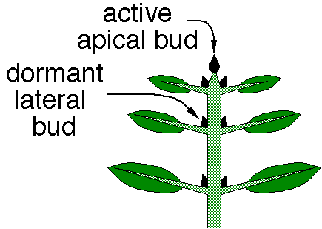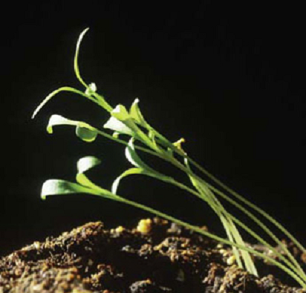
Apical dominance Phototropism

The role of gibberellins
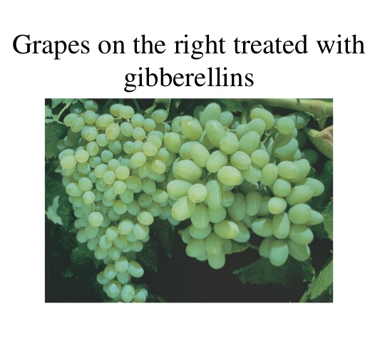
- Gibberellins stimulate the following responses in plants:
  - Stem elongation
  - Root growth
  - The germination of seeds
  - Promotes flowering
  - Fruit growth

https://www.youtube.com/watch?v=EZ5tU45Ti_g&t=29s
Fruit growth

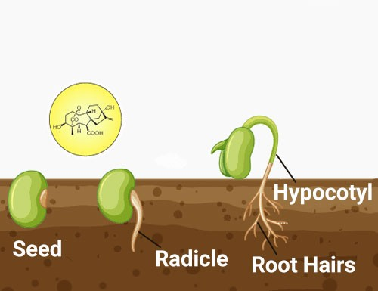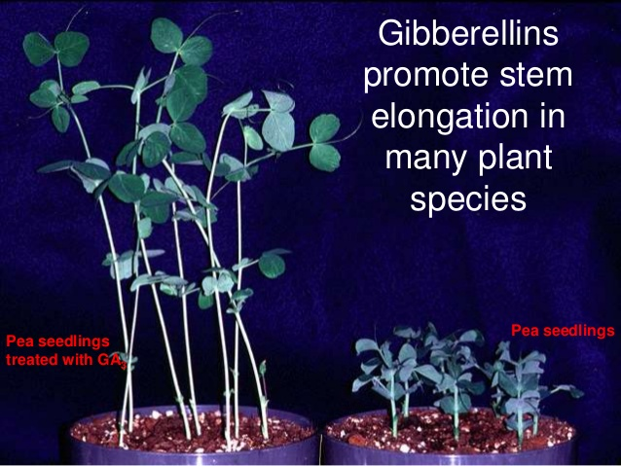

Seed germination Stem elongation

The role Abscisic Acid
- Abscisic Acid stimulate the following responses in plants:
  - Is an inhibitor of growth
  - Causes plants to become dormant in winter
  - It causes abscission in leaves and fruit (they fall off the tree)
  - Lack of water (water stress) stimulates the production of Abscisic acid
  - Causes the closing of stomata when the plant wilts

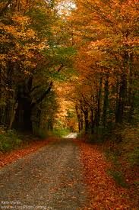
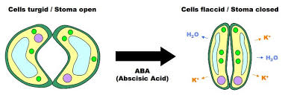
Leaf fall Stomatal closing

Activity 3.1
AIM: Testing terminology
METHOD: Completion of a table
Complete the table below:
Term | Description
a) | Chemical messenger in the plant
b) | Growth of a plant stem towards light
Geotropism | c)
Tropism | d)

UNIT 2 - The control of weeds using plant hormones

Use of auxins as weed killers
- Hormone weed killers are auxin-based selective herbicides.
- The auxins used in these weed killers are made by chemical synthesis.
- The main factor that controls the weed growth in these herbicides are the auxins.
- These herbicides can only kill weeds.
Advantages of Hormone Weed-killers…
- They are non-toxic to animals and humans.
- There is no longer the need for weeding the garden.
https://www.youtube.com/watch?v=TTLgTIipmA8

UNIT 3 - The role of auxins in geotropism and phototropism

Role of auxins in phototropism and geotropism
- Hormones control growth and development in plants.
- Auxin is an example of a hormone.
- Phototropism is the growth of a plant in the direction of a light source.
- Geotropism is the growth of a plant in response to gravity.
- The growth movement of phototropism and geotropism is due to chemical messengers (hormones) called auxins in a plant.
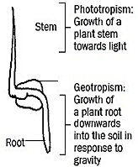

Role of auxins in phototropism | Role of auxins in geotropism
Produced at the tip of the stem/shoot | Produced at the tip of the roots
Auxins move downward evenly | Auxins move upward evenly
This even distribution brings about equal growth on all sides of the stem | This even distribution brings about equal growth on all sides of the root
As a result the stem grows upward | As a result the root grows downward
When the stem is exposed to a unilateral light (light from one side) | When the root is placed horizontally (only one side exposed to gravity)
The auxin concentration will be high on the dark side of the stem – light destroys auxins | The auxin concentration will be high on the lower side of the root – gravity attracts auxins
More growth occurs on the dark side because auxins stimulate growth on the dark side | More growth occurs on the upper side because auxins inhibit growth on the lower side
As a result the stem bends towards the light | As a result the root bends downwards
G A I L
P A S D

Mnemonic:
P A S D
In Phototropism Auxins Stimulate growth In Dark side of stem and the stem bends towards the light
G A I L
In Geotropism Auxins Inhibit growth in the Lower side of the root and the root bends towards gravity

Remember: In plant stems/shoots, a high concentration of auxins STIMULATES cell division and growth, BUT in roots, a high concentration of auxins INHIBITS cell division and growth.

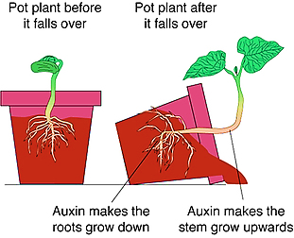

Activity 3.2
AIM: To be able to answer questions on plant responses to the environment
METHOD: Question and answer
Question 1
Various options are given as possible answers to the following questions. Choose the answer and circle only the letter (A to D).
Questions 1.1 and 1.2 are based on Diagrams I and II, which illustrate the response of the tip of a young shoot to a light stimulus.
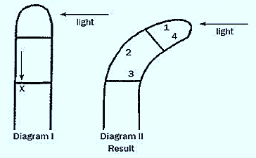

1.1. | The arrow X represents the unequal distribution of …

 | A  B  C  D | Abscisic acid.  Mineral salts.  Gibberellins.  Auxins.

1.2. | The curving of the shoot in Diagram II is due to more rapid cell growth in region(s) …

 | A  B  C  D | 1.  2.  1 and 4.  3 and 4.

1.3. | The diagram above represents …

 | A  B  C  D | Geotropism.  Apical dominance.  Phototropism.  Gravity.

Question 2 (Taken from Life Sciences P1 DBE/Feb-March 2015)

Nthabiseng investigated the effect of auxins on the growth of three plant shoots.
(A, B and C). The plant shoots were treated as follows:
- Shoot A – Not treated in any way
- Shoot B – Tip removed and agar plate with auxins placed on top
- Shoot C - Tip removed and agar plate without auxins placed on top
All shoots were exposed to the same light conditions.
NOTE: Agar is a jelly-like substance that allows auxins to diffuse through it.
The diagram below illustrates the set-up at the beginning of the investigation.

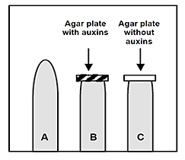

2.1. | Identify the independent variable in this investigation.
2.2. | State TWO factors that must be kept constant in this investigation.
2.3. | Explain the results observed in:  - Shoot B after a few days  - Shoot C after a few days
2.4. | Suggest TWO ways in which Nthabiseng could have improved the reliability of her investigation.

Question 3 (Taken from Life Sciences P1 DBE/Nov 2015)
The diagram below shows the growth movement of a part of a plant towards a stimulus.
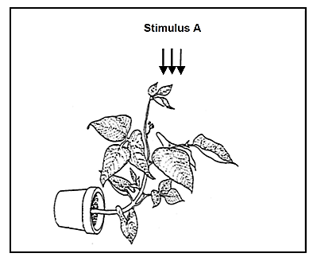

3.1. | What growth movement is represented in the diagram?
3.2. | Identify the stimulus labelled A.
3.3. | Name the growth hormone that is responsible for the growth movement named in QUESTION 3.1.
3.4. | Will a high concentration of the growth hormone named in QUESTION 3.1 stimulate or inhibit growth in the roots?
3.5. | Name the phenomenon where the buds at the tip of the plant regulate the growth of the lateral branches.

Question 4 (Taken from Life Sciences P2 DBE/Nov 2018)

Weeds are problematic to farmers because they invade farm fields and outcompete crop plants for space. This reduces the crop yield.
Farmers spray their fields with chemicals, known as herbicides, to kill the weeds. Some weeds, however, have evolved to be resistant to herbicides.

Scientists investigated the time it took for a species of weed to develop resistance to five types of herbicides. The results are shown in the table below.

TYPES OF HERBICIDE | TIME TAKEN FOR WEEDS TO DEVELOP RESISTANCE (years)
2,4-D | 9
Dalapon | 9
Picloran | 25
Dicloflop | 7
Triflularin | 26

4.1 | Refer to the passage above and state how weeds act to reduce crop yield.
4.2 | Identify the:  - Independent variable  - Dependent variable
4.3 | Name the herbicide:  - To which the weeds developed resistance the fastest  - That remained effective for the longest period of time
4.4 | The scientists used the same weed species when investigating resistance to the different herbicides.  - Describe how the scientists would have determined the resistance of the weeds to the herbicides.  - Explain how the use of the same weed species improved the validity of the investigation.
4.5 | Draw a bar graph to show the time taken for the evolution of resistance to the herbicides.

Question 5 (Taken from Life Sciences P2 DBE/Nov 2013)

A learner investigated the effects of two plant growth substances, gibberellins and auxins, on apical dominance. The apical buds of nine pea plants of the same species, age and height were removed. These plants were then divided equally into three groups.
In each group the cut surface of the remaining shoot (growing stem) of the pea plants was treated in one of the following ways:
Group 1: Coated with a paste containing gibberellins of the same concentration.
Group 2: Coated with a paste containing auxins of the same concentration.
Group 3: Coated with a paste only (containing no plant growth hormones)

The hormones diffuse into the plant until no more hormones remain in the paste.
The treated plants were all grown under the same conditions in the laboratory. The length of the lateral branches of each plant was measured after every two days for a period of 12 days. Measurements were taken at the same time for all treated plants and the average for each group was calculated.

The results of the investigation are shown in the graph below.
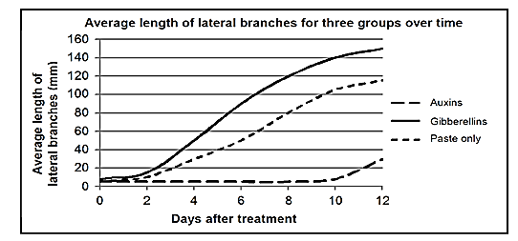

5.1 | State ONE function of the gibberellins that led to the results obtained in the investigation.
5.2 | Calculate the difference in the average length of the lateral branches between the plants treated with gibberellins and the plants treated with the paste only on the 8th day after the treatment.  Show ALL working.

UNIT 4 - The role of chemicals and thorns in plant defence mechanisms

Plants have adapted to prevent herbivores from eating them.
- Chemical defences: plants produce chemicals called phytoecdysteroids to defend against insects. The chemicals cause insects to moult prematurely, lose weight and if enough is ingested, metabolic damage and death. Cultivated tobacco plants produce nicotine. The leaves are eaten by insects and kills them. The leaves of mopane trees contain high levels of tannins making the leaves distasteful to herbivores.
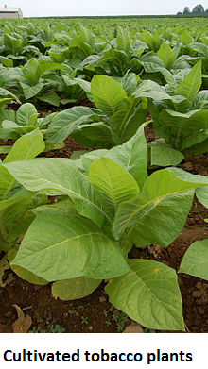
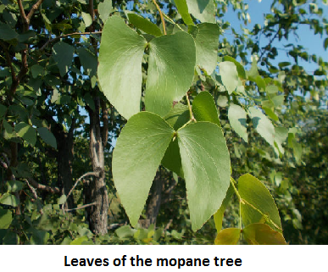

- Thorns: this is a common term for a sharp structure found on plants for protection against herbivores. There are various types of sharp structures:
o Prickles are modified extensions of the cortex and epidermis of a plant that shape into a sharp, needle-like structure, for example rose bushes.
o Thorns are modified branches or stems that form hard, pointed and sharp ends that can pierce the skin of herbivores. Examples are acacia trees, kei apples and lemon trees.
o Spines are modified leaves that have a cylindrically shaped hard and sharp point, for example aloes and cacti. Spines also reduce water loss by the plant.

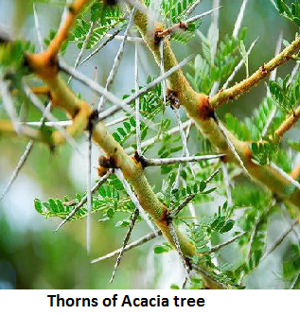
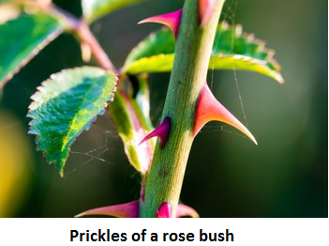

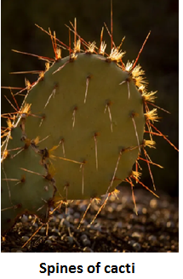

RESOURCES
http://www.scholastic.com/browse/article.jsp?id=3757140
Life: The Science of Biology - useful website with animated tutorials, activities, flash cards, self-quizzes, glossary etc
Dr. Saul's Biology in Motion - original, entertaining, interactive biology learning activities
Biology-Online - useful site for biological information, ideal for homework, research projects, and general interest
www.biologymad.com/
https://www.khanacademy.org
https://www.youtube.com/channel/UCS3wWlfGUijnRIf745lRl2A

MODULE SUMMARY
This module covers all the requirements for the DBE NSC exams w.r.t. the topic: plant responses to the environment. It is important to use diagrams to explain observations made w.r.t. the response of a plant on an external stimulus.

REFERENCES
- DBE Exam guidelines for learners
- GDE ATP
- 2013-2019 NSC past papers
- 2014-2019 national diagnostic report on learner performance
- Approved grade 12 national textbooks
- Internet
- Gauteng grade 12 Life Sciences Revision booklet

