MODULE 2: MEASUREMENTS
INTRODUCTION
In this module you will look at the concept of measurement with specific focus on:
- Conversions within and between the metric and imperial systems; Measuring/calculating time and timetables; speed, distance and time.
- Area and volumes of rectangles, circles and other circular objects
- Volume and surface areas of rectangular, triangular prism, cylindrical prism pyramids, cones and spheres
OVERVIEW
In this topic, you will work with complex projects in familiar and unfamiliar contexts
SPECIFIC OBJECTIVES
At the end of this module you will be able to:
- Read, record and perform calculations involving time values and timetables
- Calculate speed, distance and time
- Calculate/measure the perimeter, area, surface area and volume of objects.
- Calculate/measure the Volume and surface areas of rectangular, triangular prism, cylindrical prism pyramids, cones and spheres.
- Determine/calculate appropriate quantities of materials/components required to complete a task or project.

GLOSSARY OF TERMS

Term / concept | Definition/ Explanation
Area | The amount of two-dimensional (2-D) space occupied by a 2-D shape. Area of a shape is the size of its surface. It is measured in square units.
Two-Dimensional drawings | A diagram or picture having length and width only
Two-Dimensional plans | A plan or design having length and width only, but possibly representing three dimensional objects
Three Dimensional models | A dimensional construction of a real-life object. It is a solid, it has length, breadth/ width and height
Circle | A closed curve that is everywhere at the same distance from a fixed point
Circumference | Distance around a circle / perimeter of a circle
Conversion | A change from one system /unit to another
Conversion factor | Values used to convert/ change quantities from one measuring system to another.
Cylinder | Three dimensional object with congruent parallel circles s bases that are joined by a curved surface
Diameter | A straight line passing through the centre of a circle and touching the circle at both ends thus dividing the circle into two equal halves.

CONTENT

You will study this module through the following units

Unit 1 | Conversions, measuring time, timetables and speed.
Unit 2 | Two-Dimensional Measurement
Unit 3 | Three-Dimensional Measurement

UNIT 1: Conversions, Measuring Time, Timetables and Speed.
INTRODUCTION

In this unit you will look at the concept of Conversions, measuring time, timetables and speed.
LEARNING OUTCOME
At the end of this Unit, you should be able to:
- Convert within and between the metric and imperial systems, solid to liquid measurements and temperature.
- Measure time, calculate time differences, timetables, speed, distance and time
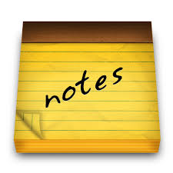

LESSON NOTES

- Metric System
- South Africa use measuring system called the metric system
- However, some European countries use different system called the imperial system
- Metric system works in the multiples of 10’s
- Imperial system doesn’t work in the multiples of 10’s and can be difficult to manipulate
- Some common units used in the metric system:
Table 1: Length, Mass and Volume Units
Length (metres) | Mass  (grams) | Volume  (litres)
Km | Kg | Kl
H | H | H
D | D | D
m | g | l
d | d | d
cm | cg | cl
mm | mg | ml

NB: Use the first letters only
Symbol | Prefix
k | Kilo | 1
h | Hecto | 10 | 1
d | Deca | 100 | 10 | 1
m or ℓ or g | Base | 1000 | 100 | 10 | 1
da | Deci | 10 000 | 1000 | 100 | 10 | 1
c | Centi | 100 000 | 10 000 | 1000 | 100 | 10 | 1
m | milli | 1000 000 | 100 000 | 10 000 | 1000 | 100 | 10

Length symbol | Length | Volume unit | Volume | Weight unit | Weight
km | Kilometre | kℓ | Kilolitre | kg | Kilogram
hm | Hectometre | hℓ | Hectolitre | hg | Hectogram
dm | Decametre | dℓ | Decalitre | dg | Decagram
m | Metre | ℓ | Litre | g | Gram
dam | Decimetre | daℓ | Decilitre | dag | Decigram
cm | Centimetre | cℓ | Centilitre | cg | Centigram
mm | Millimetre | mℓ | Millilitre | mg | Milligram

Example of pneumonic for conversion:
Keke Hate Doing business during cold months

- Imperial System
- Some countries such as USA and Liberia use different system called the imperial system
- Imperial system doesn’t work in the multiples of 10’s and can be difficult to manipulate.
- Working with imperial conversions, the conversions should be given to where it is required in a question.
- Some units used in the imperial system:
Table 2: Length, Mass and Volume Units
Length | Mass | Volume
12 in = 1 ft | 16 oz = 1 lb | 16 floz = 1 pt
3 ft = 1 yard | 14 lb = 1 stone | 2 pt = 1 quart
1 769 yd = 1 mile | 2 240 lb = 1 ton | 4 quart = 1 gal

- Temperature
- Temperature conversions between the metric and imperial system
- To convert temperatures form Celsius to Fahrenheit or vice versa, one of the following formulae will be provided:
Table 3
⁰Fahreinheit | ºCelsius
°F = (1,8 × °C) + 32° | °C = (°F − 32°) ÷ 1,8

- Solids to Liquids
- Volume can be measured using different units: either unit³ or in litres.
- Conversions are as follows and one of them should be given if it needs to be used:

Table 4
1 ml = 1 cm³
1 l = 1 000 cm³
1 kl = 1 m³

- Measuring Time and working with timetables
- Work with the following:
Table 5
- A minute has 60 seconds.
- An hour has 60 minutes.
- A day has 24 hours
- A week has 7 days
- A month we generally say has 4 weeks, but can also be 28, 29, 30 or 31 days.
- A year has 12 months or 52 weeks or 365 days
(We don’t normally consider a leap year.
- A decade has 10 years.
- A century has 100 years.

- Time can be written using a 12 hour clock or a 24 hour clock.

Table 6
12 hour clock format | 24 hour clock format
8 am | 08:00
8 pm | 20:00
4:30pm | 16:30
2:42 am | 02:42

- Working with Speed, Distance and Time
- One of the following formulae should be given when needed and the formula should be rearranged depending on what need to be calculated.

Table 7
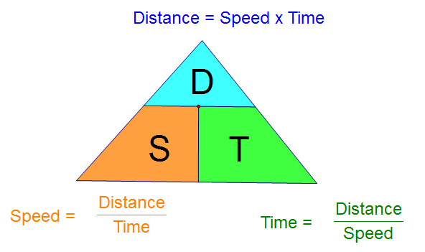

ACTIVITY 1.1.1

Instructions
- Individual activity
- Duration: 30 minutes
- Refer to the questions provided
- Task 1: Answer the questions and allocate marks or indicate were marks are allocated.
Task 2: Identify the taxonomy levels for each questions
- These questions are intended to prompt you to consolidate the unit and possible ways in which this section can be taught
- Report Back and Discussion
- Resources: Table 1 – 7, Training manual, Note pad, Pen and Calculator

- A dog eats 150g of dog food twice a day. How many kg of dog food does the dog eat in a fortnight?

- If ¼ of the volume of the coffee in the 1,7litre flask is milk, how many fluid ounces of milk is in the flask? Use 1 floz = 28 ml

- Hardware sells nails by the kilogram. One inch of nails weigh approximately 18 mg. How long, in mm, is a 1 inch nail, correct to 1 decimal place?

- The stove you have to bake in is an old one and only has the temperature in °Fahrenheit. You are making rusks and have to dry them overnight at a temperature of 176°F. Convert this temperature to °Celsius (80ºC)

- A container has the following dimensions: 120 cm × 300 cm × 430 cm. How many litres of liquid can the box hold?

- The Vaal Dam can store 2536 million m³ of water when full. However, it was 65,4% full on the 30 January 2020. How many litres of water was in the dam?

- Two friends, Ben and Mike, take part in a 15km fun run. Ben took 1 h 23 min 12 sec and Mike took 1 h 39 min 4 sec. How long did Ben wait at the finish line for Mike?

- Attached is a timetable showing school alarm times
 | Monday | Tuesday | Wednesday | Thursday | Friday
Staff | 07:30 | 07:30 | 07:30 | 07:30 | 07:30
Register | 07:40 |  |  |  | 07:40
1 | 08:00 | 07:40 | 07:40 | 07:40 | 08:00
2 | 08:30 | 08:50 | 08:25 | 08:30 | 08:30
3 | 09:20 | 09:40 | 09:10 | 09:20 | 09:15
4 | 10:10 | 10:30 | 09:50 | 10:10 | 10:00
Break | 11:00 | 11:20 | 10:35 | 11:00 | 10:45
5 | 11:55 | 11:50 | 11:00 | 11:55 | 11:15
6 | 12:40 | 12:40 | 11:40 | 12:40 | 12:00
7 | 13:25 | 13:25 | 12:20 | 13:25 | 12:45
 | 14:10 | 14:10 | 13:00 | 14:10 | 13:30
  - The staff has a meeting every morning. How long do they spend on meetings in a fortnight.
  - How many assemblies are there in a week?
  - Why do you think the school finishes so early on a Wednesday?
  - What is the average time per lesson on a Wednesday, correct to two decimal place?
- Thabiso is riding a bicycle at a speed of 8,5 m/s.
  - Convert 8,5 m/s to km/h
  - How long will it take him to travel 45 km? Give the answer in hours, minutes and seconds.

UNIT 2: TWO-DIMENSIONAL MEASUREMENT
INTRODUCTION

In this unit participants will look at the concept of Perimeter/Area and Volumes of rectangles, circles and other circular objects
LEARNING OUTCOME
At the end of this Unit, participants should be able to:
- Calculate the perimeter, area, surface area and volume of an object
- Determine/calculate appropriate quantities of materials/components required to complete a task

LESSON NOTES

- 2-D shape/ diagram is a flat figure with 2 dimensions; it does not have the thickness.

- Calculating perimeter
- Perimeter is the total length/distance around a shape or around the boundary.
- Perimeter of a circle is called the Circumference.
- Perimeter is measured in single units e.g. m, cm, mm, etc
- Length means measurement between two points in a straight line. E.g. length of a room.
- Circumference is a distance around a circle.
- When dealing with semi-circle, remember to divide the formula of circle by 2
- Perimeter of a semi-circle is half perimeter of the circumference.
- Ensure that all units are the same before calculating perimeter.
- The inner part of the shape should be excluded when calculating the perimeter.
- If the formula requires diameter, change the radius to diameter by multiplying radius by 2.
- Use the value of $π$ as ( $π$ = 3.142)
- Calculating area
- Area is the amount of space occupied by a 2-D (2-Dimensional) figure.
- It is measured in square units e.g. $m^{2}$, $cm^{2}$, etc
- Substitute values on the formula and simplify
- When dealing with complex figures, always divide it into smaller figures, calculate the segments and add the answers together.
- Polygon: Is a two dimensional figure with many sides

Polygon | Description | Shape
Triangle | A polygon with 3 sides | 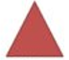
Quadrilateral | A polygon with 4 sides
Pentagon | A polygon with 5 sides
Hexagon | A polygon with 6 sides | 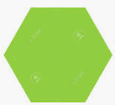
Heptagon | A polygon with 7 sides
Octagon | A polygon with 8 sides
Nonagon | A polygon with 9 sides | 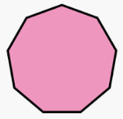
Decagon | A polygon with 10 sides
The perimeter and area of the following shapes should be considered:
Shape | Perimeter | Area
Rectangle  $b$  $l$ | $$P=l+l+b+b$$  $$P=2l+2b$$ | $$A=l×b$$
Square  $s$  s | $$P=s+s+s+s$$  $$P=4s$$ | $$A=s×s$$
Triangle  r  2  1  q  s  h  b  When a rectangle is divided diagonally into 2 halves, 2 triangles are produced. | $$P=q+r+s$$ | $$A=\frac{1}{2}×b×⊥h$$

Circles  Diameter  Radius | C $=2πr$  OR  C $=π×d$ | $A=π×r^{2}$
Semi-circle  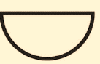  Diameter | P = $\frac{1}{2}π$d | A = $\frac{1}{2}π$r²
- Diameter is a straight line that divides a circle into two equal parts.
- Radius is half of the diameter.

Additional Notes:
--------------------------------------------------------------------------------------------------------------------------------------------------------------------------------------------------------------------------------------------------------------------------------------------------------------------------------------------------------------------------------------------------------------------------------------------------------------------------------------------------------------------------------------------------------------------------------------------------------------------------------------------------------------------------------------------------------------------------------------------------------------------------------
----------------------------------------------------------------------------------------------------------------------------------------------------------------------------------------------------------------------------------------------------------------------------------------------------------------------------------------------------------------------------------------

Example 1:
- Mahlodi is a manger at BKN dance studio.
- The North wing and the south wing have equal width of 2800mm and the diameter of the carpet is 2.4m.
- Study the floor plan of her studio and answer the following questions:
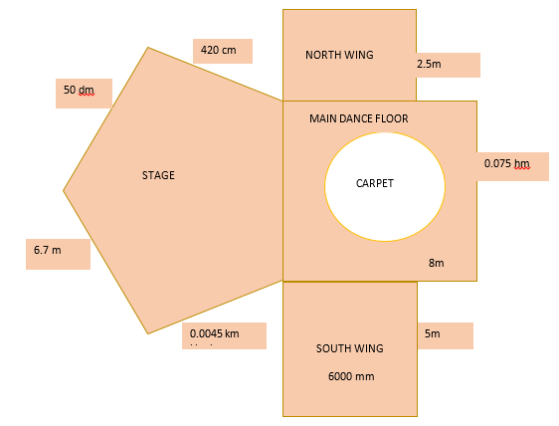
- Name of the shape of the stage
- Show that the perimeter of the stage is 27.9 m
- Determine the perimeter of the dance studio
- Determine the area of the main dance floor that will be covered with a carpet.

Example 2:
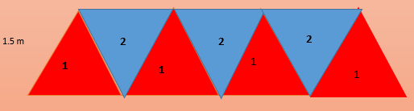

Molo is designing traditional beads. She draws the triangles on the material she is using and decorate each peace with beads of different colours as indicated in the diagram above. The length of the material is 2m and the breadth is 1.5 m. The base of each triangle is 70 cm and the perpendicular height of 0.9 m .The opposite sides of a triangle are equal as it is an isosceles triangle. The sides equal to 55 cm.

- Find the perimeter of the material
- Determine the perimeter of the drawn triangles
- Show that surface area of the material to be cut is 2.205 m²
- Thuli claimed that the piece of material that will not be decorated is 1m² , verify her claim.

Activity 2.1.1 Group Discussion (15 Minutes)

Instructions
- Participants should form groups of 4 – 5
- Refer to the questions provided
- Task 1: Answer the questions and allocate marks for each solution.
Task 2: Identify the taxonomy levels for each questions
- Report Back and Discussion
- Resources: Training manual, laptop and Calculator

Pitso has upgraded the area at the back of his house. He has added the picnic area, braai area and kids’ corner where his family can relax during their spare time. Study the sketch of the upgraded area below and answer the following questions:
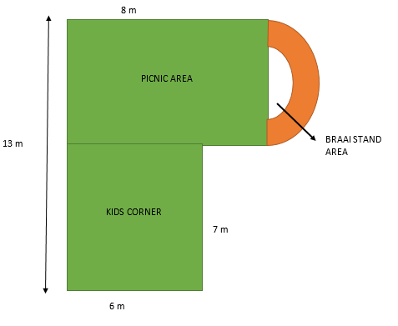
- Define perimeter in this context.
- Hence determine the perimeter of the upgraded area. Round off your final answer to 1 decimal place. You may use the formula: Area of a circle = π × d
  - The picnic area and Kids corner will be covered with an artificial grass carpet. Determine the amount of artificial grass needed to cover the two areas.
  - MHM traders are selling the artificial grass carpet for R299 per 2 m $×$ 1.5 m, excluding VAT Determine the total cost (VAT inclusive) of the artificial carpet needed.
  - Moosa, the manager at MHM is buying 30 m of artificial grass carpet from India at 7160 INR (Indian Rupee) including shipping. Pitso claims that his profit is more than 50%. Verify his claim.
N.B Use Xe currency converter to find the exchange rate.
- A portion of the braai area will be occupied by a braai stand as indicated in the diagram.
- The diameter of the braai stand area is 3.5 m. The remaining portion of the braai area will be plastered
    - Determine the area that will be occupied by the braai stand.
    - Show that the area to be plastered is 10.02 m².

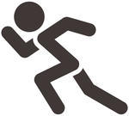
Activity 2.1.2 Individual Activity (30 Minutes)

Instructions
- Refer to the context provided
- These questions are intended to advance skills that can be used in the classroom and possible ways in which this section can be taught
- Task 1: Prepare solutions for this activity
- Task 2: Show mark allocation and explanation thereof.
- Solutions and Discussion
- Resources: Training manual, Flip chart, Koki pens

Lesego is upgrading her garden by putting in a flower bed, pond, stepping stones and a new deck. She asked a landscape architect to design the new garden
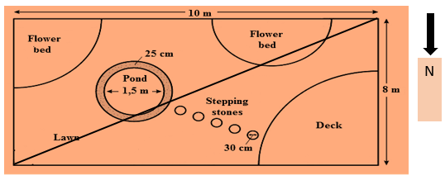
- Five stepping stones are placed from the deck to the pond. Determine the area (in cm²) of all the stepping stones, if the diameter of a stepping stone is 30 cm.
Area = $π×$ (radius)²
Use $π=$ 3,142

--------------------------------------------------------------------------------------------------------------------------------------
- Convert the inner diameter of the pond to inches if 1 millimetres equals to 0.039 inches.

--------------------------------------------------------------------------------------------------------------------------------------
- Pieces of grass are used to cover the lawn area. The length of each piece of grass is 700 mm and the width is 500 mm.
Calculate the area of one piece of grass in square metres (m²).
--------------------------------------------------------------------------------------------------------------------------------------
- Lesego has observed that the shade from the house divides the garden diagonally into 2 parts during mid-day as indicated in the diagram. It covers the East part of the garden. Determine the area of the garden that will not be covered by the shade.
--------------------------------------------------------------------------------------------------------------------------------------

Activity 2.1.3 Group Discussion (30 Minutes)
Instructions

- Participants should form groups of 4 – 5
- Refer to the context provided
- This activity is intended to advance skills that can be used in the classroom and possible ways in which this section can be taught
- Task 1: Develop a context and three possible questions ( TL 2 – 4) based on the resource provided
- Task 2: Prepare solutions for the questions, indicating mark allocation.
- Report Back and Discussion
- Resources: Training manual, Flip chart, Koki pens

Resource A:
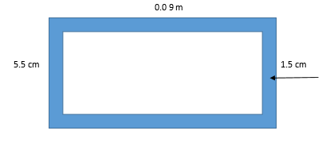

Resource B:

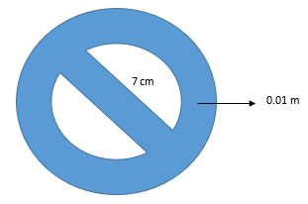

UNIT 3: THREE-DIMENSIONAL MEASUREMENT
INTRODUCTION
In this unit participants will look at the concept of Surface Area and Volumes of cubes, prisms, rings and other complex shapes.
LEARNING OUTCOME
At the end of this Unit, participants should be able to:
- Calculate the surface area and volume of an object
- Determine/calculate appropriate quantities of materials/components required to complete a task
LESSON NOTES:

- 3-D shape/diagram: A dimensional construction of a real-life object. It is a solid, it has length, breadth/ width and height.
- Calculating surface area:

- Break the complex shape down into its basic shapes such as square, rectangle, triangle or circle.
- Units must always be the same when calculating area.
- Use the given formula or choose the suitable formula
- Add the areas of all the basic shapes together to get the total area of the complex shape.
- To find the net shape , subtract the areas
- Area determined by multiplying 2 sides or squaring the radius when working with circle, the unit is always squared

- Calculating volume:
- Volume: Amount of space that an object or substance occupies.
- Capacity: The maximum amount that something may contain
- Units must always be the same when calculating area.
- Use the given formula or choose the suitable formula
- The volume is determined by multiplying 3 sides, therefore the units are always cubed

Example 1
Puseletso is selling 0.75 litre of pine-gel and she uses two types of containers to package it. As indicated in the diagram below. The volume of the cylindrical container is 785.5m³, while the volume of a rectangular container is 812 cm³. Study the diagrams below and answer the questions that follow:
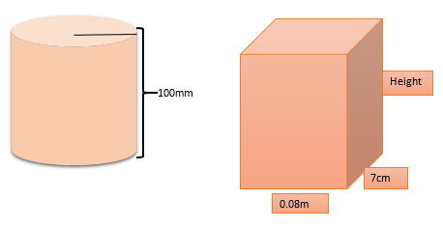

- Define volume in the given context.

-----------------------------------------------------------------------------------------------------------------------------
- Determine the diameter of a cylindrical container in centimetres.

------------------------------------------------------------------------------------------------------------------------------
- Show that the height of the rectangular container is 14.5 cm.

------------------------------------------------------------------------------------------------------------------------------
- Which of the two containers do you think will attract more customers? Explain the volume of a cylinder to litres.
NB: 1 litre = 1 000 cm³

-------------------------------------------------------------------------------------------------------------------------------
-----------------------------------------------------------------------------------------------------------------------------------------------------------------------------------------------------------------------------------------------------------------------------------------------------------------------------------------------------------------------------------------------
---------------------------------------------------------------------------------------------------------------------------------------------------------------------------------------------------------------------------------------------------------------
---------------------------------------------------------------------------------------------------------------------------------------------------------------------------------------------------------------------------------------------------------------
---------------------------------------------------------------------------------------------------------------------------------------------------------------------------------------------------------------------------------------------------------------
---------------------------------------------------------------------------------------------------------------------------------------------------------------------------------------------------------------------------------------------------------------
------------------------------------------------------------------------------------------------------------------------------
Example 2
Traveling Water is the name of a company hiring water tank trucks to transport water to building sites.
The picture below shows a water truck with a capacity of 18 000 litre. The truck has a cylindrical shape water tank.
A PICTURE OF A WATER TRUCK WITH A CAPACITY OF 18 000 LITRE
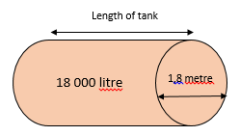

Use the information above to answer the questions that follow:
- Explain the term capacity in the given context.

----------------------------------------------------------------------------------------------------------------------------------------
- If the water tank is to be filled to 80% of its capacity, how much water, in kilolitres, is needed to fill the tank to this level?

----------------------------------------------------------------------------------------------------------------------------------------
- Determine (in metres) the radius of the water tank.

----------------------------------------------------------------------------------------------------------------------------------------
- Convert 18 000 litres to cubic metres (m³).

----------------------------------------------------------------------------------------------------------------------------------------
- Calculate the inner length of the water tank. Round your answer off to ONE decimal place. You may use the following formula:
Capacity = $π×$ (radius)² $×$ length
Use $π=$ 3,142
----------------------------------------------------------------------------------------------------------------------------------------------------------------------------------------------------------------------------------------------------------------------------------------------------------------------------------------------------------------------------------------------------------------------------------------------------------------------------------------------------------------------------------------------------------------------------
Example 3
The chocolate below was given to all participants at the competition.
Study the diagrams below and answer the questions that follow.
- Calculate the total area of all the rectangular sides of the chocolate pack.
You may use the following formula:
Area = length × Width
- Calculate the perimeter of one triangle in mm.

Additional Notes--------------------------------------------------------------------------------------------------------------------------------------------------------------------------------------------------------------------------------------------------------------------------------------------------------------------------------------------------------------------------------------------------------------------------------------------------------------------------------------------------------------------------------------------------------------------------------------------------------------------------------------------------------------------------------------------------------------------------------------------------------------------------------------------------------------------------------------------------------------------------------------------------------------------------------------------------------------------------------------------------------------------------------------------------------------------------------------------------------------------------------------------------------------------------------------------------------------------------------------------------------------------------------------------------------------------------------------------------------------------------------------------------------------------------------------------------------------------------------------------------------------------------------------------------------------------------------------------------------------------------------------------------------------------------------------------------------------------------------------------------------------------------------------------------------------------------------------------------------------------------------------------------------------------------------------------------------------------------------------------------------------------------------------------------------------------------------------------------------------------------------------------------------------------------------------------------------------------------------------------------------------------------------------------------------------------------------------------------------------------------------------------------------------------------------------------------------------------------------------------------------------------------------------------------------------------------------------------------------------------------------------------------------------------------------------------------------------------------------------------------------------------------------------------------------------------------------------------
Activity 2.3.1 Group Discussion (30 Minutes)
Instructions
- Refer to the questions provided
- These questions are intended to advance skills that can be used in the classroom and possible ways in which this section can be taught
- Task 1: Answer all the questions
- Task 2: Allocate marks for each question
- Report Back and Discussion
- Resources: Training manual, Note Pad, Pen and Calculator
PICTURE OF A CONCRETE TROUGH | OUTER DIMENSIONS OF A TROUGH
Length : 3 m
Width : 685 mm
Height : 40 cm
Volume of a rectangular prism = length $×$ width $×$ height
Note : A trough is a long , narrow, open container for animals to drink from.
1ℓ = 1000 cm³

Use the information above to answer the following questions:
- Calculate , in cm³, the volume of concrete used to make this trough if the trough can hold a maximum of 485 $l$ of water.
--------------------------------------------------------------------------------------------------------------------------------
- A cow drinks 56$l$ of water per day. Alfred stated that a full trough has enough water for 6 cows per day. Verify , with calculations , whether this statement is CORRECT.
--------------------------------------------------------------------------------------------------------------------------------
- Determine how long , to the nearest minute, it will take to fill a half empty trough if the water flos in at a rate of 14.5ℓ per minute.
--------------------------------------------------------------------------------------------------------------------------------

Activity 2.3.2 Group Discussion (30 Minutes)
Instructions
- Participants should form groups of 4 – 5
- Refer to the questions provided
- These questions are intended to advance skills that can be used in the classroom and possible ways in which this section can be taught
- Task 1: Answer all the questions
- Task 2: Identify the taxonomy levels for each questions
- Report Back and Discussion
- Resources: Training manual, Note Pad, Pen and Calculator

During winter many children develop coughs.
Cough syrups are sold in bottles packed in rectangular prism-shaped boxes.
Children are given cough syrup using a cylindrical measuring cup.
The diagrams below show the bottle, the box and measuring cup.
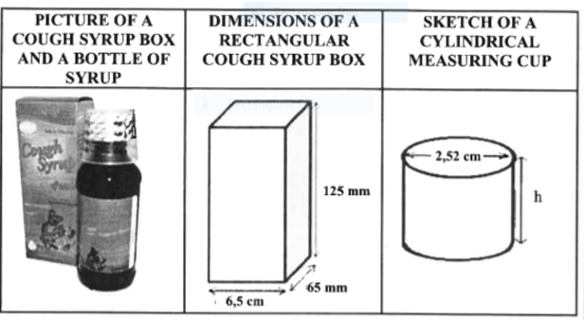

Use the inofrmation above to answer the questions that follow:
- Consider cough syrup box.
- Calculate (in cm3) the total surface area of the cough syrup box.
- Give a practical reason why a cartoon picture would feature on
the box of cough syrup for children.
- Calculate ( in cm ) the height of the medicine measuring cup in the diameter is 2.52 cm and the volume is 10 mℓ.
- Nolo bought his son a chocolate from the supermarket after buying the cough syrup.
The chocolate was wrapped in a cone wrap as shown in the diagram below . Determine the volume of the cone.
You may use the formula : Volume of a cone = $\frac{1 }{3}π×r^{2}×h$

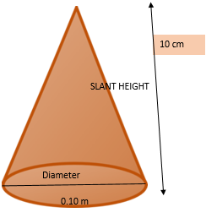

Additional Notes:
-------------------------------------------------------------------------------------------------------------------------------------------------------------------------------------------------------------------------------------------------------------------------------------------------------------------------------------------------------------------------------------------------------------------------------------------------------------------------------------------------------------------------------------------------------------------------------------------------------------------------------------------------------------------------------------------------------------------------------------------------------------------------------------------------------------------------------------------------------------------------------------------------------------------------------------------------------------------------------------------------------------------------------------------------------------------------------------------------------------------------------------------------------------------------------------------------------------------------------------------------------------------------------------------------------------------------------------------------------------------------------------------------------------------------------------------------------------------------------------------------------------------------------------------------------------------------------------------------------------------------------------------------------------------------------------------------------------------------------------------------------------------------------------------------------------------------------------------------------------------------------------------------------------------------------------------------------------------------------------------------------------------------------------------------------------------------------------------------------------------------------------------------------------------------------------------------------------------------------

Activity 2.3.3 Group Discussion (30 Minutes)
Instructions
- Participants should form groups of 4 – 5
- Refer to the questions provided
- These questions are intended to advance skills that can be used in the classroom and possible ways in which this section can be taught
- Task 1: Answer all the questions
- Task 3: Allocate marks for each question
- Report Back and Discussion
- Resources: Training manual, Note Pad, Pen and Calculator

Adapted from WC Prelim 2019 P2

Corniël made a tent for camping with his friends while fishing over the weekend as shown in the diagram below :
1,5 m
2,45m
1,75 m
1,737 m cm

- the length is 2,45m
- the breadth 1,75 m
- the slant height 1,737 m and
- the perpendicular height 1,5 m.

- Calculate the amount of material that is needed to make the tent. The ground cloth is attached to the structure of the tent. Use the formula:
Surface area = 2(length $×$ slant height) + ( length breadth ) + ( base $×$perpendicular height )

Corniel brought his 3 sons along to teach them to catch fishes. He also brought a cricket ball and a spherical stress ball to enable them to play while relaxing. His older son clained that the cricket ball has a greater volume. Verify his claim.
You may use the formula : Volume of a sphere = $\frac{4}{3}$ $π$r³
The dimensions of the balls are indicated in the table below
Diameter = 2.59 inches  1 inch = 2.54 cm | Radius = 2 cm

Activity 2.3.4. Individual Work (20 Minutes)
Instructions
- Refer to the context provided: How to download a video lesson
- These questions are intended to advance ICT skills that can be used in the classroom
- Task : Download a video lesson for calculating volume of a Cone
- Report Back and Discussion
- Resources: Training manual, Laptop and Wi-fi
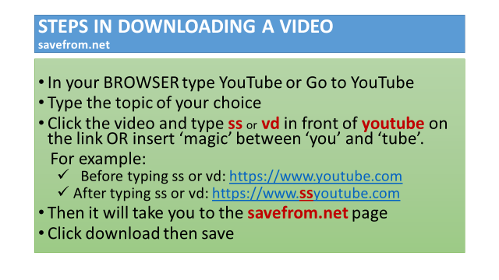

SUMMARY FOR THE UNIT
- In this module, participants were exposed to calculating perimeter, area and volume including surface area and circumference; calculated rectangles, triangles and circles viz. quarter, semi and three –quarters using known formulae and calculated rectangular prisms, cylinders and cones using known formulae.

- Summary of 2D and 3D shapes
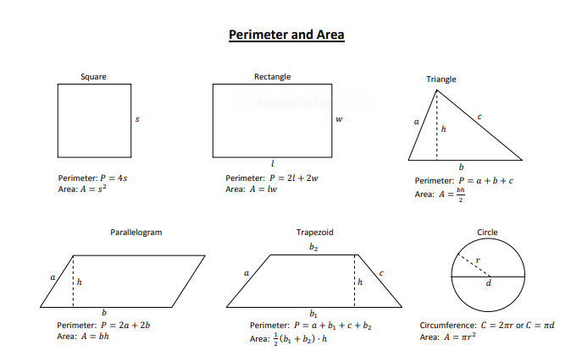

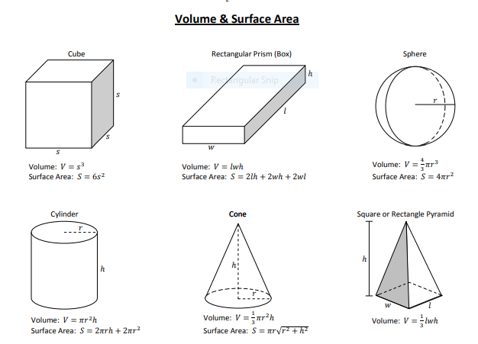

RECOURCES FOR MODULE 2

  - Free state 2019 Preliminary Paper 1
  - DBE 2019 June and November NSC Paper 2 Question 2
  - Mpumalanga 2019 Preliminary Paper 2
  - Western Cape 2019 Preliminary Paper 2

REFLECTION
You should provide learners with conversion tables or methods like ‘King Henry Died a Miserable Death Called Measles’ when doing conversions from one unit of measurement to another. Glossary of terms such as radius and diameter should be reinforced on a regular basis. Teachers should provide learners with enough exercises on how to substitute correct values into a given formula. Teachers should encourage learners to write a glossary at the back of their books of the different terms’ meanings as they complete each topic

END OF MODULE 2

