MEIOSIS
Two types of cell division occur in organisms, namely mitosis and meiosis. During mitosis cells make exacts copies of themselves.
Meiosis usually takes place in the reproductive organs (in animals) to produce gametes. During this cell division, the diploid chromosome number is halved. Meiosis takes place in two phases. (cell division takes place twice). The resulting cells will have chromosomes that are hybrids because genetic recombination occurs during meiosis. Meiosis is important in sexual reproduction as it involves the combination of genetic information from both parents. This process allows cells to have half the number of chromosomes, so two of these cells can come back together to form a new organism with the complete number of chromosomes. It not only helps produce gametes, it also ensures genetic variation.
TERMINOLOGY:
Autosomes: | Chromosomes that are not sex chromosome. There are 22 pairs of autosomes in a diploid cell.
Centriole: | An organelle in the cytoplasm of the cell, which gives rise to spindle fibres during meiosis and mitosis.
Centromere: | Structure that holds two chromatids together to form a chromosome.
Chiasma: | Point where crossing over takes place between chromatids of the homologous chromosome during prophase 1.
Chromatid: | It is a single thread of a double stranded chromosome. Two chromatids are joined by a centromere to form a chromosome.
Chromosome: | A structure made up of two chromatids joined by a centromere that carries the hereditary characteristics within the DNA.
Diploid number (2n): | Complete chromosomal number represented in pairs, which is characteristic of an organism.
Gametes: | Haploid cells (n) which contain half the chromosome number of the diploid generation. Egg cells and sperm cells are the gametes necessary in sexual reproduction where the fusion of the two gametes results in a new individual.
Gene: | The unit of heredity transmitted in the chromosome, which controls the development of the characteristics.
Gonosomes: | Sex chromosomes. There are one pair of sex chromosomes in a diploid cell: the XX chromosomes in females and XY chromosomes in males.
Haploid number (n): | Half the number of chromosomes present in gametes after meiosis has occurred.
Homologous chromosomes | Maternal and paternal chromosomes having the same shape and size which are paired but differs in genetic material.
Bivalent: | A pair of homologous chromosomes physically held together by at least one DNA crossover.
Maternal: | From the mother / female parent.
Meiosis: | A process of cell division whereby the chromosomal number is halved for the production of haploid gametes (sperm cells and egg cells).
Mitosis: | A process of cell division where the resulting daughter cells have the same diploid chromosomal number as the original parent cell.
Non-disjunction: | The homologous chromosomes do not separate due to failure of the centromere to divide during meiosis I & II. The resulting gametes will have either an extra chromosome/copy or another gamete will have one less chromosome.
Paternal: | From the father / male parent.
Somatic cells: | Normal diploid body cells.
Spindle fibres: | Micro-tubules that form during cell division which radiate out from the centrosomes and draw the chromosomes to the poles.
Variation: | The morphological and physiological differences that can be seen between members of the same species.
Zygote: | The resulting diploid cell after fertilization has occurred

Where does meiosis take place in animals?
Meiosis usually takes place in the reproductive organs of animals. The following diagrams illustrate where it takes place in males and females.
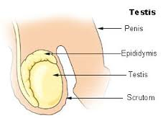
In men meiosis takes place in the testis and in women in the ovary as well as the fallopian tube
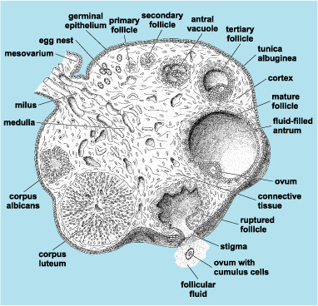
Where does meiosis take place in plants?
In plants meiosis takes place during the production of spores. It usually takes place in the anther and ovule in flowering plants. The following diagram shows where meiosis takes place in plants.
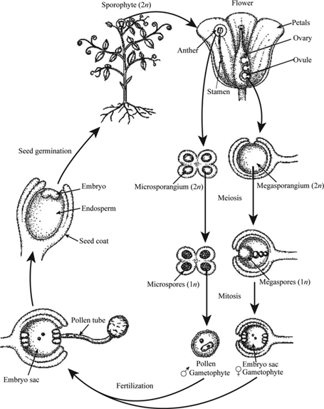
Structure of a chromosome
It is important to know what a chromosome is and what the difference between a replicated and unreplicated chromosome. The diagram below illustrates the structure of chromosomes. It starts at DNA level and shows how DNA is supercoiled to form a chromosome.

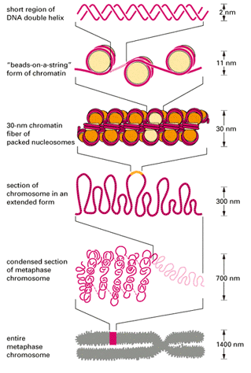

DNA replication
Replication takes place during interphase where two copies of the chromosome is made. Each copy is now called a chromatid which is joined by a centromere. This is illustrated by the diagram below:
Single chromosome before Double chromosome with two chromatids
replication in interphase after DNA replication
Chromosome number
- Every species has a specific number of chromosomes in the nucleus.
- Somatic cells (body cells) have the diploid number(2n)(equal amount of chromosomes)
- There are two chromosomes of each kind, one from the mother and one from the father.
- Sex cells (gametes) contain only half the number of chromosomes (n)
- When a female (n) gamete and a male gamete(n) fuse the resultant zygote is diploid (2n)
- Human somatic cells have 46 chromosomes in the nuclei and gametes have 23 chromosomes.
The process of meiosis
Stages of meiosis
Meiosis 1
Prophase 1
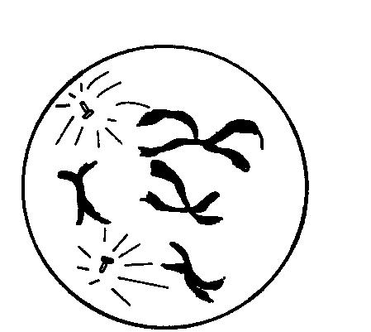
1. Chromosomes shorten and become visible as two chromatids
joined by a centromere.
2. Homologous pairs of chromosomes are now visible.
3. The nuclear membrane and nucleolus disappear
4. The spindle starts to form.
5. Chromatids from each homologous pair touch. The point where
they touch is called a chiasma.
6. DNA is crossed over (swopped) at the chiasma.

__________________________________________________________________
Metaphase 1
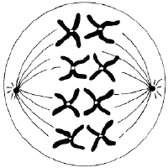
- The spindle extends across the whole cell.
• The homologous chromosomes line up along the
equator of the spindle in their homologous pairs.
• One chromosome of each pair lies on either side of the equator. Random arrangement
• The centromere of each chromosome attaches to the
spindle fibres.

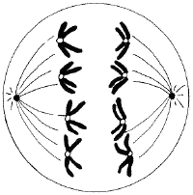
___________________________________________________________________
Anaphase 1
1. Chromosomes-- move to opposite sides of the cell, spindle fibers shorten
2. Cell begins to split: a furrow forms in animal cells; a cell plate forms in plant cells

Telophase 1
1. The nuclear membrane re-forms around the chromosomes
2. The nucleolus reforms
3. The cell splits into two cells
1. The nuclear membrane re-forms around the chromosomes
2. The nucleolus reforms
3. The cell splits into two cells

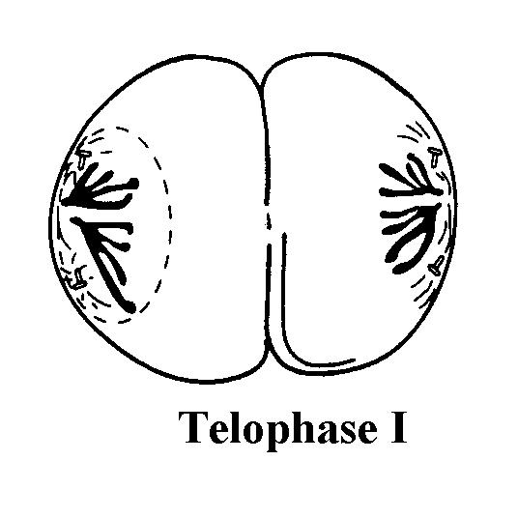
Telophase 1
1. The nuclear membrane re-forms around the chromosomes
2. The nucleolus reforms
3. The cell splits into two cells
1. The nuclear membrane re-forms around the chromosomes
2. The nucleolus reforms
3. Each pole has half the number of chromosomes
present in the original cell.
4. The cell membrane constricts and divides the
cytoplasm in half to form two cells.

MEIOSIS II

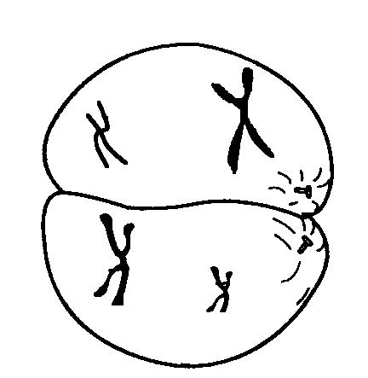
Prophase 2
1. Centrioles move to opposite sides-- in animal
cell
2. Nuclear membrane and nucleolus disintegrate
3. Chromosomes formed with 2 chromatids
4. At the very end of prophase, the spindle forms

1. The nuclear membrane re-forms around the chromosomes
2. The nucleolus reforms
3. The cell splits into two cells
1. The nuclear membrane re-forms around the chromosomes
2. The nucleolus reforms
3. The cell splits into two cells

________________________________________________________________
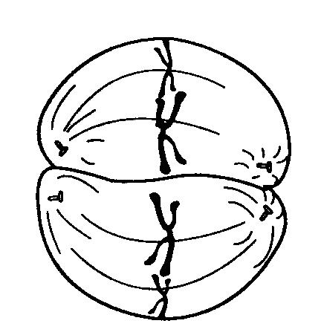
Metaphase 2
- Centromeres, which hold the chromatids
together, attach to spindle fibers
- Chromatids line up across the equator of
the cell

_______________________________________________________________
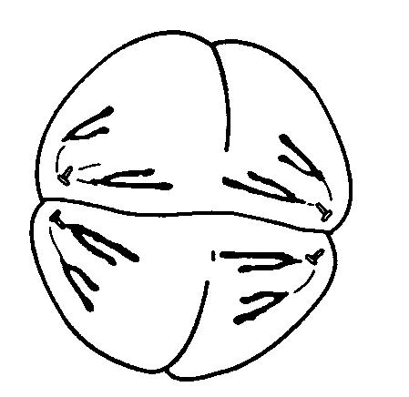
Anaphase 2
- Centromeres split and chromatids-- -- move to opposite sides of the cell
- Cell begins to split: a furrow forms in animal cells; a cell plate forms in plant cells

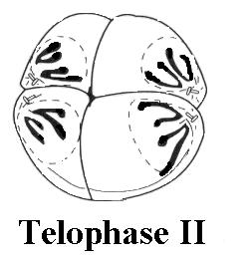
________________________________________________________________
Telophase 2
- The nuclear membrane re-forms around the single stranded chromosomes
- The nucleolus reforms
- The cell splits into four haploid sister cells

1. The nuclear membrane re-forms around the chromosomes
2. The nucleolus reforms
3. The cell splits into four haploid sister cells

1. The nuclear membrane re-forms around the chromosomes
2. The nucleolus reforms
3. The cell splits into four haploid sister cells

The difference between meiosis and mitosis:
 | MITOSIS | MEIOSIS
Site where it occurs | Somatic cells | Ovaries and testis  Ovules & anthers
Purpose of process | Growth | Formation of haploid gametes
Number of daughter cells produced | Two identical cells | 4 haploid cells genetically different
Number of divisions | One nuclear division | Two nuclear divisions

What is non-disjunction and what are the consequences of this?
The homologous chromosomes do not separate due to failure of the centromere to divide during meiosis I & II. This usually happens during anaphase 1 or 2. The resulting gametes will have either an extra chromosome/copy on chromosome pair or another gamete will have one less chromosome
Down syndrome
The condition is named after Dr Down who described it the first time in 1866. People with Down syndrome have 47 chromosomes instead of 46 because the 21st set of chromosomes did not divide properly during anaphase 1 in oogenesis. Both chromosomes of the homologous pair then end up in one ovum (which now has 24 chromosomes). If fertilisation takes place, the resulting zygote will have 47 instead of 46 chromosomes. This condition is called trisomy 21, because there are three (tri) chromosomes on the 21st pair of chromosomes.
Karyotype is the number and visual appearance of the chromosomes in the cell nuclei of an organism or species. It is an individual's collection of chromosomes. This is sometimes used by examiners to ask questions about Down syndrome. The following images illustrate the differences between normal karyotypes and the karyotype of a women with Down syndrome.
The first 22 pairs of chromosomes are non-sex chromosomes and are called. The 23rd pair of chromosomes are sex chromosomes, also known as gonosomes. They are composed of one large X and one small Y chromosome in the case of males or two large X chromosomes in the case of females.
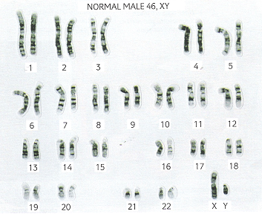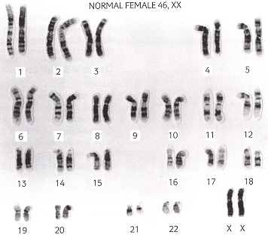
In the Down syndrome karyotype one can clearly see that there are three chromosomes at position 21 instead of only two as the karyotypes of the normal male and female above indicate.
