**MODULE 1 – GENETICS AND HEREDITY**

**INTRODUCTION**

Genetics is the **science of inheritance** and studies the principles of heredity and variation. The hereditary instruction carried within the DNA ensures that offspring resemble their parents and ensures that **genetic variation** can take place, resulting in survival of the fittest.

During sexual reproduction, offspring are produced that resemble the parents. **Two haploid** gametes are the result of the process of **meiosis**. The gametes fuse during reproduction and the result is a **diploid zygote**, containing a double set of chromosomes. One set of the chromosomes came from the male gamete, which contains the DNA from the father. One set of chromosomes came from the female gamete and contains the DNA from the mother. The child therefore contains DNA from both parents.

At this point in time, you as the grade 12 teacher, have already finished the introduction to genetics, monohybrid crosses, sex determinations, sex linked inheritance and blood grouping. You are left with dihybrid crosses, genetic pedigree diagrams, mutations, genetic engineering, paternity testing, genetic links and the SBA practical task. We have decided to include the first topics to help you with revision activities if some of the topics were not clear when you first explained it. You will also notice that we have included terminology lists as these are crucial for good performance. Please ensure that your learners do regular terminology activities and tests.

**OVERVIEW**

This module deals with genetics and heredity. The module starts with notes and important “tips” for learners. There is a detailed terminology list, followed by monohybrid crosses, sex determination, blood grouping, dihybrid crosses, pedigree diagrams, mutations, genetic engineering and paternity testing.

**SPECIFIC OBJECTIVES**

By the end of this session, participants will be able to:

* Cut a diagram from a pdf document and modify it in the paint program before we paste it into another document.
* Solve monohybrid crosses for complete, incomplete, co-dominance, sex-linked diseases and blood groups.
* Calculate ratios and percentages of the genotype and phenotype of the F1 and F2 generations.
* Solve dihybrid crosses.
* Read and solve pedigree diagrams
* Administer and assess the gr.12 SBA task on genetics.
* Answer questions on mutations and genetic engineering.
* Introduce genetics as a topic in a fun way to learners.

**CONTENT**

You will study this module through the following units:

|  |
| --- |
| **Unit 1: How do we take images from past papers and use it in our own worksheets and/or**  **question papers?** |
| **Unit 2: How do we teach the different kinds of monohybrid crosses?** |
| **Unit 3: What is sex linked diseases and how do we determine sex?** |
| **Unit 4: What are the different blood groups and the genetics behind it?** |
| **Unit 5: What are dihybrid crosses and how do we solve it?** |
| **Unit 6: What are pedigree diagrams and how do we solve it?** |
| **Unit 7: What are mutations and genetic engineering and what are the applications of this?** |

**UNIT 1 - How do we take images from past papers and use it in our own worksheets and/or question papers?**

**Step 1: Open question paper in PDF format**

**Step 2: Go to toolbar on top, click on edit**

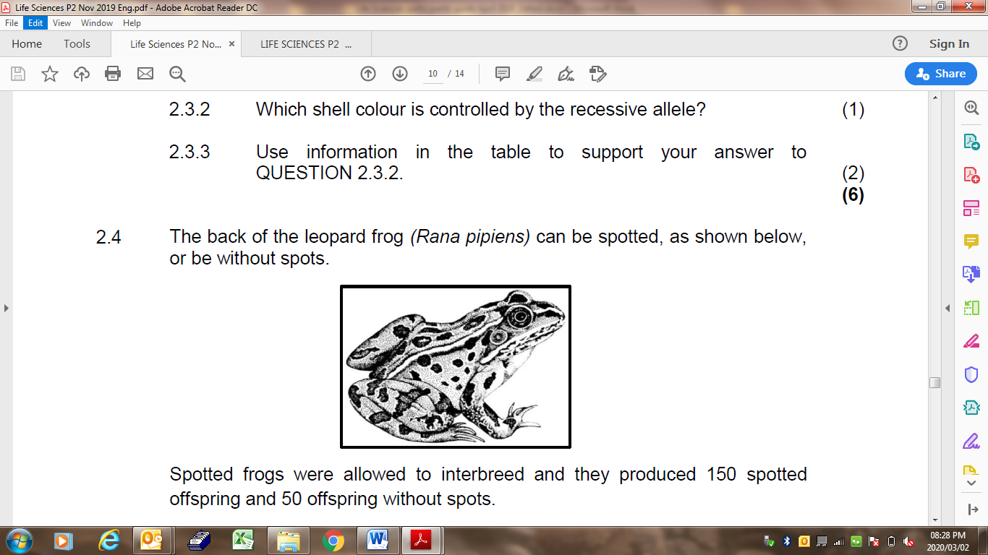

**Step 3: Click on snapshot**

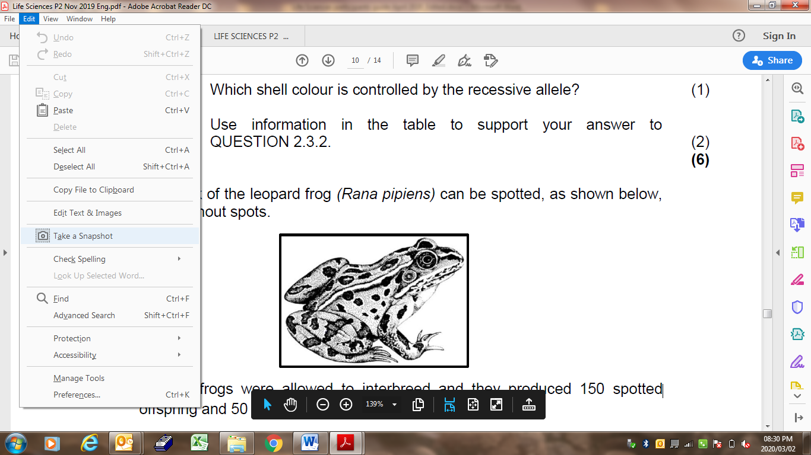

**Step 4: Highlight the diagram**

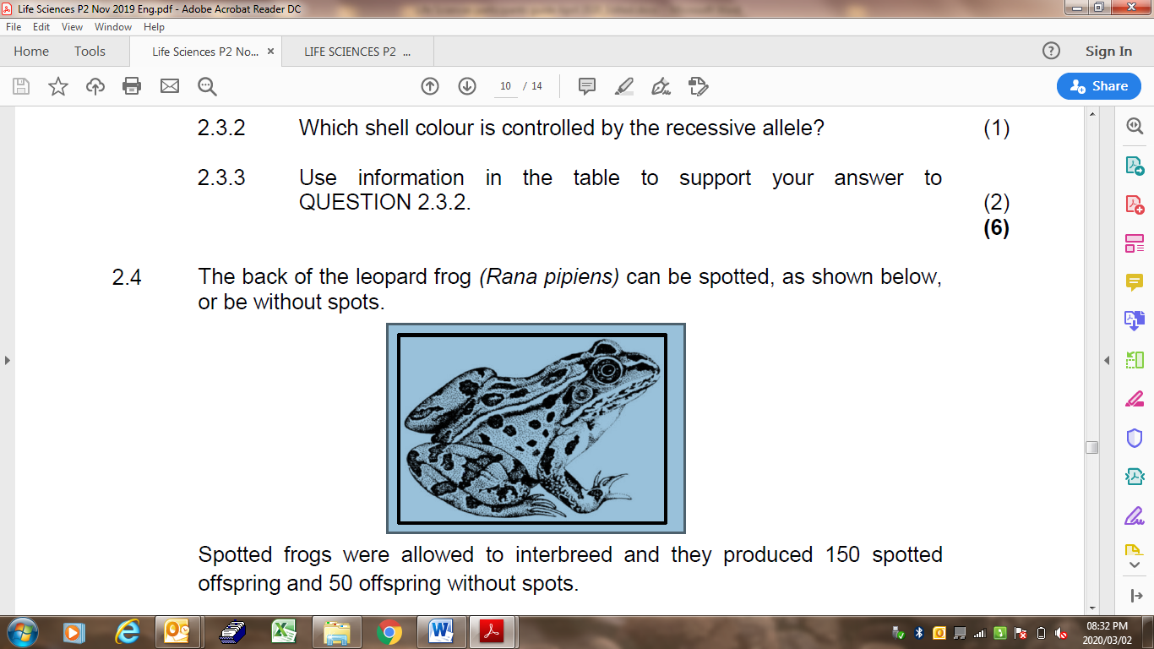

**Step 5: Open Paint on your computer**

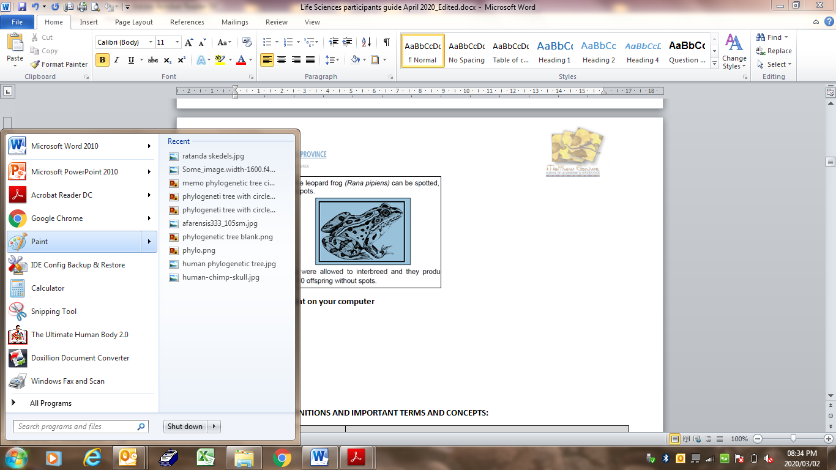

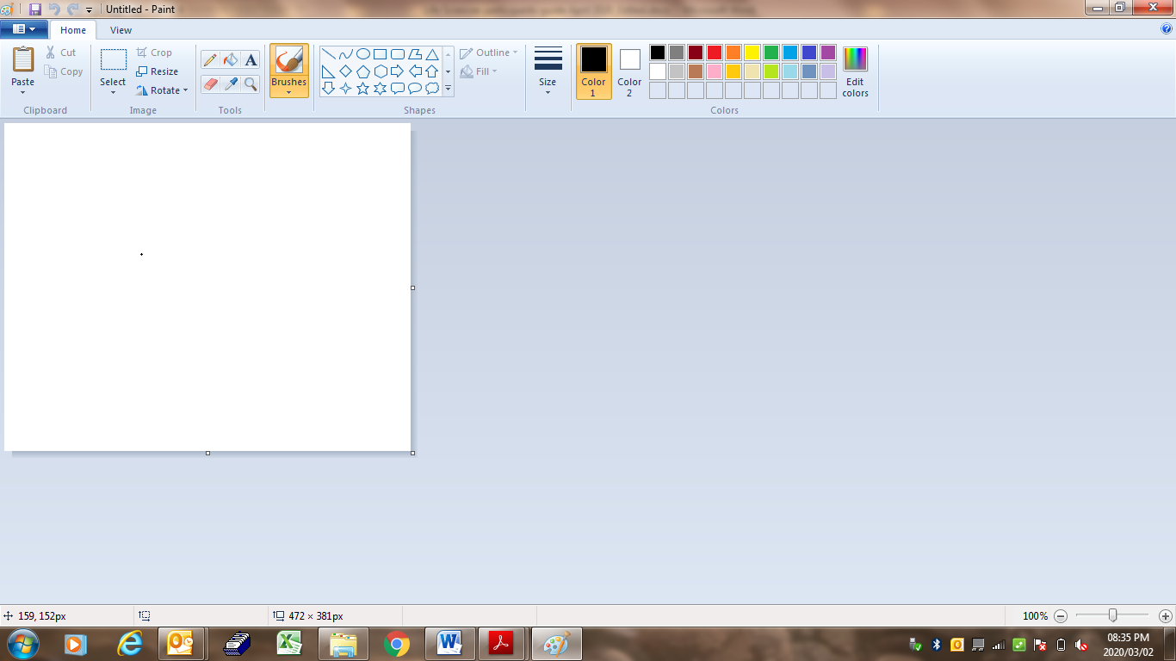

**Step 6: Click on Paste**

You can do many things with this program. you can add a shape, colour in certain parts. You could rotate it and type in labels and add label lines. All you have to do is click on the icon in the toolbar.

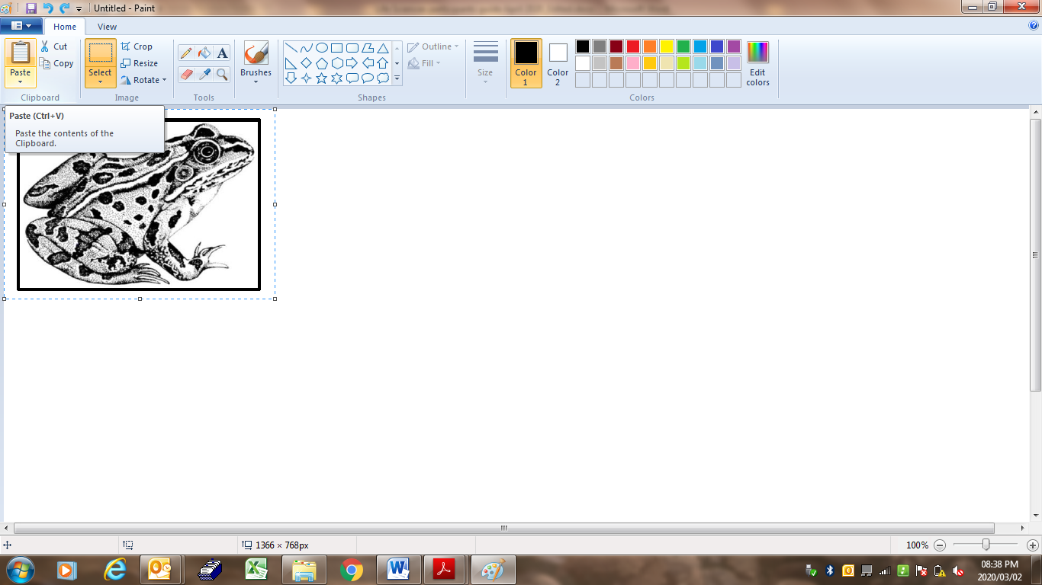

**Step 7: Now you can make the desired changes.**

**Say for example we are only interested in the head of the frog. Click select, rectangular selection and highlight the head. Then move the selection to the side.**

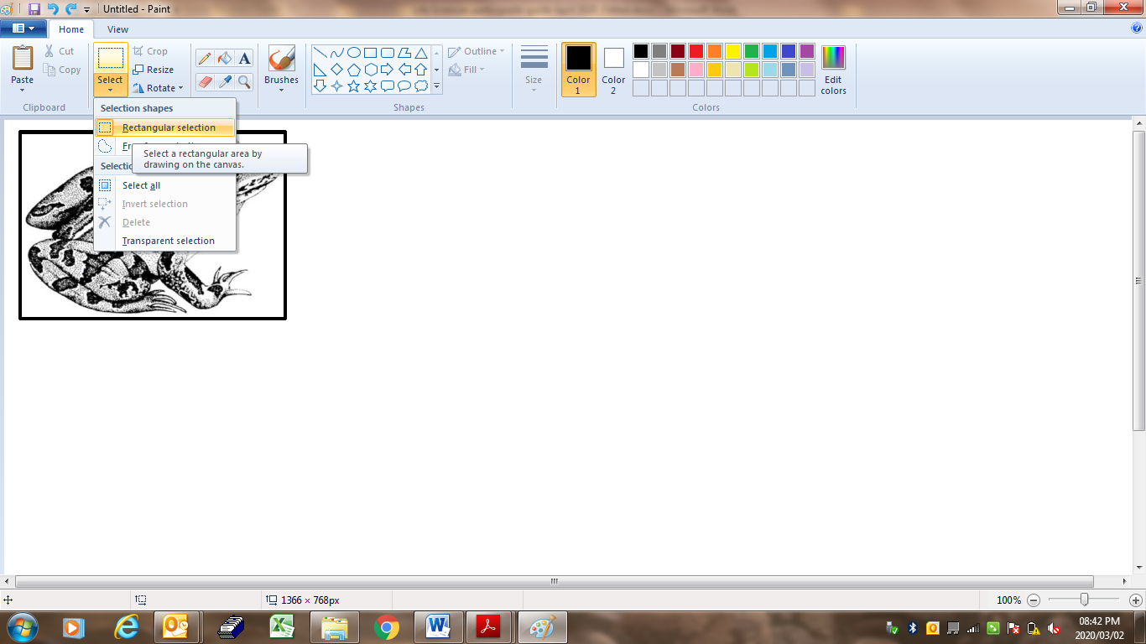 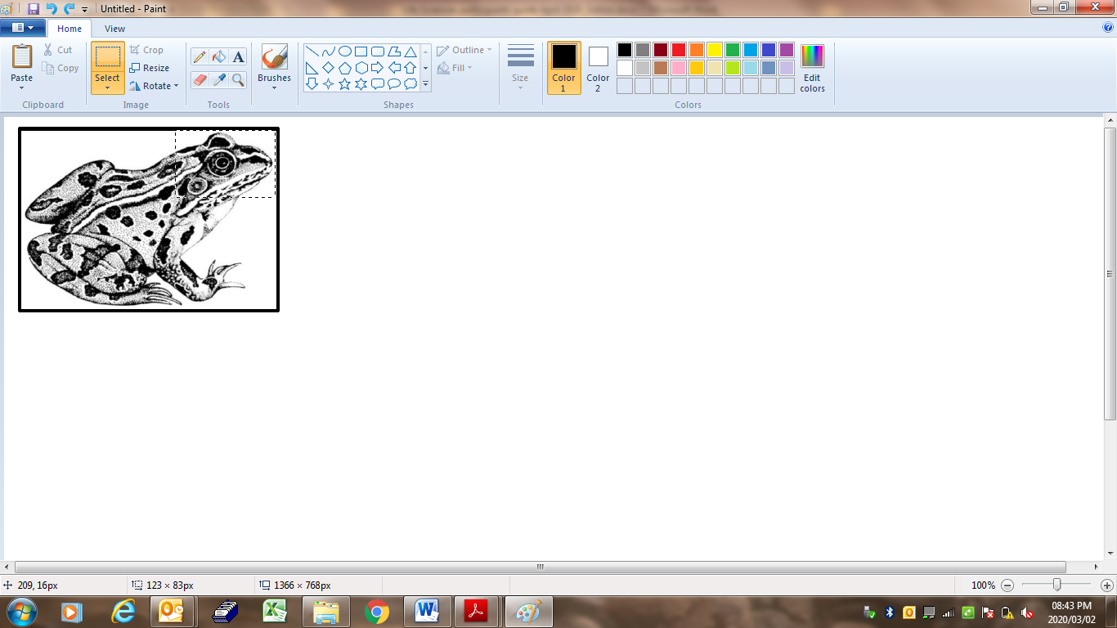

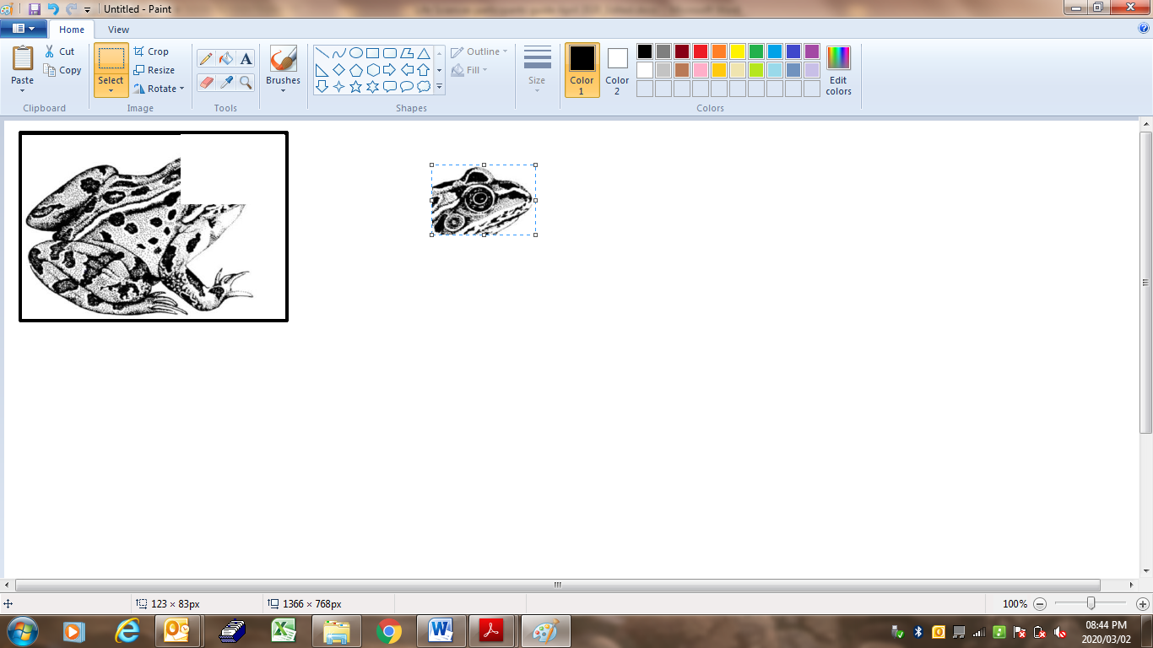

**Step 8: There is a line, erase the line with the rubber. Select the rubber and erase the line.**

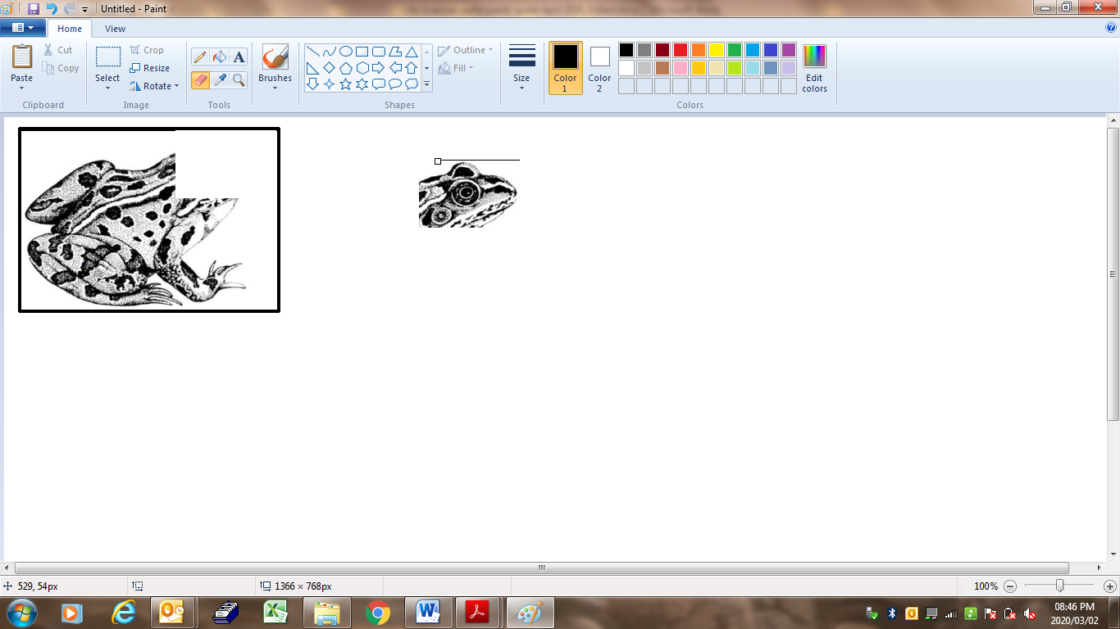

**Step 9: Select the head and click on copy**

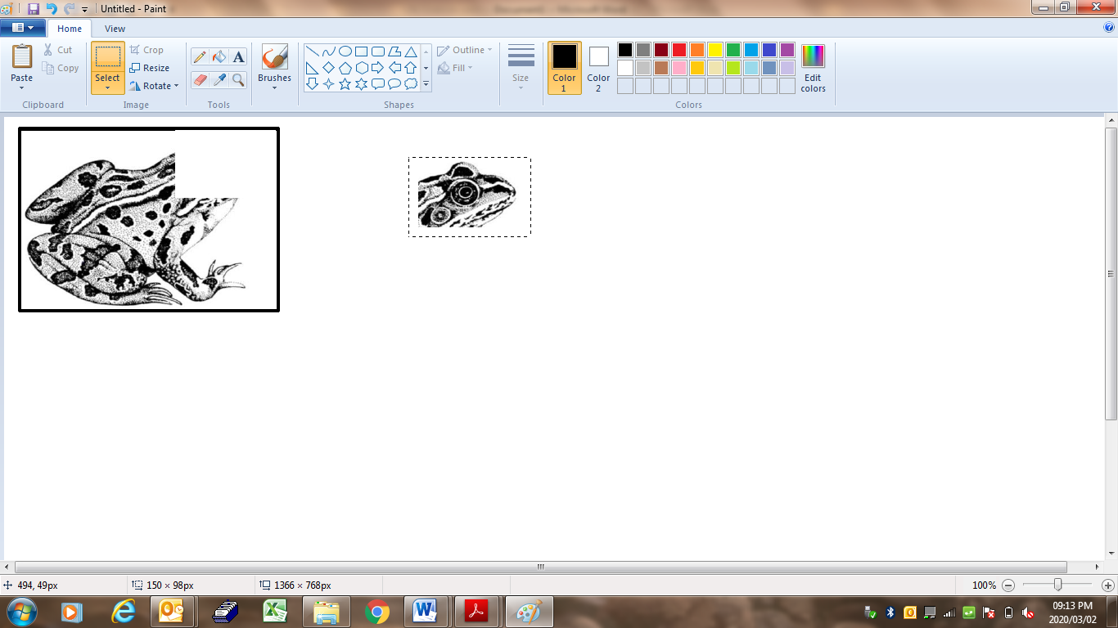

**Step 10: Go to the document where you want to insert the diagram (head) and paste it in the position where you want it**

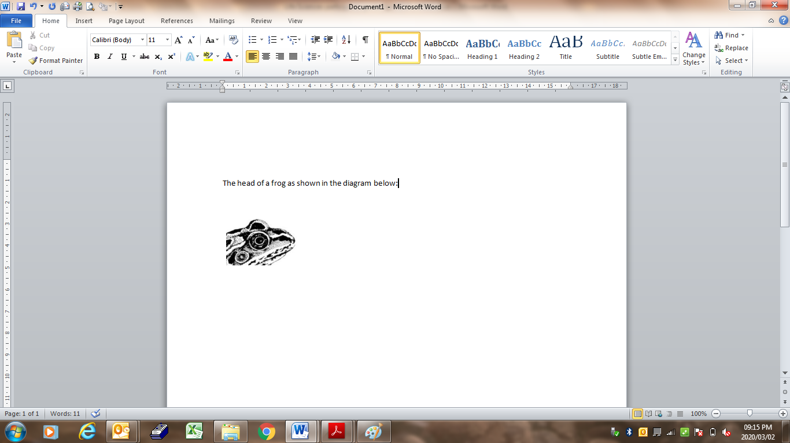

 **ACTIVITY 1.1**

**AIM: To practice working with the paint program**

**Method:**

**Select a diagram or graph from a question paper on your computer. Insert it into paint. Make any changes on the diagram and paste it back into the question paper.**

**UNIT 2 - How do we teach the different kinds of monohybrid crosses?**



* *Learners MUST understand the link between meiosis and genetics.*
* *During the crossing over in prophase I of meiosis, chromosomes share information and then during metaphase I, separate* ***randomly.***
* *This determines the combination of chromosomes and genes that you have as an individual. Genetics determines individual variation (to be different) and survival of the fittest.*
* *Learners MUST have a clear understanding of the genetic terminology in order to study genetics and answer genetic problems.*
* *Mendel’s Laws are very important - understand the concepts of dominance and how this plays a role in monohybrid crosses (mono = one = one characteristic or trait).*
* *Be aware of confusing the word ‘cross/ crossing’ with ‘crossing over’ in Meiosis. You cross individuals and calculate the chances of a characteristic or trait being in the offspring. Learners must be clear of the difference between these two terms.*
* *Questions on blood group inheritance and sex determination are often asked. The more examples of genetic crosses that they do, the better they will do.*
* *Pedigree diagrams are a popular way to express family history and are often asked in exams. Make sure they know how to answer them.*
* *There are basically* ***FOUR types of monohybrid crosses***: 
  + - **Homozygous Dominant x Homozygous recessive****HH x hh;**
    - **Heterozygous x Heterozygous Hh x Hh;**
    - **Heterozygous x Homo recessive Hh x hh;**
    - **Heterozygous x Homo dominant Hh x HH**
* In the notation of the genotype the **dominant allele** represented by a **CAPITAL LETTER** must always be written first e.g. Gg and **NOT** gG.

**DEFINITIONS AND IMPORTANT TERMS AND CONCEPTS:**

|  |  |
| --- | --- |
| **Biological term** | **Description** |
| **Albinism** | The condition that results from the absence of skin pigmentation |
| **Alleles** | Two alternative forms of a gene at the same locus |
| **Artificial selection/selective breading** | The breeding of organisms over many generations in order to achieve a desirable phenotype |
| **Biotechnology** | The use of biological processes, organisms or systems to improve the quality of human life |
| **Clone** | A copy of an organism that is genetically identical to the original organism |
| **Cloning** | The process by which genetically identical organisms are formed using biotechnology |
| **Co-dominance** | The type of inheritance where both alleles are equally dominant and both express themselves equally in the phenotype. E.g. A white cow crossed with a black bull will produce a calf with black and white patches |
| **Complete dominance** | The type of inheritance where the dominant allele masks the expression of the recessive allele in the heterozygous condition |
| **Chromatin network:** | Visible as thread-like structures in the nucleus of an inactive cell |
| **Chromosome:** | A structure made up of two chromatids joined by a centromere that carries the hereditary characteristics within the DNA |
| **Dihybrid cross** | A genetic cross involving two different characteristics e.g. shape and colour of seeds |
| **Dominant allele:** | An allele that masks or suppresses the expression of the allele partner on the chromosome pair and the dominant characteristic is seen in the homozygous (e.g.: TT) and heterozygous state (e.g.: Tt) in the phenotype. |
| **Gene** | A segment of DNA/a chromosome that codes for a particular characteristic |
| **Gene mutation:** | A change of one or more N- bases in the nuclear DNA of an organism. |
| **Genetic variation:** | This includes a variety of different genes that may differ from maternal and paternal genes resulting in new genotypes and phenotypes. |
| **Genotype** | This is the total **genetic composition** of an organism. It is the information present in the gene alleles, for example BB, Bb or bb. |
| **Genome** | The complete set of chromosomes in the cell of an organism |
| **Haemophilia** | A sex-linked genetic disorder characterised by the absence of a blood-clotting factor |
| **Heterozygous** | An individual having two non-identical alleles for a characteristic |
| **Homologous structures** | Similar structures on different organisms that suggest they have a common ancestor |
| **Homozygous:** | When two alleles that control a single trait (on the same locus) are **identical**. |
| **Hypothesis** | A tentative explanation of a phenomenon that can be tested and may be accepted or rejected |
| **Incomplete dominance** | The type of inheritance where both alleles express themselves in such a way that an intermediate phenotype is formed. E.g. A white flowering plant crossed with a red flowering plant will produce a pink flowering plant. |
| **Locus:** | The exact position or location of a gene on a chromosome. |
| **Mendel’s Law of Dominance** | When two individuals with contrasting pure breeding characteristics are crossed, the individuals of the first generation (F1) will **ALL** resemble the parent with the dominant characteristic. |
| **Mendel’s Law of Independent Assortment** | Alleles of a gene for one characteristic segregate independently of the alleles of a gene of another characteristic. The alleles for the two different genes will therefore come together randomly during gamete formation. This is also known as random assortment. |
| **Mendel’s Principle of Segregation** | During gametogenesis the two alleles of a gene separate so that each gamete will receive one allele of a gene for a specific characteristic/trait. |
| **Monohybrid cross** | A genetic cross involving one characteristic e.g. colour of seeds |
| **Mutation** | A sudden change in the sequence/order of nitrogenous bases of a nucleic acid |
| **Multiple alleles:** | When there are more than two possible alleles for one gene locus. e.g. blood groups |
| **Phenotype:** | This is the external, **physical appearance** of an organism. The phenotype is determined by the genotype. **(**phenotype, when both recessive gene alleles are present e.g.: bb) |
| **Pedigree diagram** | A diagram showing the inheritance of genetic disorders over many generations |
| **Population** | A group of organisms of the same species living in the same habitat at the same time |
| **Recessive allele:** | An allele that is suppressed when the allele partner is dominant. The recessive trait will only be expressed/seen if both alleles for the trait are homozygous recessive e.g.: tt |
| **Stem cells/meristematic cells** | Undifferentiated cells that can develop into any cell type |
| **Theory** | Explanation of an observation that is supported by facts, models and laws |

**STRATEGIES TO TEACH TERMINOLOGY:**

1. In every lesson identify new terms/concepts and write it on the board.
2. Learners will take down terms/concepts at the back of their notebooks noting the correct spelling.
3. Learners must define/write down the meaning of these words from listening to the educator’ lesson/finding meaning from the dictionary or textbook.
4. Break down the concept/term where possible- give the meaning of the prefix and suffix e.g. photo (light) synthesis (to build up).
5. Use the concept in a sentence.
6. Educators must check that learners have done the above, on a daily basis e.g. asks any learner to define a concept.
7. By the end of the year ALL learners have a comprehensive GLOSSARY of ALL terms /concepts.
8. ASSESSMENT: Biological terms to be included in all daily assessment tasks. Develop crossword puzzles. (Use various websites from internet e.g. eclipse)
9. Learning terminology also helps in answering MCQs and matching questions, etc.

 **GENETICS AND INHERITANCE:**

**The Principles of Heredity:**

**If a tall plant (dominant trait) is crossed with a short plant (recessive trait) a genetic cross could be written as follow:**

**P1 Phenotype:** Tall plants x short plants

**Genotype:** TT x tt

**Meiosis**

**Gametes:** T , T x t , t **( Mendel’s principle of segregation)**

**Fertilization**

|  |  |  |
| --- | --- | --- |
|  | **T** | **T** |
| **t** | Tt | Tt |
| **t** | Tt | Tt |

**F1**

**Genotype:** 100 % Tt (heterozygous tall)

**Phenotype:** 100% Tall **(Mendel’s Law of Dominance)**

**Note** : that the F1 offspring have characteristics from both parents but in the phenotype, all display the dominant characteristic.

The offspring of the F1 (Tt) grow and mature to become P2. The offspring of **P2** are known as F2.

**P2 Phenotype:** Tall plants x Tall plants

**Genotype:** T t x T t

**Meiosis**

**Gametes:** T , t x T , t

**Fertilization**

|  |  |  |
| --- | --- | --- |
|  | **T** | **t** |
| **T** | TT | Tt |
| **t** | Tt | tt |

**F2  Genotype:** **1 TT : 2 Tt : 1 tt**

homozygous tall : heterozygous Tall : homozygous short

**Phenotype: 75% tall : 25% short**

**1. TYPES OF DOMINANCE:**

**1.1 EXAMPLES OF MONOHYBRID CROSSES:**

There are basically **FOUR types of crosses**.

We will use one general trait e.g. hair colour:

B = brown hair colour (dominant trait)

b = blonde hair colour (recessive trait)

**CROSS EXAMPLE 1: (Homozygous dominant x Homozygous recessive)**

**P1** (first parent generation)

**Phenotype:** Brown x blonde

**Genotype:** BB x bb

**Meiosis**

**Gametes:** B , B x b , b

**Fertilization**

|  |  |  |
| --- | --- | --- |
|  | **B** | **B** |
| **b** | Bb | Bb |
| **b** | Bb | Bb |

**F1** (first filial generation = first offspring)

**Genotype:** Bb

**Phenotype:** 100% brown

**CROSS EXAMPLE 2: (Heterozygous x Heterozygous)**

**P1** **Phenotype:** Brown x Brown

**Genotype:** Bb x Bb

**Meiosis**

**Gametes:** B , b x B , b

**Fertilization**

|  |  |  |
| --- | --- | --- |
|  | **B** | **b** |
| **B** | BB | Bb |
| **b** | Bb | bb |

**F1** **Genotype:** BB : Bb Bb : bb

**1 : 2 : 1**

**Phenotype:** 75% brown and 25% blonde

**3 : 1**

**CROSS EXAMPLE 3**: **(Homozygous dominant x Heterozygous)**

**P1** **Phenotype:** Brown x Brown

**Genotype:** BB x Bb

**Meiosis**

**Gametes:** B , B x B, b

**Fertilization**

|  |  |  |
| --- | --- | --- |
|  | **B** | **B** |
| **B** | BB | BB |
| **b** | Bb | Bb |

**F1** **Genotype:** BB BB : Bb Bb

**1 : 1**

**Phenotype:** 100% brown

**CROSS EXAMPLE 4**: **(Homozygous recessive x Heterozygous)**

**P1** **Phenotype:** Blonde x Brown

**Genotype:** bb x Bb

**Meiosis**

**Gametes:** b, b x B , b

**Fertilisation**

|  |  |  |
| --- | --- | --- |
|  | **b** | **b** |
| **B** | Bb | Bb |
| **b** | bb | bb |

**F1**  **Genotype:** Bb Bb : bb bb

**1 : 1**

**Phenotype:** 50% brown and 50% blonde

**1 : 1**

|  |
| --- |
| **Activity 1.2**  **AIM: To enable participants to draw a basic monohybrid genetic cross.**  **Method: Draw a genetic cross using the information below:**  In humans, the ability to roll the tongue is because of a dominant gene. Use the letters (R) to represent rolling and (r) for non-rolling and show diagrammatically, by means of a genetic cross, how a man who is a roller, who marries a woman who is also a roller, may have a girl who cannot roll her tongue. |

**1.2. Incomplete dominance**

In this kind of dominance none of the two alleles of a gene are dominant over one another resulting in an intermediate phenotype in the heterozygous condition. In flowers this type of dominance could be viewed in flower colours.

For example a red flower is crossed with a white flower and the alleles are incomplete dominant. The cross for this type of dominance will be as follow:

Colour key: **R** (red) **W** (white)

**P1**  **Phenotype**: red x white

**Genotype:** RR x WW

**Meiosis**

**Gametes** R ,R, x W, W

**Fertilisation**

**F1**  **Genotype**: 4:4 RW

**Phenotype**: 100% pink

**Another example could be found in humans:**

Curly hair (**CC**) x Straight hair (**SS**) = Wavy hair (**CS)**

|  |
| --- |
| **Activity 1.3**  **AIM: To enable participants to complete a genetic cross on a trait that exhibit incomplete dominance.**  **Method: Complete the following questions:**  **SpongeBob loves growing flowers for his pal Sandy! Her favourite flowers, Poofkins, are found in red, blue and purple. Use the information provided and your knowledge of incomplete dominance to complete each section below.**  1. Write the correct genotype for each colour if R represents a red gene and B represents a blue  gene.  Red: _____________ Blue: ______________ Purple: _______________  2. Draw a genetic cross to indicate what the genotypes of the resulting flowers if SpongeBob crossed  a Poofkin with red flowers with a Poofkin with blue flowers. |

**1.3. Co-dominance**

In this kind of dominance both alleles of a gene are equally dominant whereby both alleles express themselves in the phenotype in the heterozygous condition

For example a red flower is crossed with a white flower and the alleles are co-dominant. The cross for this type of dominance will be as follow:

Colour key: **R** (red) **W** (white)

**P1**  **Phenotype**: red x white

**Genotype:** RR x WW

**Meiosis**

**Gametes**  R ,R, x W, W

**Fertilisation**

**F1**  **Genotype**: 4:4 RW

**Phenotype**: 100% Red with white markings/ white with red markings

**Another example in humans is: Blood groups**.

|  |  |  |  |  |  |  |  |  |  |  |  |  |  |  |  |  |  |  |
| --- | --- | --- | --- | --- | --- | --- | --- | --- | --- | --- | --- | --- | --- | --- | --- | --- | --- | --- |
| **Activity 1.4**  **AIM: To enable participants to complete a genetic cross on a trait that exhibit co-dominance.**  **Method: Complete the following questions:**  In certain marine invertebrates the colour of the shell is under the control of one gene with three alleles. In different combinations, the three alleles produce four phenotypes: orange, yellow, orange-yellow and black.  The table below shows the results of the offspring produced from crosses involving parents of different phenotypes.   |  |  |  | | --- | --- | --- | | **CROSS** | **PHENOTYPES OF SHELLS** | | |  | **PARENTS** | **OFFSPRING** | | 1 | Yellow x yellow | 27 yellow: 9 black | | 2 | Black x black | All black | | 3 | Orange x orange | 30 orange: 10 black | | 4 | Orange x yellow | All orange- yellow |   1. Name and describe the type of dominance shown by cross 4. (3)  2. Which shell colour is controlled by the recessive allele? (1)  3. Use information in the table to support your answer to QUESTION 2. (2) |

**UNIT 3 - What is sex linked diseases and how do we determine sex?**

**Sex determination in humans**

There are 22 pairs of autosomes and one pair of sex chromosomes (gonosomes) in the human karyotype. Females have XX **sex chromosomes** while males have **XY** **sex chromosomes**. Each time fertilisation occurs, there is a 50% chance of the zygote being male and a 50% chance of the zygote being female, **X + X = XX** and **X + Y = XY**.

**An example of a genetic cross to show the inheritance of sex:**

**P1** **Phenotype:** male x female

**Genotype:** XY x XX

**Meiosis**

**Gametes:** X , Y x X , X

**Fertilization**

|  |  |  |
| --- | --- | --- |
|  | **X** | **X** |
| **X** | XX | XX |
| **Y** | XY | XY |

**F1** **Genotype:** XX XX : XY XY

**1 : 1**

**Phenotype:** 50% females : 50% males

**1 :** **1**

**Sex-linked alleles**

Somecharacteristics or traits are carried on the sex chromosomes.

**HAEMOPHILIA and COLOUR BLINDNESS are two sex linked disorders that forms part of our curriculum. This is taught, if learners see this they should immediately know that it is sex linked and they should use this method. Any other sex-linked disorder will be specified as a sex-linked disorder in the question.**

Haemophilia is **a** sex-linked condition where blood fails to clot properly. This recessive allele is found only on the X chromosome of the sex chromosomes. Males have only **one X chromosome** The **Y chromosome** has no gene for blood clotting. This means that the condition of haemophilia is seen in males with only one recessive allele present. A female with one recessive allele will be a carrier because the other X chromosome will carry the normal dominant gene. A female will only be haemophilic if she has both homozygous recessive alleles.

**EXAMPLES OF HAEMOPHILIA GENETIC CROSSES:**

**EXAMPLE 1: For a normal male and female carrier (heterozygous) cross:**

**P1** **Phenotype:**  unaffected normal male x female carrier

**Genotype:** XHY x XHXh

**Meiosis**

**Gametes:** XH, Y x XH , Xh

**Fertilization**

|  |  |  |
| --- | --- | --- |
|  | **XH** | **Y** |
| **XH** | **XH**  **XH** | **XH** **Y** |
| **Xh** | **XH Xh** | **XhY** |

**F1 Genotype:** **1** XH XH :  **1** XH Xh  **1** XH Y **1** Xh Y

**normal female : female carrier : unaffected male : haemophilic male**

**25% : 25% : 25% : 25%**

**Phenotype : 50% unaffected females : 25% unaffected males : 25% haemophilic males**

**EXAMPLE 2: An affected male with an unaffected female.**

**P1** **Phenotype:** affectedmale x unaffected female

**Genotype:** Xh Y x XH XH

**Meiosis**

**Gametes:** X h , Y x X H , XH

**Fertilization**

|  |  |  |
| --- | --- | --- |
|  | **Xh** | **Y** |
| **XH** | XHXh | XHY |
| **XH** | XH Xh | XHY |

**F1 Genotype:**  XHXh XHXh XHY XHY

50% of **F1** isfemalecarriers : 50% of **F1** isnormal males

**1 : 1**

**Phenotype** : **100% normal**

|  |
| --- |
| **Activity 1.5**  **Aim: to enable participants to explain sex linked illnesses as well as to do a genetic cross on these illnesses.**  **Method: Answer the following questions:**  1. Haemophilia is a genetic disorder caused by a recessive allele on the X chromosome.  A haemophiliac female marries a normal male. Explain why all their sons will be haemophiliacs.  2. Colour blindness is a genetic disorder caused by a recessive allele on the X chromosome.  A colour blind man marries non-carrier women. Do a genetic cross to show the possible  genotypes of their children. |

**UNIT 4 - What are the different blood groups and the genetics behind it?**

 **Blood grouping**

Humans have different blood groups and this is a result of multiple alleles. The alleles namely IA, IB and i in different combinations result in four different blood groups. Learners are expected to solve genetic crosses regarding the different blood groups.

The phenotype will be the blood type and the genotype has to indicate the two different alleles present. Blood group O has two recessive alleles namely i. Blood group A and B has co-dominant alleles.

**The following table indicates the phenotype, genotype of each blood group:**

|  |  |
| --- | --- |
| **Phenotype/Blood type** | **Genotype** |
| A | **IA IA** |
| A | **IA i** |
| B | **IB IB** |
| B | **IB i** |
| AB | **IA IB** |
| O | **ii** |

**Co-dominance in humans:**

Homozygous dominant = **IA IA** (blood group A)

Homozygous dominant = **IB IB** (blood group B)

Heterozygous = **IA IB** (blood group AB)

Homozygous recessive = **ii** (blood group O)

 **1-2-3-4 Rule**

**- You can only have one blood group - You can only have two alleles for a blood group - But there are three different alleles - And there are four blood groups**

|  |  |  |  |  |  |  |  |  |  |  |  |  |
| --- | --- | --- | --- | --- | --- | --- | --- | --- | --- | --- | --- | --- |
| **Activity 1. 6**  **AIM:** To enable participants to answer questions on blood group alleles, to do a genetic cross on blood groups as well as to calculate ratios.  **Method:** Answer the following questions:  1. Human blood groups are controlled by multiple alleles.  a) How many alleles control blood groups?  b) Which TWO alleles are co-dominant in the inheritance of blood groups?  c) A man is heterozygous for blood group A and marries a woman who has blood group O. Use a  genetic cross to show the phenotypic ratio of their offspring.  **2.** A baby was kidnapped from a hospital immediately after she was born. Fifteen years later it was  discovered that Mr and Mrs Thomas, who were raising her, were not her biological parents. Mr  and Mrs George, whose baby was born around the same time, claimed that she was their child.  The blood groups of both families are shown in the table below.   |  |  | | --- | --- | | **INDIVIDUAL** | **BLOOD GROUPS** | | Child | O | | Mr Thomas | O | | Mrs Thomas | AB | | Mr George | B | | Mrs George | A |   2.1 How many genes control the inheritance of blood groups?  2.2 Name the individual whose blood group shows co-dominance.  2.3 Explain why Mr and Mrs George could possibly be the parents of this child. |

**UNIT 5 - What are dihybrid crosses and how do we solve it?**

 **DIHYBRID CROSSES**

* A dihybrid cross involves the inheritance of two characteristics.
* According to the **Law of Independent Assortment**, alleles of a gene for one characteristic segregate independently of the alleles of a gene for another characteristic. The alleles for the two genes will therefore come together randomly during gamete formation.
* This means that the two characteristics are transmitted to the offspring independently of one another.
* The above law only applies if the genes for the two characteristics are not on the same chromosome.

**Steps you should follow in working out a dihybrid cross:**

**Example**: In hamsters, the allele for black coat colour (B) is dominant over the allele for white coat colour (b). The allele for rough coat (R) is dominant over the allele for smooth coat (r). If you cross a hamster that is heterozygous black and homozygous rough, with one that is heterozygous black and heterozygous rough, what will be the phenotypes and genotypes of the offspring?

|  |  |  |
| --- | --- | --- |
| **STEP** | **What to do generally** | **What to do in this problem** |
| Step 1 | Identify the phenotypes of the two hamsters for each of the two characteristics. | According to the statement of the problem, both parents are **black** and have **rough coats.** |
| Step 2 | Choose letters to represent the alleles for the gene responsible for each characteristic. | Use the letters, e.g. **B** for black, **b** for white, **R** for rough, and **r** for smooth as provided in the question. |
| Step 3 | Write the genotypes of each parent. | According to the statement of the problem, both parents are heterozygous black, while the one is homozygous rough and the other one heterozygous rough for coat texture. Their genotype will therefore be **BbRR** and **BbRr** |
| Step 4 | * Determine the possible gametes that each parent can produce. * Remember that each parent will have two alleles for each gene. * The gametes of each parent will have only one allele for each gene because of segregation during meiosis. * Remember that because of the principle of independent assortment an allele for one gene could appear in the same gamete with any of the alleles for the other gene. | * The genotype of the parents are: **BbRR** and **BbRr** * If we represent the alleles for each gene in the following format, then we can see how these alleles could come together randomly (principle of independent assortment) to form the different types of **gametes**:   **BbRR: BbRr**   |  |  |  |  |  |  |  | | --- | --- | --- | --- | --- | --- | --- | | Alleles | B | b |  | Alleles | B | b | | R | **BR** | **bR** |  | R | **BR** | **bR** | | R | **BR** | **bR** |  | r | **Br** | **br** | |
| Step 5 | Enter the possible gametes at the top and side of a Punnett square. | Please refer to the solution that follows. |
| Step 6 | * Because of random fertilisation, gametes from both parents could fuse in different combinations to form the offspring. * In the punnet square, write down the genotypes of the offspring that will result from each possible combination of gametes | Please refer to the solution that follows. |
| Step 7 | Determine the phenotypes of the offspring from the genotypes obtained in the punnet square. | Please refer to the solution that follows. |

Solution to the problem

**P1**  Phenotype Black,Rough x Black, Rough…………………………**Step 1**

Genotype BbRR x BbRr ……………………………….**Step 2,3**

*Meiosis and Fertilisation*

|  |  |  |  |  |
| --- | --- | --- | --- | --- |
| Gametes | BR | BR | bR | bR |
| BR | BBRR | BBRR | BbRR | BbRR |
| Br | BBRr | BBRr | BbRr | BbRr |
| bR | BbRR | BbRR | bbRR | bbRR |
| br | BbRr | BbRr | bbRr | bbRr |

**Steps 4-6**

**F1** Genotype 6 different genotypes, as in the table above

Phenotype 12 Black, rough; 4 White, rough………………. ……**Step 7**

|  |  |  |  |  |  |  |  |  |  |  |
| --- | --- | --- | --- | --- | --- | --- | --- | --- | --- | --- |
| **Activity 1.7**  **AIM: to enable participants to do a dihybrid cross**  **Method: Answer the following questions regarding a dihybrid cross.**  A certain plant species has the following alleles for each characteristic:  **Number of seeds per pod**  P: one seed  p: three seeds  **Leaf shape**  L: normal shape  l: wrinkled shape  The table below shows the results of the offspring produced by a genetic cross between two plants of this species.   |  |  | | --- | --- | | **PHENOTYPE** | **NUMBER OF OFFSPRING** | | One seed and wrinkled leaves | 100 | | One seed and normal leaves | 290 | | Three seeds and wrinkled leaves | 32 | | Three seeds and normal leaves | 96 |   1.1 How many genes of the plant are considered here? (1)  1.2 Name the dominant phenotypes of the plant. (2)  1.3  Give the:  (a) Genotype of each parent (2)  (b) Number of offspring that are homozygous recessive for both characteristics (1) |

**UNIT 6 - What are pedigree diagrams and how do we solve it?**

 **Pedigree diagrams/genetic lineages**

A genetic lineage/pedigree traces the inheritance of characteristics over many generations. Learners should be able to interpret pedigree diagrams.

**How to approach answering pedigree diagram questions:**

**3**

**N**

**L**

**A**

**C**

**G**

**I**

**E**

Female with blonde hair

Male with blonde hair

Female with brown hair

Male with brown hair

**1**

**2**

**4**

**5**

**Generation**

**Analysing the genetic lineage in a pedigree diagram:**

**Step 1:** Mark all the **homozygous recessive** individuals with blonde hair. This will be all the white shapes: E, F, G, I, K, N and P as **bb** on the pedigree chart.

**Step 2:** Work from the generation line 5 up towards the generation line 1 so that you start with the last offspring on the pedigree diagram. To produce an offspring with **bb**, BOTH parents must have at least one homozygous recessive gene (**b**).

If the parent is a white shape – then the parent is **bb** and already marked. If the parent is a shaded shape and produced a **bb** offspring, then the parent must be heterozygous **Bb**. Mark the **Bb** parents on the pedigree diagram.

**Step 3:** Parents that are shaded shapes and produce only shaded shape offspring, can be homozygous **BB** or heterozygous **Bb**. Look to the next generation and then work backwards. Mark the parents on the pedigree diagram.

**Step 4:** Answer the questions that relate to the pedigree diagram.

Try to work out the genotype of A, B, C, D, H, J, L, M and O on your own first.

**Let us see if you were right:**

* A and B are **Bb** because they produce G (**bb**)
* If C is **BB** then D must be **Bb** or C is **Bb** then D is **BB** because H must be **Bb** to produce K (**bb**)
* J is **Bb** because G is **bb** and H is **Bb** (produced sister K - **bb**)
* L and M are both **Bb** because parent J is **Bb** and I is **bb** so they cannot be homozygous BB AND L and M produce a son (N) and daughter (P) that are both homozygous **bb**
* Offspring O can be either **BB** or **Bb** because both parents are heterozygous **Bb**

|  |
| --- |
| **Activity 1.8**  **AIM: To enable participants to answer analyse pedigree diagrams.**  **To enable participants to classify questions according to Bloom’s taxonomy.**  **Method: Answer the following questions regarding pedigree diagrams.**  1. A dominant allele causes the last joint of the little finger to bend inwards towards the fourth  finger (**B**) and is called ‘bent little finger’. The recessive allele (**b**) causes the little finger to be  straight.  The pedigree diagram below shows the inheritance of a ‘bent little finger’ in a family.      1.1. Explain why individuals A and B are definitely heterozygous for this trait.  1.2 Individual C has a child with a partner that has straight little fingers.  Use a genetic diagram to show the possible genotypes and phenotypes of the child.  2. The following pedigree diagram is for colour blindness. Determine the possible genotypes for  number 1-15. Colour blindness is a sex linked condition. Use Xb to indicate the affected allele  and XB to indicate the normal allele.    3. Tay-Sachs disease is caused by an autosomal recessive allele (n). Children with Tay-Sachs disease  lose motor skills and mental functions. Over time, the children become blind, deaf, mentally  retarded and paralysed. Tay-Sachs children die by the age of five.  The pedigree diagram below shows the inheritance of Tay-Sachs disease in a family.    3.1. Give:  (a) Charly's phenotype  (b) Portia's genotype  (c) Bill's genotype  3.2 Explain why Patrick is normal, but a carrier of Tay-Sachs disease.  3.3 Classify each question above according to Bloom’s taxonomy. (Refer to pages 10 and 11).  Give a reason for your classification.  3.4 Will you classify any of the questions to be difficult or very difficult?  Give a reason for your classification. |

|  |
| --- |
| https://encrypted-tbn3.gstatic.com/images?q=tbn:ANd9GcTmvb5W3o3iVwoibBV6dgGW1cSvmySKmDtq6S6HPelleSIjW6OVN1fL4lQ **Activity 1.9**  **AIM: To enable participants to administer and assess the grade 12 SBA on genetics successfully**  **Method: Follow the instructions.** |

**UNIT 7 - What are mutations and genetic engineering and what are the applications of this?**



* **MUTATIONS**

This is a sudden change in the genetic composition of an organism. it contributes to genetic variation.

* **Gene mutation**

A gene mutation is a **change** in the genetic material/DNA sequencing in the cell affecting only a few base pairs in just a single gene.

* **Chromosomal mutation**

Refer to changes in the normal structure or number of chromosomes.

* **CAUSES OF MUTATIONS**

- nuclear radiation, exposure to ultra violet light and x-rays ;

- viruses; unhealthy diet and alcohol

* **EFFECTS OF MUTATIONS**

Mutations assist the organism to **adapt** to its environment.

* **HARMFUL MUTATIONS** : causes changes in DNA that can cause errors in protein sequencing, that can result in partially or completely non- functional proteins.
* **HARMLESS MUTATIONS** : Have no effect on the structure or functioning of the organism.
* **USEFUL MUTATIONS**: Can be advantageous to the organism and they are passed on from parent to offspring.
* **Examples of mutations to be studied:**

Haemophilia, Colour-blindness and Down syndrome

* **Genetic Engineering:**

This is the process where scientists alter, swap or manipulate thegenes on the DNA, to produce an organism with desirable characteristics. Genetic engineering uses biotechnology to satisfy human needs.

The following table shows the advantages and disadvantages of genetic engineering which is **no longer** in the **exam guidelines** but still useful to show learners.

|  |  |
| --- | --- |
| **Advantages of Genetic engineering** | **Disadvantages of Genetic engineering** |
| * Production of medication/ resources cheaply * Control pests with specific genes inserted into a crop * Uses specific genes to increase crop yields/ food security * Selecting genes to increase shelf- life of plant products | * Expensive/ research money could be used for other needs * Interfering with nature or immoral * Potential health impacts * Unsure of long term effects |

The examples of genetic engineering to be studied: ***Cloning****,* ***stem cell research*** *and* ***genetically modified organisms.***

* **Cloning**

This is the process by which genetically identical organisms are produced using biotechnology.

**Process:**

* With cloning, the nucleus of a **somatic** cell (2n) of one organism is removed.
* An **ovum (n**) is taken from an ovary of **another organism**.
* The **nucleus** of the ovum is **destroyed.**
* The **somatic cell’s nucleus** (2n) is then placed inside the ovum.
* The **ovum is put back into a uterus** where it is allowed to grow and differentiate into an embryo.
* When the new offspring is produced, it is identical to the original organism.
* A sheep called Dolly was cloned successfully in 1997.

Induced division for cloning
Cell collected from a sheepâs udder.
Stage 1
 

Reference: https://www.slideshare.net/AhmedAyan/cloning-animal-cloning-clone

* **Stem Cell research:**

A stem cell is any cell in the body that can differentiate into any specialised type of tissue in the body.

* **SOURCES OF STEM CELLS**

Stem cells can be harvested from:

* umbilical cord blood (once a baby has been born),
* a foetal blastocyst and
* Bone marrow.
* **USES OF STEM CELL THERAPY**

To treat:

* cancers like Leukemia
* degenerative diseases like Multiple Sclerosis
* diabetes mellitus where the pancreas no longer produces insulin
* muscle damage
* organ damage and
* certain genetic diseases in conjunction with gene therapy
* **Genetically modified organisms PROCESS:** 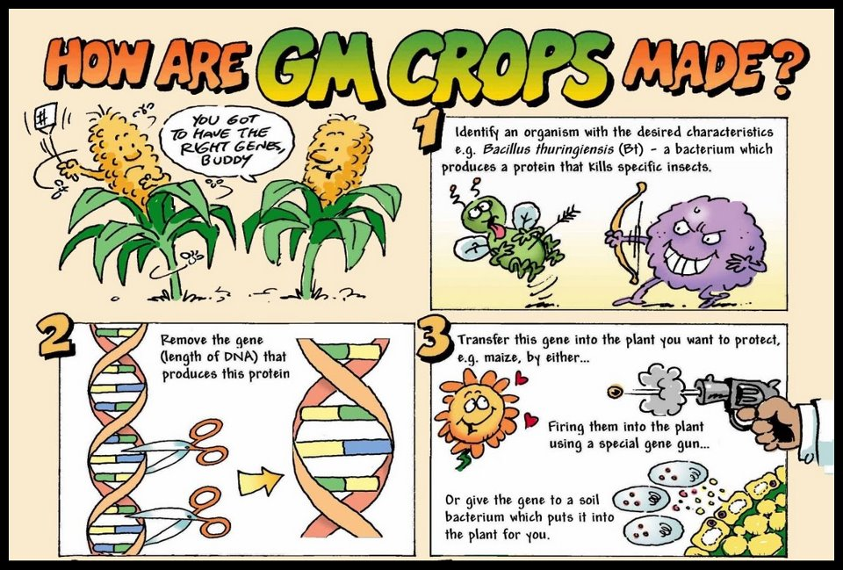
* **Benefits of genetic modification**

**e.g. The Advantages of Genetically Modified Crops**

* **Better for the environment**  
  Since GMOs require much less chemicals to thrive, the impact on the environment is lessened. The pesticides and other chemicals commonly used on non GMO crops emit greenhouse gases and pollute the ground soil.
* **Resistance to disease**  
  One of the modifications made to the crops is an added resistance to disease that would normally kill off the crops. This keeps the yields high and the prices for the consumers low.
* **Sustainability**  
  GMOs provide a stable and efficient way to sustain enough crops to feed the ever growing population of people in the world. This was the main goal of GMO crops in the first place.
* **Increased flavour and nutrition**  
  Along with resistances to insects and disease, the genes of the crops can also be altered to have a better flavor and increased nutritional value. This is good all around.
* **Longer shelf life**  
  Genetically modified foods have a longer shelf life. This improves how long they last and stay fresh during transportation and storage.
* **Keeps it affordable**  
  One of the biggest effects that the use of GMOs has had on our everyday life is the prices of produce and other foods. Since more crops can be yielded, the prices can be much lower.
* **PATERNITY TESTING**

An analysis, usually of the **DNA** or **blood type** of a mother, child, and possible father, to estimate the probability that the man is the biological father of the child.

**Blood grouping**

* Genotypes of the mother and the suspected man's blood groups are compared with those of the child.
* If the genotypes for the blood groups of the man and the mother could not lead to the blood group of the child the man is not the father of the child.
* If the genotypes for the blood groups of the man and the mother could lead to the blood group of the child it cannot be said with certainty that the man is the father of the child because other males have the same blood group.

**DNA profiles**

* Every person except identical twins has her/his own unique DNA profile.
* It can be described as an arrangement of black bars representing DNA fragments of the person.
* It is used to:
* Identify paternity

|  |
| --- |
| **Activity 1.10**  **AIM**: to enable participants to describe and debate issues surrounding cloning and stem cell research  **Method**: Answer the following question:  Essay question:  Sometimes the paternity of a son or a daughter is disputed.  Describe sex determination in humans and explain how blood grouping and DNA profiling are used in paternity testing. |

|  |
| --- |
| https://encrypted-tbn3.gstatic.com/images?q=tbn:ANd9GcTmvb5W3o3iVwoibBV6dgGW1cSvmySKmDtq6S6HPelleSIjW6OVN1fL4lQ **Activity 1. 11**  **AIM: To enable participants to introduce the topic of genetics in a fun way to their learners.**  **Method: Participants create and decode a “DNA” recipe for man’s best friend to observe how variations in DNA lead to the inheritance of different traits. Strips of paper (representing DNA) are randomly selected and used to assemble a DNA molecule. Participants read the DNA recipe to create a drawing of their pet, and compare it with others in the group to not similarities and differences.**  **CREATING A DOG**  Follow the directions below to create a DNA recipe for a dog. Using the ***Dog Traits Key,*** read your DNA recipe and make a drawing of your dog showing all of its traits.  **Directions:**   1. Make sure you have an envelope containing “Dog DNA”. It should contain 8 coloured strips:   Each strip is a gene, and the symbols on the strip represents nitrogenous basis.     1. Leave the strips in the envelope. 2. Determine the first trait of your dog (body shape) by randomly picking a piece of dog DNA out of the envelope. 3. Look at the symbols on the DNA strip you have chosen. Match the pattern to one you see on the ***Dog Traits Key*** for body shape. 4. Circle the picture for body shape that matches the DNA piece that you picked. 5. Set the piece of DNA aside and repeat steps 3-5 for the next trait on the key. 6. After circling the matching picture, tape the second piece of DNA to the first to make one long strand. This will become the DNA recipe for your entire dog. 7. Repeat these steps for each of the traits listed on the ***Dog Traits Key***. 8. When you have finished, draw your dog with all of its traits (the traits you have circled on the ***Dog Traits Key***) on a separate piece of paper. 9. Hang up the picture of your dog along with its DNA recipe (the DNA pieces you chose attached in a long strand).   ***Is your dog different from or the same as the others in the group?*** |

**RESOURCE**

https://wordmint.com/public_puzzles/200551

<http://learn.genetics.utah.edu>

<https://bit.ly/2YbySBm>

Download the free SCOP genetics app on Android from Wits University:

<https://play.google.com/store/apps/details?id=scoping.genetics&hl=en>

**MODULE SUMMARY**

Life exists in a variety of life forms and it is in the study of DNA, genetics and inherited characteristics that life at molecular level intersects with Strand 4: Diversity, Change and Continuity in the CAPS curriculum.

In order to understand species, speciation, biodiversity and change, it is **essential to understand how DNA and chromosomes enable continuity and** change. This module covers all the requirements for the DBE NSC exams w.r.t. the topic: Genetics and Heredity:

**REFERENCES**

* DBE Exam guidelines for learners
* GDE ATP
* 2015-2019 NSC past papers
* 2014-2019 national diagnostic report on learner performance
* Approved grade 12 national textbooks
* Internet
* Gauteng grade 12 Life Sciences Revision booklet