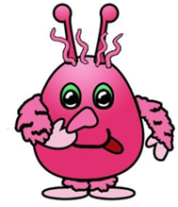**LIFE SCIENCES Grade 12**

|  |  |
| --- | --- |
| **Total** |  |
|  | **30** |

**Practical Task Term 2: Genetics and Heredity**

**Date:** ____________________________________

**Name: ___________________________________**

**Duration:** 1 hour

**SECTION A**

**QUESTION 1**

**INSTRUCTIONS TO LEARNERS – THIS IS AN INDIVIDUAL TASK.**

**THE TASK MUST BE DONE IN CLASS UNDER**

**CONTROLLED CONDITIONS.**

**Background**

Every family has observable characteristics, or traits, that are passed on from parents to their children. We can categorize these traits in two different ways: as genotype and phenotype. A person’s **genotype** is the set of genes that he/she carries (what their DNA ’says’). The **phenotype is** the observable characteristics (what we can see). Different versions of the same gene are called **alleles**. To keep things simple, we give the genotype a two-letter code. You will be given codes to use in this exercise.

Each letter of the two-letter code is an allele. Remember that you get two copies of each gene: one from mom and one from dad.

**Materials for each group**

• 2 alien ‘parents’

• Pen or pencil

• Scissors

• Beaker

• Glue or tape

• Crayons or pencil crayons

**Procedure**

1. Meet your partner at your station. Receive two pictures of “aliens” from the teacher. Assign one alien to be the “mom” and the other the “dad” to each one of you. You will be “crossing” these two aliens to create a beaker baby.

2. Based on phenotypes (what we see), figure out the genotypes (what the DNA really says) of your alien. Do this by circling the appropriate phenotype for each trait in **Table 1**. The corresponding genotype is listed. Write this code in the genotype column. *See the example here:*

**What we see Genotype**

**(case sensitive)**

**B. Hair Colour** Red = HH Pink = Hh White = hh **Hh**

**C. Hair Curl** Curly = MM Wavy = Mm Straight = mm **MM**

3. Write the corresponding alleles for each trait (one letter per box) in **Table 2.** Each letter represents an allele version of that gene. The information for the “mom” should go on one colour and the “dad” information on the other colour. *See the example here:*

**Trait**

**Genotype**

**Allele 1 Allele 2**

**B. Hair colour H h**

**C. Hair Curl M M**

4. From **Table 2** cut out each allele and place all of the alleles for the “mom” and for the “dad” into the beaker.

5. **Shake the beaker to mix all of the versions!** Randomly draw out different colours for each trait from the beaker so that you create complete genotypes for each trait. Remember: Each trait needs a version of the gene from “mom” and a version of the gene from “dad”.

6. As you draw out versions, write them in the “what the DNA says” columns

in **Table 3 (*Child’s Genetic Make-Up)***.

7. Go back to the **Table 1** and determine the traits of the offspring and put the

information in the “what we see” column of **Table 3**.

8. Draw a **detailed picture** of your offspring with the appropriate traits based on their genotype. Clearly label all 8 traits of your offspring.

**Table 1 - Traits and Genotypes of your “Alien”**

Is it “mom” or “dad”? __________

Circle what you see and write the genotype for your alien in the last box.

**Trait**

**What you See Phenotypes**

**Genotype**

(case sensitive)

**B. Body colour** Orange = BB Pink = Bb Blue = bb

**H. Hair colour** Red = HH Pink = Hh White = hh

**M. Hair curl** Curly = MM Wavy = Mm Straight = mm

**A. Antenna** 2 = AA 1 = Aa None = aa

**E. Eye colour** Brown = EE Green = Ee Blue = ee

**N. Nose** Trunk = NN Parrot = Nn Button = nn

**L. Hairy arms and**

**feet** Very hairy = LL Some hair = Ll No hair = ll

**R. Tongue roll** Roller = RR (Rr = Roller) Non-Roller = rr

***\*note:*** *If your alien is a tongue roller, you chose whether their genoype is RR or Rr.*

Transfer the information to **Table 2** for cutting

**Table 2 - Personal traits – Versions of the gene separated for your “alien”**

Write the corresponding alleles for each trait in (one letter per box) below**.** Each letter represents an allele version of that gene. The information for the girl should go on one colour and the boy information on the other colour.

**Trait What the DNA says**

**Allele 1 Alelle 2**

**B. Body colour**

**H. Hair colour**

**M. Hair curl**

**A. Antenna**

**E. Eye colour**

**N. Nose**

**L. Hairy arms and feet**

**R. Tongue roll**

\****When you finish filling out the table, cut along the dashed lines***

**Table 3 - The Child’s Genetic Make-Up**

Shake the beaker to mix all of the versions! Randomly draw out different colours for each trait from the beaker so that you create complete genotypes for each trait. Remember: Each trait needs a version of the gene from “mom” and a version of the gene from “dad”. As you draw out versions, write them in the “what the DNA says” columns.

**Trait**

**What the DNA says**

***allele from “mom” alien allele from “dad” alien***

**What we see**

**B. Body colour**

**H. Hair colour**

**M. Hair curl**

**A. Antenna**

**E. Eye colour**

**N. Nose**

**L. Hairy arms and feet**

**R. Tongue roll**

Go back to **Table 1** and determine the traits of the offspring and put the information in the “what we see” column.

**QUESTION 1**

Draw and colour a **detailed picture** of your offspring with the appropriate traits based on his or her genotype. Clearly label all 8 traits of your offspring.

|  |  |  |  |  |  |  |  |
| --- | --- | --- | --- | --- | --- | --- | --- |
| **Genotype** | | | | | | | |
| Body colour | Hair colour | Hair curl | Antenna | Eye colour | Nose | Hairy arms and feet | Tongue roll |
|  |  |  |  |  |  |  |  |
| (8) | | | | | | | |
| **QUESTION 2** | | | | | | | |
|  | | | | | | | |
| If you were to repeat this activity, would the offspring be exactly alike? Explain your answer. | | | | | | | |
| (2) | | | | | | | |
| **(10)** | | | | | | | |

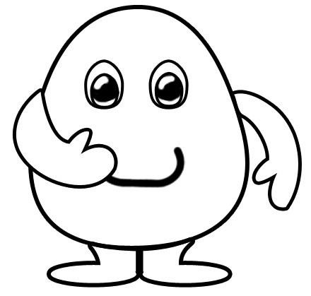

**SECTION B**

**QUESTION 3**

|  |
| --- |
| In cats the gene for coat colour is sex-linked. **Calico cats** are domestic [cats](https://en.wikipedia.org/wiki/Cat) with a spotted or particoloured coat that is predominantly white, with patches of two other colours (often, the two other colours are orange and black). The genotype XB XB is black, Xb Xb is orange and XBXb is tortoiseshell. The cat shown in the picture below is a typically ‘calico cat’. |

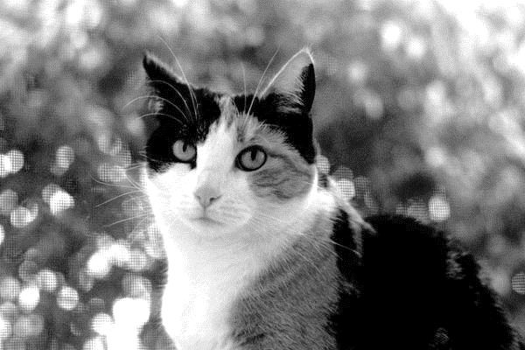

[*https://encrypted-tbn0.gstatic.com/images?q=tbn:ANd9GcQcxTIghYJmjhM0M2OT93R_4cmbg-*

*zrcmhLXg0xBc5u6ptrJVgz*]

* 1. A tortoiseshell female is mated with a black male. In a genetic diagram,

work out the genotype and phenotype of the offspring of these two parents. (6)

* 1. What percentage of each type of offspring can be expected? (1)
  2. Would one expect to find any tortoiseshell males? Explain. (3)

# (10)

**QUESTION 4**

A learner investigated the frequency of certain dominant and recessive

characteristics in his class.

## His hypothesis was:

**There will be more learners with dominant characteristics than learners with recessive ones.**

He used 10 boys and 10 girls to investigate the following characteristics. He collected

the data over a two week period.

|  |  |  |
| --- | --- | --- |
| **Characteristic** | **Dominant** | **Recessive** |
| Tongue rolling | roller | non roller |
| Number of fingers | five fingers | six fingers |
| Hair | curly hair | straight hair |
| Earlobe attachment | free earlobe | attached earlobe |

The results of the investigation are shown in the table below:

|  |  |  |  |  |  |  |  |
| --- | --- | --- | --- | --- | --- | --- | --- |
| **Tongue rolling** | | **Number of fingers** | | **Hair** | | **Earlobe attachment** | |
| Roller | Non roller | 6 Fingers | 5  Fingers | Curly | Straight | Free earlobe | Attached earlobe |
|  |  |  |  |  |  |  |  |
|  |  |  |  |  |  |  |  |
|  |  |  |  |  |  |  |  |
|  |  |  |  |  |  |  |  |
|  |  |  |  |  |  |  |  |
|  |  |  |  |  |  |  |  |
|  |  |  |  |  |  |  |  |
|  |  |  |  |  |  |  |  |
|  |  |  |  |  |  |  |  |

4.1 Process the results of the investigation and tabulate the findings neatly. (5)

4.2 Which TWO processes occur during meiosis to make it possible for a child to

inherit different genes from his/her parents? (2)

4.3 Which characteristic shows the largest difference between dominant and

recessive alleles? (1)

4.4 Explain if this learner’s hypothesis can be accepted or rejected? (2)

**(10)**

**[30]**

