**Responding to the environment**

**The nervous system**

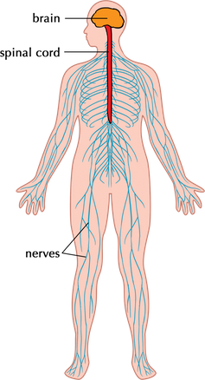

1. **Terminology & definitions:**

|  |  |
| --- | --- |
| **Biological term** | **Description** |
| Afferent neuron | Neuron that carries impulses to the CNS |
| Alzheimer’s Disease | Progressive mental deterioration that can occur in middle or old age, due to generalized degeneration of the brain |
| Autonomic nervous system | The part of the peripheral nervous system that controls involuntary actions |
| Axon | The long threadlike part of a nerve cell along which impulses are conducted from the cell body to other cells |
| Central nervous system | The part of the nervous system that consist of the brain and spinal cord |
| Cerebrospinal fluid | A watery fluid, continuously produced and absorbed, which flows in the ventricles (cavities) within the brain and around the surface of the brain and spinal cord |
| Dementia | A general term used for memory loss and loss of other intellectual abilities |
| Dendrite | A part of the neuron that conducts impulses towards the cell body |
| Efferent neuron | Neuron that carries impulses to the CNS |
| Effectors | Are muscles or gland that respond to the message from the nervous system (brain and spinal cord) |
| Medulla oblongata | The part of the brain that controls the heart rate |
| Meninges | A collective name for the membranes that protect the brain |
| Multiple sclerosis | A disorder of the nervous system that is characterised by the breakdown of the myelin sheath of neurons |
| Myelin sheath | A fatty layer wrapped around them, which acts as insulation |
| Nerve | Bundle of neurons |
| Neuron | One nerve cell |
| Neurotransmitter | Chemical that is released from a nerve cell which thereby transmits an impulse from a nerve cell to another nerve, muscle, organ, or other tissue |
| Peripheral nervous system | The part of the nervous system made up of cranial and spinal nerves |
| Receptors | Structures located in the sense organs. They convert a stimulus into an impulse |
| Stem cells/meristematic cells | Undifferentiated cells that can develop into any cell type |
| Stimulus | A detectable change (e.g. pain, heat, light, sound) that will be received by a receptor and converted into an impulse |
| Synapse | 1. A junction between two nerve cells, consisting of a minute gap across which impulses pass by diffusion of a neurotransmitter |

1. **Nervous co-ordination**

* To survive, all organisms need to be able to sense changes in their environment and to control their responses to these changes.
* The nervous system and the endocrine system are important communication systems that co-ordinate, intergrade and carry out the activity of body cells, tissues, organs and the organism.
* They maintain a constant internal balance, while reacting to the changes that occur in both the external and internal environment.

1. **Reaction to stimuli in the environment**

* The nervous system and sense organs play an important part in picking up stimuli, gathering information and responding quickly to changes from both the external and internal environment to maintain a constant state.
* The nervous system in vertebrates performs five main functions
  1. Gathers information using the senses
  2. Transmits information to processing areas of the brain
  3. Processes information
  4. Formulates responses to stimuli
  5. Sends information back through the network of effector organs to execute the response

1. **Structure of the nervous system**

**NERVOUS SYSTEM**

**ANS**

**PNS**

**CNS**

**CENTAL NERVOUS SYSTEM**

* Brain
* Spinal cord
* Consists of multipolar neurons
* Aka connector /interneurons

**PERIPHERAL NERVOUS SYSTEM**

* cranial nerves
* Spinal nerves
* Unipolar& bipolar neurons
* Aka sensory & motor neurons

**AUTONOMIC NERVOUS SYSTEM**

* Nerves that branch off the CNS
* E.g. Vagus nerve

**5. The Central Nervous System**

* The brain and the spinal cord together form central nervous system (CNS)
* The whole CNS is surrounded by a system of membranes called the meninges, that protect it.
* The brain is housed in the cranium and the spinal cord in the vertebral column

**6. Structure and function of the parts of the brain**

* The brain consists of three main external parts
  + The large cerebrum
  + The smaller spherical cerebellum
  + The brainstem which has the medulla oblongata and the pons
* The cerebrum and cerebellum are divided into two hemispheres
* The two hemispheres of the cerebrum are joined by the corpus collosum

**Cerebrum**

• Controls voluntary

actions

• Receives and interprets

sensations from sense

organs

• Higher thought processes

**Medulla oblongata**

• Transmits nerve impulses between the spinal cord and the brain

• Controls involuntary actions such as heartbeat and breathing

**Corpus callosum**

* Connects the left and

right hemispheres of

the brain – allowing

communication between

both hemispheres

**Hypothalamus**

* Control centre for hunger,

thirst, sleep, body

temperature and emotions

**Structure of the brain and the functions** **of the different parts**

**Cerebellum**

• Coordinates all voluntary movements

• Controls muscle

tension to maintain

balance

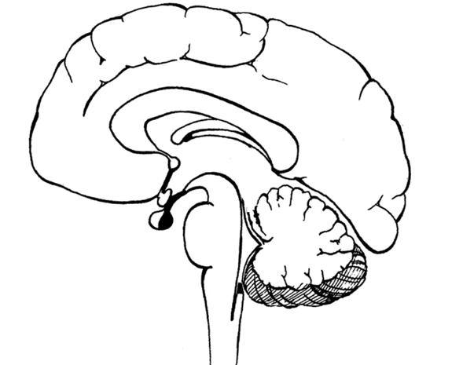

**7. The spinal cord**

* The spinal cord is inside the vertebral canal and is an extension of the brain Protection: vertebrae, meninges and cerebrospinal fluid.
* From each side of the cord 31 pairs of spinal nerves arise from ventral and dorsal roots.
* Function:
  + The spinal cord is the pathway for all impulses conducted to and from the brain.
  + The grey matter lies on the inside in the shape of an ‘H’
  + The white matter lies on the outside (opposite to the cerebrum).
  + The spinal cord processes all reflex actions.
  + The spinal cord functions automatically and is not controlled by the will.
  + Sympathetic and parasympathetic nerve impulses are conducted along the spinal cord to all organs.

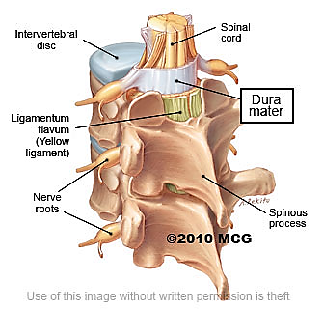

**8. Peripheral nervous system**

* The peripheral nervous system (PNS) is all the nervous tissue outside the central nervous system (CNS).
* It is divided into the somatic nervous system and autonomic nervous system and is made of 43 pairs of nerves:
  + 12 pairs of cranial nerves
  + 31 pairs of spinal nerves
* Function: the somatic nervous system received information from receptors and conveys the information to the CNS.
* It also transmits the impulses from the CNS to effector organs

**9. Autonomic nervous system**

* The autonomic nervous system (ANS) controls the heart rate, breathing, digestion and gland functions e.g. salivary glands secreting saliva
* The autonomic nervous system HAS two branches.
* The sympathetic branch prepares the body for energy-expending, stressful, or emergency situations.
* The parasympathetic branch is active under ordinary, restful conditions
* The two systems have an opposite effect: one stimulates, the other inhibits i.e. each organ in the body is innervated by the sympathetic nerve and parasympathetic nerve.
* This is known as double innervation
* E.g. the sympathetic nerve causes the iris to dilate and the parasympathetic nerve causes the iris to constrict

|  |  |
| --- | --- |
| **Sympathetic branch** | **Parasympathetic branch** |
| 1. Increases heart rate | 1. Decreases heart rate |
| 1. Relaxes walls of the bladder | 2. Contracts wall of the bladder |
| 1. Dilates pupils | 3. Constricts pupils |
| 1. Constricts many arteries | 4. Dilates arteries |
| 1. Increases blood pressure | 5. Decreases blood pressure |

**10. Neurons – nerve cells**

* Neurons are specialized cells which connect the **brain and spinal cord** to all other parts of the body.
* Each neuron has the following parts:

1. Cell body

2. Dendrites

3. Axon

* The **dendrites always carry the impulse to** the cell body and the **axon always carries the impulse away** from the cell body
* **Axons** and **dendrites** may be **myelinated** i.e. they have a fatty layer wrapped around them, which acts as insulation
* **Bundles of neurons** form **nerves**

**11. Types of neurons**

* Sensory neurons
  + afferent neurons
  + carry impulses to CNS
  + either unipolar or bipolar
  + sensitive to stimuli in the environment
* Connector/inter neurons
  + receive impulse from sense organs
  + always multipolar
  + integrates or analyses information
  + effects a response
* Motor neurons
  + efferent neurons
  + carry impulses away from CNS
  + always multipolar
  + effect a response

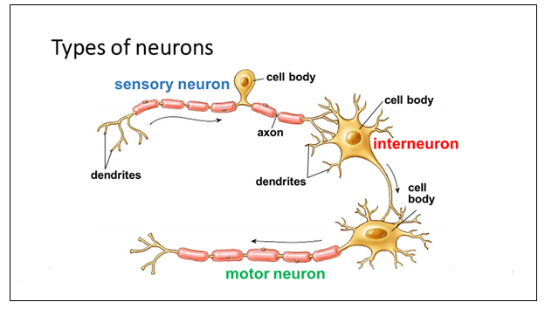

**12. A reflex arc**

* The simplest form of nervous activity is the reflex action, which are actions you do without thinking.
* The nerve pathway taken in a reflex action is called a **reflex arc.**
* The nervous message goes to the spinal cord, and then a message passes from the spinal cord directly to an effector to give an immediate response.

**13. Significance of a reflex arc**

* A reflex action is involuntary or automatic.
* Simple reflexes are inborn safety mechanisms to protect the body by producing immediate responses to the changes in the external and internal environments.

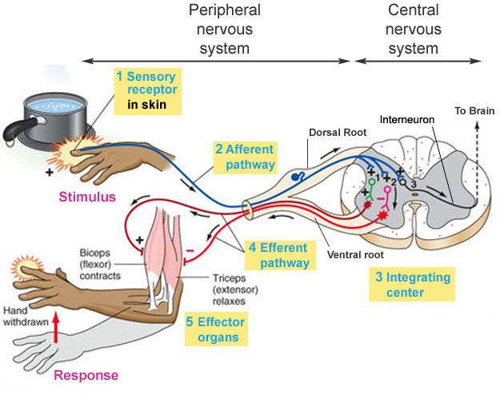

**14. A synapse**

* A synapse is the point where an impulse passes from the terminal branch of the axon one neuron to the dendrite of the next neuron.
* The neurons NEVER touch each other.
* The gap between the two neurons is called the synaptic gap.
* Chemical neurotransmitters such as acetylcholine/dopamine/serotonin help to transmit the impulse from one neuron to the next across the synaptic gap.

**15. Significance of a synapse**

* Ensures that the impulse travels in one direction.
* At the synapse a nerve impulse can either be speeded up slowed down or blocked.
* Therefore, it enables unnecessary or unimportant background stimuli be filtered out.
* Channels impulses so that reactions are integrated and become part of learning and memory.

**16. Diseases of the Nervous system**

**Alzheimer’s Disease**

* Alzheimer’s disease (AD) is the most common form of dementia
* Usually affecting people over 65, although some people may develop early-onset AD.
* Characterized by a loss of neurons and synapses in the cortex of the brain, as well as the presence of clumps of proteins (amyloid plaques) and tangled bundles of fibers
* There is no cure for the disease, which is progressive and eventually leads to death
* **Cause:** unknown
* **Symptoms:** the loss of brain function results in
  + slower thinking
  + behaviour changes
  + confusion about events, time and place
  + Difficulty recognizing people the know
  + Difficulty speaking, swallowing and walking
* **Cure:** none
* **Treatment**:
  + Researchers are trying to find better ways to treat the disease, delay its onset and prevent it from developing
  + Stem-cell research and therapeutic cloning hold great potential for providing a cure for Alzheimer’s disease

**Multiple sclerosis**

* Multiple sclerosis (MS)is a progressive, degenerative disorder of the central nervous system (CNS), including the brain, optic nerve and spinal cord.
* MS commonly occurs between the ages of 20 – 40 and affects more women than men.
* Multiple sclerosis means ‘many scars’, resulting in damage to the axon-coating myelin sheath of nerve cells in communication pathways.
* Scattered patches of demyelination in the pathways make it impossible for messages to move these hard areas.
* **Cause:** auto-immune disease
* **Symptoms:** MS affects:
  + Movement, feeling and co-ordination and balance
  + Vision, tingling and numbness, muscle weakness and spasms,
  + Fatigue
  + Bladder and bowel problems
  + Pain
  + Concentration and memory loss
  + Mood swings
* **Cure:** none
* **Management strategies:** 
  + Healthy lifestyle
* Stem-cell research and biologically engineered production of interferons slow down the progress of the disease