

**SENIOR CERTIFICATE EXAMINATIONS**

|  |
| --- |
| LIFE SCIENCES P1 **2017** |

**MARKS: 150**

**TIME: 2½ hours**

**This question paper consists of 16 pages.**

# INSTRUCTIONS AND INFORMATION

|  |  |  |
| --- | --- | --- |
| Read the following instructions carefully before answering the questions. |  |  |

|  |  |  |  |
| --- | --- | --- | --- |
| 1.  2.  3.  4.  5.  6.  7.  8.  9.  10.  11. | Answer ALL the questions.  Write ALL the answers in the ANSWER BOOK.  Start the answers to EACH question at the top of a NEW page.  Number the answers correctly according to the numbering system used in this question paper.  Present your answers according to the instructions of each question.  Do ALL drawings in pencil and label them in blue or black ink.  Draw diagrams, tables or flow charts only when asked to do so.  The diagrams in this question paper are NOT necessarily drawn to scale.  Do NOT use graph paper.  You must use a non-programmable calculator, protractor and a compass, where necessary.  Write neatly and legibly. |  |  |

**SECTION A**

**QUESTION 1**

|  |  |  |  |
| --- | --- | --- | --- |
| 1.1 | Various options are provided as possible answers to the following questions. Write down the question number (1.1.1–1.1.10), choose the answer and make a cross (X) over the letter (A–D) of your choice in the ANSWER BOOK. |  |  |

|  |  |  |  |  |  |  |  |  |  |  |  |
| --- | --- | --- | --- | --- | --- | --- | --- | --- | --- | --- | --- |
|  | **EXAMPLE:**   |  |  |  |  |  |  |  |  | | --- | --- | --- | --- | --- | --- | --- | --- | | ***1.1.11*** | **A** |  | **B** |  | **C** |  | **D** | |  |  |

|  |  |  |  |  |
| --- | --- | --- | --- | --- |
|  | 1.1.1 | Monoculture refers to farming with … |  |  |

|  |  |  |  |  |  |
| --- | --- | --- | --- | --- | --- |
|  |  | A  B  C  D | different crops every year.  one type of irrigation.  only one type of crop.  plants and livestock on the same farm. |  |  |

|  |  |  |  |  |
| --- | --- | --- | --- | --- |
|  | 1.1.2 | The part of a sperm cell that contains enzymes to digest the membrane of the ovum is the … |  |  |

|  |  |  |  |  |  |
| --- | --- | --- | --- | --- | --- |
|  |  | A  B  C  D | tail.  mid-piece.  nucleus.  acrosome. |  |  |

|  |  |  |  |  |
| --- | --- | --- | --- | --- |
|  | 1.1.3 | Where are sperm cells in humans temporarily stored? |  |  |

|  |  |  |  |  |  |
| --- | --- | --- | --- | --- | --- |
|  |  | A  B  C  D | Vas deferens  Epididymis  Urinary bladder  Prostate gland |  |  |

|  |  |  |  |  |
| --- | --- | --- | --- | --- |
|  | 1.1.4 | Poaching refers to the … |  |  |

|  |  |  |  |  |  |
| --- | --- | --- | --- | --- | --- |
|  |  | A  B  C  D | relocation of organisms to a new habitat when the old habitat is destroyed by fire.  intentional introduction of alien plants.  use of chemicals to kill pests.  illegal removal of organisms from their habitat. |  |  |

|  |  |  |  |  |
| --- | --- | --- | --- | --- |
|  | 1.1.5 | The hormone that prepares the human body for an emergency situation is … |  |  |

|  |  |  |  |  |  |
| --- | --- | --- | --- | --- | --- |
|  |  | A  B  C  D | ADH.  thyroxin.  adrenalin.  GH. |  |  |

|  |  |  |  |  |
| --- | --- | --- | --- | --- |
|  | 1.1.6 | A function of amniotic fluid is to … |  |  |

|  |  |  |  |  |  |
| --- | --- | --- | --- | --- | --- |
|  |  | A  B  C  D | serve as a micro-filter preventing germs from entering the foetus.  act as a shock absorber to protect the foetus.  keep the foetus at a temperature lower than body temperature.  serve as a medium for the sperm to swim in. |  |  |

|  |  |  |  |  |
| --- | --- | --- | --- | --- |
|  | 1.1.7 | The part of the male reproductive system where meiosis takes place is the ... |  |  |

|  |  |  |  |  |  |
| --- | --- | --- | --- | --- | --- |
|  |  | A  B  C  D | seminiferous tubules.  seminal vesicles.  urethra.  epididymis. |  |  |

|  |  |  |  |  |
| --- | --- | --- | --- | --- |
|  | 1.1.8 | A scientist wants to investigate the influence of nitrogen-containing fertilisers on the pH of soil.  To make her investigation more reliable she should … |  |  |

|  |  |  |  |  |  |
| --- | --- | --- | --- | --- | --- |
|  |  | A  B  C  D | use potassium-containing fertilisers on many soil samples.  use nitrogen-containing fertilisers on many soil samples.  test the effect of nitrogen-containing fertilisers on clay soils only.  use different amounts of soil and potassium-containing fertilisers in each sample. |  |  |

|  |  |  |  |  |
| --- | --- | --- | --- | --- |
|  | 1.1.9 | A municipality is planning the development of a new landfill site for a town. Some of the factors that need to be taken into consideration when developing this landfill site are:   1. The site should be lined with an impermeable layer. 2. The site should be located far from water systems. 3. The site should be covered with soil daily. 4. All endangered species must be removed and relocated.   Which ONE of the following combinations is aimed at protecting the environment from pollution? |  |  |

|  |  |  |  |  |  |
| --- | --- | --- | --- | --- | --- |
|  |  | A  B  C  D | (i), (ii), (iii) and (iv)  (i), (ii) and (iii) only  (i), (ii) and (iv) only  (i) and (ii) only |  |  |

|  |  |  |  |  |
| --- | --- | --- | --- | --- |
|  | 1.1.10 | A cancerous tumour in the pituitary gland/hypophysis causes an  undersecretion of TSH in a patient. One of the possible effects of this on the patient is that his weight … |  |  |

|  |  |  |  |  |  |
| --- | --- | --- | --- | --- | --- |
|  |  | A  B  C  D | decreases because his metabolic rate increases.  remains the same because his metabolic rate is not affected.  decreases because his metabolic rate decreases.  increases because his metabolic rate decreases. (10 x 2) |  | **(20)** |

|  |  |  |  |
| --- | --- | --- | --- |
| 1.2 | Give the correct **biological term** for each of the following descriptions.  Write only the term next to the question number (1.2.1 to 1.2.9) in the ANSWER BOOK. |  |  |

|  |  |  |  |  |
| --- | --- | --- | --- | --- |
|  | 1.2.1  1.2.2  1.2.3  1.2.4  1.2.5  1.2.6  1.2.7  1.2.8  1.2.9 | The variety of plant and animal species on earth  Measurement of the total amount of carbon dioxide emissions of an individual per year  The type of pollution caused when water is released into a river or the sea after being heated in power stations or industries  The accumulation of nutrients in ponds from the over-use of fertilisers on land, stimulating excessive growth of algae  A hormone that stimulates the maturation of sperm and puberty in males  The tube in the male reproductive system that connects the epididymis with the urethra  The hormone which regulates the salt balance in humans  The hormone that stimulates the mammary glands to secrete milk  The division of the cytoplasm through the constriction of the cell membrane at the end of cell division (9 x 1) |  | **(9)** |

|  |  |  |  |
| --- | --- | --- | --- |
| 1.3 | Indicate whether each of the descriptions in COLUMN I applies to **A ONLY**,  **B ONLY**, **BOTH A AND B** or **NONE** of the items in COLUMN II. Write **A only**, **B only**, **both A and B** or **none** next to the question number (1.3.1 to 1.3.3) in the ANSWER BOOK. |  |  |

|  |  |  |  |  |  |
| --- | --- | --- | --- | --- | --- |
| **COLUMN I** | | **COLUMN II** | |  |  |
| 1.3.1 | Plant hormone that stimulates the germination of seeds | A:  B: | Gibberellins  Abscisic acid |  |  |
| 1.3.2 | Hormones secreted by the pituitary gland/hypophysis | A:  B: | Thyroxin  FSH |  |  |
| 1.3.3 | Secretions from this gland contribute to the formation of semen | A:  B: | Cowper's gland  Prostate gland |  |  |
|  |  |  | (3 x 2) |  | **(6)** |

|  |  |  |  |
| --- | --- | --- | --- |
| 1.4 | The diagram below represents a reflex arc. |  |  |

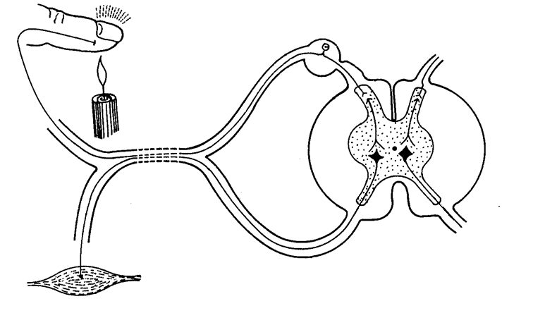

**A**

**B**

**C**

**D**

**E**

**F**

|  |  |  |  |  |
| --- | --- | --- | --- | --- |
|  | 1.4.1 | Give the LETTER and NAME of the part that: |  |  |

|  |  |  |  |  |  |
| --- | --- | --- | --- | --- | --- |
|  |  | (a)  (b)  (c) | Controls one-directional transmission of impulses  Transmits impulses from the sensory neuron to the correct motor neuron  Transmits impulses to the cell body |  | (2)  (2)  (2) |

|  |  |  |  |  |
| --- | --- | --- | --- | --- |
|  | 1.4.2 | Give only the LETTER of the: |  |  |

|  |  |  |  |  |  |
| --- | --- | --- | --- | --- | --- |
|  |  | (a)  (b) | Neuron that is damaged when a person is able to feel pain, but cannot react to the stimulus  Effector |  | (1)  (1)  **(8)** |

|  |  |  |  |
| --- | --- | --- | --- |
| 1.5 | Study the diagram below of the sequence of events that takes place from the fertilisation of the ovum to the development of the embryo in a part of the human female reproductive system.  The arrows indicate the direction of development of one ovum after fertilisation. |  |  |

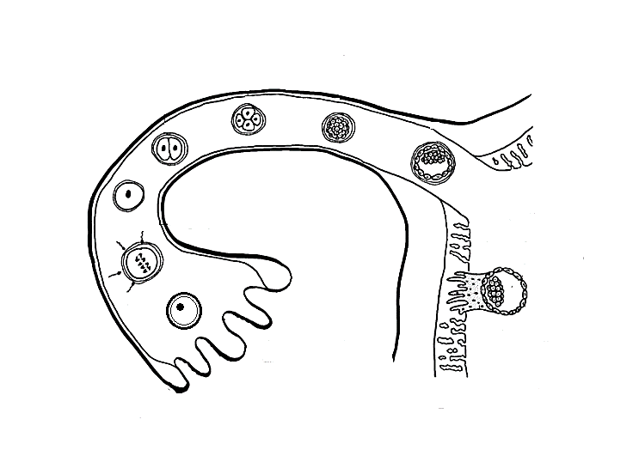

**B**

**A**

**E**

**F**

**G**

**H**

**C**

**D**

|  |  |  |  |  |
| --- | --- | --- | --- | --- |
|  | 1.5.1 | Identify: |  |  |

|  |  |  |  |  |  |
| --- | --- | --- | --- | --- | --- |
|  |  | (a)  (b)  (c) | Structure **C**  The stage of embryo development at **E**  The structure that develops from a combination of parts **F** and **H** |  | (1)  (1)  (1) |

|  |  |  |  |  |
| --- | --- | --- | --- | --- |
|  | 1.5.2 | Name the process that takes place: |  |  |

|  |  |  |  |  |  |
| --- | --- | --- | --- | --- | --- |
|  |  | (a)  (b) | At **B**  When **G** attaches to part **F** |  | (1)  (1) |
|  | 1.5.3 | Give the chromosome number of: | |  |  |

|  |  |  |  |  |  |
| --- | --- | --- | --- | --- | --- |
|  |  | (a)  (b) | The cells at **D**  Cell **A** |  | (1)  (1)  **(7)** |

|  |  |  |  |  |
| --- | --- | --- | --- | --- |
|  |  | **TOTAL SECTION A:** |  | **50** |

|  |  |  |
| --- | --- | --- |
| **SECTION B** QUESTION 2 |  |  |

|  |  |  |  |
| --- | --- | --- | --- |
| 2.1 | Study the diagram of one-day-old hatchlings **A** and **B** below. The diagram is not drawn to scale. |  |  |

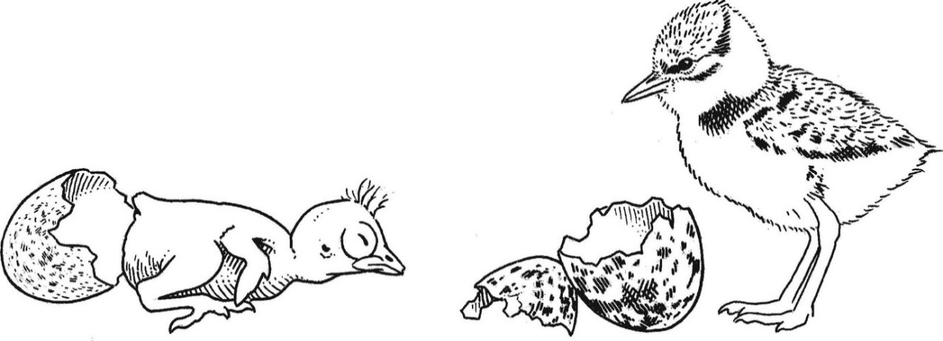

**A**

**B**

Egg shell

Egg shell

|  |  |  |  |  |
| --- | --- | --- | --- | --- |
|  | 2.1.1 | State TWO visible features in hatchling **A** which indicate altricial development. |  | (2) |

|  |  |  |  |  |
| --- | --- | --- | --- | --- |
|  | 2.1.2  2.1.3 | The diagram represents ovipary.  Explain ONE possible advantage of vivipary when compared to ovipary.  Explain why you would expect that the yolk content of the egg of hatchling **B** was more than that of hatchling **A**. |  | (2)  (2)  **(6)** |

|  |  |  |  |
| --- | --- | --- | --- |
| 2.2 | During a national census done in 2010 in a certain country, information was gathered on the number of people in the population who suffer from different eye diseases/disorders. The total population of this country was 142 million.  The results are shown in the table below. |  |  |

|  |  |
| --- | --- |
| **TYPE OF EYE DISEASE/DISORDER** | **NUMBER OF PEOPLE**  **(millions)** |
| Macular degeneration (retina cells die) | 2,1 |
| Glaucoma (increased pressure in the eyeball) | 2,7 |
| Diabetic retinopathy (decreased blood flow to the retina) | 7,6 |
| Cataracts | 24,4 |
| Short-sightedness | 34,1 |
| Long-sightedness | 14,1 |

|  |  |  |  |  |
| --- | --- | --- | --- | --- |
|  | 2.2.1  2.2.2  2.2.3  2.2.4 | Which eye disease/disorder is the least common in the population?  What percentage of the population is suffering from  long-sightedness? Show ALL your working.  Draw a bar graph to represent the number of people in the population that suffer from cataracts, short-sightedness and  long-sightedness.  Which eye disease/disorder in the table is: |  | (1)  (3)  (6) |

|  |  |  |  |  |  |
| --- | --- | --- | --- | --- | --- |
|  |  | (a)  (b) | The result of the lens becoming cloudy or opaque  Found in people that are able to see nearby objects clearly, while distant objects are blurred |  | (1)  (1)  **(12)** |

|  |  |  |  |
| --- | --- | --- | --- |
| 2.3 | Read the passage and study the graph. |  |  |

|  |  |  |  |
| --- | --- | --- | --- |
|  | Accumulation of greenhouse gases in the atmosphere changes the climate. Melting glaciers, rising sea levels and new and more frequent weather extremes will change the entire world. Water supplies are decreasing, crop yields are dropping, forests are burning and our oceans are becoming more acidic.  Climate change scientists warn that if we do not reduce our greenhouse gas emissions, average global temperatures could increase by 4 oC or more by the year 2100, with frightening implications.  2006 2008 2010 2012 2014 2016  **CO2 (parts per million)**  405  400  395  390  385  380  375  **Changes in CO2 levels in the atmosphere from 2006 to 2017**  **Year** |  |  |

|  |  |  |  |  |  |
| --- | --- | --- | --- | --- | --- |
|  | 2.3.1 | Write ONE phrase from the passage that indicates that climate change affects the following: | |  |  |
|  |  |  | |  |  |
|  |  | (a)  (b) | Food security  Water availability |  | (1)  (1) |

|  |  |  |  |  |
| --- | --- | --- | --- | --- |
|  | 2.3.2  2.3.3 | From the graph, state the CO2 level in the atmosphere in 2013.  Describe how the destruction of forests by humans contributes to global warming. |  | (2)  (3)  **(7)** |

|  |  |  |  |
| --- | --- | --- | --- |
| 2.4 | *Eichornia sp.* (commonly called the water hyacinth) is an invasive alien species that reduces the water quality in many of South Africa's rivers, dams and lakes. It is a fast-growing floating plant. It can invade, cover and take over the entire surface of a lake or dam in a few months.  Explain THREE ways in which aquatic alien plants, like the water hyacinth, could upset the balance in ecosystems. |  | **(6)** |

|  |  |  |  |
| --- | --- | --- | --- |
| 2.5 | Study the diagram of a phase during meiosis below. |  |  |

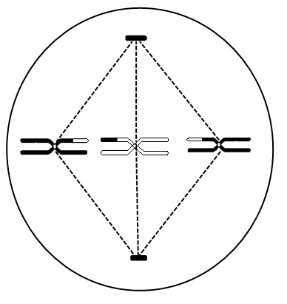

**A**

|  |  |  |  |  |
| --- | --- | --- | --- | --- |
|  | 2.5.1  2.5.2  2.5.3  2.5.4  2.5.5 | Identify part **A**.  Identify the phase represented in the diagram.  Explain your answer to QUESTION 2.5.2.  Explain how the phase identified in QUESTION 2.5.2 contributes to variation in the gametes.  How many chromosomes: |  | (1)  (1)  (2)  (2) |

|  |  |  |  |  |  |
| --- | --- | --- | --- | --- | --- |
|  |  | (a)  (b) | Were present in the original cell at interphase  Will be present in each gamete that forms at the end of meiosis |  | (1)  (1) |

|  |  |  |  |  |
| --- | --- | --- | --- | --- |
|  | 2.5.6 | Which process resulted in the two chromatids in each chromosome being different from each other? |  | (1)  **(9)**  **[40]** |

|  |  |  |  |
| --- | --- | --- | --- |
| **QUESTION 3** | |  |  |
|  | |  |  |
| 3.1 | A scientific investigation was conducted with 20 cyclists to determine whether caffeine can increase stamina.  The procedure was as follows:   * The group of cyclists was given the first cup of coffee, containing no caffeine, to drink. * The group then had to cycle for as long as possible at the same speed. * They cycled around a 400 m track on level ground. * The group was given a second cup of coffee, containing caffeine, to drink before cycling for the second time.   The table below shows the average time the group of cyclists was able to pedal after drinking decaffeinated coffee (coffee without caffeine) and drinking coffee with caffeine. |  |  |

|  |  |
| --- | --- |
| **TYPE OF COFFEE** | **AVERAGE DURATION OF CYCLING (minutes)** |
| Decaffeinated coffee (250 mℓ with no caffeine) | 82 |
| Coffee with caffeine (250 mℓ with caffeine) | 123 |

|  |  |  |  |  |  |
| --- | --- | --- | --- | --- | --- |
|  | 3.1.1 | State the question that the scientists were trying to answer through this investigation. | |  | (2) |
|  | 3.1.2 | Identify the: | |  |  |
|  |  |  | |  |  |
|  |  | (a)  (b) | Independent variable  Dependent variable and how it was measured |  | (1)  (2) |

|  |  |  |  |  |
| --- | --- | --- | --- | --- |
|  | 3.1.3 | What is the relationship between caffeine consumption and the stamina of the cyclists? |  | (2) |

|  |  |  |  |  |
| --- | --- | --- | --- | --- |
|  | 3.1.4  3.1.5  3.1.6 | Explain the purpose of giving the cyclists decaffeinated coffee to drink during the investigation.  The cyclists were NOT told whether or not the coffee they drank contained caffeine.  Explain why the cyclists were NOT given this information.  The procedure does not indicate how much time passed between each cycling exercise.  Explain why this is an important factor to know. |  | (2)  (2)  (2)  **(13)** |

|  |  |  |  |
| --- | --- | --- | --- |
| 3.2 | Study the graph below. |  |  |

|  |  |  |  |  |  |
| --- | --- | --- | --- | --- | --- |
|  |  |  | |  |  |
|  | 3.2.1 | Identify: | |  |  |
|  |  |  | |  |  |
|  |  | (a)  (b) | Hormone **A**  Hormone **B** |  | (1)  (1) |

|  |  |  |  |  |
| --- | --- | --- | --- | --- |
|  | 3.2.2 | What effect does an increase in hormone **A** have on the endometrium? |  | (2) |

|  |  |  |  |  |
| --- | --- | --- | --- | --- |
|  | 3.2.3 | Ovulation is indicated on the graph. |  |  |

|  |  |  |  |  |  |
| --- | --- | --- | --- | --- | --- |
|  |  | (a)  (b)  (c) | Define *ovulation*.  On which day did ovulation take place?  Which hormone secreted by the pituitary gland stimulates ovulation? |  | (2)  (1)  (1) |

|  |  |  |  |  |
| --- | --- | --- | --- | --- |
|  | 3.2.4 | Explain why high levels of hormone **B** prevent the development of new follicles. |  | (2) |

|  |  |  |  |  |
| --- | --- | --- | --- | --- |
|  | 3.2.5 | Explain evidence in the graph that indicates that no fertilisation took place during the menstrual cycle shown above. |  | (3)  **(13)** |

|  |  |  |  |
| --- | --- | --- | --- |
| 3.3 | Diagram **A** shows an upright pot plant. Diagram **B** shows the same pot plant one week after falling over. The plant was exposed to uniform light from all directions before and after falling over. |  |  |

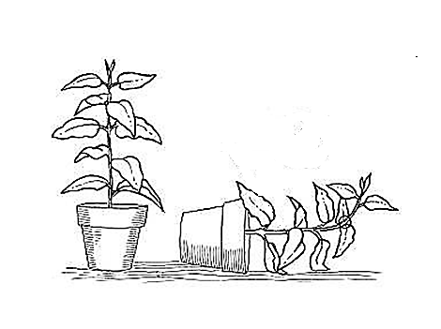

**Diagram A**

**Diagram B**



Ground

Ground

|  |  |  |  |  |
| --- | --- | --- | --- | --- |
|  | 3.3.1  3.3.2  3.3.3  3.3.4 | Which type of tropism is illustrated in diagram **B**?  Explain why the stem of the plant bent upwards, as illustrated in diagram **B**.  Explain the advantage that the upward bending of the stem could have for the plant.  State how the roots in diagram **B** would react. |  | (1)  (4)  (2)  (1)  **(8)** |

|  |  |  |  |
| --- | --- | --- | --- |
| 3.4 | The graph below shows the relationship between the levels of ADH in the blood and tubular reabsorption in the kidney. |  |  |

|  |  |  |  |  |
| --- | --- | --- | --- | --- |
|  | 3.4.1  3.4.2  3.4.3 | Which structure in the body produces ADH?  Describe the relationship shown in the graph.  Explain why the level of ADH at **X** probably indicates that the person is experiencing a cold day. |  | (1)  (2)  (3)  **(6)** |

|  |  |  |
| --- | --- | --- |
| **TOTAL SECTION B:** |  | **80** |

|  |  |  |
| --- | --- | --- |
| **SECTION C**  **QUESTION 4** |  |  |

|  |  |  |  |  |
| --- | --- | --- | --- | --- |
| A man was accidentally locked in a cool room in which the temperature was 8 oC.  He was only released after six hours when a co-worker heard his cries for help.  Describe how his body maintained his temperature at 37 oC and how his co-worker heard his cries for help.  Content:  Synthesis: | |  | | (17)  (3)  **(20)** |
|  | |  | |  |
| **NOTE:** | NO marks will be awarded for answers in the form of flow charts, tables or diagrams. |  |  | |

|  |  |  |  |
| --- | --- | --- | --- |
|  | **TOTAL SECTION C:**  **GRAND TOTAL:** |  | **20**  **150** |