GRADE | 12 | SUBJECT |  | LIFE SCIENCES |  | WEEK |  | 15 |  | TOPIC | STRUCTURE OF BRAIN  Time: 40 min |  | Lesson | 2,3
LESSON SUMMARY FOR: DATE STARTED: |  |  |  |  |  |  |  |  | DATE COMPLETED:
LESSON OBJECTIVES |  |  | The learners must be able to:  ⦁ Identify the different parts of mammalian brain  ⦁ State the function of different parts of mammalian brain  ⦁ Draw and label parts of human brain from model / MRI scan / sheep brain

TEACHER ACTIVITIES | LEARNER ACTIVITIES | TIMING | RESOURCES NEEDED
Introduction  Teacher briefly revises concepts on the human nervous system.  Main Body (Lesson presentation)  Show/ demonstrate to learners the model of brain, if a sheep brain is not available.  Educator must emphasise the location of : cerebrum, cerebellum; pons; medulla oblongata; corpus collusum; spinal cord; central canal; meninges.  Use the blackboard/ transparencies to draw / display diagram of brain so that learners correlate parts on the diagram with that of the brain model.  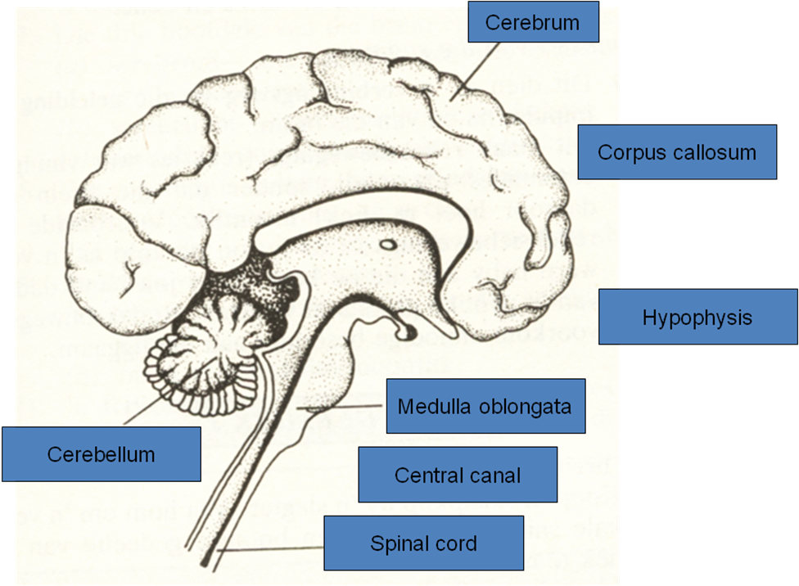  - Give each group a model / MRI scan / of a brain  (If teacher has more than one type of resource, it could be rotated amongst the groups )  - Give learners the criteria for completion:  Provide heading for the drawing  Draw the human / mammalian brain in the resource provided  (Learners may provide more labels than required in assessment guidelines  Label the various parts  Learners must complete the drawing by referring to the criteria for a biological diagram.  Teacher highlights the following:  CEREBRUM:  Consists of the outer grey matter (cell bodies of neurons )and inner white matter ( myelin sheath of axons).  Main functions of the cerebrum:  - Centre for voluntary actions which include you deciding to write in your book.  - Perception of senses like the ability to smell, feel, hear and see.  - Centre for higher mental activities like thinking, remembering and analysing.  CEREBELLUM :  Has the same structure as cerebrum but is much smaller.  Main functions of the cerebellum:  - Co-ordinates muscle movements.  - Responsible for balance and equilibrium.  MEDULLA OBLONGATA :  Responsible for involuntary actions like:  - Regulation of breathing  - Regulation of heart beat  - Constriction and dilation of blood vessels  Conclusion  - Learners work in groups to complete as much of the mind map as possible. Those complete can be assessed by peers.  - Give learners homework. | Learners revise previous  content through informal question and answers posed by the life science teacher.  Learners complete activity by completing a labelled drawing into their work books.  Peer assessment of drawing.  Home work: Using textbook, learner must state 2 functions for parts that is required in guidelines. this should be marked the next day. | 10 min  10 MIN  15 min  5 min  20min  20 min | Model / MRI scan of human brain / sheep brain  SIPP Booklets for 2014 compiled Question papers and answer booklets  Worksheets on cloning  CAPS 12 Life science –Solutions for All by McMillan- pg 275  Focus on Life science CAPS Gr 12 by Maskew Miller  Understanding Life science Gr.12 by T Isaac – 3rd Edition  Life Science Gr 12 – Top Class by Shuter’s (CAPS)  Via Afrika (CAPS) Life science Gr 12 -

Reflection/Notes:

Name of Teacher: |  | HOD:
Sign: |  | Sign:
Date: |  | Date:

