GRADE | 12 | SUBJECT |  | LIFE SCIENCE |  | WEEK | 15 |  | TOPIC | DIVISIONS OF THE NERVOUS SYSTEM  Time: 80 min |  | Lesson | 2
LESSON SUMMARY FOR: DATE STARTED: |  |  |  |  |  |  |  | DATE COMPLETED:
LESSON OBJECTIVES |  |  | The learners must be able to:  - Draw a schematic representation of the division of the nervous system  - Differentiate between central, peripheral and autonomic nervous system  - Identify the peripheral nervous system on a diagram  - State the functions of the Autonomic Nervous System  - Tabulate the difference in functions between the sympathetic and parasympathetic nerves

TEACHER ACTIVITIES | LEARNER ACTIVITIES | TIMING | RESOURCES NEEDED
Introduction  The nervous system (involving nerves) and endocrine system (involving hormones) are two components that help us respond to the environment .  Ask learner wat the need for a nervous system in humans is.  - Reaction to stimuli (stimuli can be external and internal)  - Coordination of the various activities of the body  The nervous system (involving nerves) and endocrine system (involving hormones) are two components that help us respond to the environment  (Use the blackboard/ transparencies to draw / display diagram)  Nervous system  Autonomic system  Somatic system  Peripheral Nervous system  Central Nervous system  Spinal cord  Brain  Parasympathetic division  Sympathetic division  Main Body/ Content  - Teacher highlights the following:  - Human nervous system is divided into two parts, the central nervous system (CNS) and the peripheral nervous system (PNS).  - CNS consists of the parts of the brain and the spinal cord.  - PNS consists of the somatic nervous system and the autonomic nervous system.  - Somatic nervous system is involved in all voluntary actions while the autonomic nervous system is involved in all involuntary muscles and actions.  - ANS is divided into the sympathetic and parasympathetic divisions.  - Sympathetic division prepares the organs of the human body for an emergency situation while the parasympathetic division is responsible for returning the organs to their normal functioning.  Conclusion  - Give learners the following questions to help understanding of content :  - Name the two main parts of the human nervous system?  Central and peripheral nervous system.  - Name the two parts that CNS?  Brain and spinal cord.  - Distinguish between somatic and autonomic nervous system?  Somatic nervous system controls voluntary actions while autonomic nervous system controls involuntary actions.  - Distinguish between sympathetic and parasympathetic divisions of the autonomic nervous system?  Sympathetic division prepares the organs of the human body for an emergency situation while the parasympathetic division is responsible for returning the organs to their normal functioning.  Homework:  - Educator gives learners homework to write a mini essay on the location and functions of the peripheral nervous system using a diagram as a guidance.  Explain to learners that there are 12 pairs of cranial nerves connected to brain and 31 pairs of spinal nerves connected to spinal cord, which form the peripheral nervous system. | Learners copy simplified version of schematic representation of division of nervous system into their work book.  Learners tabulate the differences between sympathetic and parasympathetic nerves on pupil size; heartbeat; breathing rate; peristalsis.  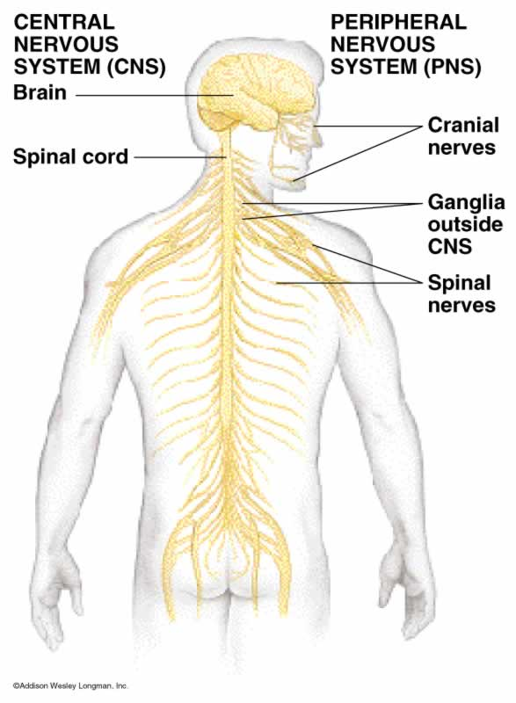 | 10 min  25 min  25 min  20min | CAPS Solutions for All – Life Science Gr 12 by McMillan  SIPP Booklets for 2014 compiled Question papers and answer booklets  Worksheets  Focus on Life science CAPS Gr 12 by Maskew Miller  Understanding Life science Gr.12 by T Isaac – 3rd Edition  Life Science Gr 12 – Top Class by Shuter’s.  Via Afrika Life Science GR 12 (CAPS)

Reflection/Notes:

Name of Teacher: |  | HOD:
Sign: |  | Sign:
Date: |  | Date:

