GRADE | 12 | SUBJECT |  | LIFE SCIENCE |  |  | WEEK | 16 |  | TOPIC | TRANSMISSION OF NERVE IMPULSE  Time: 40 min |  | Lesson | 3
LESSON SUMMARY FOR: DATE STARTED: |  |  |  |  |  |  |  |  | DATE COMPLETED:
LESSON OBJECTIVES |  |  | The learners must be able to:  - Define a synapse  - Draw and label the structure of synapse  - SIGNIFICANCE of synapse

TEACHER ACTIVITIES | LEARNER ACTIVITIES | TIMING | RESOURCES NEEDED
Lesson presentation using blackboard / transparencies  - Introduction  - Pre-knowledge: Basic structure of neuron  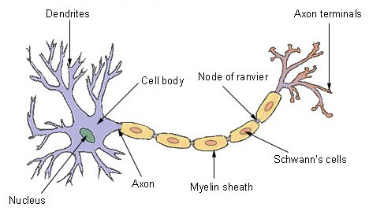  Educator revises how nerve impulses travel.  Main Body (Lesson presentation)  - Teachers draws diagram below on blackboard / transparency  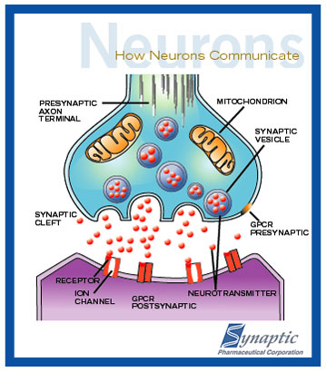  - Teacher highlights the following for the structure of the synapse:  - Synapse (synaptic cleft) is a microscopic space between:  - axon of one neuron and  - dendrite of another neuron.  - Neurons do not touch each other.  - The teacher adds additional information to discuss the transmission of an impulse from one neuron to another. The additional information can be added to the diagram present on blackboard / transparency.  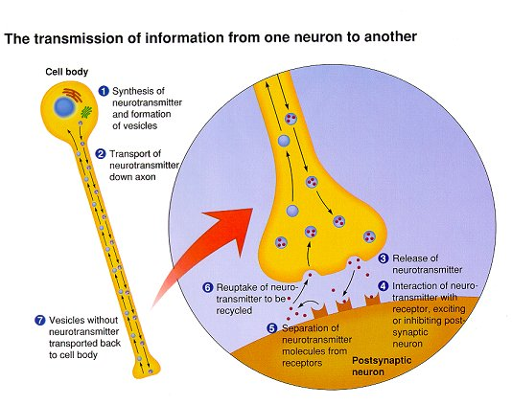  - Teacher highlights the following for the structure of the synapse:  - Impulse (action potential) reaches the presynaptic axon terminal.  - Vesicles (with neurotransmitter) fuse with the axon (presynaptic) membrane.  - This releases neurotransmitter molecules into the synaptic cleft.  - These molecules then bind to receptors in the dendrite (postsynaptic membrane).  - This creates a new impulse in the dendrite which is transported to the cell body of next neuron.  2.2 Conclusion  - Informal assessment to consolidate lesson.  - Name the microscopic gap between neurons.  Synapse.  - What do we called the chemical substance that is responsible for carrying an impulse from one neuron to another?  Neurotransmitters.  - Provide labels for the parts numbered 1, 2, 3, 5, 6 and 8 in the diagram below.  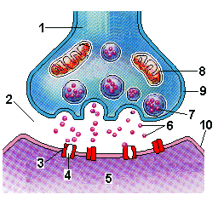  1 – axon / presynaptic end of axon  2 – synaptic cleft  3 – receptor  5 – dendrite / postsynaptic end  6 – neurotransmitter  8 - mitochondrion  - Give learners homework on nerve impulse transmission | Learners revise the structure of a neuron and transmission of nerve impulse  Learners must complete simplified drawing of structure of synapse in work books.  Learners develop simplified version of transmission in workbook  Informal assessment to consolidate understanding of work on synapse  - Home work: All activities to be completed in learners’ work book. | 5 min  10 min  15 min  10 min | CAPS Solutions for All – Life Science Gr 12 by McMillan  SIPP Booklets for 2014 compiled Question papers and answer booklets  Worksheets  Focus on Life science CAPS Gr 12 by Maskew Miller  Understanding Life science Gr.12 by T Isaac – 3rd Edition  Life Science Gr 12 – Top Class by Shuter’s.  Via Afrika Life Science GR 12 (CAPS)

Reflection/Notes:

Name of Teacher: |  | HOD:
Sign: |  | Sign:
Date: |  | Date:

