GRADE | 12 | SUBJECT |  | LIFE SCIENCE |  |  | WEEK | 17 |  | TOPIC | HUMAN EYE – FUNCTIONING  Time: 40 min |  | Lesson | 2
LESSON SUMMARY FOR: DATE STARTED: |  |  |  |  |  |  |  |  | DATE COMPLETED:
LESSON OBJECTIVES |  |  | The learners must be able to:  - Identify the basic internal structure of the human eye  - State the functions of the parts of the human eye  - State the characteristics of the parts of the eye in relation to function  - Summarise information on the functions of various parts on mind map

TEACHER ACTIVITIES | LEARNER ACTIVITIES | TIMING | RESOURCES NEEDED
Lesson presentation using blackboard / transparencies  Introduction  - Teacher discuss internal structure of human eye (Refer to labelled mind map / textbook / diagram below)  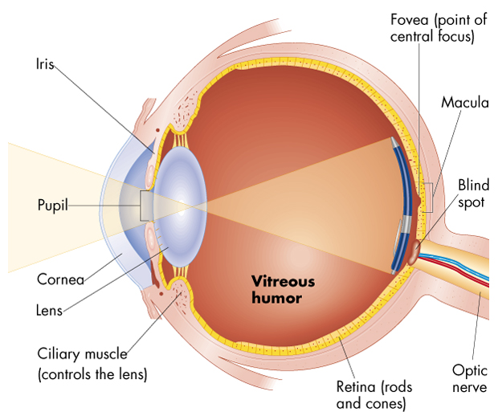  Main Body (Lesson presentation)  - Teacher provides basic functions of the various parts of the human eye. Teacher instructs learners to place functions on the mind map of human eye. Teacher highlights the following functions of the various parts of the human eye:  - Conjunctiva – protects the cornea  - Sclera – protects the inner parts of ear. Also helps to maintain the shape of eye  - Cornea – allows light to enter eye. Also cause refraction of light that enter the eye.  - Choroid – provides nutrients to eye and removes waste from eye  - Retina – convert light stimuli to impulses  - Optic nerve – carries impulse from retina to the cerebrum  - Iris – has antagonistic muscles that controls the size of the pupil in process called pupil mechanism.  - Pupil – controls the amount of light that enters eye.  - Ciliary muscles in ciliary body – by contraction and relaxation it control the shape of the lens and thus its refractive ability. Makes it possible to view near and distant objects. Process is called accommodation.  - Lens – changes shapes to refract light.  - Suspensory ligaments – attaches lens to ciliary body.  - Vitreous humour – helps to maintain shape of eyeball  - - Aqueous humour - clear fluid that fills the space between lens and cornea  Conclusion  - Teacher facilitates the completion of the functions on the mind map. Allow for peer assessment of mind map content.  - Give learners homework. | Learners respond to informal questions.  Learners place functions  (in blue) in boxes on mind  map provided.  Home work:  Using textbook, learners  complete assigned  homework. | 10 min  15 min  15 min | CAPS Solutions for All – Life Science Gr 12 by McMillan  SIIP Booklets for 2014 compiled Question papers and answer booklets  Worksheets  Focus on Life science CAPS Gr 12 by Maskew Miller  Understanding Life science Gr.12 by T Isaac – 3rd Edition  Life Science Gr 12 – Top Class by Shuter’s.  Via Afrika Life Science GR 12 (CAPS)

Reflection/Notes:

Name of Teacher: |  | HOD:
Sign: |  | Sign:
Date: |  | Date:

