GRADE | 12 | SUBJECT |  | LIFE SCIENCE |  |  | WEEK | 17 |  | TOPIC | HUMAN EYE- PUPILLARY MECHANISM  Time: 40 min |  | Lesson | 3
LESSON SUMMARY FOR: DATE STARTED: |  |  |  |  |  |  |  |  | DATE COMPLETED:
LESSON OBJECTIVES |  |  | The learners must be able to:  - Understand the formation of an image  - Explain papillary mechanism during dim and bright light

TEACHER ACTIVITIES | LEARNER ACTIVITIES | TIMING | RESOURCES NEEDED
Lesson presentation using blackboard / transparencies  Introduction  - Teacher revises basic structure of the human eye.  Main Body (Lesson presentation)  - Teacher highlights the following aspects of the formation of an image:  There are 3 basic parts:  - Pathway of light and image formation:  - light passes through various parts of the eye until it reaches the retina  - as light passes through different substances it is refracted  - cornea refracts light the most  - lens ensure fine, sharp focusing  - light rays converge on yellow spot of the retina  - image on retina is upside down and reversed (left to right)  - Stimulation of photoreceptors:  - rods and cones are stimulated by light  - photopigments are broken down  - this creates electrical impulses  - Pathway of nerve impulses:  - impulses travel via optic nerve to cerebral cortex  - for interpretation  - Teacher provides or draws simplified version of the illustration below on blackboard / transparency.  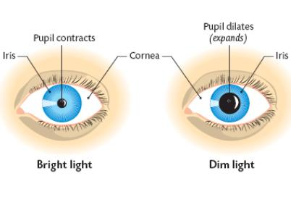  Teacher highlights the following for the structure of the structure of the iris:  - This is a response of the eye to changes in light intensity.  - Iris controls the amount of light that enters the eye.  - It contains two set of involuntary muscles;  - the radial and  - circular muscles  - The muscles function antagonistically (do the opposite).  - Teacher highlights the following for the pupil mechanism:  In dim light  - Radial muscles contract.  - Circular muscles relax.  - The pupil enlarges (dilates).  - Thus more light enters the eye.  In bright light  - Radial muscles relax.  - Circular muscles contract.  - The pupil becomes smaller (constricts).  - Thus less light enters the eye  Conclusion  - Teacher facilitates the completion of the functions on the mind map. Allow for peer assessment of mind map content.  - Give learners homework. | Learners revise the structure of a human eye.  Learners make summarised notes of image formation.  Learners complete summary of pupil mechanism on mind map.  Learners must be able to tabulate differences in pupillary mechanisms during dim and bright light.  Learners complete labelling on mind map. Allow for peer assessment.  Home work: Using textbook, learners complete assigned homework. | 5 min  15 min  15 min  5 min | Model of the human eye.  - Life Sciences (Mind Action Series):  CAPS Solutions for All – Life Science Gr 12 by McMillan  SIIP Booklets for 2014 compiled Question papers and answer booklets  Worksheets  Focus on Life science CAPS Gr 12 by Maskew Miller  Understanding Life science Gr.12 by T Isaac – 3rd Edition  Life Science Gr 12 – Top Class by Shuter’s.  Via Afrika Life Science GR 12 (CAPS)

Reflection/Notes:

Name of Teacher: |  | HOD:
Sign: |  | Sign:
Date: |  | Date:

