GRADE | 12 | SUBJECT |  | Life Sciences |  |  | WEEK | 17 |  | TOPIC | HUMAN EYE – DISEASES  Time: 40 min |  | Lesson | 5
LESSON SUMMARY FOR: DATE STARTED: |  |  |  |  |  |  |  |  | DATE COMPLETED:
LESSON OBJECTIVES |  |  | The learners must be able to:  • Explain all definitions related to this chapter  • Explain nature and treatment (glasses and surgery) for:  - Short-sightedness  - Long-sightedness  - Astigmatism  - Cataracts

TEACHER ACTIVITIES | LEARNER ACTIVITIES | TIMING | RESOURCES NEEDED
Lesson presentation using blackboard / transparencies  - Introduction  - Teacher revises different parts of human eye.  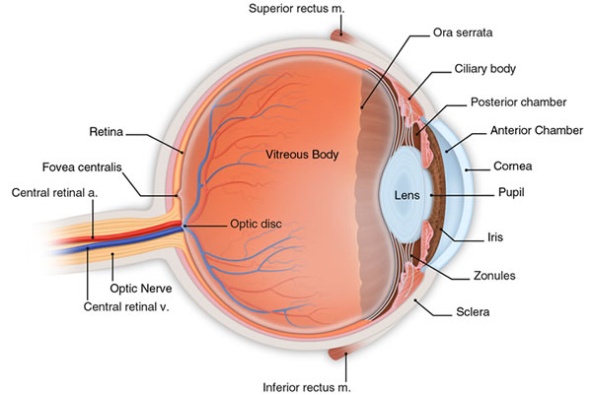  2.1 Main Body (Lesson presentation)  - Teacher divides learners into groups (4-8 learners)  - Teacher assign each group a disorder and highlights the following:  - Short-sightedness (myopia)  - Near objects are clearly visible but distant objects are out of focus  - Due to eyeball being longer or cornea being too rounded  - Corrected with concave lenses  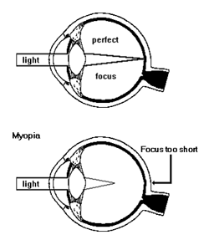  - Long-sightedness (hypermetropia)  - Distant objects are clearly visible but near objects are out of focus  - Due to eyeball being shorter or cornea being too flat  - Corrected with convex lenses  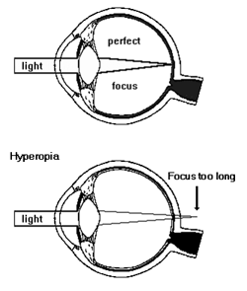  - Astigmatism  - Image is unclear or blurry.  - Due to cornea being shaped like a rugby ball  - This leads to light rays being focused on two places.  - Corrected with glasses, contacted lenses and laser surgery  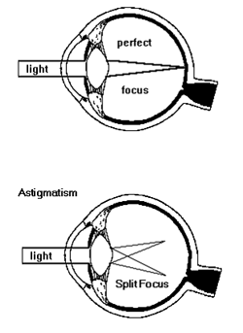  - Cataracts  - Clouding of lens  - Corrected by surgical removal of lens and replaced with clear, synthetic lens.  2.3 Conclusion  - Teacher facilitates the presentation of group information.  - Give learners homework. | - Learner respond to informal revision  2. Learners collaborate to ensure understanding of eye disorders.  Groups present their  assigned content to their  peers.  Home work: Learner uses textbook to complete the home work. | 5 min  10 min  10 min  10 min  5 min | - Model of human eye  - The Answer Understanding Life Sciences: p  - Focus on Life Sciences:  - Life Sciences (Mind Action Series):  - Spot on Life Sciences  - Model of human eye  - The Answer Series  - Understanding Life Sciences  - Focus on Life Sciences  - Life Sciences (Mind Action Series):  - Gr 12 Life sc. Exam Fever Study guide  Home work:  - The Answer Series  - Life Sciences (Mind Action Series  - Spot on Life Sc.

Reflection/Notes:

Name of Teacher: |  | HOD:
Sign: |  | Sign:
Date: |  | Date:

