GRADE | 12 | SUBJECT |  | LIFE SCIENCE |  |  | WEEK | 17 |  | TOPIC | HUMAN EYE- ACCOMODATION  Time: 40 min |  | Lesson | 4
LESSON SUMMARY FOR: DATE STARTED: |  |  |  |  |  |  |  |  | DATE COMPLETED:
LESSON OBJECTIVES |  |  | The learners must be able to:  • The basic structure of the human eye  • Understand binocular vision in human  • Explain the mechanism of accommodation  • Summarise information on the mind map

TEACHER ACTIVITIES | LEARNER ACTIVITIES | TIMING | RESOURCES NEEDED
Lesson presentation using blackboard / transparencies  Introduction  Teacher revises basic structure of the human eye.  Main Body (Lesson presentation)  - Teacher provides diagram below by placing it on blackboard / transparency:  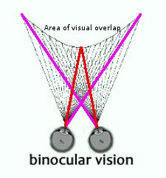  - Teacher highlights the following aspects of the binocular vision:  - Vision in which both eyes are used together.  - Their visual fields overlap  - So the view from each eye is slightly different  - Cerebrum combines information in single image  - Binocular vision helps to judge distance, depth and size of object  - Teacher provides or draws simplified version of the illustration below on blackboard / transparency.  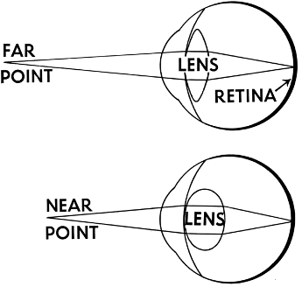  - Teacher highlights the following for the mechanism of accommodation:  - Accommodation is to change the focal length of the lens by changing its shape or curvature.  - Due to changes in the distance between the object and the eye.  Distant vision (> 6 meters)  - Ciliary muscle is relaxed  - Ciliary bodies tend to moves further from each other.  - Suspensory ligaments to become taut / tensed.  - Lens becomes less convex (less rounded)  - This decreases the refractive power of the lens.  Near vision (< 6 meters)  - Ciliary muscle contracts  - Ciliary bodies move closer to each other.  - Less tension on the suspensory ligaments.  - Lens becomes more convex (more rounded).  - This increases its refractive power of the lens.  Conclusion  Give learners homework  - Teacher consolidates content on the human eye by revision. Diagram and questions provided by teacher.  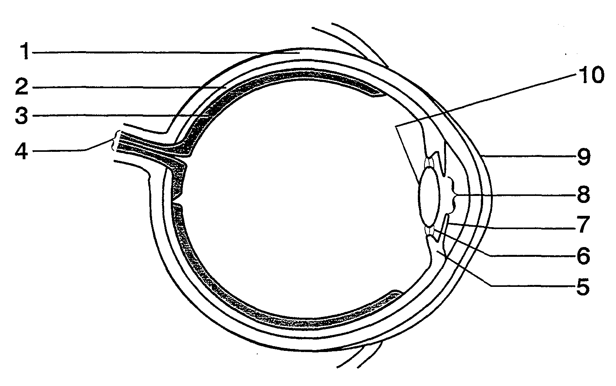  Write down the name and number of the part which transmits impulses from the eye to the brain.  Give learners questions on the eye from past exam papers to answer as homework. | 1. Learners revise the  basic structure of a eye.  Learners make summarised notes of binocular vision.  Learners complete summary of accommodation on mind map.  Home work: Learners complete labelling of diagram given to them by educator. Allow for peer assessment.  Home work: Using textbook, learners complete assigned homework. | 5 min  10 min  15min  10 min | Model of the human eye.  WORKSHEET ON EYE  CAPS Solutions for All – Life Science Gr 12 by McMillan  SIIP Booklets for 2014 compiled Question papers and answer booklets  Worksheets  Focus on Life science CAPS Gr 12 by Maskew Miller  Understanding Life science Gr.12 by T Isaac – 3rd Edition  Life Science Gr 12 – Top Class by Shuter’s.  Via Afrika Life Science GR 12 (CAPS)

Reflection/Notes:

Name of Teacher: |  | HOD:
Sign: |  | Sign:
Date: |  | Date:

