GRADE | 12 | SUBJECT |  | LIFE SCIENCE |  |  | WEEK | 18 |  | TOPIC | HUMAN EAR – DISORDERS  Time: 40 min |  | Lesson | 5
LESSON SUMMARY FOR: DATE STARTED: |  |  |  |  |  |  |  |  | DATE COMPLETED:
LESSON OBJECTIVES |  |  | The learners must be able to:  ⦁ Know all definitions related to this chapter  ⦁ Explain the causes and treatment of following hearing defects:  - Middle ear infections (Treatment using grommets)  - Deafness (hearing aids and cochlear implants)

TEACHER ACTIVITIES | LEARNER ACTIVITIES | TIMING | RESOURCES NEEDED
Lesson presentation using blackboard / transparencies  Introduction  Teacher revises different parts of human ear and the process of hearing using the following diagram similar , to the one below, using question and answer method to recapitulate functioning and parts of ear.  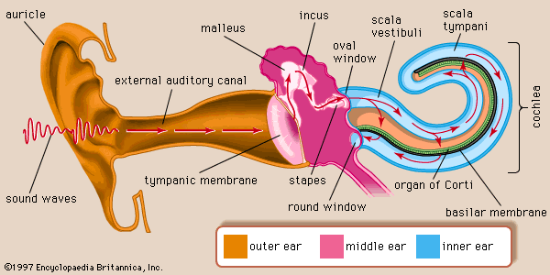  Main Body (Lesson presentation)  - Teacher highlights the following about middle ear infections and deafness:  - Middle ear infection (called otitis media)  - Symptoms  - Ear ache, fever, limited loss of hearing, leaking of fluid and dizziness.  - Causes  - Due to viral infection, usually after cold or flu.  - Treatment  - Simple surgical procedure called myringotomy (cut ear drum and insert grommet)  - Deafness  - Types  - Conductive - path of sound wave/vibration is incomplete or non-functional.  - Neural – due to damage to organ of Corti, auditory nerve or cerebral cortex.  - Causes  - Heredity, age, problems during pregnancy or birth, hardening of wax, side effect of diseases like meningitis, German measles or mumps.  - Treatment  - Hearing aids make sounds louder. It can be used by people who suffer from conductive deafness. It is worn outside the ear.  - Cochlear implants (bionic ear) is an electronic device that is surgically implanted inside the ear.  Conclusion  - Explain to learners that deaf people also have human rights. | - Learner respond to informal revision  2. Learners summarise information in work book.  3. Learners participate in classroom discussion.  Home work:  Learner uses textbook /experiences to complete the home work on hearing disorders. | 5 min  15 min  15 min  5 min | Model of Ear  Gr 12- Life Science Exam Fever Study Guide  CAPS Solutions for All – Life Science Gr 12 by McMillan  SIIP Booklets for 2014 compiled Question papers and answer booklets  Worksheets  Focus on Life science CAPS Gr 12 by Maskew Miller  Understanding Life science Gr.12 by T Isaac – 3rd Edition  Life Science Gr 12 – Top Class by Shuter’s.  Via Afrika Life Science GR 12 (CAPS)

Reflection/Notes:

Name of Teacher: |  | HOD:
Sign: |  | Sign:
Date: |  | Date:

