GRADE | 12 | SUBJECT |  | LIFE SCIENCE |  | WEEK |  | 18 |  | TOPIC | HUMAN EAR- BALANCE MECHANISM  Time: 40 min |  | Lesson | 3
LESSON SUMMARY FOR: DATE STARTED: |  |  |  |  |  |  |  |  | DATE COMPLETED:
LESSON OBJECTIVES |  |  | The learners must be able to:  ⦁Understand that the ear has apparatus for hearing and balance  ⦁Identify the hearing apparatus in the model/ diagram given on the ear  ⦁Explain the pathway of sound waves until hearing is perceived  ⦁Draw and label the Organ of Corti

TEACHER ACTIVITIES | LEARNER ACTIVITIES | TIMING | RESOURCES NEEDED
Lesson presentation using blackboard / transparencies  Introduction  - Teacher revises different parts of human ear involved in the hearing process.  Main Body (Lesson presentation)  - Teacher copies diagram below onto blackboard / transparency  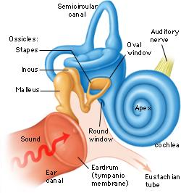  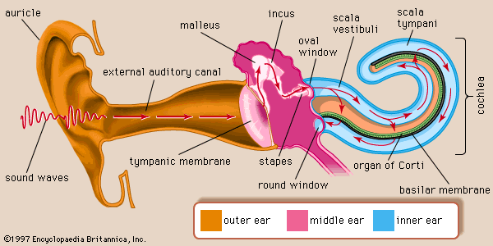  - Teacher highlights the functions of the following parts of the human ear:  - Sound, which is made up of invisible energy, is produced and travels through air  - Pick up by the pinna and concentrated on the auditory canal  - Auditory canal carries the sound wave to the tympanic membrane (ear drum)  - Vibrations of the eardrum cause the vibrating of the malleus  - Malleus causes vibrating on the incus  - Incus causes vibrating of the stapes  - Stapes transfers vibrations to a membrane called the oval window  - Transfer from large tympanic membrane to small oval window causes the amplification of the sound (making it louder)  - Vibration carried to the fluid of the cochlea  - Cochlea, a snail-shaped, fluid filled set of three chambers.  - Organ of Corti is located in the middle chamber, which is the organ of hearing.  - It contains sensory receptors called hair cells.  - As the vibration moves through the liquid of the different chambers it stimulates the hair cells which create a nerve impulse.  - Nerve impulse is carried by the auditory Nerve, which travels to the cerebral cortex where it is interpreted.  Conclusion  - Teacher facilitates the completion of the flow diagram.  - Teacher consolidates the content of the lesson using the following by informal assessment:  Provide labels and name for the parts responsible for the following:  - Making the sound louder.  A – auditory ossicles in middle ear  - Converting vibration into a nerve impulse.  G - cochlea  - Transports sound wave from pinna.  K – auditory canal  - Maintains equal pressure of both side of part labelled L to ensure effective transfer of sound wave / vibration.  H – Eustachian tube  - Transports impulse to cerebral cortex for interpretation  F – cochlea branch of auditory nerve  - Give learners homework from activities in their textbooks or worksheet using activities from other resource books/ exam papers. | Learner respond to informal revision  Learners create a flow diagram of the basic process in boxes on mind map provided.  Learners complete flow  diagram showing pathway  of sound in their workbooks  and on diagram provided  using a red pen  Home work: Learners must draw a cross – section of cochlea showing Organ of Corti and completes answers to activities in their workbooks. | 5 min  10 min  15 min  10 min | - Model of Ear  - Transparency on the inner ear involved in the hearing process  CAPS Solutions for All – Life Science Gr 12 by McMillan  SIIP Booklets for 2014 compiled Question papers and answer booklets  Worksheets  Focus on Life science CAPS Gr 12 by Maskew Miller  Understanding Life science Gr.12 by T Isaac – 3rd Edition  Life Science Gr 12 – Top Class by Shuter’s.  Via Afrika Life Science GR 12 (CAPS)

Reflection/Notes:
Name of Teacher: |  | HOD:
Sign: |  | Sign:
Date: |  | Date:

