GRADE | 12 | SUBJECT |  | LIFE SCIENCE |  |  | WEEK | 19 |  | TOPIC | ENDOCRINE SYSTEM- FUNCTION OF GLANDS  Time: 160 min |  | LESSON | 2-5
LESSON SUMMARY FOR: DATE STARTED: |  |  |  |  |  |  |  |  | DATE COMPLETED:
LESSON OBJECTIVES |  |  | The learners must be able to:  - Identify the location of endocrine glands listed in syllabus  - Name the hormones produced by endocrine glands mentioned in syllabus  - State the functions of hormones produced  - Use mind map to summarise content for this lesson

TEACHER ACTIVITIES | LEARNER ACTIVITIES | TIMING | RESOURCES NEEDED
Lesson presentation using blackboard / transparencies  Introduction  - Definitions related to the chapter (Write definitions for lesson on blackboard/transparency)  ⦁ Revise location of endocrine glands  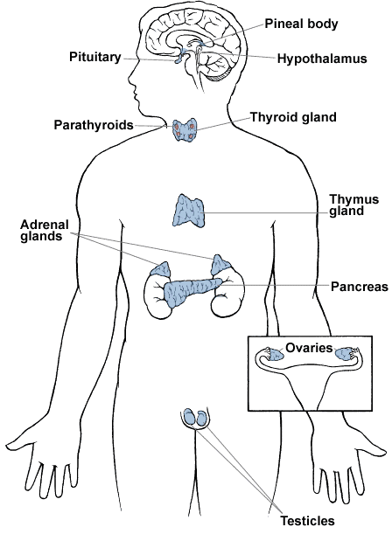  Main Body (Lesson presentation)  - Teacher highlights the following functions of the hormones produced by the underlined endocrine glands.  Posterior lobe of pituitary (ADH)  - It helps with the reabsorption of water by the kidney.  Pituitary Gland/ Hypophysis (GH, TSH, FSH, LH, prolactin)  - Growth hormone/ GH - stimulates the growth of bone and other  body tissues and its metabolism;  - Prolactin, which activates milk production in women who are breastfeeding;  - TSH, which stimulates the thyroid gland to produce thyroxin  - FSH which stimulates the development of the follicle in ovaries  - LH stimulates the Graafian follicle to release ovum / responsible for ovulation  Adrenal Glands( Adrenalin, aldosterone)  - Adrenalin - prepares the body for emergency situations.  - Increasing heart rate, breathing rate, blood pressure, conversion of glycogen to glucose, blood flow to strategic organs and cellular respiration rate and diameter of pupils.  - Decreases blood flow to intestines and skin.  - Aldosterone which increases the reabsorption of sodium and water and the release (secretion) of potassium in the kidneys  Pancreatic Islets of Langerhans (insulin, glucagon)  - Insulin - converts glucose to glycogen to be stored in the liver  and muscles.  - Glucagon –converts glycogen in liver and muscles to glucose to be  released into the bloodstream.  Ovary (oestrogen, progesterone)  - Oestrogen is responsible for secondary sex characteristics at puberty. Causes the lining of the uterus, and the endometrium, to grow and thicken in preparation of implantation of a fertilized egg.  - Breaks down and repairs endometrium during menstrual cycle  - Progesterone causes the lining of the uterus, the endometrium, to grow and thicken in preparation of implantation of a fertilized egg.  Testis ( testosterone)  - Responsible for secondary sex characteristics at puberty  - maintain reproductive organs  - sex drive or libido  - needed for sperm production  Thyroid glands (thyroxin)  - Increase cellular respiration rate  - Promotes development of the brain and nervous system.  - Promotes development of cardiovascular system.  - Controls the basal metabolic rate  Conclusion  Teacher facilitates completion of mind map. Also allows peer assessment amonst learners to re-enforce their acquired knowledge.  Revise content before learners write examinations. | Learners respond to questions asked by teacher on location of endocrine glands and characteristics of hormones.  Learners complete endocrine system function section on the mind map  Learners complete endocrine system mind map and allow time for peer assessment.  Using textbook, learners research functions of the listed hormones.  Learners do revision exercises before examination starts. | 5 min  20 min  40 min  15min  120min | CAPS Solutions for All – Life Science Gr 12 by McMillan  SIIP Booklets for 2014 compiled Question papers and answer booklets  Worksheets  Focus on Life science CAPS Gr 12 by Maskew Miller  Understanding Life science Gr.12 by T Isaac – 3rd Edition  Life Science Gr 12 – Top Class by Shuter’s.  - Via Afrika Life Science GR 12 (CAPS)

Reflection/Notes:

Name of Teacher: |  | HOD:
Sign: |  | Sign:
Date: |  | Date:

