GRADE | 12 | SUBJECT |  | LIFE SCIENCES |  | WEEK | 24 |  | TOPIC | PLANT HORMONES  Time: 40 min |  | Lesson | 5
LESSON SUMMARY FOR: DATE STARTED: |  |  |  |  |  |  |  | DATE COMPLETED:
LESSON OBJECTIVES |  |  | The learners must be able to:  ⦁ Explain the uses of plant hormones :  - Auxins as herbicides  - Auxins to control apical dominance  - Auxins and Gibberellins to stimulate fruit development  ⦁ Summarise information on mind map

TEACHER ACTIVITIES | LEARNER ACTIVITIES | TIMING | RESOURCES NEEDED
Lesson presentation using blackboard / transparencies  - Introduction  Briefly explain what is a :  Stimulus: changes in the environment eg. cold , hot, pain, pressure, sound, light, touch  Receptors : receive stimuli ( explain to learners that the brain needs information/ signals on the external environment)  (Ask simple question related to why plants need to respond to the  environment- what stimuli do you think plants react to ?)  Main Body (Lesson presentation)  General functions of auxins  - Stimulates cell division  - Stimulates cell elongation  - Stimulates development of fruit  - Control abscission of fruit and leaves  - Responsible for apical dominance  - Stimulate the development of adventitious roots  - Cause phototropism and geotropism  General functions of gibberellins  - Stimulates cell elongation  - Stimulates root growth  - Promote flowering  - Promote the growth of lateral buds  - stimulate the germination of seeds  - Teacher highlights the following aspects of the uses of plant hormones in agriculture:  - Auxins as herbicides  - Synthetic auxins like 2,4 dichlorophenoxyacetic acid (2,4 D) are used as weed killers (herbicides)  - 2,4 D kills broad leaved weeds but not grasses, so farmers spray maize fields. The weeds are killed but not the maize plants.  - Auxins to control apical dominance  - Auxins are produced by apical buds (tip)  - It slows down the growth of lateral buds  - Thus plants growth rapidly upwards, but side branches grow slowly.  - Results in cone shape structure  - This is called apical dominance  - Plant growers cut tip off certain plants to ensure a short. bushy plant structure.  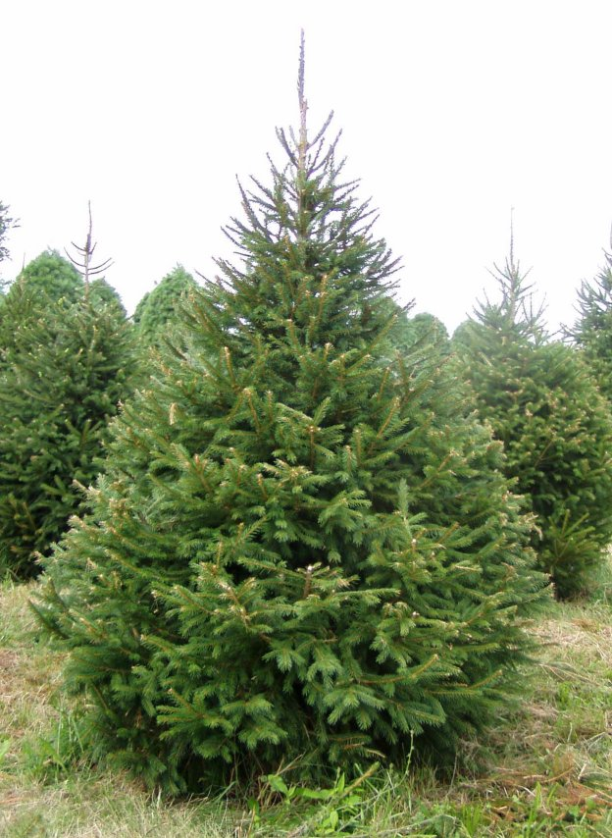  Auxins to stimulate fruit development  Pollination produces seeds that release auxins that promote fruit growth.  Auxins are sprayed on plants to ensure fruit development although no pollination has taken place.  This produces seedless fruit.  Low concentrations of auxins are sprayed on fruit trees to delay abscission.  Gibberelins to stimulate fruit development  Development of fruit without seeds (parthenocarpy).  Farmers spray grapes which produces larger grapes.  Also leads to greater internodes on vines.  This limits fungal infections.  Ethylene gas injected into airtight storage rooms to ripen bananas and other fruit  Conclusion  - Revise all concepts discussed | Notes on plant hormones used in agriculture given to learners.  Learners make summarised notes on mind map.  Homework:  Learners read up on notes issued to them | 5 min  10 min  10 min  5 min  10 min | CAPS Solutions for All – Life Science Gr 12 by McMillan  SSIP Booklets for 2014 compiled Question papers and answer booklets  Worksheets  Focus on Life science CAPS Gr 12 by Maskew Miller  Understanding Life science Gr.12 by T Isaac – 3rd Edition  Life Science Gr 12 – Top Class by Shuter’s.  Via Afrika Life Science GR 12 (CAPS)

Reflection/Notes:

Name of Teacher: |  | HOD:
Sign: |  | Sign:
Date: |  | Date:

