Plant hormones Mind map
A.
Functions:

Auxins in phototropism

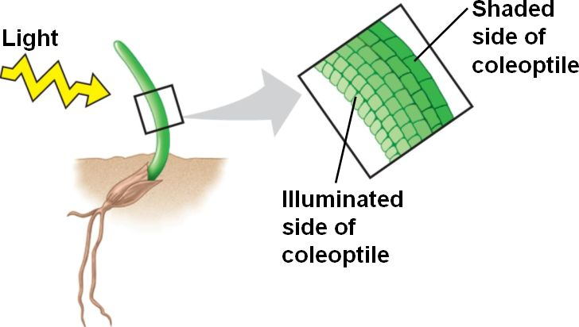

B.
Functions:

C.
Functions:

Plant defense mechanisms

Chemicals:

Thorns:

Plant hormones in agriculture

Auxins

Gibberellins:

