GRADE | 12 | SUBJECT |  | LIFE SCIENCE |  |  | WEEK | 25- EVOLUTION |  | TOPIC | Variation  Time: 40 min | Lesson | 5
LESSON SUMMARY FOR: DATE STARTED: |  |  |  |  |  |  |  |  | DATE COMPLETED:
LESSON OBJECTIVES |  |  | The learners must be able to:  - discuss causes of variation between individuals of the same species  - distinguish between continuous and discontinuous variation

TEACHER ACTIVITIES |  |  | LEARNER ACTIVITIES |  | TIMING | RESOURCES NEEDED
Introduction:  Educator revises previous days concepts with the learners  Main Body (Lesson presentation):  Give the definition of a biological species and a population to learners to write down.  Ask the learners what they think will contribute to differences (variations) within a species.  Educator explains that :  Discuss the following factors that causes variation that exists amongst individuals of the same species:  • Meiosis  - Crossing over  - Random arrangement of chromosomes  • Mutations  • Random fertilisation  • Random mating  Discuss the difference between Continuous and discontinuous variation  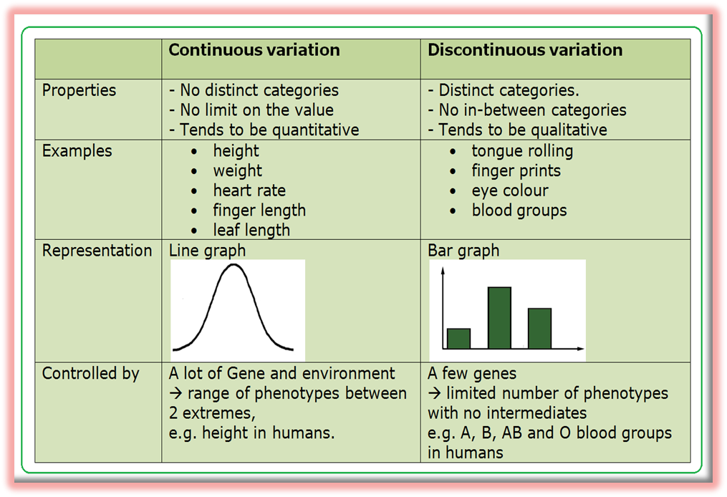  Conclusion :  Learners do the homework. |  |  | Learners have to write a mini essay on the causes of variation and the two types of variation for homework |  | 10 min  20min | SIIP Booklets for 2014 compiled Question papers and answer booklets  CAPS 12 Life science –Solutions for All by McMillan  Focus on Life science CAPS Gr 12 by Maskew Miller  Understanding Life science Gr.12 by T Isaac – 3rd Edition  Life Science Gr 12 – Top Class by Shuter’s (CAPS)  Via Afrika (CAPS) Life science Gr 12
Reflection/Notes:
Name of Teacher: |  | HOD:
Sign: |  | Sign:
Date: |  | Date:

