GRADE | 12 | SUBJECT |  | LIFE SCIENCE |  | WEEK |  | 26-EVOLUTION BY NATURAL SELECTION |  | TOPIC |  | DARWINS THEORY OF EVOLUTION BY NATURAL SELECTION  ARTIFICIAL SELECTION  Time: 40 min | Lesson | 2
LESSON SUMMARY FOR: DATE STARTED: |  |  |  |  |  |  |  |  | DATE COMPLETED:
LESSON OBJECTIVES |  |  | The learners must be able to:  - Explain the Darwin’s theory of natural selection  - Use an example to apply theory of natural selection  - explain artificial selection

TEACHER ACTIVITIES | LEARNER ACTIVITIES | TIMING | RESOURCES NEEDED
Introduction:  Briefly revise :  The theories of Lamarck and why his theory was rejected.  Darwin’s historical background  Main Body / Presentation:  Educator must use w/ sheets/ transparencies/ activities from various resources listed as well as other relevant resources , to explain the observations that Darwin has made, which led to his theory of natural selection :  Teacher must ask the question: What do you understand by the term natural selection ?  Educator uses the diagram alongside to explain natural selection/survival of the fittest with the advantageous gene.  Answer:  Natural selection is a phenomenon whereby individuals with the most suitable characteristics based on the genotype will be able to survive / cope with challenges or adapt best to environment.  - Plants and animals produce a large number of offspring with variation eg. Beetles produce many offspring with colour variation as this is a source of foods for birds. Those beetles whose colour allows them to camouflage against predatory birds will survive.  - Individuals that had suitable or favourable genes/ genotype led to advantageous phenotypic characteristics  - Individuals with the advantageous phenotypic characteristics were able to cope with selection pressures of the environment. This led to survival of the fittest within the species.  - More individuals with desirable genetic traits were born.  Artificial selection is also known as selective breeding, since humans determine which genes will be passed on to future generations.  Farmers, scientists and pet breeders choose their best individuals to interbreed so that they may produce the best characteristics.  Artificial selection of a crop: Maize plants with full kernels were allowed to cross – pollinate by farmers so that the genes for full kernels could be passed onto the new maize plants.  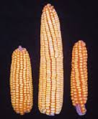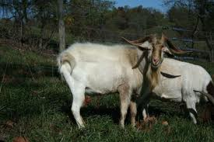  Artificial selection of domesticated animals: In South Africa farmers select goats which are able to withstand heat and drought and allow them to inbreed as they are resistant to diseases and produce good meat.  Conclusion:  Teacher must explain the example of the white and dark pepper moths  ( Biston betularia) with regards to natural selection in the industrialised city of Manchester, and relate to the theory of natural selection based on Darwin’s observations.  Teacher must guide learners on skills of essay writing of natural selection using the picture under leaner activities. | Learners do correction on activities based on previous lesson.  Learners take down the following flow diagram to illustrate natural selection after explanation by educator  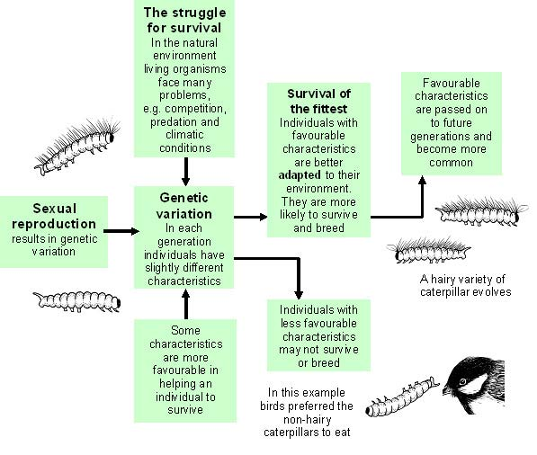  Learners must respond to questions.  They must take down the correct answer in their work books  Learners should draw a mind – map/ concept map of Darwin’s theory of natural selection based on Darwin’s observations.  Homework : Learners have to do questions from past papers. | 10 min  20 min  10 min | Powerpoint presentations  CAPS Solutions for All – Life Science Gr 12 by McMillan  SIIP Booklets for 2014 compiled Question papers and answer booklets  Worksheets  Focus on Life science CAPS Gr 12 by Maskew Miller  Understanding Life science Gr.12 by T Isaac – 3rd Edition  Life Science Gr 12 – Top Class by Shuter’s.  Via Afrika Life Science GR 12 (CAPS)

Reflection/Notes:

Name of Teacher: |  | HOD:
Sign: |  | Sign:
Date: |  | Date:

