GRADE | 12 | SUBJECT |  | LIFE SCIENCE |  | WEEK |  | 26–EVOLUTION BY NATURAL SELECTION |  | TOPIC | ORIGIN OF IDEAS : JEAN BAPTIST LAMARCK THEORY OF EVOLUTION  Time: 40 min |  | Lesson | 1
LESSON SUMMARY FOR: DATE STARTED: |  |  |  |  |  |  |  |  | DATE COMPLETED:
LESSON OBJECTIVES |  |  | The learners must be able to:  - Explain the two ideas of Lamarck’s theory  - Apply Lamarck’s theory to specific examples  - Explain why Lamarck’s theory was rejected  - State what are vestigial organs

TEACHER ACTIVITIES | LEARNER ACTIVITIES | TIMING | RESOURCES NEEDED
Introduction:  Briefly revise all concepts of origins of life discussed in earlier lessons to ensure learners do not forget and confuse facts. Also highlight the importance of using proper biological terminology to explain evolution.  Educator explains that :  Lamarck was a French scientist who supported evolution.  He believed that evolution was due to :  - Inheritance of acquired characteristics  - b) Law of use and disuse  Main Body / Presentation:  Educator must explain the above two theories using examples from activities in various textbooks as well as past exam papers to show how the two theories apply, in explaining Lamarck’s theory.  - Inheritance of acquired characteristics- an organism is determined to change a particular organ in order to adapt to the environment. The offspring of the changed organism will then inherit their parents new body part.  - Law of use and disuse- Organisms change the structure of their body organs by either using it more often, causing it to become stronger, and longer and if the organ is used less it will become smaller and slowly disappear.  Explain an example in which Lamarck’s two laws apply:  Initially there were short –necked giraffe, as fossils of this were found in the Western cape.  These short necked giraffes fed ion the lower leaves of trees.  There was competition with other herbivores that also feds on lower leaves.  In order to avoid competition the giraffes became stretching their necks to eat leaves on higher branches.  This stretching made the giraffes neck longer (Law of use and disuse) and this characteristic will then be passed onto the offspring (Law of inheritance of acquired characteristic).  Eventually all giraffe will have long necks as they no longer needed to compete with buck for leaves on lower branches.  Conclusion:  Educator explains that Lamarck’s theory was later rejected after Mendel’s discovered that acquired genes cannot be inherited or transmitted to offspring.  Explain to learners that vestigial organs are organs that become smaller if it is not used. | Learners may ask question on any concept of evolution that they may not understand thus far.  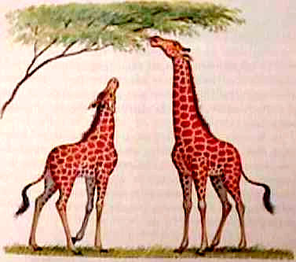  Learners use the above picture from their textbooks to explain the two theories. | 10 min  20 min  10 min | CAPS Solutions for All – Life Science Gr 12 by McMillan  SSIP Booklets for 2014 compiled Question papers and answer booklets  Articles on Malaria and TB  Focus on Life science CAPS Gr 12 by Maskew Miller  Understanding Life science Gr.12 by T Isaac – 3rd Edition  Life Science Gr 12 – Top Class by Shuter’s.  Via Afrika Life Science GR 12 (CAPS)

Reflection/Notes:

Name of Teacher: |  | HOD:
Sign: |  | Sign:
Date: |  | Date:

