GRADE | 12 | SUBJECT |  | LIFE SCIENCES |  | WEEK |  | 27 |  | TOPIC | HUMAN ORIGINS: Ardipithecus Autralopithecines  Time: 40 min |  | Lesson | 3
LESSON SUMMARY FOR: DATE STARTED: |  |  |  |  |  |  |  |  | DATE COMPLETED:
LESSON OBJECTIVES |  |  | - The learners must be able to :  State the name of fossils found in the Sterkfontein caves  - Differentiate between structural features of Ardipethicus, Australopithecus es  - Discuss the advantages of bipedalism

TEACHER ACTIVITIES | LEARNER ACTIVITIES | TIMING | RESOURCES NEEDED
Introduction  Revise the similarities between humans and other primates. Mark worksheet on the difference between humans and chimpanzees  Main Body / Presentation  Educator explains that :  There are three lines of evidence that support the idea of common ancestors for living hominids including humans:  • Fossil evidence: Evidence from fossils of different ages show that the anatomical characteristics of organisms changed gradually over time.  • Genetic evidence: mitochondrial DNA  • Cultural evidence: tool-making  • Explain to learners that they will be looking at the anatomical features of fossils of the following three genera:  - Ardipithecus  - Australopithecus  - Homo  as well as:  - The age of each fossil found/time-line for the existence of the three genera  - The fossil sites where they were found: emphasis on the fossil sites that form a part of the Cradle of Humankind  - The scientists who discovered them  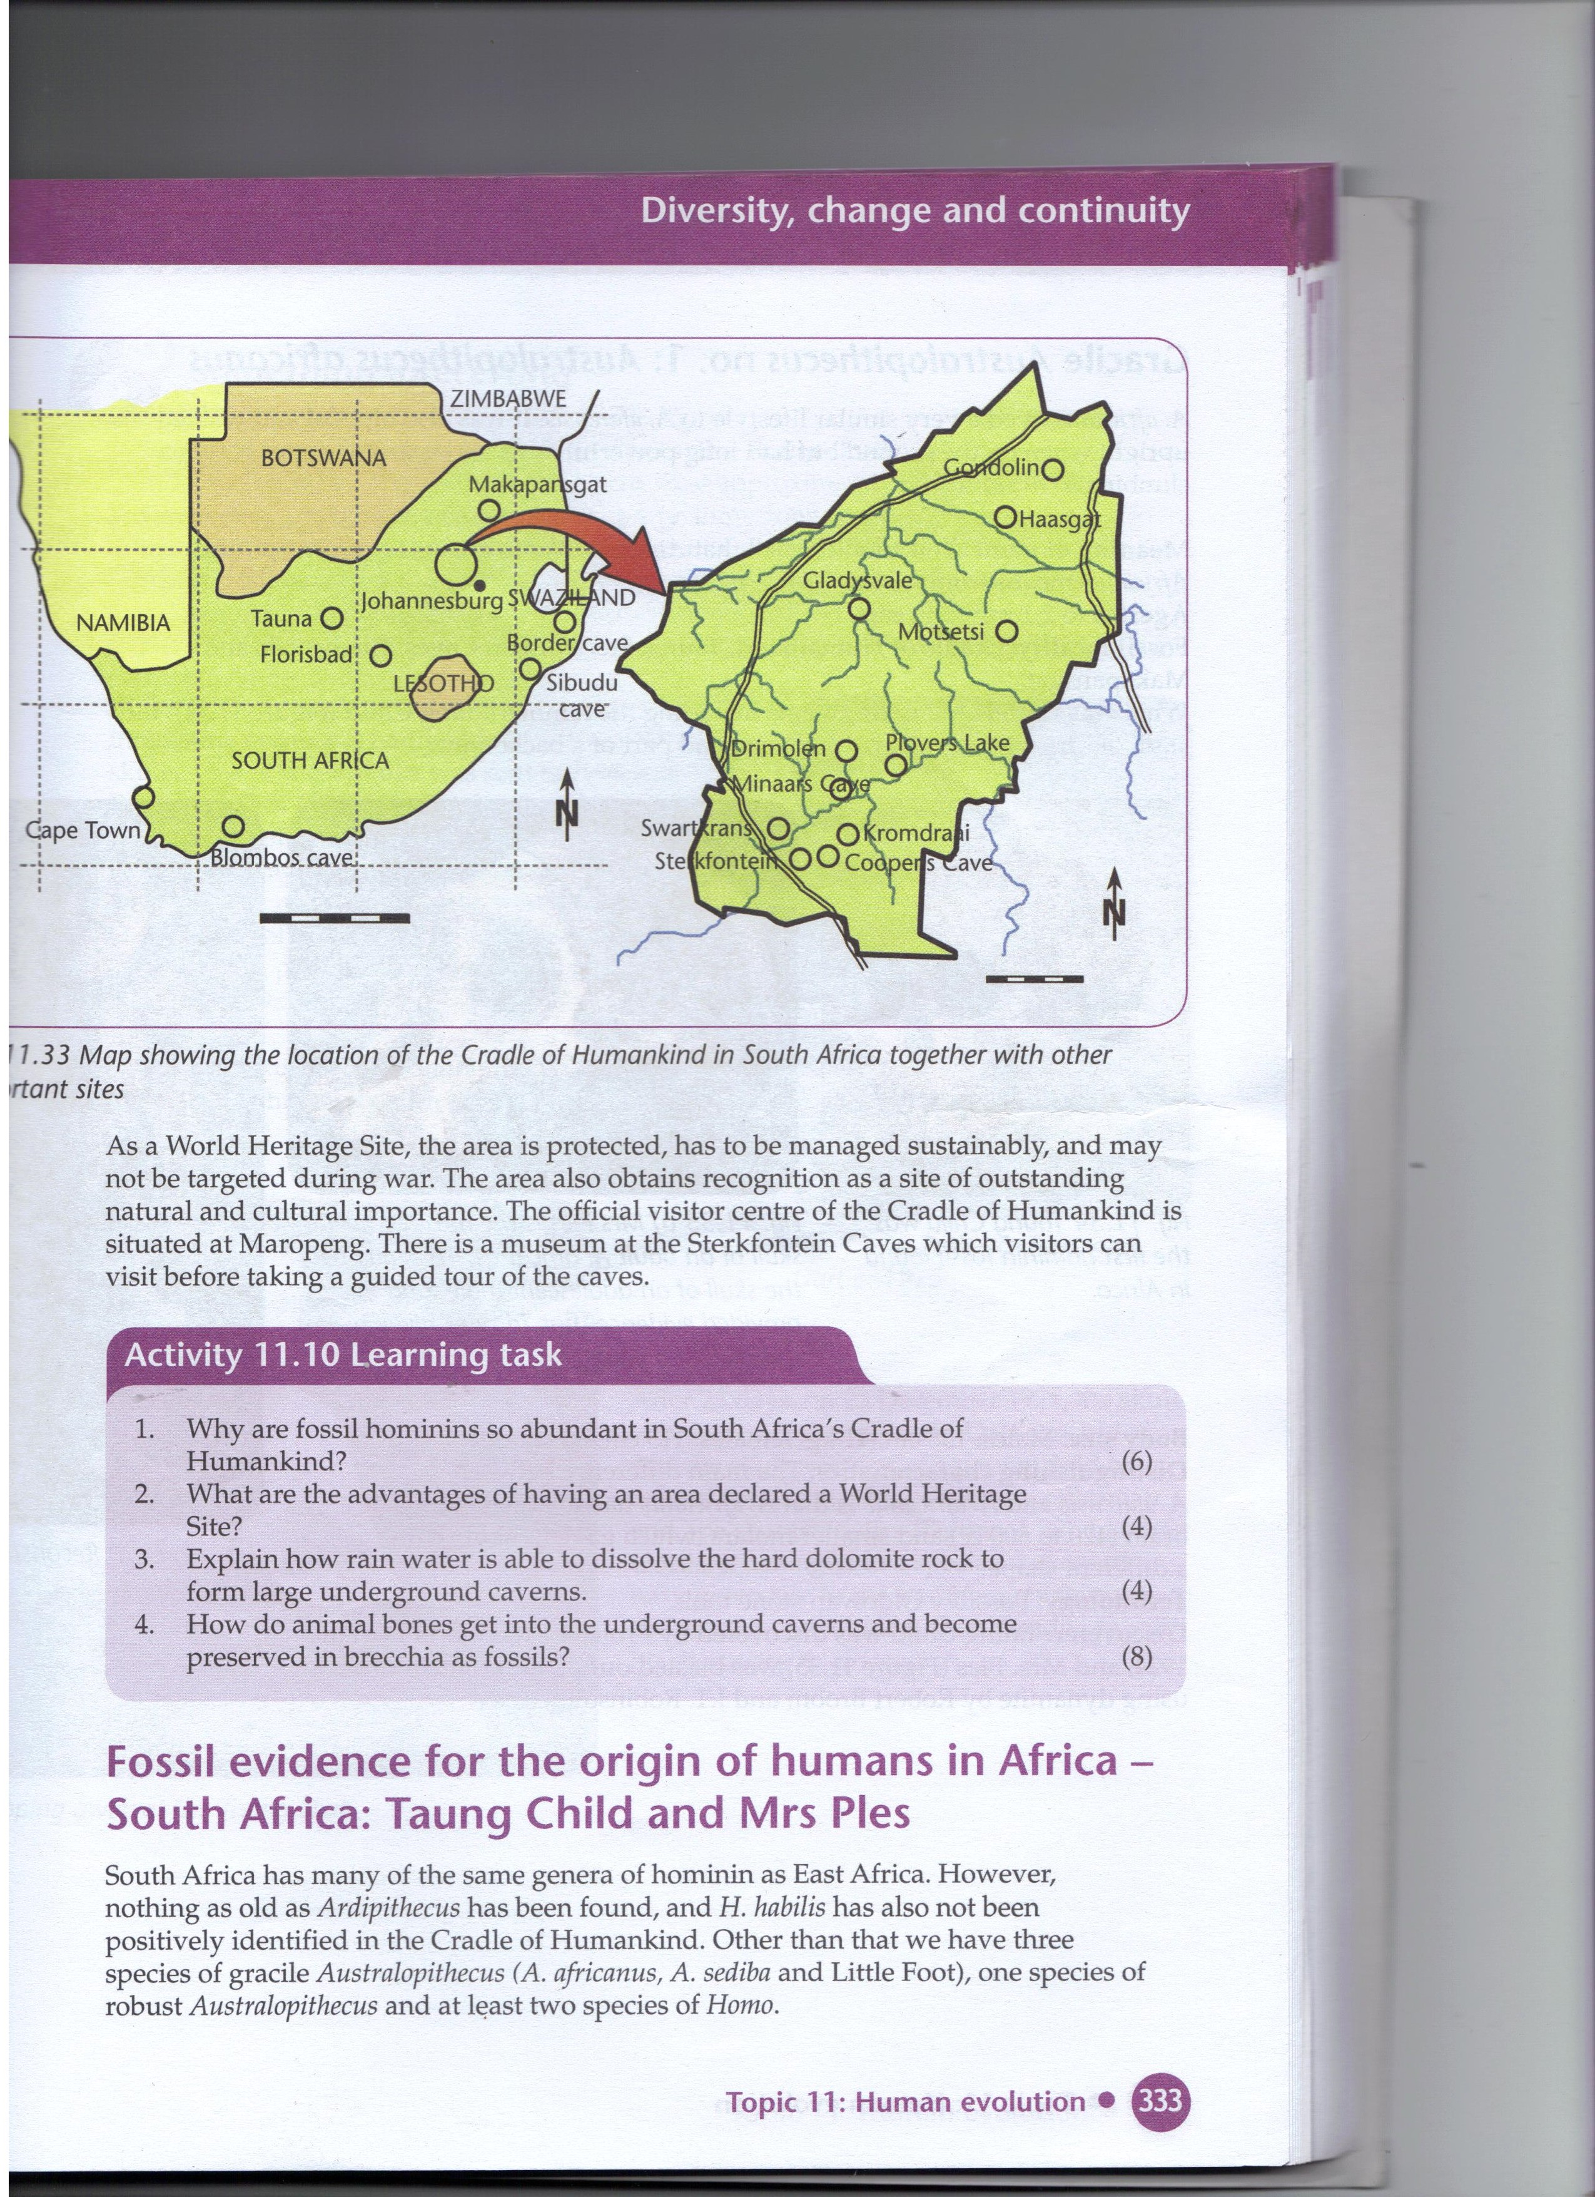  1. Ardipithecus ramidus -(Ardi)  4-5 million years ago in Eastern Africa Ethiopia.(middle Awash river valley)  Discovered by Tim White in 1994  Small brain 300-350cm3  More prognathism- pointed face poorly developed chin  Grasping big toe (swing from branch to branch on trees)  Skeleton adapted for bipedalism as well.  2. Australopithecines originates from two words :  Austral meaning southern and pithecus meaning ape – man.  There three Australopithecus fossils are :  a)Australopithecus afarensis ( lived 3,6 mya) – came from “afar” which means Out of Africa.  It was discovered in Ethiopia  It was named “ Lucy” and discovered by an American paleoanthropologist  Australopithecius afarensis was a first bipedal primate.  It had a mixture of human and ape-like features and lived on the Savannah woodland. This fossil has a small body size, small canines indicating a diet of nuts, fruits and seeds, big toes in line with other toes as in humans and a protruding jaw and face.It had long arms for climbing trees to escape predators.  b) Australopithecus africanus- lived about 3,2 mya.  Three such fossils were found in the Sterkfontein Caves in South Africa  Tuang child, Mrs Ples and Little Foot are examples of Australopithecus africanus fossils  They lived in the savannah woodland of South Africa.  They had a long arms for climbing trees , a small brain size similar to apes, Foramen magnum and a S- shaped spine under/ ventral part of skull indicating they were bipedal .  Laetoli Footprints- these were footprints found in hardened volcanic ash in Tanzania. It had footprints of the Autralopithecus or hominid species.  There toe features was like that of humans who do not wear shoes.  These footprints were discovered 3,6 mya.  The Laetoli footprint is an example of a cast fossil.  c) Australopithecus sediba or Karabo (lived about 1. 9 mya) – discovered on 15August 2008 by palaeontologist Lee Burger, 9 yr. old son in South Africa. Lee Burger is a scientist at the Univ. of Witwatersrand.  Sediba means “natural well” or “spring” in Sotho as these fossils were discovered near a deep well. They were fossilised in lime rich sand.  Conclusion:  Learners have to do questions from past papers regarding this topic. | Learners respond to questions on evolution asked by educator.  Learners draw a concept map of the Australopithecines to summarise information using educator’s explanations and textbooks.  earners write down important points on advantages of bipedalism from their textbooks. | 10 min  10 min  10 min  10 min | SIIP Booklets for 2014 compiled Question papers and answer booklets  Worksheets on cloning  CAPS 12 Life science –Solutions for All by McMillan- pg 275  Focus on Life science CAPS Gr 12 by Maskew Miller  Understanding Life science Gr.12 by T Isaac – 3rd Edition  Life Science Gr 12 – Top Class by Shuter’s (CAPS)  Via Afrika (CAPS) Life science Gr 12 -

Reflection/Notes:

Name of Teacher: |  | HOD:
Sign: |  | Sign:
Date: |  | Date:

