GRADE | 12 | SUBJECT |  | LIFE SCIENCES |  | WEEK |  | 27 |  | TOPIC | HUMAN ORIGINS: Homo species  Time: 40 min |  | Lesson | 4
LESSON SUMMARY FOR: DATE STARTED: |  |  |  |  |  |  |  |  | DATE COMPLETED:
LESSON OBJECTIVES |  |  | The learners must be able to :  - List the THREE Homo species  - State the structural features of the Homo species  • Give examples of Homo species

TEACHER ACTIVITIES | LEARNER ACTIVITIES | TIMING | RESOURCES NEEDED
Introduction  Revise the all work on Australopithecus genus discussed in previous lessons. Educator checks whether all learners have done a mind- map or concept map on Australopithecus genus.  Main Body / Presentation  Educator explains that :  About 2,5 mya there was a more human like hominid species that appeared.  They had larger and more complex brains. There brow ridges were smaller, with smaller faces and no ridges on top of skull.  Their dentition indicated a diet which comprised of more meat than fruits and seeds. It is thought they have evolved from the recent Australopithecus genus, which was light- boned. There were 3 homo species :  The 1st is the  - Homo habilis ( handyman) 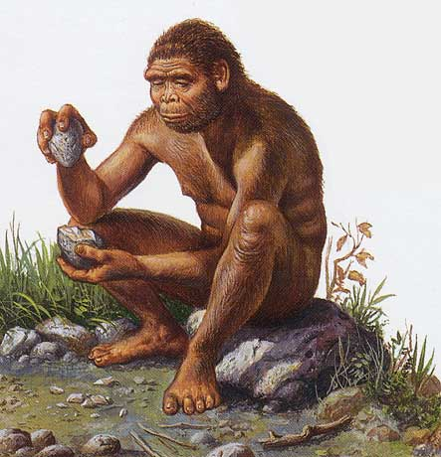  - Used stone tools. He migarted to East Africa, hunted animals. Making of tools required intelligence and dexterity. Brain size was big. Pronounced brow ridges, big toe in line with other toes as in humans, small generalised teth, legs positioned upright for walking. Lightly built rounded skull.  - The 2nd is the :  - Homo erectus or Java man (upright man)- lived 2 mya.  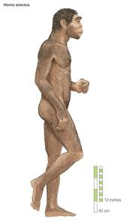  He evolved in Africa and moved out of Africa into Asia, Europe and Indonesia. They were tall as humans but more strongly built.  Made more complex tools. Had a frightening appearance as they were more heavily boned and built. Needed to be strong to survive cold Europe climate. Modern hands, bipedal, strongly built jaw, thick shelf- like brow ridges.  The 3rd is : Homo Neanderthalensis evolved 200 000 years ago  They are the humans’ closest ancestral relative. They were bipedal and had hands like modern humans. It was discovered in a limestone valley in Neander Valley in Germany. They brain capacity was large and the skull had no ridges. The femoral bone and pelvic bones were strong indicating that they spent most of the time on foot.  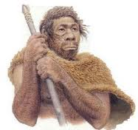  Conclusion:  The last of the homo species is the :  Homo sapiens (wise man or Floribad man) : Originated 100 000 ya till present.  Educator explains that we (modern man) is a Homo sapiens and that our first human ancestor originated 100 000 ya. Homo sapiens have a larger cranium which is more rounded and smoother. The jaw is slightly curved with very short canines.  Homework:  Learners have to do questions from past papers regarding this topic. this should include questions with phylogenetic trees | Learners respond to questions on Australopithecus from concept map drawn.  Learners draw a concept map of the Homo species to summarise information using educator’s explanations and textbooks.  Learners must analyse the pictures of these skulls and state which of these belongs to Australopithecus species, humans, Homo species, or apes  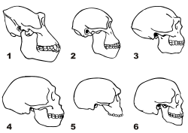  ANSWERS :  - Gorilla  - Australopithecus afarensis  - Australopithecus africanus  - Homo habilis  - Homo erectus  - Homo sapiens( human)  Learners write down important points in their workbooks and incorporate as part of the mind – map on different Homo species.  Allow time for learners to discuss and ask questions as this lesson may spark interest in them.  Learners must be able to make a comparison amongst all hominids and hominins from diagrams / data given to them.  Learners have to do questions from past papers regarding this topic. this should include questions with phylogenetic trees | 10 min  15 min  15 min | SIPP Booklets for 2014 compiled Question papers and answer booklets  Worksheets on cloning  CAPS 12 Life science –Solutions for All by McMillan- pg 275  Focus on Life science CAPS Gr 12 by Maskew Miller  Understanding Life science Gr.12 by T Isaac – 3rd Edition  Life Science Gr 12 – Top Class by Shuter’s (CAPS)  Via Afrika (CAPS) Life science Gr 12 -

Reflection/Notes:

Name of Teacher: |  | HOD:
Sign: |  | Sign:
Date: |  | Date:

