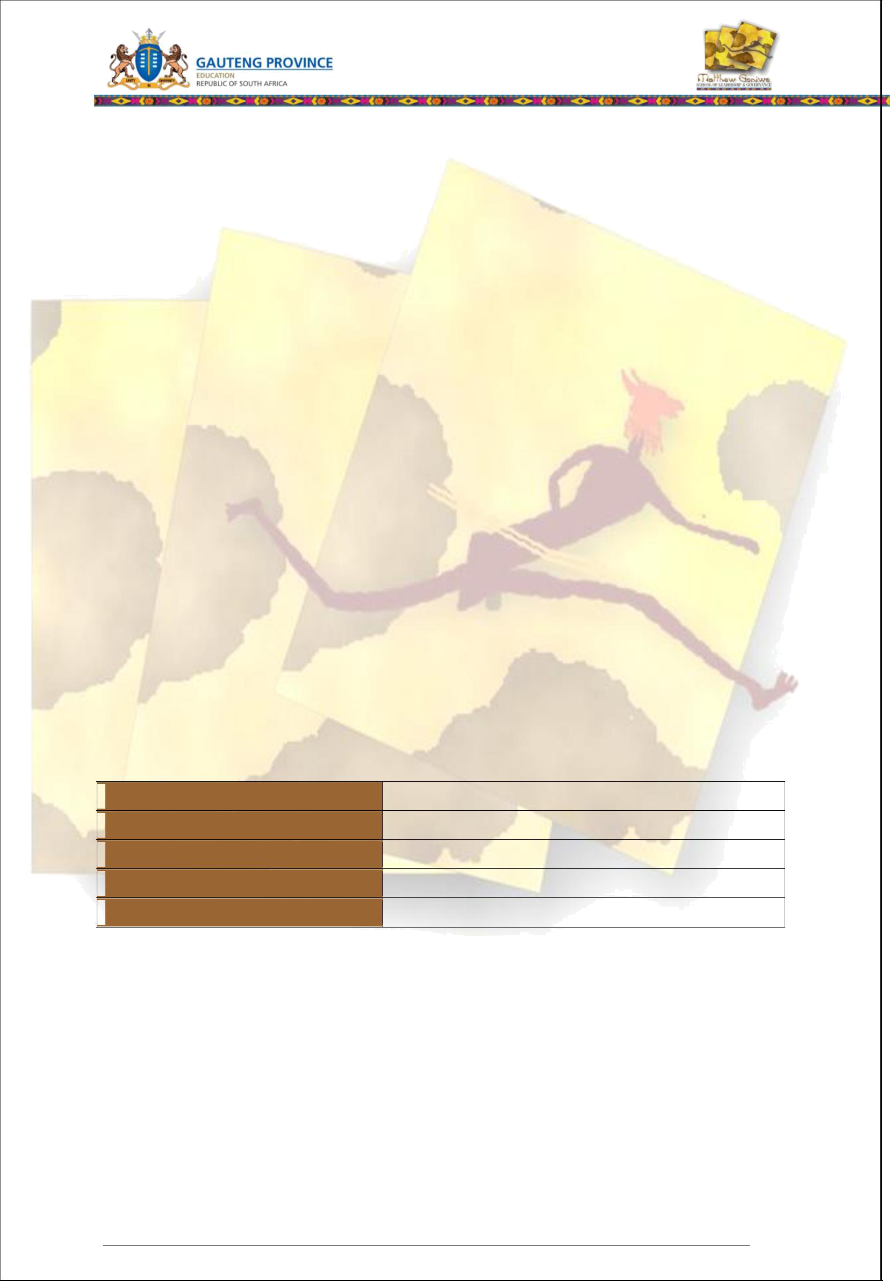

Learner Workbook

Module 4: Facilitate and monitor development in ECD

Learner Name and Surname

Learner ID

Company/Branch

Date

Learner Signature

SAQA ID 244480: Facilitate the holistic development of babies, toddlers and young children; NQF Level 4, 16 Credits SAQA ID 244468: Prepare resources and set up the environment to support the development of babies, toddlers and young children; NQF Level 3, 5 Credits SAQA ID 244475: Observe and report on child development; NQF Level 4, 6 Credits

SAQA ID 119462: Engage in sustained oral/signed communication and evaluate spoken/signed texts; NQF Level 4, 5 Credits

Version 1 (April 2013) Learner Workbook 1

Version 1 (April 2013) Learner Workbook 2
Table of Contents

CLASS ACTIVITIES 4

Class Activity 1: Facilitate development of babies, toddlers and young children 4

Class Activity 2: Identify activities to support the development of babies, toddlers and young

children 7

Class Activity 3: Source and select resources 10

Class Activity 4: Adapt resources 14

Class Activity 5: Set up the learning environment 17

Class Activity 6: Store materials and physical resources 19

Class Activity 7: Facilitate the development of babies, toddlers and young children 21

Class Activity 8: Ensure that communication promotes development 25

Class Activity 9: Use appropriate behaviour and conflict management 27

Class Activity 10: Reflect on own facilitation 30

Class Activity 11: Evaluate spoken discourse 34

Class Activity 12: Reflect on the use and effectiveness of the resources 35

Class Activity 13: Observe and report on child development 37

Reflection 45

Facilitator Observation Checklist 47

Version 1 (April 2013) Learner Workbook 3
Facilitation Agenda Day 9

Class Activities

During and after the initial training the learner will be required to complete a number of activities. These activities will be both individual and group activities (class activities formative activities). The activities are numbered and are to be included in the learner's Portfolio of Evidence. These activities will measure the progress of the learner through the programme. For authenticity reasons these activities must be handwritten.


Class Activity 1: Facilitate development of babies, toddlers and young children

Please follow the instructions from the facilitator to complete the formative activity:

244480.1.1

244480.1.2

244480.1.3
244480.1.4

- Rank yourself on a scale of 0 (not at all) to 5 (always) to assess whether you have a good understanding of how to facilitate the development of the children in your ECD centre (answer as honestly as possible):

 |  | How I facilitate the development of the children in the |  |  | 0 | 1 | 2 | 3 | 4 | 5
 |  | ECD centre:
 | 1. |  | I answer all questions from the children as patiently
 |  |  | and as honestly as possible.
 | 2. |  | I provide a display board where the child can show off
 |  |  | his/her work.
 | 3. |  | I am prepared to tolerate an untidy work area if the
 |  |  | children have not yet completed some creative task
 |  |  | (painting, modelling, etc.)
 | 4. |  | I show the children he/she is loved for own sake and
 |  |  | not for achievements
 | 5. |  | I give the children responsibilities suitable to age.
 | 6. |  | I help him/her to make own plans and decisions.
 | 7. |  | I take the children on trips to places of interest.
 | 8. |  | I teach the children how to improve on the tasks he/she
 |  |  | does.
 | 9. |  | I encourage the children to get along with children from
 |  |  | different backgrounds.
 | 10. |  | I set a reasonable standard of behaviour and see the
 |  |  | children follow it.
 | 11. |  | I never compare the children unfavourably to other
 |  |  | children.
 | 12. |  | I never denigrate/insult the children as a form of
 |  |  | punishment.
 | 13. |  | I provide books for the children.
 | 14. |  | I encourage the children to think things out for
 |  |  | themselves.
 | 15. |  | I regularly read to the children.

Version 1 (April 2013) Learner Workbook 4

Facilitation Agenda Day 9

  - I teach the children early reading habits.

  - I give careful consideration to the individual needs of each child.

  - I never mock the child for making a mistake.

  - I encourage the children to remember stories, poems and songs.

  - I encourage the children to be sociable with adults of all ages.

  - I devise practical experiments to help the children find out about things.

  - I look for specific things to praise in the children's activities.

  - I avoid general praise that I do not really mean.

  - I provide opportunities for real decision-making by the children.

  - I encourage the children to be individuals.

  - I never dismiss failures by the children with the comment "I can't do it either‟.

  - I encourage the children to be as independent of adults as possible.

  - I would sooner the child failed by him/herself than succeeded because I did most of the work

- Identify and list your own areas for improvement from the activity above:

Version 1 (April 2013) Learner Workbook 5

Facilitation Agenda Day 9

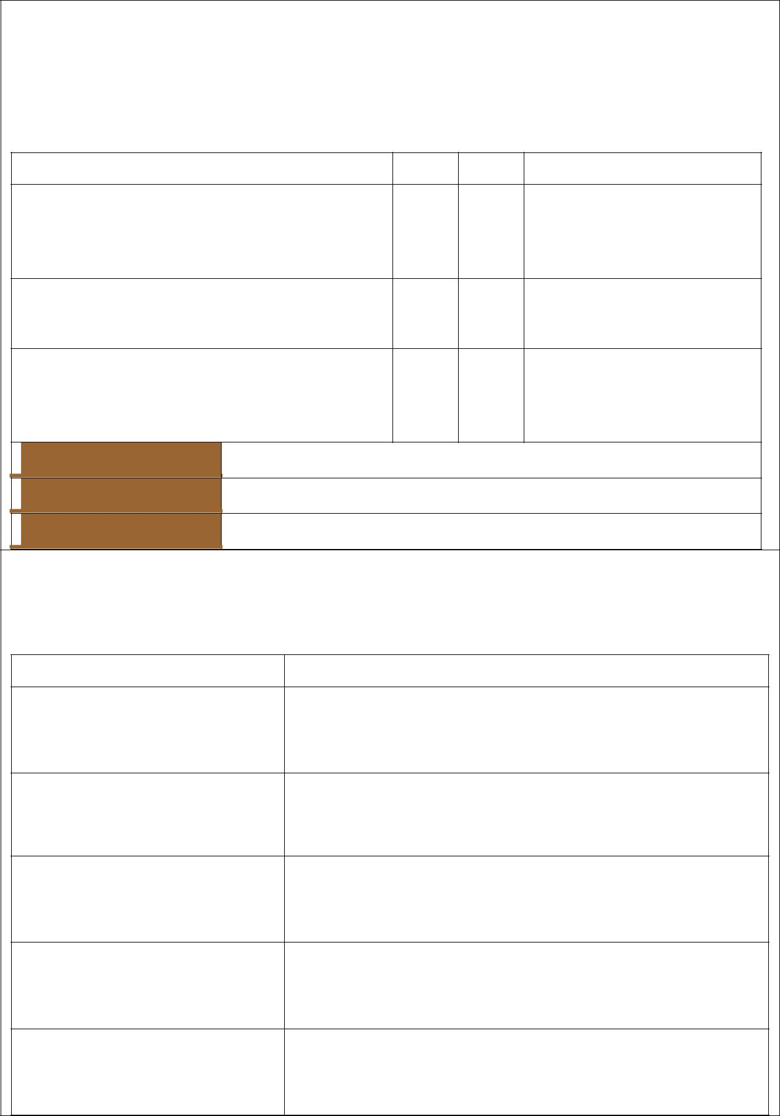
- With your partner, discuss your respective “weaknesses”/ areas for improvement. Compare similarities and differences. Write down three ( 3) strategies that both of you feel will improve your facilitation:

Sign each other's answers to verify that you have agreed on the strategies written down:

The learner has correctly: |  | Yes | No |  | Comment

identified three (3) strategies to facilitate development of the children in an ECD centre

selected strategies that are educationally sound

selected strategies that are recommended by policies of both ECD centre and Government

Name of member

Signature

Date

- The following incidents happen at your ECD centre. Explain how you can use them as teachable moments. What will you teach?

Observed activity |  | Teachable perspective

It's been raining all day and children are becoming restless

Watching a spider spinning a web

Arguing about a scarce toy

Dropping puzzle pieces on the floor

A toddler getting onto a rocking horse

Place any extra evidence after this page; mark it clearly for easy reference.

Version 1 (April 2013) Learner Workbook 6

Facilitation Agenda Day 9

Class Activity 2: Identify activities to support the | 244468.1.1
development of babies, toddlers and young children | 244468.1.2
Please follow the instructions from the facilitator to | 244480.1.1
complete the formative activity:

- “Through play, children practise the roles they will play later in life.” In your group, discuss this statement and how the ECD practitioner can exert a positive influence in this regard:

2. Study the following daily programme and then answer the questions set below:

06:30 | - 08:00 | Arrival & free play
08:00 | – 08:30 | Breakfast
08:30 | – 09:00 | Morning ring
09:00 | – 10:00 | Indoor free play
10:00 | – 10:10 | Tidy up time
10:10 | – 11:10 | Outdoor free play
11:10 | – 11:30 | Music and movement
11:30 | – 11:40 | Toilet time
11:40 | – 12:00 | Story
12:00 | – 12:30 | Lunch
12:30 | – 12:40 | Tidy up
12:40 | – 14:30 | Rest
14:30 | – 15:00 | Wake up/toilet/snack time
15:00 | – 16:30 | Outdoor free play/Departure time

- Identify the age group for whom this is an appropriate daily programme.

- Explain why you say this is an appropriate programme for this age group:

Version 1 (April 2013) Learner Workbook 7

Facilitation Agenda Day 9

- In your group, brainstorm three (3) indoor and three (3) outdoor activities that are fun, relevant and meaningful to the life-world of the children and that can be incorporated into the daily programme:

- Lerato has saved enough money to buy toys and resources for the ECD centre. She chooses two items for babies under one year old, two for ages
2–3, and two more items for ages 4–6.

  - With your partner, think of developmentally appropriate toys for the different age groups, and recommend good resources for Lerato's group:

Two items for babies under one year old

Two items for ages 2–3

Two items for ages 4–6

- Now work alone to choose one of these resources to create a fun game or activity that the older children (age 4–6) would enjoy. Decide what fun element you could include.

- Present the activity to the group and explain:

  - What makes it developmentally appropriate for that age group? Which skills and abilities does it develop?

Version 1 (April 2013) Learner Workbook 8

Facilitation Agenda Day 9

• What makes the activity fun?

- Ask two members to sign off that you have met the criteria:

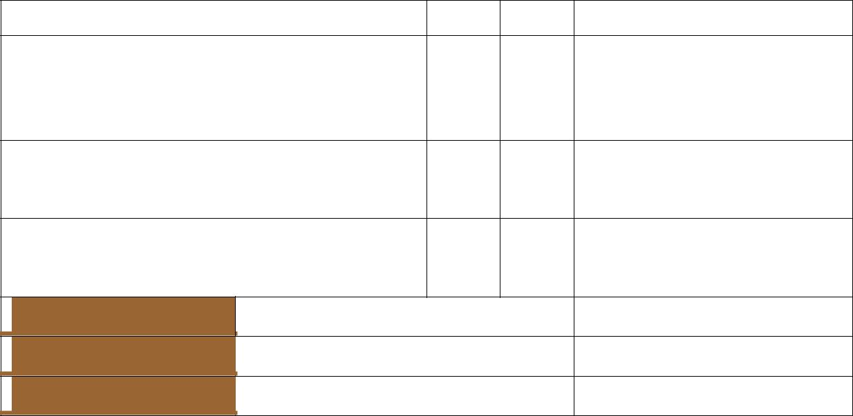
The learner has correctly: |  | Yes | No |  | Comment

explained what makes it developmentally appropriate for that age group

explained which skills and abilities it develops

explained why the children will find the activity fun

Name of member

Signature

Date

Place any extra evidence after this page; mark it clearly for easy reference.

Version 1 (April 2013) Learner Workbook 9

Facilitation Agenda Day 9

Class Activity 3: Source and select resources | 244468.1.3
Class Activity 3: Source and select resources | 244468.2.1
Please follow the instructions from the facilitator to | 244468.2.2
complete the formative activity: | 244468.2.3
 | 244468.2.4

1. Define the concept of “resources” as used in relation to play in an ECD centre:

- List five (5) criteria that you will you to determine whether resources selected are appropriate for use in planned activities and support their identified purpose:

- Draw up a 10-point checklist that you will use to check toys and games for safety:

 |  |  | There is/are NO: |  | 

Version 1 (April 2013) Learner Workbook 10

Facilitation Agenda Day 9

- Draw up a 10-point checklist that you will use to check fixed outdoor equipment for safety:

 |  | Safety Criteria: |  | 

- Analyse the following resources in terms of their suitability for a 4-year-old in an ECD centre in an impoverished area in Mpumalanga. Rank them from 1 (most suitable) to 3 (least suitable) and give a reason for your answer:

 |  | Resource | Comment on suitability:

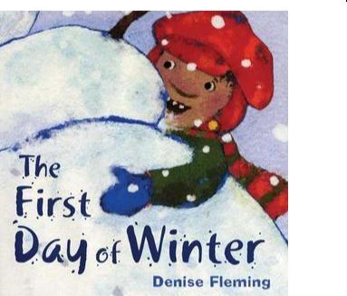

Version 1 (April 2013) Learner Workbook 11

Facilitation Agenda Day 9
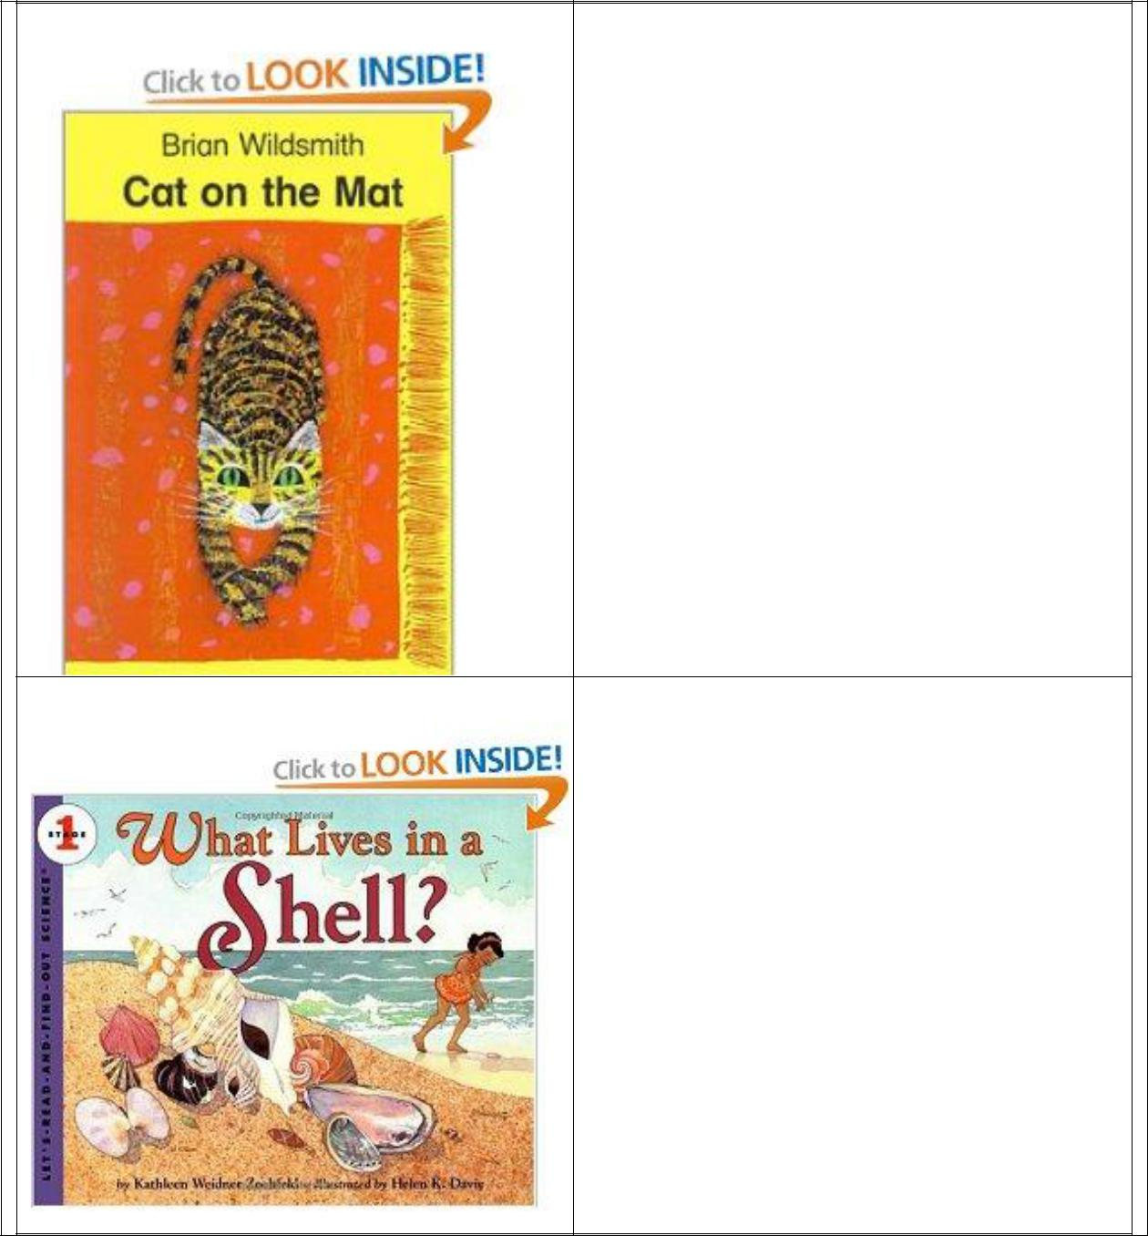

Version 1 (April 2013) Learner Workbook 12

Facilitation Agenda Day 9
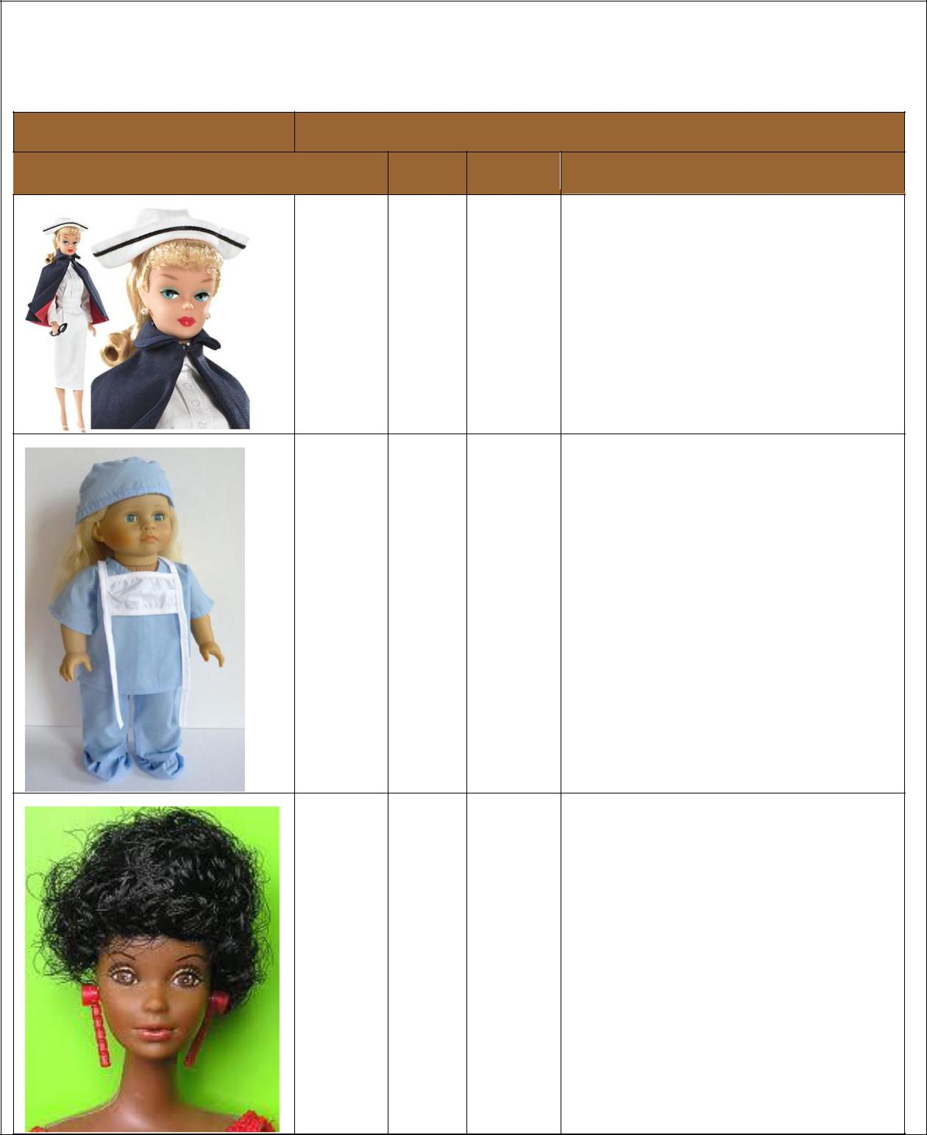

- Analyse the following resources that are going to be donated to a township ECD centre to check if they are suitable and free from cultural, race and gender bias:

Resource |  | Cultural, race or gender bias
Toy | Culture | Race | Gender | Comment

Place any extra evidence after this page; mark it clearly for easy reference.

Version 1 (April 2013) Learner Workbook 13

Facilitation Agenda Day 9

Class Activity 4: Adapt resources | 244468.3.1
Class Activity 4: Adapt resources | 244468.3.2
Please follow the instructions from the facilitator to | 244468.3.3
complete the formative activity: | 244468.3.4
 | 244468.3.5
 | 244468.3.6
- Make suggestions on how to adapt at least three (3) of the resources you have in your classroom so that they are suited to children with special needs:

- Adapt the following poster so that it is more suitable for your class. Your theme is “How to look after our pets”.

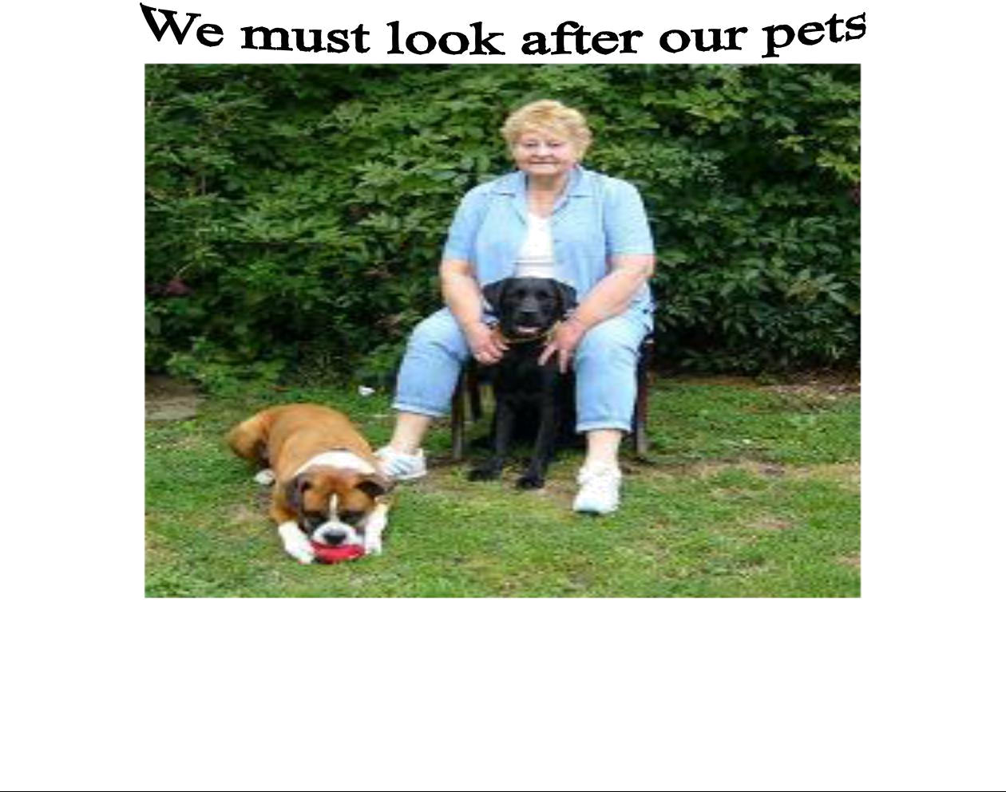

Version 1 (April 2013) Learner Workbook 14

Facilitation Agenda Day 9

Describe your new poster which will be more suitable and will meet the following criteria:

- Adapted resources are appropriate for use in planned activities and support the identified purposes.

- Adapted resources are safe and durable.

- Adaptations help to strike a balance between the familiar and unfamiliar, thus providing consistency and challenge for the children in their life-world experiences,

- Adaptations are free from cultural, race and gender bias.

- Adaptations are appropriate to the developmental needs and interests of the children.

Description of my new poster:

Version 1 (April 2013) Learner Workbook 15

Facilitation Agenda Day 9

Use this page to draw a rough draft of the poster:

Place any extra evidence after this page; mark it clearly for easy reference.

Version 1 (April 2013) Learner Workbook 16

Facilitation Agenda Day 9

Class Activity 5: Set up the learning environment | 244468.4.1
Class Activity 5: Set up the learning environment | 244468.4.2
Please follow the instructions from the facilitator to | 244468.4.3
complete the formative activity: | 244468.4.4


- You want to continue with the theme of caring for animals. Plan extensions to any two of the following learning areas: book, block, numeracy, literacy or fantasy

  - Make a drawing showing how the area will be set up. Label the drawing to show that the environment is conducive to sensory and motor exploration, allowing children to apply their knowledge and to make meaning:

Version 1 (April 2013) Learner Workbook 17

Facilitation Agenda Day 9
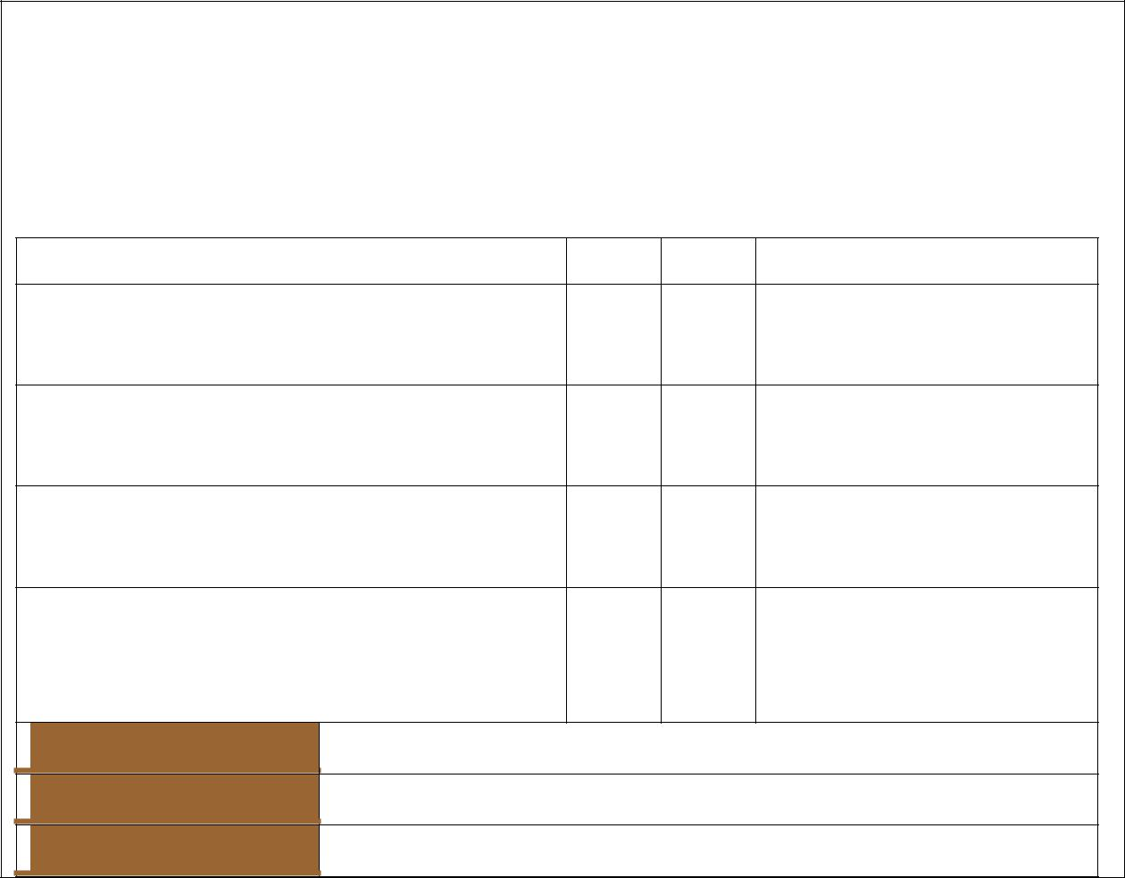

- Present your plan to your partner and explain how you have considered the sensory-motor needs, the space available, the health and safety of the children. Ask your partner to evaluate your plan and fill in the following form:

The learner has correctly: |  | Yes | No |  | Comment

considered the sensory-motor needs of the children

utilised the space available

ensured that the environment is safe and healthy

taken into account the particular requirements of the ages and special needs of the children

Name of member

Signature

Date

Place any extra evidence after this page; mark it clearly for easy reference.

Version 1 (April 2013) Learner Workbook 18

Facilitation Agenda Day 9


Class Activity 6: Store materials and physical

_{resources} 244468.4.5 244468.4.3

Please follow the instructions from the facilitator to complete the formative activity:

- Find pictures of inexpensive storage ideas for your classroom and paste them here:

2. Make a list of the materials and physical resources that you need to store:

Version 1 (April 2013) Learner Workbook 19

Facilitation Agenda Day 9

3. List storage options that you have available to keep items safe yet accessible:

- Using the materials made available to you by the facilitator, create a simple storage unit for magazines or paper:

  - Ask your partner to evaluate your storage unit and fill in the following form:

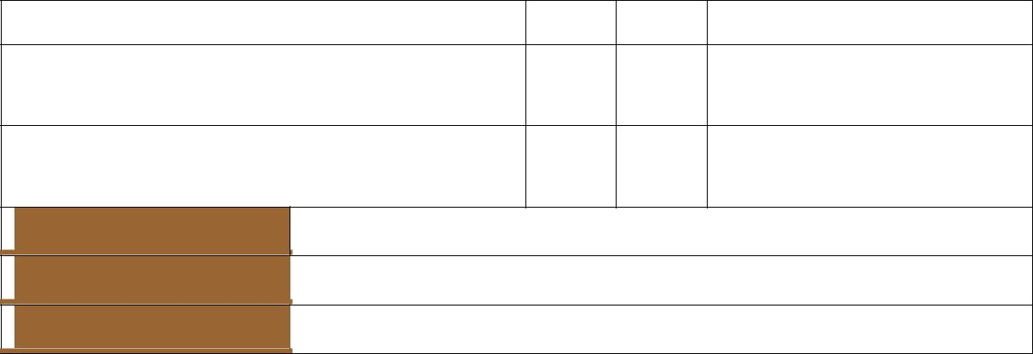
The learner has correctly: |  | Yes | No |  | Comment

stored materials and physical resources in an organised manner

stored materials and physical resources in an accessible manner
Name of member

Signature

Date

Place any extra evidence after this page; mark it clearly for easy reference.

Version 1 (April 2013) Learner Workbook 20

Facilitation Agenda Day 9


Class Activity 7: Facilitate the development of babies, toddlers and young children

Please follow the instructions from the facilitator to complete the formative activity:

244480.1.5
244480.1.8

244480.1.9
244480.1.10

- Identify the domains that are developed by the following resources in each age group:

  - physical (gross and fine motor development)

  - cognitive (language and sensory development)

  - socio-emotional (addressing psychological and emotional development)



Mobiles for babies

Child-safe activity mirrors for babies

Simple puzzles for toddlers

Small tricycles and wagons for toddlers

Dress-up with accessories for young children

Puppets for young children

Version 1 (April 2013) Learner Workbook 21

Facilitation Agenda Day 9


- Below we have listed one toy from each age group. With your partner design an indoor activity that develops the child holistically, ensuring the children‟s physical and emotional safety, security and comfort:

 | Toy and age of |  | Description of activity | How it develops a particular
 | child |  |  | domain

Mobile for baby

Simple puzzles for toddlers

Puppets for young children

- In your group, brainstorm a list of “good manners” that children should be taught/modelled:

Version 1 (April 2013) Learner Workbook 22

Facilitation Agenda Day 9

- Work with your partner to create an activity for each developmental age group (babies, toddlers and young children) to teach a particular aspect of “good manners”.


Age group | Activity description

Babies

Toddlers

Young children

5. Consider the following case study and then answer the questions that follow:

Three-year-old Janey neglects washing her hands after going to the toilet and if you try to wash them for her, she puts them behind her back and starts to cry. The other children tease her about being “dirty”.

Work on your own and then swap answers with your partner to evaluate the work.

- How can you make hand washing more enjoyable so that Janey does a better job of washing her hands? Make up a response or a game that you could suggest to Janey on the spot the next time she goes to the toilet.

- How could you use Janey‟s hand-washing activity to promote good hand-washing for the whole group? Write this up as a group activity for circle time.

- How can the teasing by the other children be used as a teachable moment?

Version 1 (April 2013) Learner Workbook 23

Facilitation Agenda Day 9

d) Rate each of your answers on a scale of 1–4 for a good answer, where 1= not enough useful guidance

2 = some good ideas but needs more work

3 = good ideas and practical too

4 = excellent and fun ideas, easy to do

Report your findings you are the most proud of to the class. Make your notes here:

Place any extra evidence after this page; mark it clearly for easy reference.

Version 1 (April 2013) Learner Workbook 24

Class Activities

Class Activity 8: Ensure that communication | 244480.1.6
Class Activity 8: Ensure that communication | 244480.1.7
promotes development | 119462.1.1
Please follow the instructions from the facilitator to | 119462.1.3
complete the formative activity: | 119462.1.4
- Select the one correct answer to each of the following questions:

  - Children's language development unfolds with physical development and is not dependent on verbal input from care-givers.

    - True
    - False

    - Somewhat true

  - By allowing the child freedom of expression in story telling situations and creative activities like art, the facilitator is encouraging antisocial and undisciplined behaviour.

      - True

      - False

      - Sometimes true

  - When the facilitator responds warmly to the child in verbal or nonverbal interactions, the child's sense of security and confidence with regard to the developmental task is

      - improved
      - damaged

      - not affected at all

  - Using humour to a child is a useful way of defusing situations where a child might otherwise feel criticised.

      - True
      - False
      - Humour is sometimes disrespectful.

  - The most important part of communicating with a child is

      - listening with attention (active listening)
      - engaging the child in conversations
      - using stories

If you are unsure about any of the answers, discuss them with your mentor.

- Research how children can learn to communicate effectively in every activity and present your findings to the class in the form of a short speech:

  - Ask your partner to assess your presentation according to the following rubric. She or he must also give you constructive feedback:

25

 | Learner Signature | Date
Version 1 | Learner Workbook

 |  |  |  |  |  | Class Activities
 | Criteria for effective presentations |  |  | 1 | 3 |  | 5
 | Speaker's style and tone attract the audience.
 | Content is factual and accurate.
 | Tone, register and pitch are appropriate for informative
 | presentation.
 | Body language is friendly and adds to the interest of the
 | presentation.
 |  | TOTAL/ 20:
 | Name of member
 | Signature
 | Date
 | Feedback

Place any extra evidence after this page; mark it clearly for easy reference.

26

 | Learner Signature | Date
Version 1 | Learner Workbook

Class Activities


Class Activity 9: Use appropriate behaviour and conflict management

Please follow the instructions from the facilitator to complete the formative activity:

244480.1.11

119462.1.2

119462.2.2

119462.2.3

- Work with a partner. Read the following example and discuss your answers with your partner.

Busi, age 3, is very withdrawn and cries every time her mother drops her off in the mornings. In the afternoons when she comes to fetch her, you hear her saying things like, “I didn’t like the singing and I didn’t like Daniel pushing me over.” She does not report any positive events to her mother and does not respond positively to friendly gestures from the other children.

- In what way could you express something positive to Busi about herself? Try to identify both verbal and non-verbal responses that would be positive.

- In what way could you reward Busi for saying positive things? Try to identify both verbal and non-verbal ways of rewarding her.

- What kind of activities would help Busi make friends at the ECD centre?

27

 | Learner Signature | Date
Version 1 | Learner Workbook

Class Activities

- You have noticed that Michael regularly soils himself and you need to decide how to handle the problem. With your partner answer the following questions:

  - Why is it inappropriate for a three-year-old child to be soiling himself so often?

  - What are your guesses about why he is doing so?

  - Is it helpful to punish a child for lack of control over bowel movements? Explain how you will handle this issue.

  - Identify the steps to take if you are feeling frustrated or unable to cope with any of the children's behaviour in your ECD centre.

  - Name the support systems that are available to you both at your place of work and at home, to avoid your frustrations reaching a breaking point.

28

 | Learner Signature | Date
Version 1 | Learner Workbook

Class Activities

- Identify a conflict situation that has happened recently at the ECD centre and describe it to your partner. Take turns to role-play a facilitator's good response to the two children involved in the conflict situation, using the skills identified in the rubric below. Take turns to observe the response and make notes about the strategies and responses used by the "facilitator".

 | The learner has correctly: |  | Yes | No | Comment
 | managed his/her own feelings
 | allowed children's feelings to be
 | expressed
 | helped the children to articulate and
 | name feelings
 | separated feelings and behaviour
 | suggested a creative outlet for feelings
 | managed destructive or inappropriate
 | behaviour through limit-setting and
 | encouragement of alternative behaviour
 | Name of member
 | Signature
 | Date
- Explain the concept of “managing feelings” and how you would use it in your
ECD centre:

Place any extra evidence after this page; mark it clearly for easy reference.

29

 | Learner Signature | Date
Version 1 | Learner Workbook

Class Activities


Class Activity 10: Reflect on own facilitation

Please follow the instructions from the facilitator to complete the formative activity:

244480.2

244475.2

244475 EEK1

- Learning Styles Self-Assessment Questionnaire: Circle or tick the answer that most represents how you generally behave.

- When I get a new television or DVD player I generally:

  - read the instructions first

  - ask someone to tell me how it works
  - turn it on and figure out how it works myself

- When I cook a new meal, I like to:

  - follow a written recipe

  - ask a friend how she cooks it
  - follow my instincts, testing as I cook

- I remember things best by:

  - writing notes or keeping printed details

  - saying them aloud or repeating words and key points in my head
  - doing and practising the activity or imagining it being done

- When I go shopping for clothes, I tend to:

  - imagine what they would look like on
  - discuss them with the shop staff

  - try them on and test them out

- If I was buying a new kettle, I would:

  - look at adverts
  - discuss what I need with my friends

  - test different types

- When I am learning a new skill, I am most comfortable:

  - watching what the teacher is doing
  - talking through with the teacher exactly what I‟m supposed to do

  - giving it a try myself and work it out as I go

- When I concentrate, I most often:

  - focus on the words or the pictures in front of me

  - discuss the problem and the possible solutions in my head

  - move around a lot, fiddle with pens and pencils and touch things
- I choose household furniture because I like:
  - their colours and how they look

  - the descriptions the sales-people give me
  - their textures and what it feels like to touch them

- My first memory is of:
  - looking at something

  - being spoken to
  - doing something

30

 | Learner Signature | Date
Version 1 | Learner Workbook

Class Activities

- When I am anxious, I:

  - visualise the worst-case scenarios

  - talk over in my head what worries me most
  - can't sit still; I fiddle and move around constantly

- When I have to revise for an exam, I generally:

  - write lots of revision notes and diagrams

  - talk over my notes, alone or with other people
  - imagine making the movement or creating the formula

- If I am explaining to someone I tend to:

  - show them what I mean

  - explain to them in different ways until they understand
  - encourage them to try and talk them through my idea as they do it

- I really love:

  - watching films, photography, looking at art or people watching

  - listening to music, the radio or talking to friends

  - taking part in sporting activities, eating fine foods or dancing

- Most of my free time is spent:

  - watching television
  - talking to friends

  - doing physical activity or making things

- When I first contact a new person, I usually:

  - arrange a face to face meeting
  - talk to them on the telephone

  - try to get together whilst doing something else, such as an activity or a meal

- I first notice how people:

  - look and dress
  - sound and speak

  - stand and move

- If I am angry, I tend to:

  - keep replaying in my mind what it is that has upset me
  - raise my voice and tell people how I feel

  - stamp about, slam doors and physically demonstrate my anger

- I find it easiest to remember:

  - faces
  - names

  - things I have done

- I think that you can tell if someone is lying if:
  - they avoid looking at you
  - their voices changes

  - they give me funny vibes

- When I meet an old friend:
  - I say “It's great to see you!”
  - I say “It's great to hear from you!”

  - I give them a hug or a handshake.

31

 | Learner Signature | Date
Version 1 | Learner Workbook

Class Activities

Now add up how many As, Bs and Cs you selected.

As = Bs = Cs =

Note: Your facilitator will explain the three learning styles related to your score.

- As a group write down as many behaviours or personal characteristics as you can think of which make someone a wonderful and effective ECD practitioner and what makes someone an ineffective ECD practitioner.

- Based on your self-assessment, reflect on the following, write down your answers and discuss them with your partner:

  - What am I sure of doing well?
  - What is the special quality or strength that I bring to my facilitation?
  - What is it that I suspect I need more knowledge and experience of?

  - What skill have I struggled with for a while and need help with, but am too afraid to ask?

  - Where can I get help for this neglected skill?

  - How can I use my special quality or strength to get help with this skill or to address it?

  - What praise would I like to hear from myself for my work?

32

 | Learner Signature | Date
Version 1 | Learner Workbook

Class Activities

- Write a brief report (1/2 page) to your supervisor/mentor in which you provide recommendations to build on your strengths and address your identified weaknesses in order to support future facilitation.

Place any extra evidence after this page; mark it clearly for easy reference.

33

 | Learner Signature | Date
Version 1 | Learner Workbook

Class Activities

Class Activity 11: Evaluate spoken discourse | 119462.2.1
Class Activity 11: Evaluate spoken discourse | 119462.4.2
Please follow the instructions from the facilitator to | 119462.4.2
Please follow the instructions from the facilitator to | 119462.4.4
complete the formative activity: | 119462.4.4
Have a discussion with your partner on a problem with resources in your ECD centre and what can be done about it. Ask a third learner to observe the discourse and sign off the following form to confirm that your contribution to the discussion is appropriate in relation to audience, purpose and context.

 | Learner |  |  |  |  |  |  | Date
 | Name
 | The impact (e.g. clarity of purpose,
 | speaker's/signer's capability) of your |  |  |  |  | Yes /
 | discourse is described, explained |  |  |  |  |  |  |  |  | Comments
 |  |  |  |  |  | No
 | and judged
 | Did the learner:
 | speak clearly and purposefully?
 | come across as
 | capable?
 | maintain audience
 | contact?
 | present his/her
 | points successfully?
 | Person Signature
 | Person Name
 | Person Designation
 | Person Contact
 | Details

Swap roles until you’ve all had a turn to evaluate spoken discourse.

Place any extra evidence after this page; mark it clearly for easy reference.

34

 | Learner Signature | Date
Version 1 | Learner Workbook

Class Activities

Class Activity 12: Reflect on the use and | 244468.5.1
effectiveness of the resources | 244468.5.2
effectiveness of the resources | 244468.5.3
Please follow the instructions from the facilitator to complete the formative activity: | 244468.5.3
 | 244468.5.4
1. Read the following article before answering the questions below:
Cotlands advocates for the essential right to education

Earlier this week the ruling party and teacher unions butted heads over the essentialness of education. While both make strong arguments it is often in debating education policies that we tend to forget the most important players in education are the children, and in order to correct our past mistakes we need to get back to basics, the basics being early childhood development.

It is estimated that over 83% of children in South Africa do not access any form of structured early childhood learning.

Of the 17% that do access Early Childhood Development (ECD) centres more than half have limited access to proper sanitation, inadequate access to stimulating resources or activities and are exposed to less than hygienic environments.

According to a study conducted by the UN in 2011, pupil to teacher ratios further hamper learning for children in ECD centres.

“A large number of schools have teacher-pupil ratios in excess of 40 in Grade R. Class sizes of this magnitude are problematic and do not meet the needs of early childhood development.”

These alarming statistics have impelled Cotlands to champion the right to education for all children in South Africa.

“It is imperative that we tackle the issue of early childhood learning with great urgency. If we, as a society do not address the problem that lies before us then we too contribute to infringement of the rights of thousands of children,” said Cotlands CEO, Jackie Schoeman.

Children with learning difficulties and/or disabilities are even more marginalised as resources for children with special needs become devastatingly scarce in low-income areas.

With limited resources and poor funding, children in rural and township areas have little chance of competing in the job market with children in more affluent regions. Children who do not receive access to learning opportunities early on will almost always be at a disadvantage and needing to “play catch up” throughout their academic years.

Cotlands maintains that while education is essential , declaring it an essential service to merely prevent teachers from striking without addressing the key problems serves no purpose. It is crucial that government, together with all stakeholders work towards reducing the teacher to pupil ratio, create facilities for children with learning difficulties as well as children with disabilities, increase access to early childhood development centres and address the issue of sanitation and nutrition at schools. Declaring education an essential service does not negate our responsibility to provide children with quality education.

“The basic principal is simple – children start their learning journey through play. For us it is essential that we create access to resources that will develop those skills needed for later learning and we do this through well-crafted play sessions or play with purpose,” added
Schoeman.

Cotlands has formulated play sessions that target vulnerable children who do not have access to ECD centres. The children’s organisation offers this essential service free to community children along with a nutrition program that addresses yet another imperative right.

“It is important that we strengthen the fabric of our society by allowing children access to the rights set out in our constitution. We encourage all wanting to improve the quality of education to join the fight to advance the state of early childhood development.”

Source: http://www.cotlands.org.za/cotlands-advocates-for-the-essential-right-to-education/#ixzz2R7rKkHdp

35

 | Learner Signature | Date
Version 1 | Learner Workbook

Class Activities

- List the difficulties that the majority of ECD centres face in terms of resources:

- Reflect on the extent to which a lack of resources can hamper early childhood development:

- Reflect on how a lack of resources can impact on children with special needs:

- Write a short report (1/2 page) on what resources you feel your ECD centre needs and identify and note ways to improve upon the selections and adaptation for future resourcing needs:

Place any extra evidence after this page; mark it clearly for easy reference.

36

 | Learner Signature | Date
Version 1 | Learner Workbook

Class Activities

Class Activity 13: Observe and report on child | 244475.1
Class Activity 13: Observe and report on child | 244475.2
development | 244475.3
Complete the following in small groups/individually as | 244475
per the instructions from your facilitator: | EEK1
 | 244475
 | EEK2
 | 119462.3
- Working together in your class group, come up with ideas as to why observation of babies, toddlers and young children is necessary. See if you can come up with 5 (five) suggestions in your group.

- It is important to improve your observation skills. Write down twelve (12) differences you can see between the following pictures:

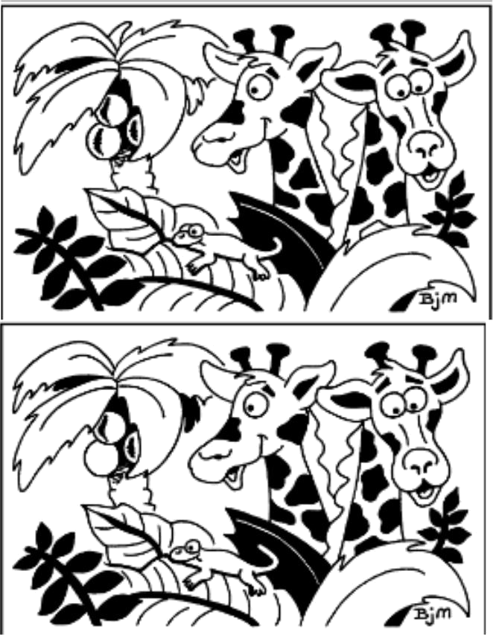

37

 | Learner Signature | Date
Version 1 | Learner Workbook

Class Activities

- Divide into two teams. One team leaves the room. The remaining ECD practitioners each then change an item of clothing by swapping something with another ECD practitioner or by turning something inside out. Once this is done the members of the team outside the room are brought back in and attempt to spot all the changes. A point is awarded for each change that is spotted. The teams then change roles, and the winning team is the one that scores the most points.

  - What did I learn in this activity?

.

38

 | Learner Signature | Date
Version 1 | Learner Workbook

Class Activities

- Kim’s Game is a good test of observation and memory.

The organiser puts about twenty small objects on a tray and allows the ECD practitioners a few minutes to memorise them. (The ECD practitioners are not allowed to make notes.) The tray is then covered with a cloth, and the ECD practitioners are each given a piece of paper and a pencil and they are then asked to write down as many objects as they can remember. The winner is the one who remembers the most objects.

Another way to play is to ask the players to turn their backs to the tray once they have been given time to see the objects. The organiser then removes one of the items and moves the positions of the others. The winner is the first to say which object has been removed.

This is a good game to play with your class (simplified and with fewer items of course!).

a. What did I learn in this activity?

39

 | Learner Signature | Date
Version 1 | Learner Workbook

Class Activities

- Draw up a questionnaire to find out about a class member. You must include questions on the following topics:

  - family

  - where they live

  - interests

You must have a minimum of four (4) questions per topic. You must include Open-Ended (OE) and Closed (C) questions. Indicate after each question whether it is Open or Closed. Use the following table for your questionnaire:


Ask a group member to assess your questionnaire:

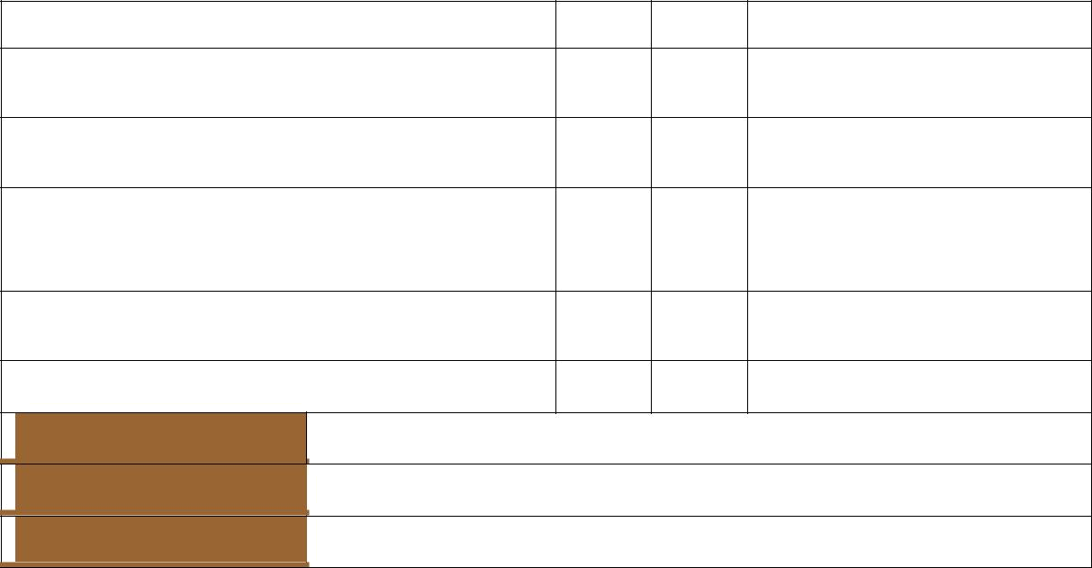
 |  | Yes | No |  | Comment

Are the questions clear and understandable?

Is there a balance between open-ended and closed questions?

Is the difference between open-ended and closed questions understood? Are they clearly marked OE or C?

Are there a minimum of three questions per topic?

Do the questions relate to the topics?

Name of member

Signature

Date

40

 | Learner Signature | Date
Version 1 | Learner Workbook

Class Activities

- Individual task: Complete the checklist that you will use to observe whether a toddler of 24-36 months has reached certain milestones in his/her development by filling in the missing words:

 | Criteria |  |  | Date of
 | Criteria |  |  | observation
 | PHYSICAL
Climbs well
Walks ………………. stairs alone, placing both feet on each step
Walks …………….. stairs alternating feet with support
Swings leg to kick ball
Runs easily
Pedals tricycle
Bends over easily without …………………….
 | FINE MOTOR
Makes vertical, horizontal, circular strokes with pencil/crayon
Turns book pages ………………….. at a time
Builds a tower of more than 6 blocks
Holds a pencil in ………………… position
Screws and unscrews jar lids, nuts, and bolts
Turns rotating handles
 | LANGUAGE
Recognises and identifies almost all common objects and
pictures
Understands most sentences
Understands physical relations (on, in, under)
Can say name, ……………….., and sex
Uses pronouns (I, you, me, we, they)
Strangers can understand …………………… of his/her words
 | COGNITIVE
Makes mechanical toys work
Matches object in hand/room to …………………….. in a book
Plays make-believe with dolls, animals, people
Sorts objects by ……………………..
Completes puzzles with ……………………. pieces
Understands concept of “two”
 | EMOTIONAL AND SOCIAL
Separates …………………….. from parents
Expresses a wide range of emotions
Objects to major …………………………. in routine

41

 | Learner Signature | Date
Version 1 | Learner Workbook

Class Activities

- Mrs Tobias is a single parent. You have an interview with her about her child, Ben, who is very active and noisy. You need to give Ms Tobias feedback in an interview about Ben. This is not affecting his development yet, but it is affecting your class. You are trying to get Mrs Tobias to cooperate and encourage Ben to be quiet during certain times while he is at home: mealtimes, bedtimes and listening while his mom reads a story. The aim is to get the mother to set limits and encourage quiet behaviour at certain times at home, which will help reinforce your efforts at the ECD centre. Identify which activities Ben has to be quiet for, in your programme.

Discuss how you need to communicate with Mrs Tobias in order to achieve a favourable response:

42

 | Learner Signature | Date
Version 1 | Learner Workbook

Class Activities

- With your partner, role-play a feedback interview with a parent. In the interview, give the parent the information you have gathered in your observation of his/her four-year-old child.

Make sure you meet all the key requirements for giving feedback:

  - confidentiality

  - clear and relevant feedback

  - sensitivity to diversity and emotions

  - constructive and meaningful feedback

  - recommendations

a. Ask two members of the group to assess your role play:

The learner has correctly: |  | Yes | No | Comment/ example
respected confidentiality
given clear and relevant feedback
displayed sensitivity to diversity and
emotions
given constructive and meaningful
feedback
made recommendations
Name of member
Signature
Date

43

 | Learner Signature | Date
Version 1 | Learner Workbook

Class Activities

- Role-play responding to a concerned parent who feels that his four-year-old child is not being prepared adequately for Grade 1. This is after there has been a lot of negative publicity in the newspapers regarding Grade 12s' literacy and numeracy skills. Now the parent wants you to teach his child to read and write and do sums and definitely does not understand the value of play.

  - Report back to the class what you learnt about the difficulties of dealing with angry parents.

  - The group member who roleplayed the parent should also give feedback to the class about the facilitator responses that were the most useful and reassuring to the parent.

Report back:

Feedback from the “parent”:

Place any extra evidence after this page; mark it clearly for easy reference.

44

 | Learner Signature | Date
Version 1 | Learner Workbook

Reflection

Reflection | 244480
Reflection | 244468
Individually complete the following: | 244475
 | 119462


The purpose of reflection is for you to consider what you have learnt and how you will use it in the future. Answer the following questions as honestly as you can:

- After the training programme, I can now (tick):

- facilitate development of babies, toddlers and young children
- reflect on own facilitation
- source and select resources
- adapt resources
- set up the environment
- reflect on the use and effectiveness of the resources
- observe babies, toddlers and young children
- record observations
- give feedback on observations
- respond critically yet sensitively as a listener/audience
- analyse own responses to spoken/signed texts and adjust as required
- use strategies to be an effective speaker/signer in sustained oral/signed interactions
- evaluate spoken/signed discourse

- How would you apply what you have learnt during this skills programme in the workplace?

- What was the most significant thing you have learnt in this programme?

- What do you think you still need to learn more about? (Action Plan)

- What did you enjoy most about the training?

45

 | Learner Signature | Date
Version 1 | Learner Workbook

Reflection

6. If there was something about the training that you could change, what would it be?

46

 | Learner Signature | Date
Version 1 | Learner Workbook

Facilitator Observation Checklist

Facilitator Observation Checklist | 244480
Facilitator Observation Checklist | 244468
The facilitator needs to provide feedback on the participation of each learner in the class: | 244475
 | 119462

The purpose of the facilitator observation checklist is to provide the learner with feedback about his/her participation during the formative class activities and also to highlight the observed strengths and perceived weaknesses that the learner displayed during the workshop and/or learning programme.

The facilitator is required to complete the Facilitator Observation checklist for each learner in his/her Learner Workbook. The learner has to sign off the document to confirm that he/she has received the observation feedback.

 | Learner Name |  |  |  |  |  |  |  |  |  |  | Facilitator Name |  |  |  |  |  |  |  |  |  |  |  |  |  |  | Date
 | Class Activity |  |  |  |  | Group/ |  |  |  | Completed |  |  |  |  | Participation |  |  |  |  |  |  |  |  |  | Comments on perceived strengths and weaknesses of the
 |  |  |  |  |  | Individual |  |  |  |  |  | ✓ |  |  | ☺ |  |  | 😐 |  |  |  | ☹ |  |  | learner
 | 1. | Facilitate development of babies,
 |  | toddlers and young children.
 | 2. | Identify activities to support the
 |  | development of babies, toddlers and
 |  | young children.
 | 3. | Source and select resources.
 | 4. | Adapt resources.
 |  |  |  |  |  |  |  |  |  |  |  |  |  |  |  |  |  |  |  |  |  |  |  |  |  | 47
 |  |  |  |  |  |  |  |  |  |  | Learner Signature |  |  |  |  |  |  |  |  |  |  | Date
 | Version 1 |  |  | Learner Workbook

Facilitator Observation Checklist

 | Class Activity |  |  |  | Group / |  |  |  | Completed |  |  | Participation |  |  |  |  |  |  |  |  |  | Comments on perceived strengths and weaknesses of the
 |  |  |  |  | Individual |  |  |  | ✓ |  |  | ☺ |  |  | 😐 |  |  |  | ☹ |  |  | learner
 | 5. | Set up the learning environment.
 | 6. | Store materials and physical resources.
 | 7. | Facilitate the development of babies,
 |  | toddlers and young children.
 | 8. | Ensure that communication promotes
 |  | development.
 | 9. | Use appropriate behaviour and conflict
 |  | management.
 | 10. | Reflect on own facilitation.
 | 11. | Evaluate spoken discourse.
 | 12. | Reflect on the use and effectiveness of
 |  | the resources.
 | 13. | Observe and report on child
 |  | development.
 |  |  |  |  |  |  |  |  |  |  |  |  |  |  |  |  |  |  |  |  |  |  | 48
 |  |  |  |  |  |  |  |  | Learner Signature |  |  |  |  |  |  |  |  |  | Date
 | Version 1 |  | Learner Workbook

Facilitator Observation Checklist

 | Class Activity |  |  | Group/ |  |  | Completed |  |  | Participation |  |  |  |  |  |  |  |  |  | Comments on perceived strengths and weaknesses of the
 | Class Activity |  |  | Individual |  |  | ✓ |  |  | ☺ |  |  |  | 😐 |  |  | ☹ |  |  | learner
 | 14. Reflection |  |  | Individual
 | Has the learner sufficiently demonstrated application of the following CCFO‟s during the facilitated session?
 |  |  |  |  |  |  |  |  |  |  |  | CCFO3: |  |  |  |  |  |  |  |  | CCFO4:
 |  |  |  |  |  |  |  |  |  |  |  |  |  |  |  |  |  |  |  |  | Collect, analyse, organise and critically
 | CCFO1: | CCFO2: |  |  |  |  |  |  |  |  |  | Organise and manage oneself and one's
 | CCFO1: |  |  |  |  |  |  |  |  |  |  |  |  |  |  |  |  |  |  |  | evaluate information:
 | Identify and solve problems: |  |  |  |  |  |  |  |  |  |  | activities responsibly and effectively
 | Identify and solve problems: | Work effectively with others and in teams: |  |  |  |  |  |  |  |  |  |  |  |  |  |  |  |  |  |  | about the development of babies, toddlers
 | - that occur during activities and developing |  |  |  |  |  |  |  |  |  |  | through:
 | - that occur during activities and developing | through group activities |  |  |  |  |  |  |  |  |  |  |  |  |  |  |  |  |  |  | and young children
 | - that occur during activities and developing |  |  |  |  |  |  |  |  |  |  | the general and specific activities related
 | - alternative ways of dealing with these
 | - alternative ways of dealing with these | using interactive speech/signing in |  |  |  |  |  |  |  |  |  |  |  |  |  |  |  |  |  |  | through the gathering and assessment of
 | - using context to decode and make |  |  |  |  |  |  |  |  |  |  | to planning and organising the activities
 | - using context to decode and make | activities, discussion and research |  |  |  |  |  |  |  |  |  | the organisation of own and children's |  |  |  |  |  |  |  |  | information from observations
 | - meaning individually and in groups in oral,
 | - meaning individually and in groups in oral, | projects |  |  |  |  |  |  |  |  |  |  |  |  |  |  |  |  |  |  | fundamental to the process of growing
 | - reading and written or signed activities |  |  |  |  |  |  |  |  |  |  | space
 | - reading and written or signed activities |  |  |  |  |  |  |  |  |  |  |  |  |  |  |  |  |  |  |  | language capability across language
 |  |  |  |  |  |  |  |  |  |  |  | using language
 |  |  |  |  |  |  |  |  |  |  |  |  |  |  |  |  |  |  |  |  | applications and fields of study
 | Yes/No |  |  | Yes/No |  |  |  |  |  |  |  |  |  |  |  |  |  |  | Yes/No |  | Yes/No
 | CCFO5: |  |  |  |  |  |  |  |  |  |  | CCFO7:
 | CCFO5: |  |  |  |  |  |  |  |  |  |  | Understand the world as a set of inter-
 | Communicate effectively using visual, |  |  |  |  |  |  |  |  |  |  |  |  |  |  |  |  |  |  |  | CCFO8:
 | Communicate effectively using visual, |  |  |  |  |  |  |  |  |  |  | related parts of a system through:
 | mathematical and/or language skills: | CCFO6: |  |  |  |  |  |  |  |  |  | the manner in which the preparation and |  |  |  |  |  |  |  |  | Contribute to the full development of
 | during all facilitation activities
 | during all facilitation activities | N/A |  |  |  |  |  |  |  |  |  | set-up impacts on Early Childhood |  |  |  |  |  |  |  |  | oneself: by engaging with texts that
 | through questioning and communication |  |  |  |  |  |  |  |  |  |  | Development (ECD) |  |  |  |  |  |  |  |  | stimulate awareness and development of
 | of feedback, as well as reporting |  |  |  |  |  |  |  |  |  |  | using language to explore and express |  |  |  |  |  |  |  |  | life skills and the learning process
 | in formal and informal communications |  |  |  |  |  |  |  |  |  |  | links, and exploring a global range of
 |  |  |  |  |  |  |  |  |  |  |  | contexts and texts
 | Yes/No |  |  | Yes/No |  |  |  |  |  |  |  |  |  |  |  |  |  |  | Yes/No |  | Yes/No

 |  |  |  | 49
 |  | Learner Signature | Date
Version 1 | Learner Workbook

Facilitator Observation Checklist

 | Statement by the facilitator: |  |  |  | Additional comments: (optional)
 | The learner has demonstrated sufficient |  | Yes | No
 | knowledge and skill during class to proceed |  | Yes | No
 | with the summative assessment (circle Yes or No).
 | Learner Signature |  |  |  | Facilitator Signature

50

Learner Signature | Date

Version 1 Learner Workbook

